HUMPBACK WHALE
RECOVERY PLAN

2005 - 2010

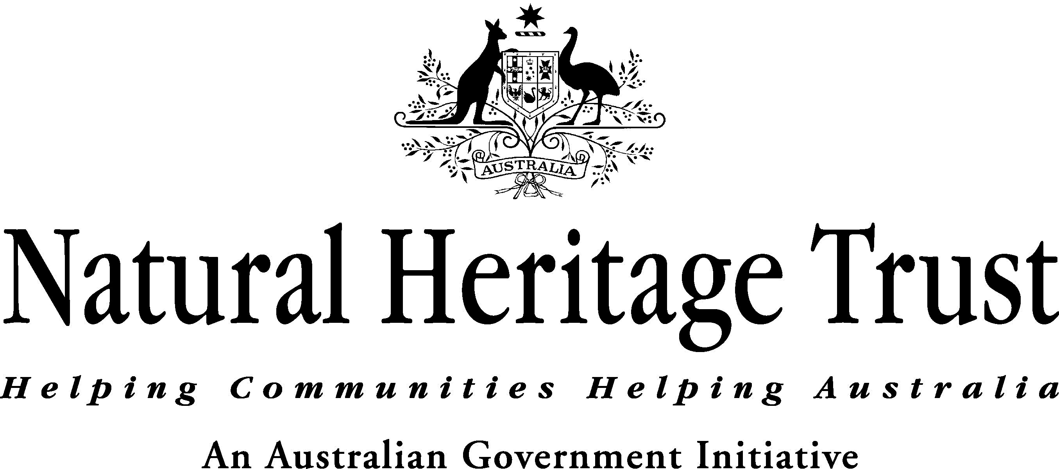


The humpback whale (Megaptera novaeangliae) is listed as vulnerable under the Environment Protection and Biodiversity Conservation Act 1999 (EPBC Act). This plan outlines the measures necessary to ensure recovery of the Australian populations of humpback whales and is set out in accordance with Part 13, Division 5 of the EPBC Act.

Objectives
The objectives are:
- the recovery of populations of humpback whales utilising Australian waters so that the species can be considered secure in the wild;
- a distribution of humpback whales utilising Australian waters that is similar to the pre-exploitation distribution of the species; and
- to maintain the protection of humpback whales from human threats.

For the purposes of this plan ‘secure in the wild’ is defined qualitatively, recognising that stricter definitions are not yet available, but will be refined and where possible quantified during the life of this plan by work currently underway and identified in the actions of this plan.

‘Secure in the wild’ with respect to humpback whales in Australian waters means: a population with sufficient geographic range and distribution, abundance, and genetic diversity to provide a stable population over long time scales.

Criteria to measure performance of the plan against the objectives
It is not anticipated that these objectives will be achieved within the life of the plan for both migratory populations of Australian humpback whales. However, the following criteria can be used to measure the ongoing performance of this plan against the objectives:
- secure populations of humpback whales in Australian waters were recorded, or populations continued to recover at, or close to, the optimum biological rate (understood to be approximately 8-10% per annum at the commencement of this plan);
- populations of humpback whales in Australian waters were known to have a distribution similar to the pre-exploitation distribution, or the range of humpback whale populations continued to expand towards pre-exploitation distributions; and
- domestic and international protection regimes that support the recovery of the species were maintained and where possible improved.

Species information
The humpback whale is a moderately large baleen whale (order Cetacea, family Balaenopteridae). The species is found virtually worldwide, but with apparent geographical segregation. Each year Australian humpback whales migrate from Southern Ocean summer feeding grounds to sub-tropical winter calving grounds. The northern and southern hemisphere populations appear to be distinct given temporal migration separation.

In the 19th and 20th centuries, humpback whales were hunted extensively throughout the world’s oceans and as a result it is estimated that 95% of the population was eliminated. In Australia, it is estimated that humpback whales were reduced to 3.5 - 5% of pre-whaling abundance. The International Whaling Commission (IWC) imposed a ban on humpback whaling in the southern hemisphere in 1963 and an international moratorium on commercial whaling came into effect in 1985-86.

In Australia, humpback whales are distributed throughout the Australian Antarctic, Commonwealth offshore, State and Territory waters. Australia has two migratory populations of humpback whales, a west coast and an east coast population (known as Group D and Group E respectively in international fora). Population levels prior to exploitation are difficult to estimate but it has been suggested that the west coast population was between 16,000-30,000 and the east coast population was approximately 27,000. In 1999, the west coast population was estimated to be between 8,000 and 14,000 individuals with a rate of increase of approximately 10.14% from 1982 to 1994. In 1999, the east coast population was estimated to be 3,160-4,040 individuals with a rate of increase of approximately 10.9% from 1978 to 1999. It is likely that these rates of increase will fall as the populations near maximum abundance.

Humpback whales utilising Australian waters currently have tropical calving grounds along the mid and northern parts of the east and west coasts of Australia, and feeding grounds in the Southern Ocean. The majority of humpbacks in Australian waters migrate north to tropical calving grounds from June to August, and south to the Southern Ocean feeding areas from September to November. The exact timing of the migration period can change from year to year and may be influenced by water-temperature, the extent of sea-ice, predation risk, prey abundance and location of feeding ground.

Feeding is likely to be related to krill density and primarily occurs in Southern Ocean waters south of 55°S. However, several opportunistic feeding areas have also been found off the coast of Australia. The available information suggests that a portion of the east coast population disperses into the South Pacific including New Caledonia, Tonga and probably other western South Pacific Islands. Although there are known links between these areas, the levels of exchange are poorly understood and the rates of recovery are likely to be lower for those found near the island groups than close to the east Australian coast.

Further information on the biology, population status, distribution and habitat of humpback whales can be found on the Species Profiles and Threats Database – www.deh.gov.au/sprat. This information is regularly updated to ensure that it reflects the most recent research.

Habitat critical to the survival of humpback whales
It is not currently possible to define habitat critical to the survival of humpback whales. The flexibility and adaptability of the species’ habitat requirements are not known, and it is not clear if all the currently used areas are critical to survival or whether the loss of one of these areas could be sustained. The plan therefore focuses on habitat important to the survival of humpback whales.

For the purpose of this plan, habitat important (and potentially critical) to the survival of humpback whales is defined as those areas known to seasonally support significant aggregations of whales, and those ecosystem processes on which humpback whales rely - in particular known calving, resting and feeding areas, and certain sections of the migratory pathways.

Figure 1 illustrates the distribution, indicative migratory pathways and recognised aggregation areas for humpback whales utilising Australian waters. It should be noted that the boundaries presented on the map are indicative only and there is inherent variability in the movements of the species.

Calving
Currently known calving areas (based on observations of mothers with very young calves) for Australian humpback whales include:
- Western Australia - Southern Kimberley between Broome and the northern end of Camden Sound;
- Queensland - Great Barrier Reef complex between approximately 14°S and 27°S; and
- less frequently along the migratory pathways.

Migration
Along parts of the migratory route there are narrow corridors and bottlenecks resulting from physical and other barriers where the majority of the population passes close to shore (i.e. within 30 km of the coastline). These habitat areas are important during the time of migration and include:
- Western Australia - Geraldton/Abrolhos Islands, and Point Cloats to North West Cape; and
- Queensland - east of Stradbroke Island, and east of Moreton Island.

Resting
Resting areas are used by cow-calf pairs and attendant males during the southern migration. These whales appear to use sheltered bays to opportunistically rest during migration to the feeding grounds and include:
- Western Australia - Exmouth Gulf, Shark Bay, and Geographe Bay;
- Queensland – the Whitsundays, Hervey Bay, Moreton Bay, the Swain Reefs complex Great Barrier Reef, Bell Cay, and the Palm Island Group; and
- New South Wales - Twofold Bay and Cape Byron.

Feeding
Feeding occurs primarily on Antarctic krill which congregates around the Antarctic continental shelf break and productive, transitional ice-edge zone. Oceanographic features that concentrate krill are likely to attract predators such as humpback whales. Humpback whales from the Australian west and east coast populations are known to mix to some extent at these feeding grounds.

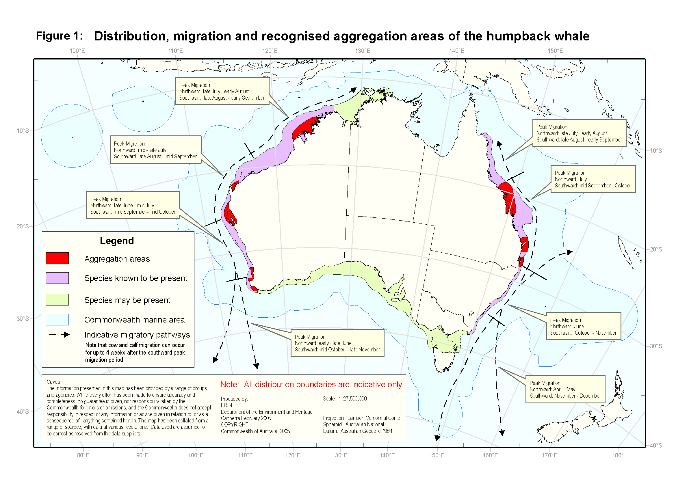

Management practices

Domestic measures
In Australia, humpback whales are listed as vulnerable under the EPBC Act. The EPBC Act established the Australian Whale Sanctuary and gives high levels of protection to cetaceans in Commonwealth waters. The Australian Whale Sanctuary encompasses the area of the Exclusive Economic Zone (EEZ) outside state waters and generally extends 200 nm from the coast, but further in some areas to cover the continental shelf and slope. It also includes the waters around the Australian Antarctic Territory and external territories including Christmas, Macquarie, Heard and McDonald Islands.

Within the Australian Whale Sanctuary it is an offence to kill, injure, take, trade, keep, move or interfere with a cetacean. The EPBC Act also makes it an offence for Australians to carry out any of these actions beyond the outer limits of the Australian Whale Sanctuary, that is, in international or foreign waters. Other than in the case of killing or taking for live display, permits may be issued by the Australian Government Minister for the Environment and Heritage to carry out these activities (e.g. for the purpose of research).

Humpback whales are protected in all States and Territories under general native species and/or threatened species protection and management legislation.

A number of measures currently exist to manage interactions with all species of whales. These include administrative guidelines under the EPBC Act relating to interactions between offshore seismic operations and whales, and both Commonwealth and State regulations to manage whale watching activities.

Within the Great Barrier Reef Marine Park activities that will interfere with cetaceans are regulated through the Great Barrier Reef Marine Park Zoning Plan 2003.

International measures
The humpback whale is afforded a degree of international protection through listing on Appendix I of the Convention on International Trade in Endangered Species (CITES), on Appendix II of the Convention on Migratory Species (CMS), and as vulnerable under the World Conservation Union’s Red List (IUCN).

In addition, Australia participates in several other international agreements that directly or indirectly relate to the conservation of marine mammals. Specifically, Australia was a founding member of the International Whaling Commission (IWC), is the host country of the Convention on the Conservation of Antarctic Marine Living Resources (CCAMLR), and a key player in Antarctic Treaty Consultative Meetings (ATCM).

Whales are protected from commercial whaling by IWC member states as part of the current moratorium and by the IWC’s Indian Ocean Sanctuary and Southern Ocean Sanctuary. Sanctuaries do not protect whales from whaling under special permit and are reviewed every ten years.

Australia is also working within the South Pacific Regional Environment Programme (SPREP) to establish a Memorandum of Understanding for the conservation and management of marine mammals in the South Pacific region, under the Convention on Migratory Species.

Threats

Identified Threats
- The resumption of commercial whaling and/or the expansion of scientific whaling
The impacts of commercial hunting on humpback whale populations have been well documented. While currently banned under the IWC moratorium on commercial whaling, the potential for commercial whaling to recommence exists and pressure may well increase as populations recover.

An additional area of concern is the potential expansion of de facto commercial whaling under the guise of scientific whaling. The IWC Convention allows member states to issue special permits to kill whales for research purposes and then process these animals for sale. Since 1986, Japan and Iceland have issued special permits for several whale species as part of their scientific whaling research programs. The recent expansion of these programs in the Northern Hemisphere involve the killing of various baleen whales including minke, Bryde's, fin, sperm and sei whales. In addition, since the implementation of the Southern Ocean Sanctuary in 1994, Japan has continued to harvest minke whales there under special permits. It is quite possible that humpback whales will be included in future research programs.

- Habitat degradation
Humpback whales use habitat seasonally and can typically be found along various parts of the Australian coastline for up to nine months of the year (April to December). Anthropogenic activities have the potential to degrade habitat important to the species. These activities may degrade habitat by operating at times that coincide with the presence of whales, or they may occur when whales are absent, but degrade habitat suitability on a permanent or semi-permanent basis. These activities may include:
- acoustic pollution (e.g. commercial and recreational vessel noise, and seismic survey activity);
- entanglement (e.g. in marine debris, fishing and aquaculture equipment);
- physical injury and death from ship strike;
- built structures that impact upon habitat availability and/or use (e.g. marinas, wharves, aquaculture installations, mining or drilling infrastructure);
- changing water quality and pollution (e.g. runoff from land based agriculture, oil spills, outputs from aquaculture); and
- changes to water flow regimes causing extensive sedimentation or erosion or altered currents in near shore habitat (e.g. canals and dredging).

The species’ dependence on inshore areas means that individual animals may be subject to the impacts from any or all of these activities. Habitat degradation may result in reduced occupancy and/or exclusion of individual whales from suitable habitat, compromised reproductive success, and mortality. It is possible that impacts on a sufficient number of individual whales could lead to broader impacts at the population level, e.g. by reducing recruitment to such an extent that species recovery is impeded. This would be more likely to arise where activities that cause habitat degradation occurred intensively and/or cumulatively, or over a large portion of their range.

It should be noted that at the time of the writing of this plan, both migratory populations of humpback whales were increasing at the optimum biological rate suggesting that to date habitat degradation has not had a negative impact on population or species recovery. Nevertheless, ongoing monitoring and management are required to ensure that habitat degradation does not become a significant issue.

Potential threats
- Climate and oceanographic change
Most of the world's leading scientists agree that global warming caused by human activity is occurring. The exact implications of these changes are unknown, but it is predicted that there will be reduced productivity of Southern Ocean ecosystems and unpredictable weather events caused by increasing ocean water temperatures, changing ocean currents, rising sea levels and reductions in sea ice.

The potential impacts of climate and oceanographic change on humpback whales are twofold:
1) Habitat availability
Humpback whale migration, feeding, resting, and calving site selection may be influenced by factors such as ocean currents and water temperature. Any changes in these factors could affect humpback whale population recovery by rendering currently used habitat areas unsuitable.

2) Food availability
Changes to climate and oceanographic processes may also lead to decreased productivity and different patterns of prey distribution and availability. Such changes would certainly effect dependant predators such as humpback whales.

- Prey depletion due to over harvesting
Humpback whales rely on krill as the main food source and require adequate supplies to accumulate energy reserves essential for migration and breeding. Depletion of krill through over harvesting may be a potential future threat for Australian populations of humpback whales. However, it should be noted that:
- the krill fishery is managed through the Convention on the Conservation of Antarctic Marine Living Resources (CCAMLR) on an ecosystem basis which takes into account the needs of predators such as whales; and
- while the fishery is likely to grow, fishing currently occurs well within the current precautionary limits.

Actions to achieve the objectives
Monitor population status and assess habitat
- Implement a program to measure population abundance, trends and recovery for Australian populations of humpback whales
- Included within this activity is the need to:
  - gather information on population structures using methodologies including genetic analyses, comparisons of photo identification and telemetry studies;
  - establish models for measuring recovery and species status, incorporating a range of indicators (e.g. current and pre-whaling population estimates, population structure, use of habitats etc); and
  - continue to collect long-term data sets using standardised survey methodologies for humpback whales in a statistically robust manner.

- Implement a program to better define the characteristics (spatial, temporal, and physical) of calving, resting, feeding, and migratory areas
- Included within this activity is the need to:
  - determine the values and characteristics of important migratory pathways and aggregation areas (calving, resting, and feeding) particularly in areas where human use is likely to impact upon the species;
  - gather information on movements, migrations, and feeding grounds – e.g. through the use of satellite tracking and other survey methods; and
  - examine the historical and potential future use of humpback whale habitat with a view to defining these areas and assessing human use activities to ensure impacts are appropriately managed and regulated.

Protect the species from threats
- Prevent commercial whaling and move to ban scientific whaling
- Australia should maintain its position on promoting high levels of protection for humpback whales in all relevant international agreements including the IWC, CITES, CMS, fisheries-related agreements, and Antarctic Treaty Consultative Meetings (ATCM).
- Australia should continue to support a ban on directed take of humpback whales.

- Protect habitat important to the survival of the species
- Ensure that in areas important to the survival of the species environmental assessment process and research activities are in place to determine the level of impact and threat of human activities, and implement management measures to ensure the ongoing recovery of the species. This should include, but not be limited to, the following actions:
  - assess and manage acoustic pollution – including the development and application of administrative guidelines under the EPBC Act such as the “Guidelines on the application of the EPBC Act to interactions between offshore seismic operations and larger cetaceans”;
  - encourage best practice approaches that will reduce the likelihood of humpback whales being entangled in marine debris, fishing and aquaculture equipment. If entanglements occur, manage the impact of individual entanglements through the application of national standards for disentangling large cetaceans;
  - ensure that humpback whale habitat requirements are considered in the establishment and management of marine conservation areas and reserves;
  - manage the potential impacts of tourism – e.g. through the application of consistent Commonwealth and State tourism and whale watching regulations; and
  - assess and manage physical disturbance and development activities (such as ship-strike, aquaculture, pollution, recreational boating, naval activities, and exploration and extraction industries) – including the application of environmental impact assessment and approvals and the development of industry guidelines and State/Commonwealth government regulations.
- Implement education programs to inform marine users (e.g. whale watchers, fishermen, and shipping crews using important habitat) about best practice behaviours and regulations when interacting with whales.

- Monitor and manage the potential impacts of prey depletion due to over harvesting
- Improve knowledge of humpback whale feeding ecology in order to determine if or when prey depletion becomes a threat.
- Australia should support regional ecosystem approaches to krill management through its involvement in CCAMLR and other fora.

- Monitor climate and oceanographic change
- Develop an understanding of the effects of climate and oceanographic change on humpback whale populations to determine if species survival and recovery are being, or are likely to be affected.

Major benefits to other native species or ecological communities
As the humpback whale is both a coastal and oceanic ranging species, marine mammal protection regimes may have benefit for other cetaceans found within Australian waters, including the large whales - blue, Bryde’s, minke, fin, sei, southern right and sperm whales. Conservation measures pertaining to calving and resting habitats may also benefit small cetaceans and other species in coastal waters.

Implementation of this plan is unlikely to have negative impacts on any other native species or ecological community.

Duration and cost of the recovery process
It is anticipated that the recovery process will take longer than the life of the plan (2005-2010), which should be reviewed after five years. A recovery plan for the species should remain in place until such time that the populations of humpback whales utilising Australian waters has improved to the point that the populations are considered secure.

The cost of this plan will be met through various direct and indirect funding activities undertaken by the Australian Government, State and Territory governments, researchers, conservation groups, marine based industries and the Australian public. Costing of specific actions will be determined at the time of activity.

Role and interests of Indigenous people
Many marine mammal species have cultural significance to Aboriginal or Torres Strait Islander people. Recognising this cultural connection to whales is important. No record has been found of whale hunting before the arrival of Europeans, although it is likely that some use was made of whales that washed ashore. Indigenous people must be considered if plans for development or use of an area are expected to impact upon indigenous ownership or native title interests. Agreements between government and Indigenous people are essential and serve to increase the involvement of all parties with a stake in the welfare and recovery of whales.

Affected interests
Organisations likely to be affected by the actions proposed in this plan include the following:

Australian Government:  Australian Fisheries Management Authority  Australian Maritime Safety Authority  Department of Agriculture, Fisheries and Forestry  Department of Defence  Department of Foreign Affairs and Trade  Department of Industry, Tourism and Resources  Department of the Environment and Heritage  Great Barrier Reef Marine Park Authority  Indigenous Land Corporation  Industry and Non-Government Organisations:  Aquaculture industry  Commercial fishers and associations  Commercial shipping  Conservation groups  Energy distribution networks  Indigenous Land Councils and communities  Local communities  Oil and gas exploration and production industry  Recreational boating clubs and associations  Recreational fishers and associations  Strandings/volunteer networks  Universities and other research organisations  Whale-watching industry and associations | State/Territory Governments:  Department of Conservation and Land Management, WA  Department of Environment and Heritage, SA  Department of Primary Industries, Water and Environment, TAS  Department of Primary Industry, QLD  Department of Sustainability and Environment, VIC  Environment Protection Agency, QLD  Fisheries agencies  Museums  Department of Environment and Conservation, NSW  Parks and Wildlife Commission, NT  Parks Victoria  Shipping, oil and gas exploration and development agencies

Social and economic impacts
It is not anticipated that this plan will have significant economic and/or social impacts in the short or long-term.

Organisations/persons involved in evaluating the performance of the plan
The Threatened Species Scientific Committee (TSSC) with the assistance of relevant scientists, managers and other stakeholders should evaluate the performance of this plan and report the results of their review to the Australian Government Minister for the Environment and Heritage.

Where to get the plan
This recovery plan is obtainable from:
http://www.deh.gov.au/biodiversity/threatened/recovery/list-common.html

Wildlife Impact and Protection Section
Wildlife Conservation Branch
Department of the Environment and Heritage
GPO Box 787
Canberra ACT 2601

