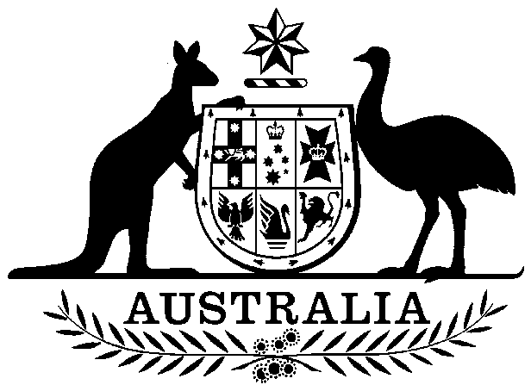
COMMONWEALTH OF AUSTRALIA

Environment Protection and Biodiversity Conservation Act 1999

Amendment of List of Exempt Native Specimens

I, GERARD EARLY, Delegate of the Minister for the Environment and Heritage, pursuant to subsection 303DC(1) of the Environment Protection and Biodiversity Conservation Act 1999 (the Act), hereby amend the list of exempt native specimens established under section 303DB of the Act by including in the list the specimens and associated notations in the Schedule.

Dated this 12th day of October 2004

………………Gerard Early…………………………

Delegate of the Minister for the Environment and Heritage

SCHEDULE
Amendment to the List of Exempt Native Specimens

Specimens to which the amendment applies | Conditions
Pecten fumatus (Commercial Scallop) and Mimachlamys asperrima (Doughboy Scallop) taken in the Bass Strait Central Zone Scallop Fishery; | The specimen, or the fish or invertebrate from which it is derived, was taken lawfully; and  The specimens are covered by the declaration of an approved Wildlife Trade Operation under section 303FN of the Act in relation to the fishery.
Specimens that are, or are derived from, fish or invertebrates, other than specimens listed under Part 13 of the Act, taken in the New South Wales Estuary Prawn Trawl Fishery; | The specimen, or the fish or invertebrate from which it is derived, was taken lawfully; and  The specimens are covered by the declaration of an approved Wildlife Trade Operation under section 303FN of the Act in relation to the fishery.
Specimens that are, or are derived from, fish or invertebrates, other than specimens listed under Part 13 of the Act, taken in the Southern and Eastern Scalefish and Shark Fishery; | The specimen, or the fish or invertebrate from which it is derived, was taken lawfully; and  The specimens are covered by the declaration of an approved Wildlife Trade Operation under section 303FN of the Act in relation to the fishery.
Specimens that are, or are derived from, fish or invertebrates, other than specimens of species listed under Part 13 of the Act, taken in the Queensland Mud Crab Fishery; | The specimen, or the fish or invertebrate from which it is derived, was taken lawfully; and  The specimens are covered bythe declaration of an approved Wildlife Trade Operation under section 303FN of the Act in relation to the fishery .
Specimens that are, or are derived from, fish or invertebrates, other than specimens of species listed under Part 13 of the Act, taken in the South Australian Giant Crab Fishery; | The specimen, or the fish or invertebrate from which it is derived, was taken lawfully; and  The specimens are covered by the declaration of an approved Wildlife Trade Operation under section 303FN of the Act in relation to the fishery.
Specimens that are, or are derived from, fish or invertebrates, other than specimens listed under Part 13 of the Act, taken in the Tasmanian Giant Crab Fishery; | The specimen, or the fish or invertebrate from which it is derived, was taken lawfully; and  The specimens are covered by the declaration of an approved Wildlife Trade Operation under section 303FN of the Act in relation to the fishery.

Native ‘flat’ oyster (Ostrea angasi) taken in the Tasmanian Native Oyster Fishery; | The specimen, or the fish or invertebrate from which it is derived, was taken lawfully; and  The specimens are covered by the declaration of an approved Wildlife Trade Operation under section 303FN of the Act in relation to the fishery.
Scalaris abalone (Haliotis scalaris) taken in Tasmanian waters by Ocean Resources Pty Ltd under the Tasmanian Living Marine Resources Management Act 1995; | The specimen, or the fish or invertebrate from which it is derived, was taken lawfully; and  The specimens are taken while the declaration of an approved Wildlife Trade Operation under section 303FN of the Act in relation to the fisheryis in force.
Catostylus mosaicus taken in Victorian waters by licensed operators under the Victorian Fisheries Act 1995; | The specimen, or the fish or invertebrate from which it is derived, was taken lawfully; and  The specimens are taken while the declaration of an approved Wildlife Trade Operation under section 303FN of the Act in relation to the fisheryis in force.
Specimens that are, or are derived from, fish or invertebrates, other than specimens of species listed under Part 13 of the Act, taken in the Victorian Giant Crab Fishery; | The specimen, or the fish or invertebrate from which it is derived, was taken lawfully; and  The specimens are covered by the declaration of an approved Wildlife Trade Operation under section 303FN of the Act in relation to the fishery.
Specimens that are, or are derived from, fish or invertebrates, other than specimens of species listed under Part 13 of the Act, taken in the West Coast Deep Sea Crab Interim Managed Fishery; | The specimen, or the fish or invertebrate from which it is derived, was taken lawfully; and  The specimens are covered by the declaration of an approved Wildlife Trade Operation under section 303FN of the Act in relation to the fishery.
Marine specimen shells taken in Western Australian waters by licenced operators under the Fish Resources Management Act 1994; | The specimen, or the fish or invertebrate from which it is derived, was taken lawfully; and  The specimens are taken while the declaration of an approved Wildlife Trade Operation under section 303FN of the Act in relation to the fishery is in force.

