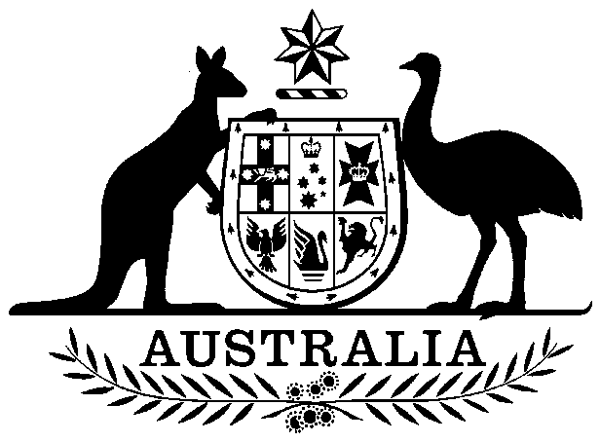
COMMONWEALTH OF AUSTRALIA

Environment Protection and Biodiversity Conservation Act 1999

Amendment of List of Exempt Native Specimens

I, IAN CRESSWELL, Assistant Secretary, Wildlife Trade and Sustainable Fisheries Branch, as Delegate of the Minister for the Environment and Heritage, pursuant to subsection 303DC(1) of the Environment Protection and Biodiversity Conservation Act 1999 (the Act), hereby amend the list of exempt native specimens established under section 303DB of the Act by including in the list the following specimens:

- Specimens that are or are derived from fish or invertebrates, taken in the South Australian Abalone Fishery, as defined in the management regime made under the South Australian Fisheries Act 1982 and Scheme of Management (Abalone Fisheries) Regulations 1991, other than specimens that belong to species listed under Part 13 of the Act.

with a notation that inclusion of the specimens in the list is subject to the following restrictions or conditions:

- The specimen , or the fish or invertebrate from which it is derived, was taken lawfully; and

- The specimen is included on the list until 21 June 2009

Dated this tenth day of June 2004

………………… Ian Cresswell ………………………
Delegate of the Minister for the Environment and Heritage

