Federal Magistrates Court Amendment Rules 2002 (No. 1)¹
Statutory Rules 2002 No. 80²
We, Federal Magistrates, make the following Rules of Court under the Federal Magistrates Act 1999.
Dated 16 March 2002
BRYANT CFM
BARNES FM
BAUMANN FM
BREWSTER FM
BROWN FM
COKER FM
CONNOLLY FM
DONALD FM
DRIVER FM
HARTNETT FM
McINNIS FM
MEAD FM
PHIPPS FM
RAPHAEL FM
RIMMER FM
ROBERTS FM
RYAN FM
SCARLETT FM
Federal Magistrates
PETER MAY
Chief Executive Officer
1 Name of Rules
These Rules are the Federal Magistrates Court Amendment Rules 2002 (No. 1).
2 Commencement
These Rules commence on gazettal.
3 Amendment of Federal Magistrates Court Rules 2001
Schedule 1 amends the Federal Magistrates Court Rules 2001.

Schedule 1 Amendments
(rule 3)

[1] Rule 1.05, General outline, sixth dot point
substitute
- Chapter 6 applies to proceedings under other Acts including the Administrative Decisions (Judicial Review) Act 1977 and the Administrative Appeals Tribunal Act 1975.
[2] Rule 1.06
omit
The Court
insert
(1) The Court
[3] Rule 1.06
insert
(2) If, in a proceeding, the Court gives a direction or makes an order that is inconsistent with any of these Rules, the direction or order of the Court prevails in that proceeding.
[4] Subrule 4.03 (1)
omit
a cross-claim
insert
an application
[5] Subrule 4.03 (2)
omit
or cross-claim
[6] Paragraph 6.08 (2) (a)
substitute
(a) on a company, as defined in section 9 of the Corporations Act 2001, in any manner permitted by section 109X of that Act; and
[7] Paragraphs 6.08 (2) (b) and (c)
omit
of the Corporations Law
insert
of that Act
[8] Paragraph 8.02 (4) (e)
substitute
(e) the wishes of the parties;
(f) for family law or child support proceedings, whether the hearing of the proceeding is likely to take longer than 2 days.
[9] Rule 21.06
omit
[10] Subdivision 21.3.1, heading
omit
[11] Subrule 21.09 (2)
substitute
(2) Subject to paragraphs 21.02 (2) (c) and 21.11 (2) (a), Order 38 of the Family Law Rules does not apply to a family law or child support proceeding in the Court.
[12] Rule 21.10
after
proceeding
insert
(other than a proceeding to which the Bankruptcy Act applies)
[13] Rule 21.10, at the foot
insert
Note For costs in a proceeding to which the Bankruptcy Act applies: see rule 29.08.
[14] Rule 21.11, heading
substitute
21.11 Taxation of costs
[15] Rule 21.11
omit
If a statement
insert
(1) If a statement
[16] Rule 21.11
insert
(2) When taxing a statement of costs, a taxing officer must apply:
(a) for a family law or child support proceeding — the scale of costs set out in Schedule 2 to the Family Law Rules; and
(b) for a general federal law proceeding — the scale of costs set out in Schedule 2 to the Federal Court Rules.
(3) In this rule:
taxing officer means a Registrar.
[17] Subdivision 21.3.2
omit
[18] Subrule 27.03 (2), second occurring
substitute
(3) If the Court appoints a new mediator, the Court may order that the mediation continue in any way the Court directs.
[19] Rule 28.05
omit
A cross-respondent
insert
(1) A cross-respondent
[20] Rule 28.05
insert
(2) A response must be filed and served within 14 days of service of the cross-claim to which it relates.
[21] After rule 29.07
insert
29.08 Costs
Unless the Court otherwise orders, a party entitled to costs in a proceeding to which the Bankruptcy Act applies is entitled to costs in accordance with the Federal Court Rules.
[22] Schedule 1, Part 3
omit
[23] Schedule 2, Part 1, Application
substitute

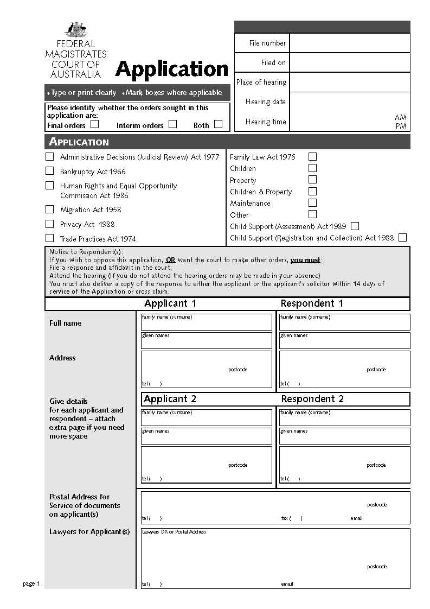
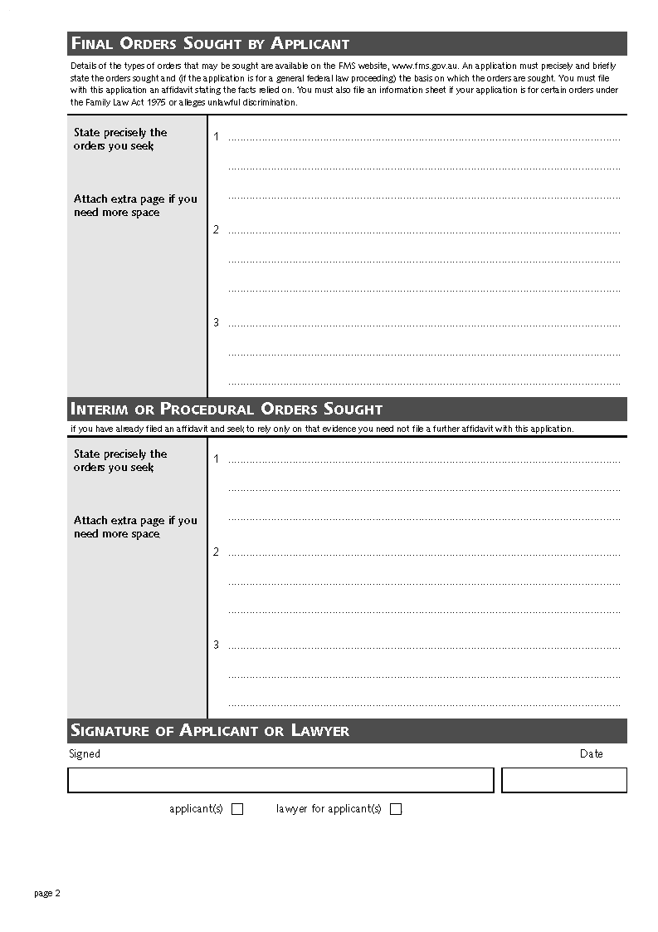
[24] Schedule 2, Part 2, Form 4
substitute
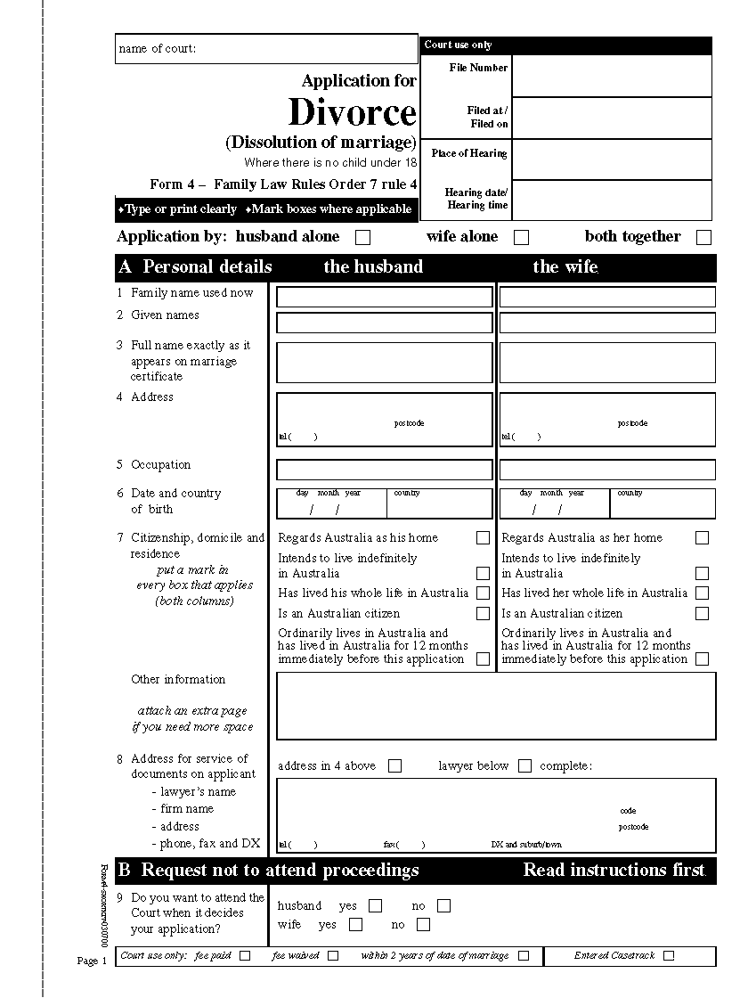
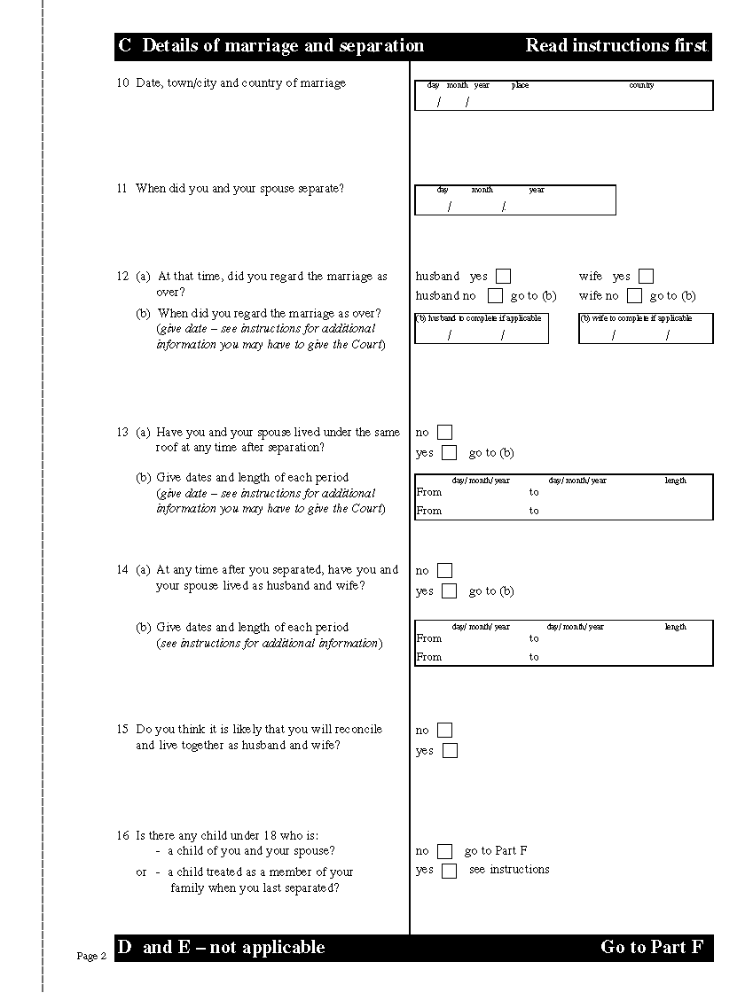
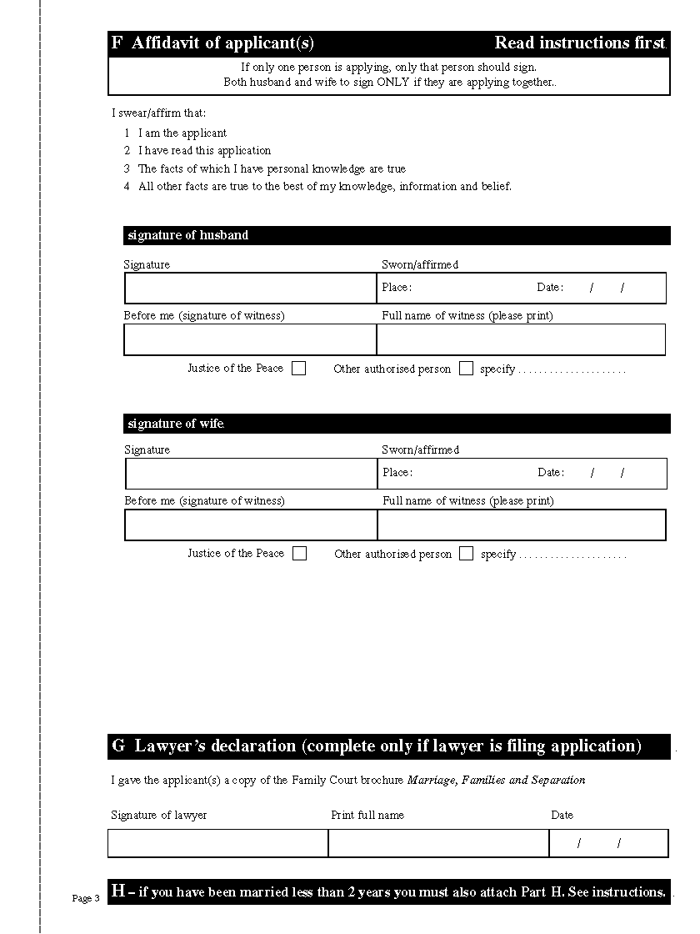
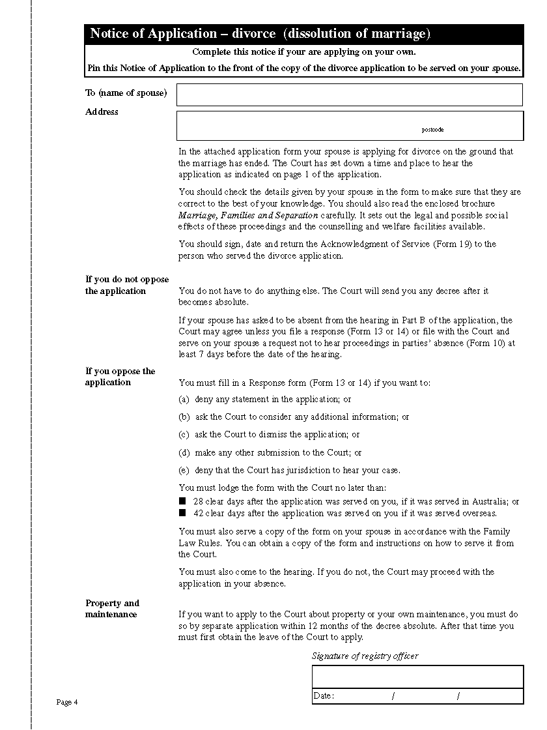
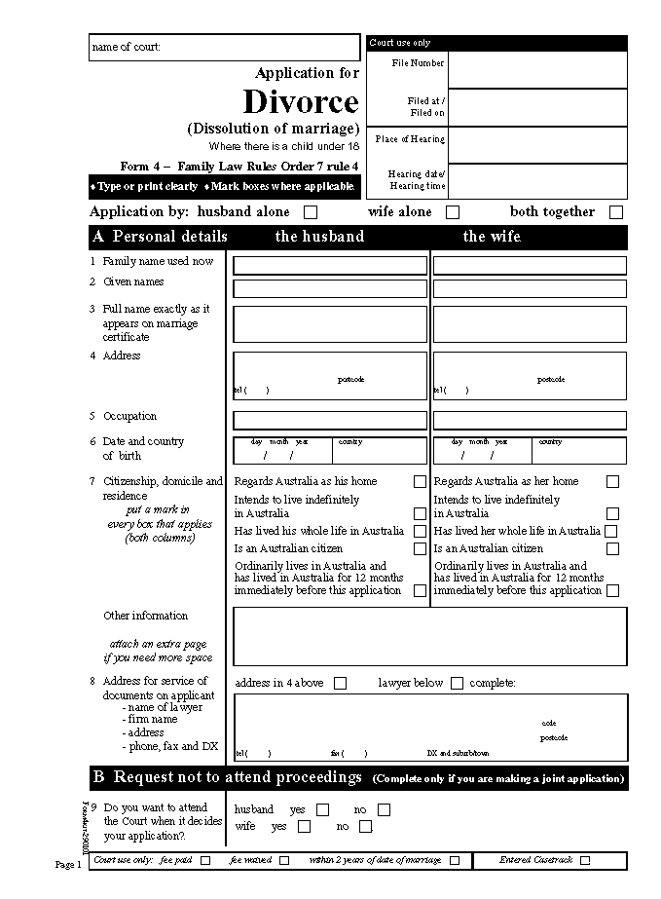
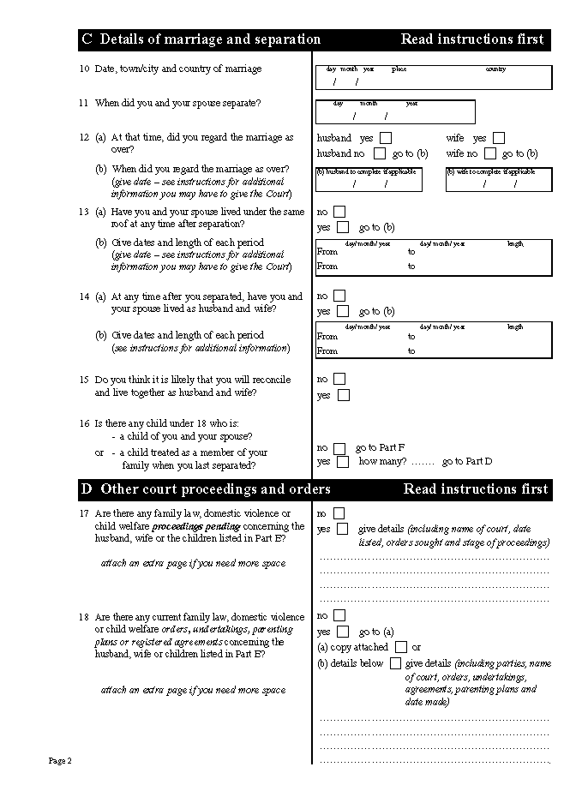
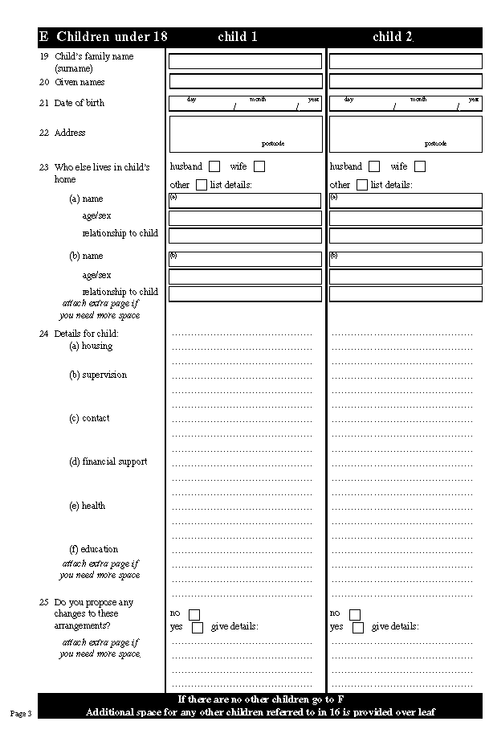
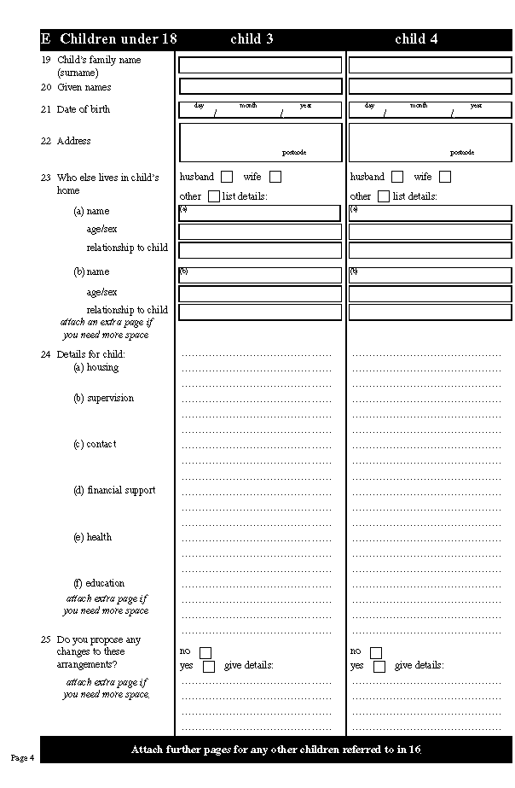
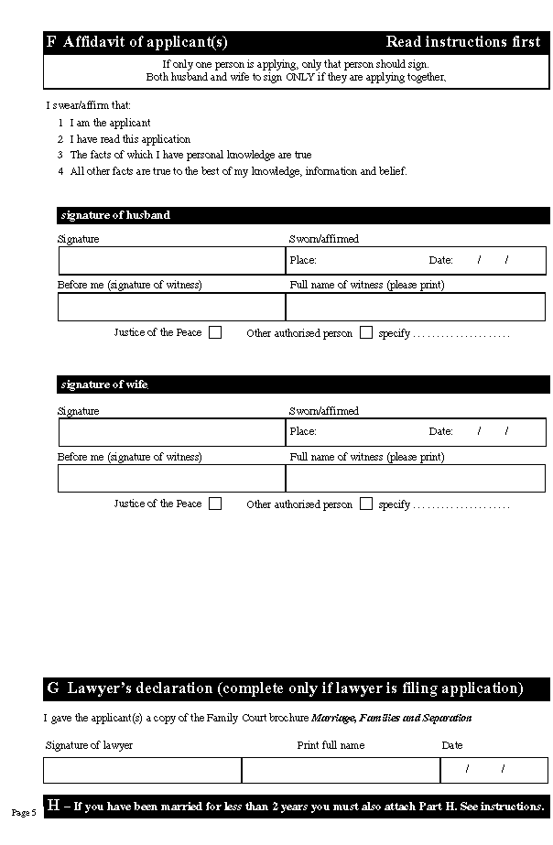
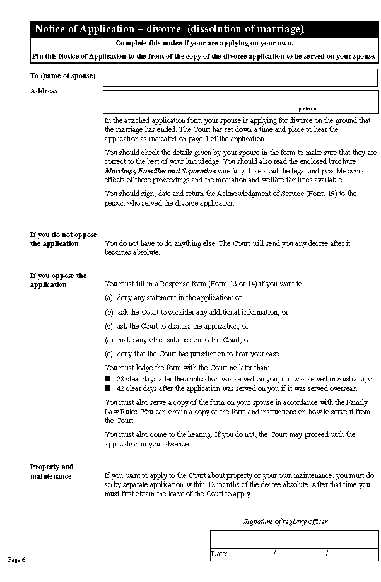
[25] Schedule 2, Part 3, Form 152
after
taxed
insert
in accordance with the Federal Court Rules
[26] Dictionary, after definition of child representative
insert
child support proceeding means a proceeding under the Assessment Act or the Registration Act.
[27] Dictionary, definition of family law proceeding
substitute
family law proceeding means a proceeding under the Family Law Act.
[28] Further amendments
Provision | omit | insert
Paragraph 1.05 (3) (a) | family law proceedings; | family law or child support proceedings;
Rule 1.05, General outline, second dot point | family law proceedings | family law and child support proceedings
Rule 1.05, General outline, third dot point | family law proceedings | family law or child support proceedings
Paragraph 2.08 (1) (a) | family law proceeding | family law or child support proceeding
Subrule 6.07 (3) | family law proceeding, | family law or child support proceeding,
Rule 10.04, note 2 | family law proceeding) | family law or child support proceeding)
Rule 10.04, note 3 | family law and child support matters: | family law and child support proceedings:
Rule 10.04, note 4 | family law proceedings: | family law or child support proceedings:
Subrule 14.11 (2) | Family Law proceeding | family law or child support proceeding
Rule 21.01, note | other than family law proceedings | other than family law or child support proceedings
Rule 21.01, note | for family law proceedings. | for family law and child support proceedings.
Paragraph 21.08 (a) | family law proceeding | family law or child support proceeding
Chapter 2, heading | Family law proceedings | Family law and child support proceedings
Rule 23.02, note | family law proceeding | family law or child support proceeding
Chapter 3, heading | Proceedings other than family law | Proceedings other than family law or child support
Rule 26.01, note | family law proceedings. | family law or child support proceedings.
Dictionary, definition of general federal law proceeding | family law proceeding. | family law or child support proceeding.
Notes
1. These Regulations amend Statutory Rules 2001 No. 195.
2. Notified in the Commonwealth of Australia Gazette on 18 April 2002.

