Corporations Regulations 2001
Statutory Rules No. 193, 2001
made under the
Corporations Act 2001
Compilation No. 195
Compilation date: 1 March 2024
Includes amendments: F2024L00199
Registered: 6 March 2024
This compilation is in 7 volumes
Volume 1: regulations 1.0.01–6D.5.03
Volume 2: regulations 7.1.04–7.6.08E
Volume 3: regulations 7.7.01–8B.5.20
Volume 4: regulations 9.1.01–12.9.03
Volume 5: Schedules 1, 2 and 2A
Volume 6: Schedules 3–13
Volume 7: Endnotes
Each volume has its own contents
About this compilation
This compilation
This is a compilation of the Corporations Regulations 2001 that shows the text of the law as amended and in force on 1 March 2024 (the compilation date).
The notes at the end of this compilation (the endnotes) include information about amending laws and the amendment history of provisions of the compiled law.
Uncommenced amendments
The effect of uncommenced amendments is not shown in the text of the compiled law. Any uncommenced amendments affecting the law are accessible on the Register (www.legislation.gov.au). The details of amendments made up to, but not commenced at, the compilation date are underlined in the endnotes. For more information on any uncommenced amendments, see the Register for the compiled law.
Application, saving and transitional provisions for provisions and amendments
If the operation of a provision or amendment of the compiled law is affected by an application, saving or transitional provision that is not included in this compilation, details are included in the endnotes.
Editorial changes
For more information about any editorial changes made in this compilation, see the endnotes.
Modifications
If the compiled law is modified by another law, the compiled law operates as modified but the modification does not amend the text of the law. Accordingly, this compilation does not show the text of the compiled law as modified. For more information on any modifications, see the Register for the compiled law.
Self-repealing provisions
If a provision of the compiled law has been repealed in accordance with a provision of the law, details are included in the endnotes.

Contents
Schedule 1—List of forms in Schedule 2 1
Schedule 2—Forms 5
Form 314 10
Form 501 12
Form 502 14
Form 503 16
Form 509A 17
Form 509B 18
Form 509E 19
Form 509H 20
Form 527 25
Form 535 28
Form 536 30
Form 537 32
Form 538 33
Form 539 35
Form 541 37
Form 542 40
Form 543 41
Form 544 42
Form 547 44
Form 548 45
Form 549 46
Form 550 47
Form 551 48
Form 552 50
Form 553 51
Form 701 52
Form 586 58
Form 587 61
Form 588 62
Form 589 66
Form 719 78
Form 719A 80
Form 719B 82
Form 720 84
Form 721 85
Form 905 86
Schedule 2A—Forms of transfer of Division 3 securities 90
Form 1 90
Form 2 92
Form 3 94
Form 4 96
Form 5 97
Form 6 99
Form 7 101
Form 8 103
Form 9 104
Form 10 105

Schedule 1—List of forms in Schedule 2
(regulation 1.0.03)

Column 1 | Column 2 | Column 3 | Column 4
Item | Provision of the Act or the Regulations | Description of form | No. of form
Chapter 1 Introductory
1 | Regulation 1.0.16 | Verification or certification of a document | 911
1A | Regulation 1.0.21 | Cover page for office copy of a court order | 105
2 | Subsection 117(2)  Subsection 163(3)  Subsection 254X(2)  Subsection 601BC(2) | Certification of compliance with stamp duty law | 207Z
3 | Subparagraph 206F(1)(b)(i) | Notice to demonstrate why disqualification should not occur | 586
4 | Subsection 206F(3) | Notice of disqualification from managing corporations | 587
4A | Subparagraph 206GAA(1)(b)(i) | Notice to demonstrate why disqualification should not occur | 588
4B | Subsection 206GAA(6) | Notice of disqualification from managing corporations | 589
Chapter 3 Internal administration
23A | Section 250P | Extension of time for holding AGM | 2501
26 | Paragraph 263(2)(b) | Notification of further issue of debentures in a series | 310
30 | Paragraph 324(2)(e) | Return of members of firm of auditors | 314
31 | Paragraph 319(5)(a)  Subsections 324(1) & (2)  Subsections 327(4) & (15)  Paragraph 329(11)(c)  Section 330 | Notice of resignation or removal of auditor | 315
Chapter 4 Various corporations
Chapter 5 External administration
43 | Subsection 414(2) | Notice to dissenting shareholder | 501
44 | Paragraph 414(9)(a) | Notice to remaining shareholder | 502
44A | Subsection 419A(3) | Notice of controller’s intention not to exercise property rights | 503
51A | Subsection 438C(3) | Notice to deliver books of company to the administrator | 509A
51B | Subsection 443B(3) | Notice of administrator’s intention not to exercise property rights | 509B
51E | Paragraph 450B(a) | Notice to creditors of execution of a deed of company arrangement | 509E
51H | Paragraph 459E(2)(e) | Creditor’s statutory demand for payment of debt | 509H
61 | Subsections 494(1) & (2) | Declaration of solvency | 520
68 | Paragraph 568(8)(a) | Application requiring liquidator to decide whether to disclaim property | 527
69 | Subsection 601AA(2) | De-registration—voluntary | 6010
75 | Subregulation 5.6.39(3) | Notice to submit particulars of debt or claim | 533
76 | Subregulation 5.6.48(3) | Notice inviting formal proof of debt or claim | 534
77 | Subregulation 5.6.49(2) | Formal proof of debt or claim (General form) | 535
78 | Subregulation 5.6.49(2) | Formal proof of debt or claim on behalf of employees | 536
79 | Subregulation 5.6.54(1) | Notice of rejection of formal proof of debt or claim | 537
80 | Regulation 5.6.58 | Provisional list of contributories | 538
81 | Subregulation 5.6.59(1) | Notice to contributories of appointment to settle list of contributories | 539
83 | Subregulation 5.6.60(2) | Certificate of liquidator of final settlement of list of contributories | 541
84 | Subregulation 5.6.61(1) | Provisional supplementary list of contributories | 542
85 | Subregulation 5.6.61(1) | Certificate of liquidator of settlement of supplementary list of contributories | 543
86 | Subregulation 5.6.62(4) | Notice to contributory of final settlement of list or supplementary list of contributories and of inclusion in list | 544
88 | Subregulation 5.6.65(1) | Notice of intention to declare a dividend | 546
89 | Subregulation 5.6.65(1) | Notice to creditor or person claiming to be a creditor of intention to declare a dividend | 547
90 | Subregulation 5.6.65(1) | Notice to creditor or person claiming to be a creditor of intention to declare a final dividend | 548
91 | Subregulation 5.6.67(3) | Notice of declaration of dividend | 549
92 | Regulation 5.6.70 | Notice to liquidator to pay dividend to a person named | 550
93 | Subregulation 5.6.71(1) | Schedule of contributories or other persons to whom a distribution of surplus is to be paid | 551
94 | Subregulation 5.6.71(2) | Notice of distribution of surplus to contributories or other persons | 552
95 | Regulation 5.6.72 | Authority to liquidator to pay distribution of surplus to a person named | 553
Chapter 6 Acquisition of shares
96 | Subsection 671B(4) | Notice of initial substantial holder | 603
97 | Subsection 671B(4) | Notice of change of interests of substantial holder | 604
98 | Subsection 671B(4) | Notice of ceasing to be a substantial holder | 605
Chapter 7 Financial services and markets
99 | Subregulation 7.6.08D(3)  Subregulation 7.6.08E(3) | Data on intermediated business with APRA-authorised general insurers, Lloyd’s underwriters and unauthorised foreign insurers | 701
Chapter 9 Miscellaneous
150 | Subsection 1287(1) | Particulars of cessation or change relating to person registered as an auditor under subsection 1287(1) | 905
154A | Subsection 1302(4) | Notice of change of address | 909

Schedule 2—Forms
(regulations 1.0.02 and 1.0.03)

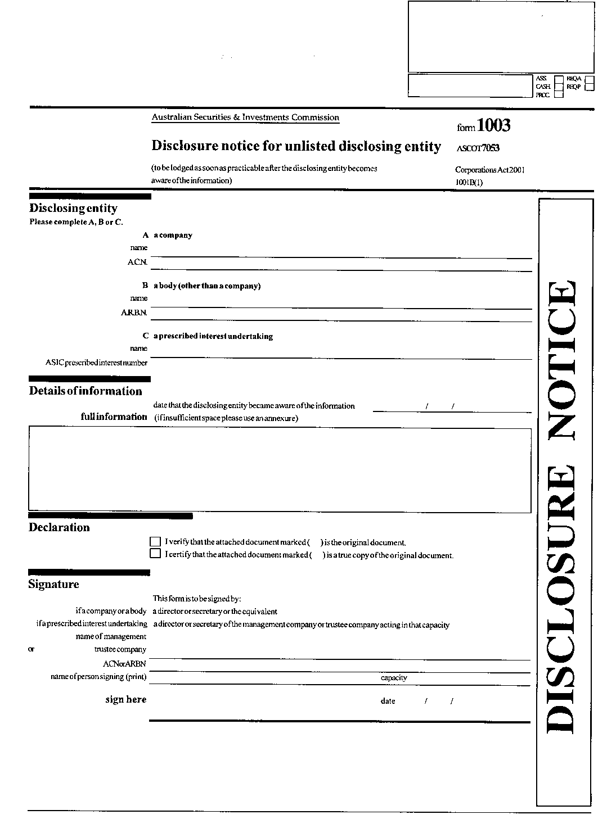
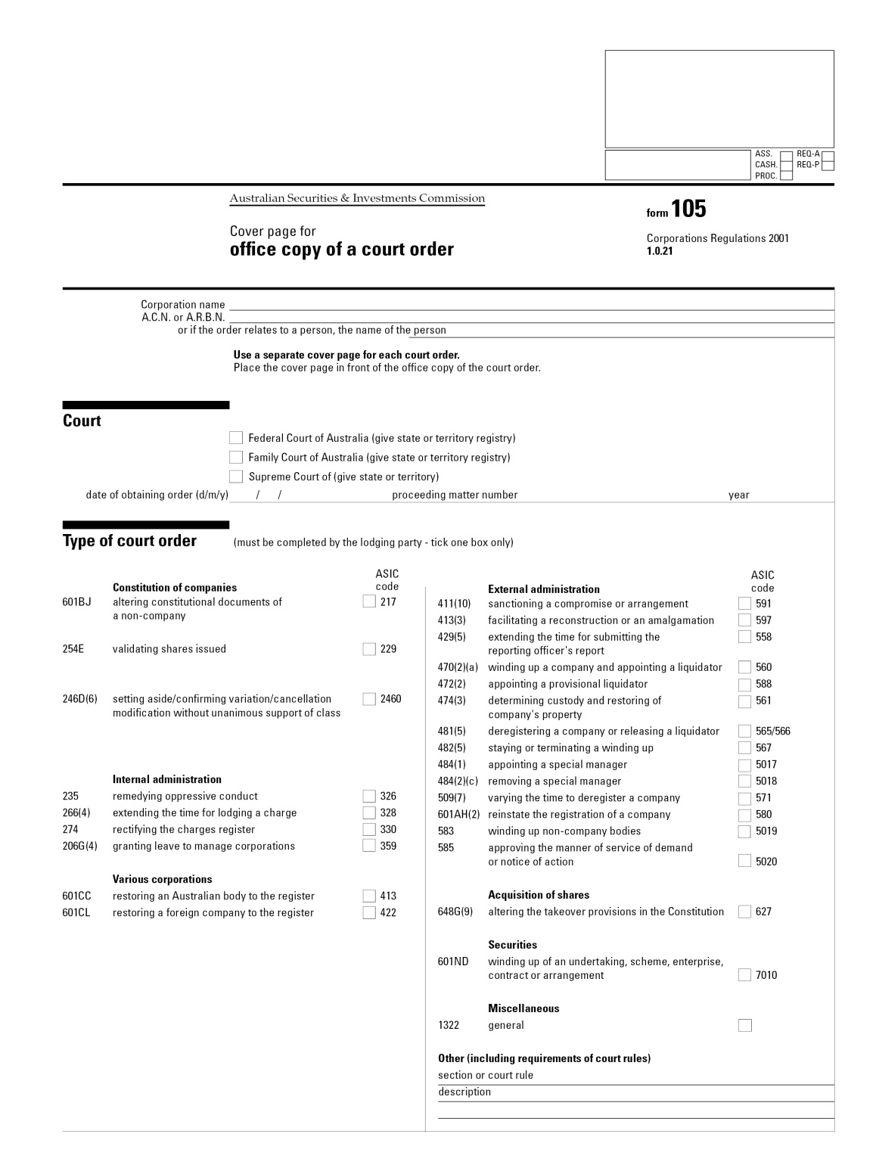
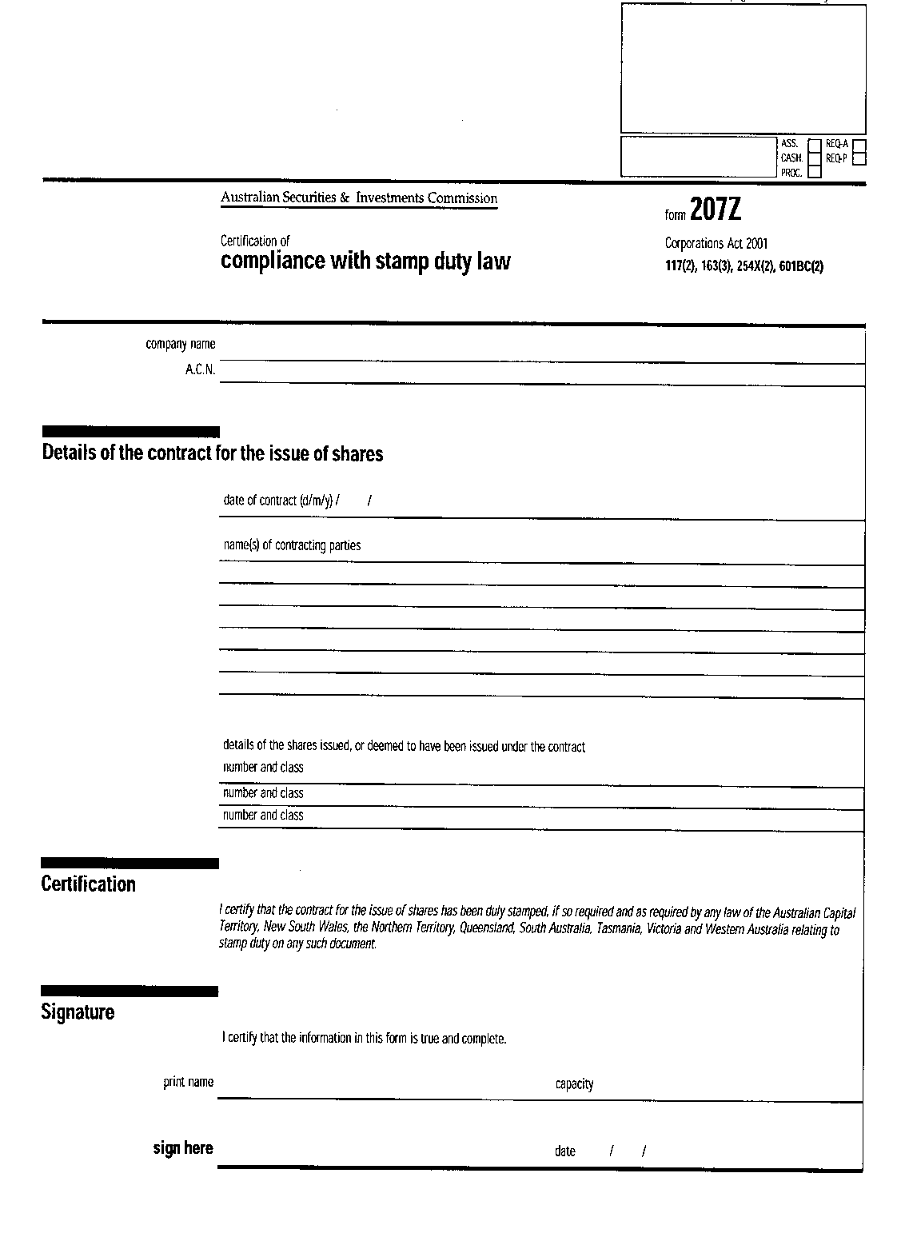
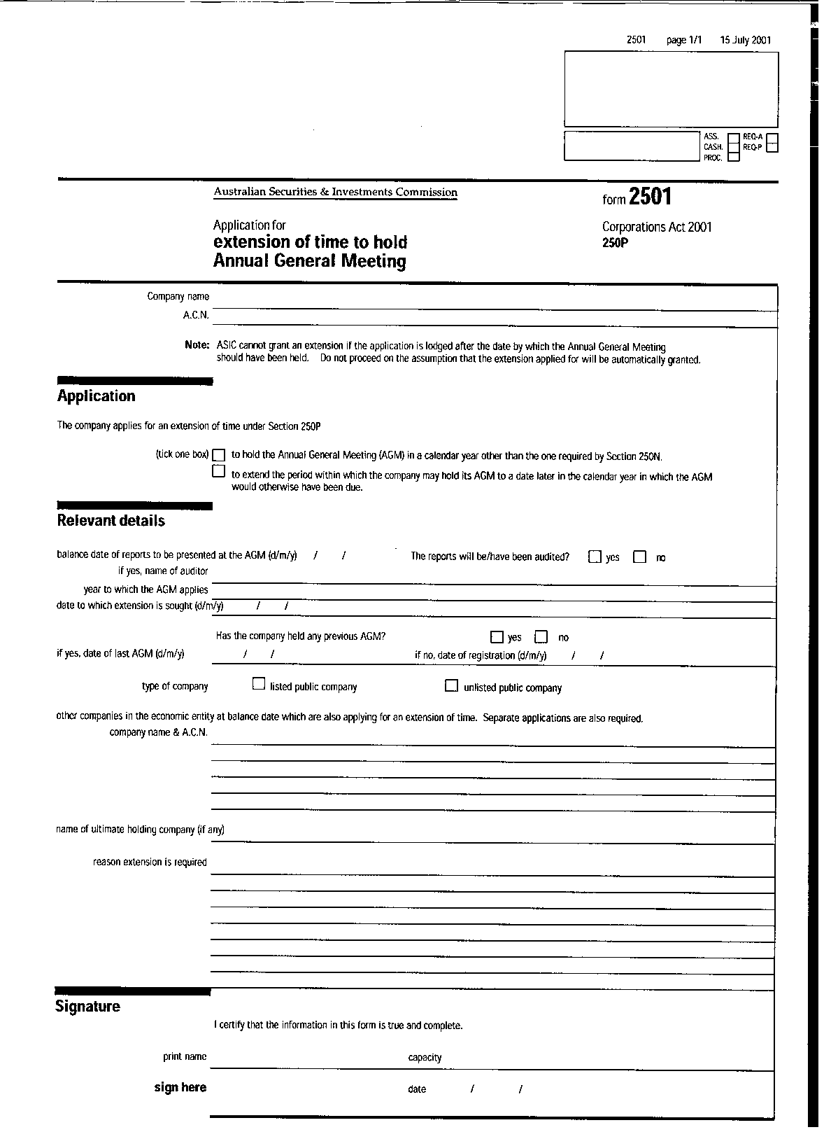
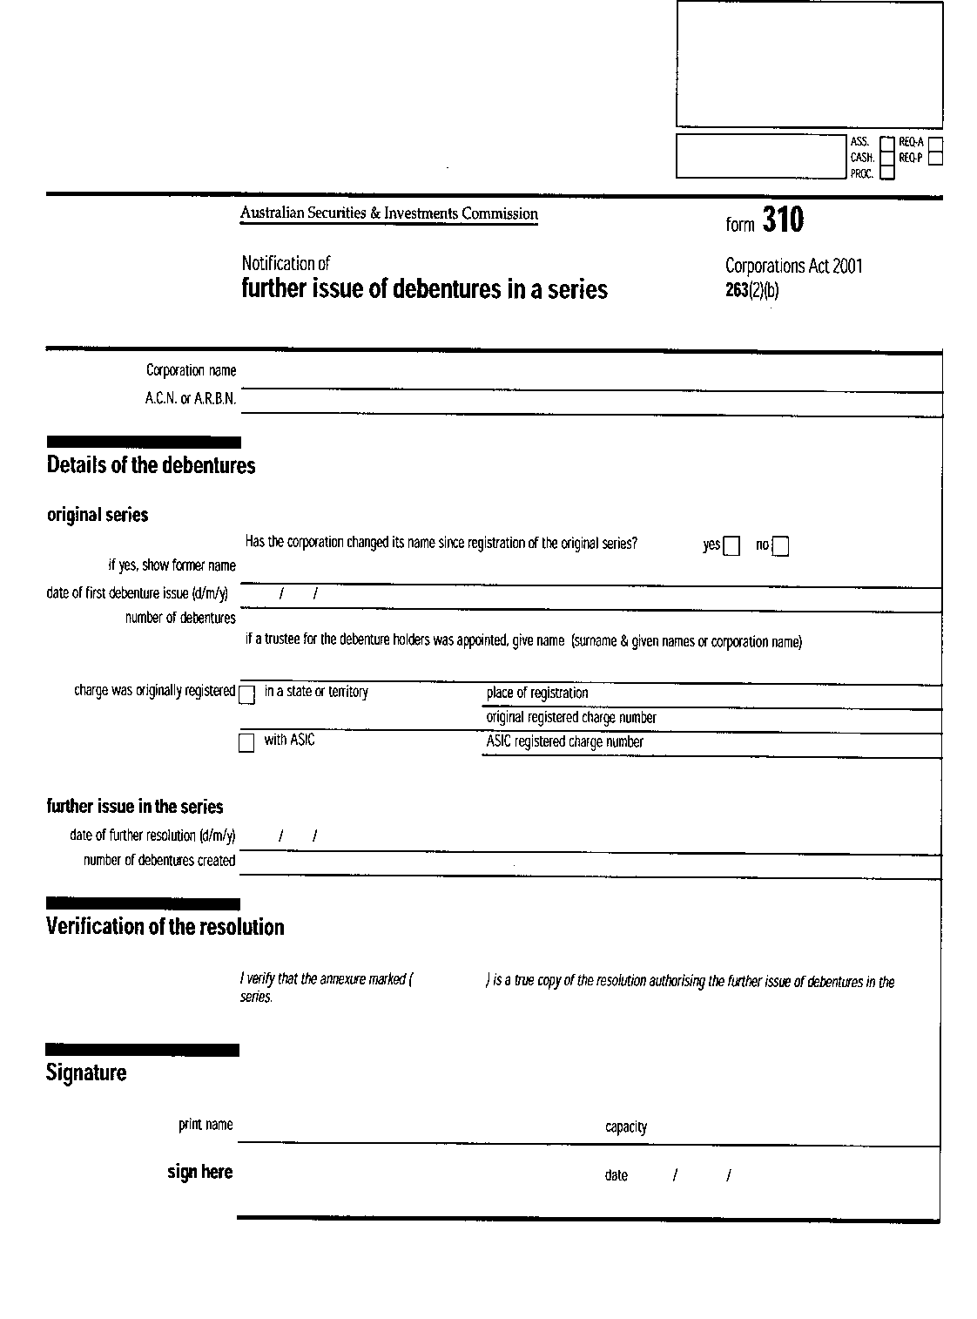

Form 314
(paragraph 324(2)(e))

Corporations Act 2001

RETURN OF MEMBERS OF FIRM OF AUDITORS
Name of firm:

Address of firm¹:

The full names and addresses of all of the members of the firm are:

Surname | First or given names | Residential address

Dated

Signature²

1. Give the address of each place of business of the firm. If there is more than one place of business, indicate the principal place of business.

2. To be signed by one of the members of the firm.
DIRECTION

Requirements relating to annexures are set out in regulation 1.0.06.
NOTE

The completion of this form does not relieve members of the firm from any obligation under the law relating to business names.
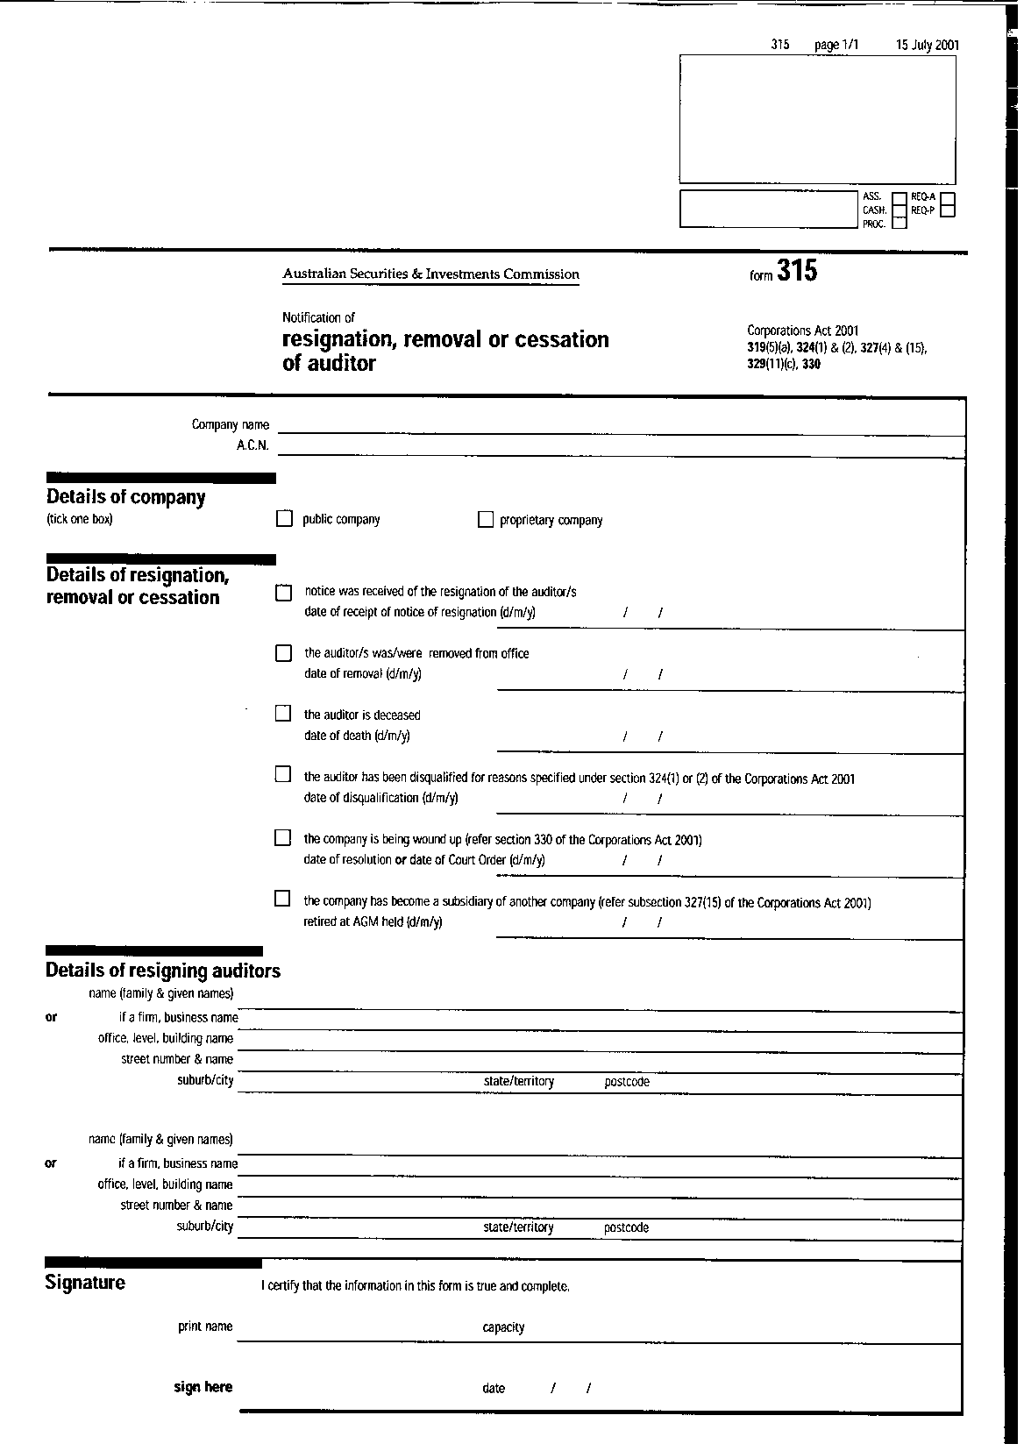

Form 501
(subsection 414(2))

Australian Company Number:

Corporations Act 2001
NOTICE TO DISSENTING SHAREHOLDER

(Note that in this form “dissenting shareholder” means a shareholder who has not assented to the scheme or contract mentioned in paragraph B, or who has failed or refused to transfer his or her shares to the transferee in accordance with that scheme or contract)

1. To
of
A. (insert name of person giving notice, in this form called “the transferee”) The transferee on (insert date) made
an offer to the holders of *shares in Limited/
*shares included in class of shares
in Limited for the transfer of those shares to the transferee, not being an offer made under a scheme or contract arising out of the making of takeover offers or a takeover announcement under the law relating to the acquisition of shares; and
B. the scheme or contract involving the transfer of those shares to the transferee was on or before (insert date) approved by the holders of not less than nine-tenths in nominal value of the shares *in that company/*included in that class of shares, other than shares already held at the date of the offer by, or by a nominee for, the transferee (or, if the transferee is a company, its subsidiary); and
C. you are a dissenting shareholder of shares *in the company/ *included in that class of shares.
2. The transferee gives you notice under subsection 414(2) that the transferee desires to acquire those shares held by you.
3. You are entitled under subsection 414(7) to require the transferee, by a demand in writing served on the transferee within one month after the date on which this notice is given, to furnish to you a statement in writing of the names and addresses of all other dissenting shareholders shown in the register of members.
*4. You are entitled not later than the expiration of one month after the date on which this notice is given or 14 days after the date on which a statement is supplied to you under subsection 414(7), whichever is the later, to elect, by notice to the transferee, which of the alternative terms offered to the approving shareholders under the scheme or contract you prefer. The alternative terms are as follows:
5. Unless, on application made by you within one month after the date on which this notice is given or within 14 days after a statement is supplied to you under subsection 414(7), the Federal Court of Australia or the Supreme Court of (State or Territory) orders otherwise, the transferee will be entitled and bound subject to subsection 414(7) to acquire your shares:
(a) on the terms on which under the scheme or contract the shares of the approving shareholders are to be transferred to the transferee; or
(b) if alternative terms were offered — on the terms for which you have elected; or
(c) if you have not so elected — on whichever of those terms the transferee determines unless the Court otherwise orders.

Dated

(signature of transferee)
*Omit if not applicable
DIRECTION

Requirements relating to annexures are set out in regulation 1.0.06.

Form 502
(subsection 414(9)(a))

Australian Company Number:

Corporations Act 2001

NOTICE TO REMAINING SHAREHOLDER

1. To
of
A. (insert name of person giving notice, in this form called “the transferee”) The transferee in (insert date) made offers to the holders of shares *in Limited/*included in class of shares in Limited for the transfer of those shares to the transferee, not being offers made under a scheme or contract arising out of the making of takeover offers or a takeover announcement under the law relating to the acquisition of shares; and
B. under the scheme or contract the transferee became an (insert date) beneficially entitled to shares in that company which together with any other shares in that company to which the transferee, or the transferee and any corporation related to the transferee, is beneficially entitled, comprise or include nine-tenths in nominal value of the shares
*in Limited/*included in that class of shares
in Limited; and
C. you are the holder of remaining shares *in that company/*included in that class of shares in that company and have not assented to the scheme or contract or been given notice in respect of those shares by the transferee under subsection 414(2).

2. The transferee gives you notice under subsection 414(9) that under that scheme or contract the transferee on (insert date) become beneficially entitled to shares in Limited and those shares together with any other shares in that company to which the transferee, or the transferee and any corporation related to the transferee, is beneficially entitled, comprise or included nine-tenths in nominal value of the shares (in that company/*included in that class of shares in that company.

3. You are entitled under subsection 414(9) within 3 months after the date on which this notice is given by notice to the transferee to require the transferee to acquire your shares.
*3. You are entitled under subsection 414(9) within 3 months after the date on which this notice is given to elect by notice to the transferee which of the alternative terms offered to the approving shareholders under the scheme or contract you will accept. The alternative terms are as follows:

4. If you require the transferee to acquire the shares held by you the transferee will be entitled and bound to acquire those shares:
(a) on the terms that under the scheme or contract were offered to the approving shareholders; or
(b) if alternative terms were offered—on the terms for which you have elected;
(c) if you do not so elect
(i) on whichever of the terms the transferee determines or
(ii) on such other terms as are agreed or as the Federal Court of Australia or the Supreme Court of` on the application of the transferee or of yourself orders.

Dated

(signature of transferee)
*Omit if not applicable
DIRECTION

Requirements relating to annexures are set out in regulation 1.0.06.

Form 503
(subsection 419A(3))

Corporations Act 2001
NOTICE OF CONTROLLER’S INTENTION NOT TO EXERCISE PROPERTY RIGHTS
To: (name), of (address) , the *owner/*lessor of property (“the specified property”) being:

(name and description of property including, if appropriate, relevant reference numbers and account numbers identifying contracts such as leasing arrangements in relation to that property)

I (name), of (address), the controller of property of (name of corporation) (“the corporation”) give you notice that I do not propose to exercise rights in relation to the specified property as controller of the specified property, whether on behalf of the corporation or anyone else.

Dated
(Controller’s signature)
*Delete if not applicable

NOTES:

1. Under subsection 419A(4) the controller is not liable for rent or other amounts by the corporation in relation to the specified property while this notice in force, but the notice does not affect a liability of the corporation.

2 Under subsection 419A(5), this notice ceases to have effect if the controller:
(a) revokes the notice, by writing to the owner/lessor; or
(b) exercises or purports to exercise a right in relation to the specified property the controller.

Form 509A
(subsection 438C(3))

A.C.N. or A.R.B.N.

Corporations Act 2001
NOTICE TO DELIVER BOOKS OF COMPANY TO THE ADMINISTRATOR
Limited (administrator appointed)

To: (name) of (address)

1. I (name), of (address), the administrator of the company, give you notice under subsection 438C(3) that I require you to deliver to me, at the above address, within (insert number being not less than 3) business days of the date of this notice, the books specified in the Schedule, being books of the company, that are in your possession.

2. Note that under subsection 438C(5), you must comply with this notice except so far as you are entitled as against the company and the administrator, to retain possession of the books.

SCHEDULE
(insert specified books)

Dated

(administrator’s signature)

Form 509B
(subsection 443B(3))

Corporations Act 2001
NOTICE OF ADMINISTRATOR’S INTENTION NOT TO EXERCISE PROPERTY RIGHTS
Limited (administrator appointed)

To: (name), of (address), the *owner/*lessor of property (“the specified property”) being:

(name and description of property, including, if appropriate, relevant reference numbers and account numbers identifying contracts such as leasing arrangements in relation to that property)

I (name), of (address) , the administrator of (name of company) (“the company”) give you notice that I do not propose to exercise rights in relation to the specified property.

Dated

(administrator’s signature)

*Delete if not applicable

NOTES

1. Under subsection 443B(4), the administrator is not liable for rent or other amounts payable by the company in relation to the specified property while this notice is in force, but the notice does not affect a liability of the company.
2. Under subsection 443B(5), this notice ceases to have effect if:
(a) the administrator revokes the notice, by writing to the owner/ lessor; or
(b) the company exercises or purports to exercise a right in relation to the specified property.

Form 509E
(paragraph 450B(a))

Corporations Act 2001
NOTICE TO CREDITORS OF EXECUTION OF A DEED OF COMPANY ARRANGEMENT
Limited (subject to deed of company arrangement)

*To (name) of (address)

*To creditors of the company

1. Notice is given under section 450B that the company executed a deed of arrangement on (insert date).

2. A copy of the deed may be inspected at (insert address).

Dated

(Signature of administrator of the
deed of company arrangement)
*Delete if not applicable

Form 509H
(paragraph 459E(2)(e))

Corporations Act 2001
CREDITOR’S STATUTORY DEMAND FOR PAYMENT OF DEBT
To (name and A.C.N. or A.R.B.N. of debtor company) of (address of the company’s registered office)

1. The company owes (name) of (address) (“the creditor”)
*the amount of $(insert amount), being the amount of the debt described in the Schedule.
*the amount of $(insert total amount), being the total of the amounts of the debts described in the Schedule.

*2. The amount is due and payable by the company.

*2. Attached is the affidavit of (insert name of deponent of the affidavit), dated (insert date of affidavit), verifying that the amount is due and payable by the company

3. The creditor requires the company, within the statutory period after service on the company of this demand:
(a) to pay to the creditor the *amount of the debt/*total of the amounts of the debts; or
(b) to secure or compound for the *amount of the debt/*total of the amounts of the debts, to the creditor’s reasonable satisfaction.

4. The creditor may rely on a failure to comply with this demand within the period for compliance set out in subsection 459F(2) as grounds for an application to a court having jurisdiction under the Corporations Act 2001 for the winding up of the company.

5. Section 459G of the Corporations Act 2001 provides that a company served with a demand may apply to a court having jurisdiction under the Corporations Act 2001 for an order setting the demand aside. An application must be made within the statutory period after the demand is served and, within the same period:
(a) an affidavit supporting the application must be filed with the court; and
(b) a copy of the application and a copy of the affidavit must be served on the person who served the demand.

A failure to respond to a statutory demand can have very serious consequences for a company. In particular, it may result in the company being placed in liquidation and control of the company passing to the liquidator of the company.

6. The address of the creditor for service of copies of any application and affidavit is (insert the address for service of the documents in the State or Territory in which the demand is served on the company, being, if solicitors are acting for the creditor, the address of the solicitors).

SCHEDULE

Description of the debt Amount of the debt
(indicate if it is a judgment debt,
giving the name of the court
and the date of the order)

*Total Amount

Dated:

signed:

Print name: capacity:

Corporation or partnership name (if applicable):

NOTES:
1. The form must be signed by the creditor or the creditor’s solicitor. It may be signed on behalf of a partnership by a partner, and on behalf of a corporation by a director or by the secretary or an executive officer of the corporation.
2. The amount of the debt or, if there is more than one debt, the total of the amounts of the debts, must exceed the statutory minimum. The statutory minimum is $2,000 or a greater amount prescribed by the regulations. From 1 July 2021, a greater amount of $4,000 is prescribed. However, for a 7-month period in 2021, a greater amount of $20,000 is prescribed in relation to a company that is eligible for temporary restructuring relief (see the Corporations Amendment (Corporate Insolvency Reforms) Regulations 2020).
3. Unless the debt, or each of the debts, is a judgment debt, the demand must be accompanied by an affidavit that:
(a) verifies that the debt, or the total of the amounts of the debts, is due and payable by the company; and
(b) complies with the rules of court.
4. A person may make a demand relating to a debt that is owed to the person as assignee.
5. The statutory period is 21 days or a longer period prescribed by the regulations. For a 7-month period in 2021, a longer period of 6 months is prescribed in relation to a company that is eligible for temporary restructuring relief (see the Corporations Amendment (Corporate Insolvency Reforms) Regulations 2020).

*Omit if inapplicable

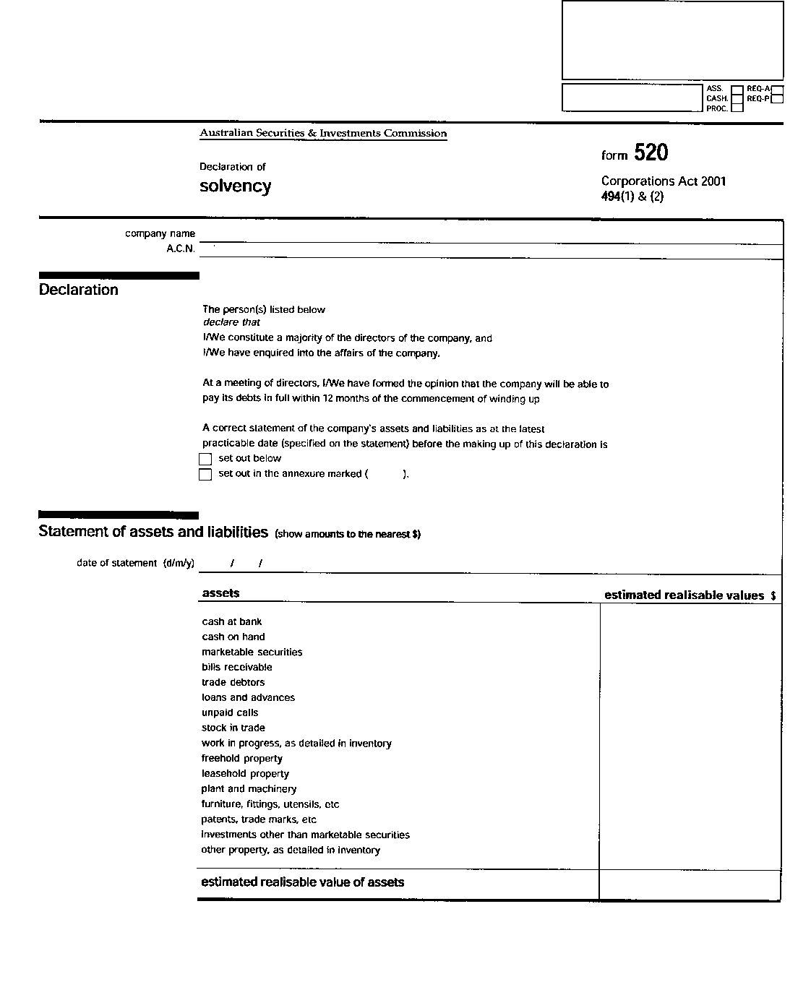
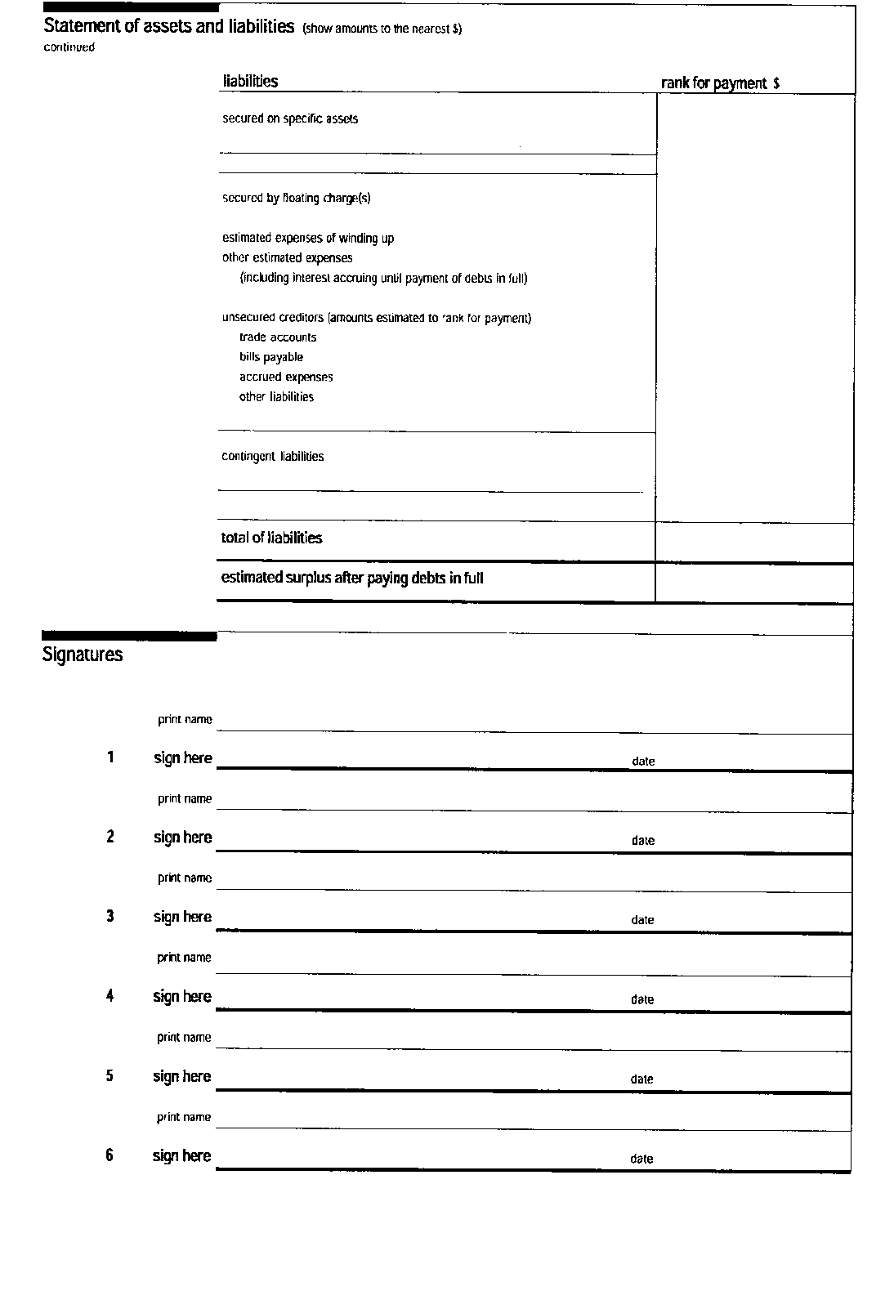

Form 527
(paragraph 568(8)(a))

Australian Company Number:

Corporations Act 2001
APPLICATION REQUIRING LIQUIDATOR TO DECIDE WHETHER TO DISCLAIM PROPERTY
Limited

To (insert name), the liquidator of the company.

Under paragraph 568(8)(a), application is made to you by (full name, address and occupation of applicant) requiring you to decide whether you will disclaim the property described in the Schedule to this notice or not.

The applicant has the following interest in the property:

SCHEDULE
Dated
(signature of applicant)
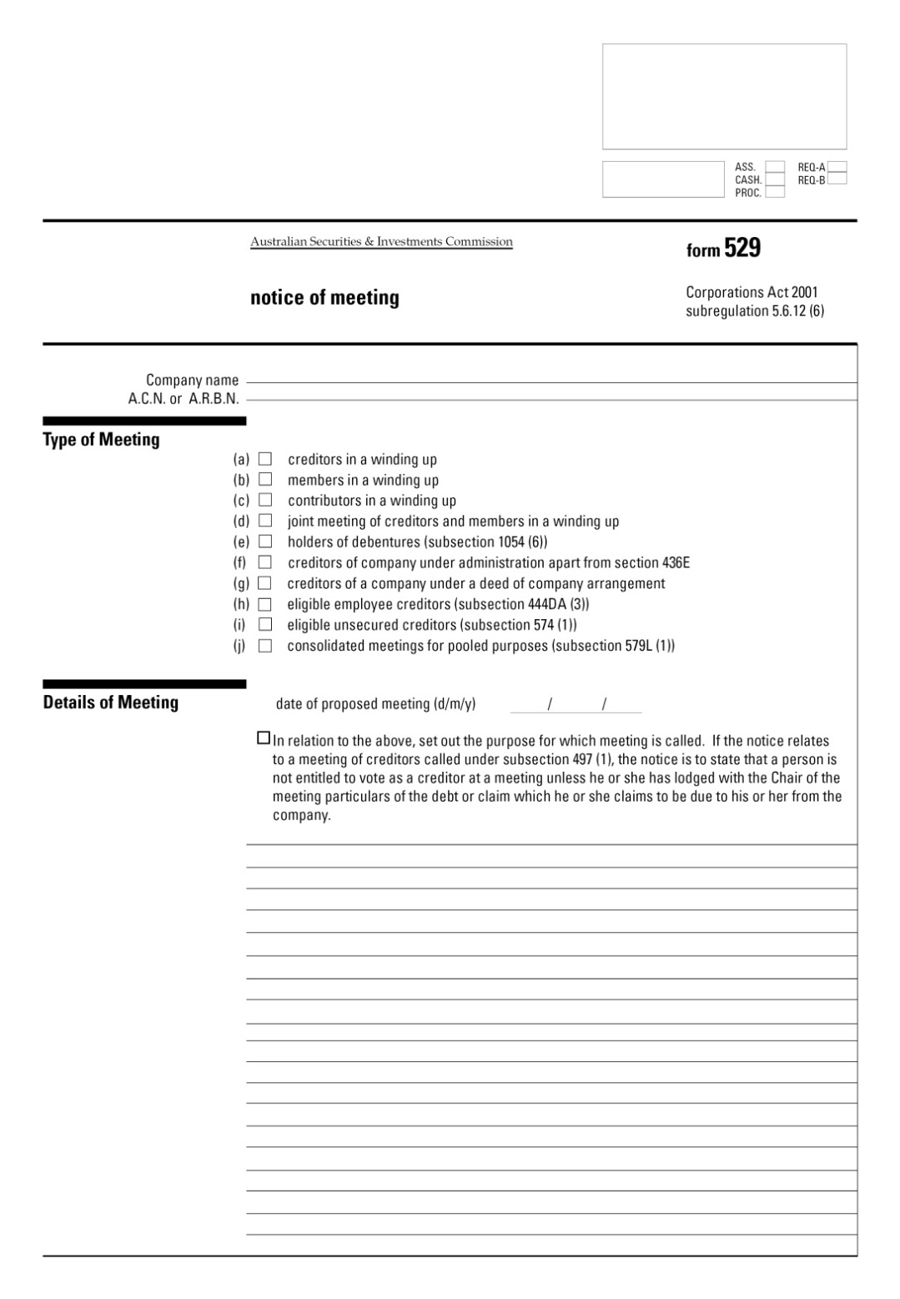
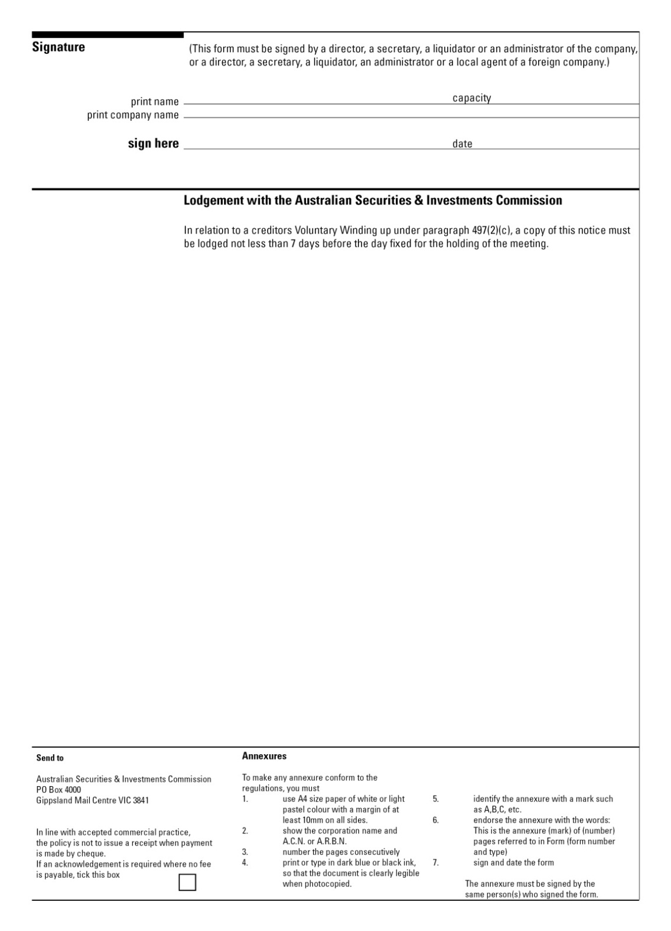

Form 535
(subregulation 5.6.49(2)

A.C.N or A.R.B.N:

Corporations Act 2001
FORMAL PROOF OF DEBT OR CLAIM (GENERAL FORM)
To the liquidator of Limited

1. This is to state that the company was on (date of court order in winding up by the Court, or date of resolution to wind up, if a voluntary winding up), and still is, justly and truly indebted to (full name and address of the creditor and, if applicable, the creditor’s partners. If prepared by an employee or agent of the creditor, also insert a description of the occupation of the creditor) for

dollars and cents

Particulars of the debt are:

Date | Consideration | Amount | Remarks
 | (state how the debt  arose) |  | (include details of voucher substantiating payment)
 |  | $ c

2. To my knowledge or belief the creditor has not, nor has any person by the creditor’s order, had or received any satisfaction or security for the sum or any part of it except for the following: (insert particulars of all securities held. If the securities are on the property of the company, assess the value of those securities. If any bills or other negotiable securities are held, show them in a schedule in the following form).

Date | Drawer | Acceptor | Amount | Due Date
 |  |  | $ c

*3. I am employed by the creditor and authorised in writing by the creditor to make this statement. I know that the debt was incurred for the consideration stated and that the debt, to the best of my knowledge and belief, remains unpaid and unsatisfied.

*3. I am the creditor’s agent authorised in writing to make this statement in writing. I know the debt was incurred for the consideration stated and that the debt, to the best of my knowledge and belief, remains unpaid and unsatisfied.

Dated

Signature
Occupation
Address

*Do not complete if this proof is made by the creditor personally

Form 536
(subregulation 5.6.49(2))

A.C.N. or A.R.B.N:

Corporations Act 2001
FORMAL PROOF OF DEBT OR CLAIM ON BEHALF OF EMPLOYEES
To the liquidator of Limited

I (full name of person making the statement) of (full address) being (occupation) state:

1. the company was, on (date of court order in winding up, if winding up was by the Court, or date of resolution to wind up if a voluntary winding up), and still is, indebted to the persons whose names, addresses and descriptions appear in Columns 2, 3 and 4 in the Schedule;

2. the debt is for wages, salaries, annual leave, retrenchment payments or long service leave, due to them for services rendered while employed by the company during the periods set out in Column 5 against the names of the persons;

3. the debt of the company due to each person is for the amount set out in Column 6 against the name of that person;

4. none of those persons has had or received any satisfaction or security in respect of that debt;

5. I am authorised as and the source of my information is as follows:
SCHEDULE

Column 1 | Column 2 | Column 3 | Column 4 | Column 5 | Column 6
No | Full name | Address of employee | Description | Period for which claim is made (see note below) | Amount of claim
Dated
Signature

Note: In case of a claim for annual leave or long service leave, insert a description of the claim.

Form 537
(subregulation 5.6.54(1))

A.C.N or A.R.B.N:

Corporations Act 2001
NOTICE OF REJECTION OF FORMAL PROOF OF DEBT OR CLAIM
Limited

To
of

1. Your claim against the company set out in the formal proof of debt or claim of (name of person submitting original proof of debt or claim) made on (date) has been *wholly disallowed/*disallowed to the extent of (particulars of part of claim disallowed)/*allowed in the sum of $ /*allowed to the extent of your claim for (particulars of part of claim allowed).

2. My grounds for disallowance of (particulars of part of claim referred to) are as follows:

3. If you are dissatisfied with my determination as set out above, you may appeal against it, no later than (number of days, being not less than 14) days after the service of this notice or, if the Court allows, within any further period, to the *Federal Court of Australia/*the Supreme court of (State or Territory). If you do not do so, your claim will be assessed in accordance with this determination.

Dated

Signature of liquidator

Address

* Omit if inapplicable

Form 538
(regulation 5.6.58)

A.C.N or A.R.B.N:

Corporations Act 2001
PROVISIONAL LIST OF CONTRIBUTORIES
Limited

The following is a provisional list of persons to be placed on the list of contributories that I have made from the records of the company, together with the number of their shares or the extent of their interest, their address and other participants:

PART 1
PERSONS WHO ARE CONTRIBUTORIES
IN THEIR OWN RIGHT

Serial  No. | Name | Address | Description of class of contributory | Number  of shares (or extent of interest) | Amount called up at date of start of winding up | Amount  paid up at date of start of winding up | Amount  not called up at date of start of winding up

PART 2
CONTRIBUTORIES WHO ARE REPRESENTATIVES OF, OR LIABLE FOR THE DEBTS OF, OTHERS

Serial  No. | Name | Address | Description  of class of contributory and in what character included | Number  of shares (or extent of interest) | Amount  called up at date of start of winding up | Amount  paid up at date of start of winding up | Amount  not called up at date of start of winding up
Dated
Signature of liquidator

Form 539
(subregulation 5.6.59(1))

A.C.N or A.R.B.N:

Corporations Act 2001
NOTICE TO CONTRIBUTORIES OF APPOINTMENT TO SETTLE LIST OF CONTRIBUTORIES
Limited

Take notice that I (name) of (address), the liquidator of the company, have appointed (time) *a.m./*p.m. on (date) at (address of place appointed for settlement), at which I must settle the list of the contributories of the company that I have made. You are at present included in that list.

Particulars of your inclusion are set out below. Unless, before or at the time appointed for the settlement, you give me sufficient reason for your exclusion, your name will be included in the settled list.

Dated

Signature of liquidator

Serial No. | Name | Address | Description  of class of contributory and in what character included | Number of shares (or extent of interest) | Amount called up at date of start of winding up | Amount paid up at date of start of winding up | Amount not called up at date of start of winding up

* Strike out whichever is inapplicable.

NOTES

1. Contributories do not have to attend the appointment referred to in this notice if they are satisfied that the particulars contained in the notice are correct.

2. A shareholder’s name cannot be omitted from the list of contributories because he or she is unable to pay calls; this question will be dealt with when application is made for payment of the calls.

3. A change of address may be notified by giving notice to the liquidator by post before the date fixed for the appointment.

Form 541
(subregulation 5.6.60(2))

A.C.N. or A.R.B.N.:

Corporations Act 2001
CERTIFICATE OF LIQUIDATOR OF FINAL SETTLEMENT OF LIST OF CONTRIBUTORIES
Limited

I (name), the liquidator of the company, certify that the result of the settlement of the list of contributories of the company is as follows:

1. The persons named in Column 2 of Schedule 1 have been included in the list of contributories as contributories of the company in respect of the number of shares or extent of interest set out opposite their names. I have listed in Part 1 of Schedule 1, contributories in their own right and, in Part 2 of Schedule 1, contributories who are representatives of, or liable for the debts of, others.

2. The persons named in Column 2 of Schedule 2 were included in the provisional list of contributories, but have been excluded from the settled list of contributories.

3. In Column 6 of Schedule 1 and in Column 6 of Schedule 2, I have set out opposite the name of each person the date when that person was included in or excluded from the list of contributories.

4. In Columns 7 and 8 of Schedule 1, I have set out opposite the name of each person the amount called up at the date of the commencement of the winding up and the amount paid up at that date in respect of the shares, or interest, of that person.

SCHEDULE 1
PERSONS INCLUDED IN THE LIST OF CONTRIBUTORIES

PART 1: CONTRIBUTIONS IN THEIR OWN RIGHT

1 | 2 | 3 | 4 | 5 | 6 | 7 | 8 | 9
Serial No. | Name | Address | Description of class of contributory and in what character included | Number of shares (or extent of interest) | Date when included in list | Amount called up at date of start of winding up | Amount paid up at date of start of winding up | Amount not called up at date of start of winding up

PART 2: CONTRIBUTORIES WHO ARE REPRESENTATIVES OF, OR LIABLE FOR
THE DEBTS OF, OTHERS

1 | 2 | 3 | 4 | 5 | 6 | 7 | 8 | 9
No. | Name | Address | Description of class of contributory and in what character included | Number of shares (or extent of interest) | Date when included in list | Amount called up at date of start of winding up | Amount paid up at date of start of winding up | Amount not called up at date of start of winding up
SCHEDULE 2
PERSONS EXCLUDED FROM THE LIST OF CONTRIBUTORIES

1 | 2 | 3 | 4 | 5 | 6
No. | Name | Address | Description of class of contributory and in what character proposed to be included | Number of shares (or extent of interest) | Date when included in list

Dated

Signature of liquidator

Form 542
(subregulation 5.6.61(1))

A.C.N or A.R.B.N.:

Corporations Act 2001
PROVISIONAL SUPPLEMENTARY LIST OF CONTRIBUTORIES
Limited

The following is a list of persons that I have found, since making out the annexed list of contributories dated , to be, or to have been, *holders of shares in/*members of the company, and who to the best of my knowledge and belief are contributories of the company:

(insert list in the same form as the original list: see Form 538)

Dated

Signature of liquidator

*Omit if inapplicable

Form 543
(subregulation 5.6.61(1))

A.C.N. or A.R.B.N.:

Corporations Act 2001
CERTIFICATE OF LIQUIDATOR OF SETTLEMENT OF SUPPLEMENTARY LIST OF CONTRIBUTORIES
Limited

I (name), the liquidator of the company, certify that the result of the settlement of the provisional supplementary list of contributories of the company that I made out on (date) is as follows:

(set out the Certificate and Schedules as in Form 541)

Dated

Signature of liquidator

Form 544
(subregulation 5.6.62(4))

A.C.N. or A.R.B.N.:

Corporations Act 2001
NOTICE TO CONTRIBUTORY OF FINAL SETTLEMENT OF LIST OR SUPPLEMENTARY LIST OF CONTRIBUTORIES AND OF INCLUSION IN LIST
Limited

To:
of:

Take notice that I (name), the liquidator of the company, on (date) settled the list of contributories of the company. You are included in that list. The character, if applicable, in which, and the number of share, or extent of interest, for which, you are included, and the amounts called dup, paid up and unpaid in respect of those shares or that interest are stated in the Schedule.

You may apply to vary the list of contributories, or to remove your name from the list, by making an application to *the Federal Court of Australia/*the Supreme court of (State or Territory) within 21 days from the service on you of this notice or, if the Court allows, any further period.

You may inspect the list at my office at (address) from Monday to Friday inclusive between the hours of (insert times making up not less than 3 hours during the normal working day) and

SCHEDULE

No. | Name | Address | Description of class of contributory and in what character included | Number of shares (or extent of interest) | Amount called up at date of start of winding up | Amount unpaid at date of start of winding up | Amount unpaid at date of start of winding up | Amount not called up at date of start winding up

Dated

Signature of liquidator

* Omit if not applicable

Form 547
(subregulation 5.6.65(1))

Corporations Act 2001
NOTICE TO CREDITOR OR PERSON CLAIMING TO BE A CREDITOR OF INTENTION TO DECLARE A DIVIDEND
Limited

A dividend (state the number of the dividend, e.g. “first”, “second”) is to be declared on (date) for the company.

*You are listed as a creditor in the report on the affairs of the company;
*You are known to me to claim to be a creditor, but your debt or claim has not yet been admitted.

You are required formally to prove your debt or claim on or before (date). If you do not, you will be excluded from the benefit of the dividend.

Dated

Signature of liquidator

Address

*Omit if inapplicable.

Form 548
(subregulation 5.6.65(1))

Corporations Act 2001
NOTICE TO CREDITOR OR PERSON CLAIMING TO BE A CREDITOR OF INTENTION TO DECLARE A DIVIDEND
Limited

A final dividend is to be declared on (date) for the company.

You are required formally to prove your debt or claim on or before (date).

If you do not, I will exclude your claim from participation, and I will proceed to make a final dividend without having regard to it.

Signature of liquidator

Address

Form 549
(subregulation 5.6.67(3))

Corporations Act 2001
NOTICE OF DECLARATION OF DIVIDEND
Limited

(State the number of the dividend, e.g. “First”, “Second”) dividend.

A dividend at the rate of in the dollar has been declared for the company and a cheque is attached for $ calculated at that rate on your debt as admitted to rank for dividend for $ .

Dated

Signature of liquidator

Address

Form 550
(regulation 5.6.70)

Corporations Act 2001
AUTHORITY TO LIQUIDATOR TO PAY DIVIDEND TO A PERSON NAMED
Limited
To the liquidator

*I/*We authorise and request you to pay to (name) of (address) all dividends as they are declared for the company, and that become due and payable to *me/*us in respect of *my/ *our claim for $ against the company.

*I/*We further request that cheques drawn for those dividends are made payable to the order of (name).

This authority remains in force until revoked by *me/*us in writing.

Date

Signature of creditor

Name of creditor

*Omit if inapplicable

Form 551
(subregulation 5.6.71(1))

Corporations Act 2001

(Note: Before completing this schedule please read carefully the “Direction for completing Form 551” at the end of this form)

SCHEDULE OF CONTRIBUTORIES OR OTHER PERSONS TO WHOM A DISTRIBUTION OF SURPLUS IS TO BE PAID

Limited

Serial No. in settled list | Name of contributory as in settled list | Address | Number of shares held as set out in settled list | Total amount called up | Total amount paid up

SCHEDULE OF CONTRIBUTORIES OR OTHER PERSONS, TO WHOM A DISTRIBUTION OF SURPLUS IS TO BE PAID

Arrears of calls at date of return | Previous distributions of capital appropriated by liquidator for arrears of calls | Amount of distribution payable per share | Net distribution payable | Date and particulars of transfer of interest or other variation in list

Signature of liquidator

Date

DIRECTION FOR COMPLETING FORM 551

If the Articles:
(a) provide that the amount divisible among members or any class of members must be dividable in proportion to the amount paid up or that ought to have been paid up at the date of winding up; or
(b) contain any other provision that requires further information before a distribution can be made;
columns should be added showing the amount called up and the amount paid up at that date in respect of shares then held by those members or that class of members, or any other facts that may be required.

Form 552
(subregulation 5.6.71(2))

Corporations Act 2001
NOTICE OF DISTRIBUTION OF SURPLUS TO CONTRIBUTORIES OR OTHER PERSONS
Limited

A distribution of surplus at the rate of per share has been declared for the company and a cheque is attached for $ calculated at that rate per share on your (number) shares.

Dated

Signature of liquidator

Address

Form 553
(regulation 5.6.72)

Corporations Act 2001
AUTHORITY TO LIQUIDATOR TO PAY DISTRIBUTION OF SURPLUS TO A PERSON NAMED
Limited

To the Liquidator

*I/*We authorise and request you to pay to (name) of (address) any distribution of surplus payable to *me/*us for the company.

*I/*We further request that the cheque drawn for that distribution be made payable to the order of (name).

This authority remains in force until revoked by *me/*us in writing.

Dated

Signature

Name(s) of person(s) completing this authority

*Omit if inapplicable.

Form 701
Data on intermediated business with APRA-authorised general insurers, Lloyd’s underwriters and unauthorised foreign insurers
Australian business number
Australian financial services licence number
Australian financial services licensee name
Reporting period
TABLE 1: Aggregate data on intermediated business with APRA-authorised general insurers, Lloyd’s underwriters and unauthorised foreign insurers
Total business placed with APRA-authorised general insurers, Lloyds underwriters and unauthorised foreign insurers | Premium invoiced this reporting period
 | Effective this reporting period | Effective after the reporting period end | Effective before the reporting period start | Total invoiced this reporting period
- Business placed directly by the general insurance intermediary with APRA-authorised general insurers
- Business placed directly, or indirectly through a foreign intermediary, by the general insurance intermediary with Lloyd’s underwriters
- Business placed directly, or indirectly through a foreign intermediary, by the general insurance intermediary with unauthorised foreign insurers
- Business placed indirectly through another general insurance intermediary, by the general insurance intermediary with:
- APRA-authorised general insurers; or
- Lloyds underwriters; or
- unauthorised foreign insurers
Total
General insurer is defined in subsection 3(1) of the Insurance Act 1973.
Lloyd’s underwriter is defined in subsection 3(1) of the Insurance Act 1973.
Unauthorised foreign insurer is defined in the Insurance Regulations 2024.
table 2: Transaction level data on intermediated business placed directly, or indirectly through a foreign intermediary, with unauthorised foreign insurers
1 | 2 | 3 | 4 | 5 | 6 | 7 | 8 | 9 | 10 | 11 | 12 | 13 | 14 | 15
Policy transaction type | Client code | Policy code | Invoice date | Effective date | APRA class of business | Premium | Currency of premium | UFI name | UFI country code | Exemption type | HVI limb | HVI value (#) | Atypical risk class | Customised reason
Note It is an offence under section 137.1 of the Criminal Code Act 1995 to provide false or misleading information to a Commonwealth entity. The Australian Prudential Regulation Authority is a Commonwealth entity.
Lodgement requirements
If information is to be lodged in Table 1 only, the licensee may lodge the information electronically or in writing.
If information is to be lodged in both Table 1 and Table 2, the licensee must lodge the information electronically. If the licensee is unable to lodge the information electronically, the licensee must arrange an alternative method of lodgement with APRA.
Requirements for forms lodged electronically
A licensee must lodge a form electronically via the licensees portal provided by APRA. A licensee must undertake the steps required by APRA to become authorised to use the portal.
A document accompanying a form may only be lodged electronically if APRA has approved, in writing, the electronic lodgement of documents of that kind. If APRA has not approved the electronic lodgement of a document, the document may be lodged in writing.
APRA may approve the electronic lodgement of:
(a) a particular kind of document; or
(b) documents in a particular class of documents.
A document is taken to be lodged with APRA electronically if it is lodged in accordance with APRA’s approval, including any requirements of the approval as to authentication.
Requirements for forms lodged in writing
If a form is lodged in writing, the form must be signed in accordance with the requirements of section 912CA of the Corporations Act 2001, as modified by regulation 7.6.08C of the Corporations Regulations 2001.
Licensees lodging by mail or in person must lodge with APRA:
(a) the signed, original form; and
(b) any information, statements, explanations or other matters required by the form; and
(c) any other material required by the form.
Licensees lodging by email must lodge with APRA:
(a) the signed form in PDF (portable document format); and
(b) any information, statements, explanations or other matters required by the form; and
(c) any other material required by the form.
Licensees lodging by email must retain signed original copies of the forms and attachments for a period of 7 years.
A form, or document, lodged with APRA in writing by, or on behalf of, an entity in an item of the following table, must be signed by the person specified in the item.
Item | Entity | Person
1 | A body that is not a foreign company | A director or secretary
2 | A body that is a foreign company | (a) a local agent; or  (b) if the local agent is a company — a director or secretary of the company
3 | An individual | An individual
4 | A partnership | (a) a partner; or  (b) if the partner is a company — a director or secretary of the company
5 | A trust | (a) a trustee; or  (b) if the trustee is a body — a director or secretary of the body
Note A body includes a body corporate or an unincorporated body, for example, a society or association — see the definition of body in section 9 of the Act.
The following table must be completed. In the table, the person’s name must be printed next to the person’s signature.
Lodgement details (for the person who physically completes the form)
Firm/organisation
Contact name/position description
ASIC registered agent number (if applicable)
Telephone number
Postal address or DX address
Signature block
Name
Signature
Capacity
Entity name (if entity acting as local agent)
Date signed

Form 586
(subparagraph 206F(1)(b)(i))
Form 586

Corporations Act 2001
Subparagraph 206F(1)(b)(i)

Notice to demonstrate why disqualification should not occur

IN THE MATTER of (1)__________________________________

Notice to demonstrate why disqualification should not occur
under section 206F of the Corporations Act 2001.

To: (2) ________________________________________________________

The records of the Australian Securities and Investments Commission (ASIC) show that you are or were an officer of ______ (3) corporations that have been wound up, being ____________________________________________________________(4),

where a liquidator has reported under subsection 533(1) of the Corporations Act 2001 (the Act) that each of the corporations may be unable to pay its unsecured creditors more than 50 cents in the dollar.

In these circumstances you are required to demonstrate, in accordance with subparagraph 206F(1)(b)(i) of the Act, why you should not be disqualified from managing corporations.

Under subsection 206F(1) of the Act you may be disqualified from managing corporations for a period of up to 5 years.

In making a decision under subsection 206F(1) of the Act ASIC is required to give you an opportunity to be heard in relation to why you should not be disqualified from managing corporations.

AREAS OF CONCERN

ASIC has identified a number of concerns about your conduct which are described in Attachment "A".

The documents on which these concerns are based are listed in Attachment "B".

OPPORTUNITY TO BE HEARD

If you wish to demonstrate why you should not be disqualified from managing corporations you should notify ASIC within 14 days from the date of service of this notice that you require an opportunity of being heard.

You may exercise your right to be heard by:

- making a written submission;

- appearing before a person ASIC has appointed to hear the matter (the delegate) and making submissions orally and appearing before the delegate to present evidence.

You may exercise your right by doing any or all of these options.

Once you have notified ASIC of your wish to demonstrate why you should not be disqualified a delegate will write to you with further details of the hearing procedure. The delegate will also inform you of the delegate’s decision as to whether the hearing will take place at one or more physical venues and/or by means of virtual enquiry technology.

If you do not wish to demonstrate why you should not be disqualified, a decision will be made by a delegate on the information available.

If you wish to have access to the documents listed in Attachment "B" you should contact ASIC as soon as possible. Access to documents which are identified as "confidential" may be given subject to strict conditions of confidentiality.

Dated this ___________________ day of __________________________20_________
Signed _____________________________________________________________
(5) Delegate of the Australian Securities and Investments Commission

Attachments
Attachment “A”
Areas of concern

Attachment “B”
List of documents upon which concerns are based

DIRECTIONS
- Insert name of person subject of the notice.
- Insert name of person subject of the notice.
- Insert number of corporations of which person was an officer.
- Insert names and ACNs of corporations.
- Insert full name of delegate signing the notice.

Form 587
(subsection 206F(3))

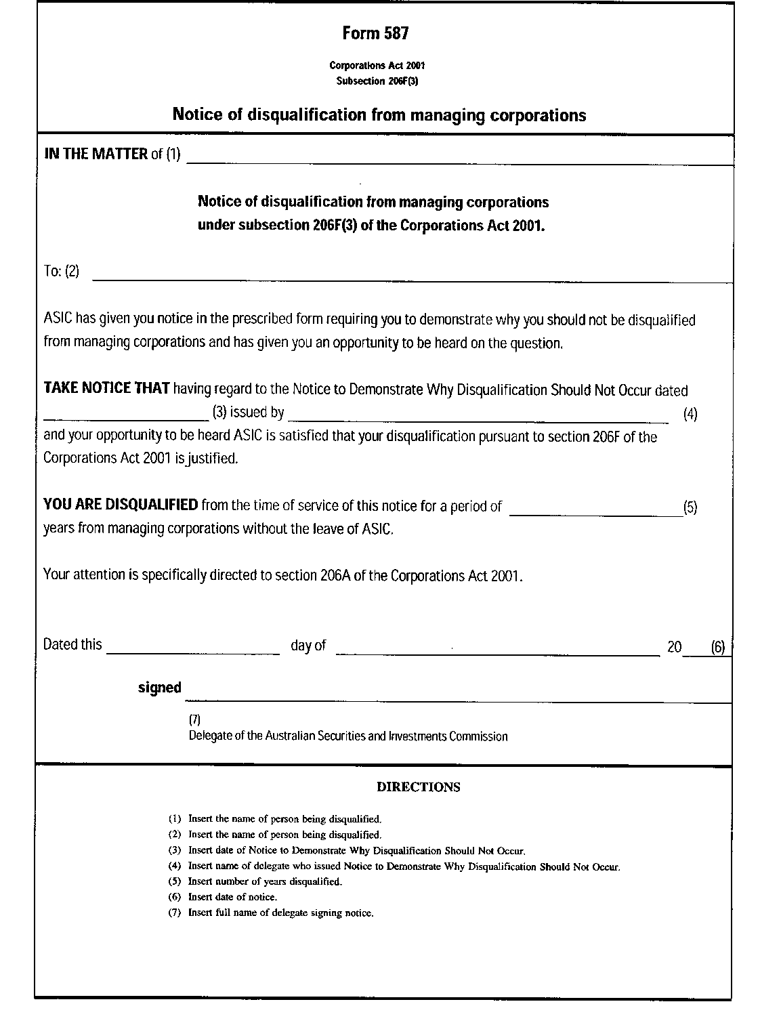

Form 588
(subparagraph 206GAA(1)(b)(i))
Form 588

Corporations Act 2001
Subparagraph 206GAA(1)(b)(i)

Notice to demonstrate why disqualification should not occur

IN THE MATTER of (1)__________________________________

Notice to demonstrate why disqualification should not occur
under section 206GAA of the Corporations Act 2001.

To: (2) ________________________________________________________

The records of the Australian Securities and Investments Commission (ASIC) show that you are or were an officer of ______ (3) corporations that have been wound up, being ____________________________________________________________(4)

where money was advanced for the purposes of paying the entitlements of employees of the corporations under the Fair Entitlements Guarantee Act 2012 and:

- the Commonwealth has received a minimal return, or no return on the advance; and
- ASIC has reason to believe that the Commonwealth is unlikely to receive more than a minimal return on the advance; and
- ASIC has reason to believe that either the corporations contravened the Corporations Act 2001 or Corporations (Aboriginal and Torres Strait Islander) Act 2006 and that the person failed to take reasonable steps to prevent the contravention or the person contravened the Corporations Act 2001 or Corporations (Aboriginal and Torres Strait Islander) Act 2006.

In these circumstances you are required to demonstrate, in accordance with subparagraph 206GAA(1)(b)(i) of the Act, why you should not be disqualified from managing corporations.

Under subsection 206GAA(1) of the Act you may be disqualified from managing corporations for a period of up to 5 years.

In making a decision under subsection 206GAA(1) of the Act ASIC is required to give you an opportunity to be heard in relation to why you should not be disqualified from managing corporations.

AREAS OF CONCERN

ASIC has identified a number of concerns about your conduct which are described in Attachment "A".

The documents on which these concerns are based are listed in Attachment "B".

OPPORTUNITY TO BE HEARD

If you wish to demonstrate why you should not be disqualified from managing corporations you should notify ASIC within 14 days from the date of service of this notice that you require an opportunity of being heard.

You may exercise your right to be heard by:

- making a written submission; or

- appearing before a person ASIC has appointed to hear the matter (the delegate) and making submissions orally and appearing before the delegate to present evidence.

You may exercise your right by doing any or all of these options.

Once you have notified ASIC of your wish to demonstrate why you should not be disqualified a delegate will write to you with further details of the hearing procedure. The delegate will also inform you of the delegate’s decision as to whether the hearing will take place at one or more physical venues and/or by means of virtual enquiry technology.

If you do not wish to demonstrate why you should not be disqualified, a decision will be made by a delegate on the information available.

If you wish to have access to the documents listed in Attachment "B" you should contact ASIC as soon as possible. Access to documents which are identified as "confidential" may be given subject to strict conditions of confidentiality.

Dated this ___________________ day of __________________________

Signed …………………………………………………………

_____________________________________
(5) Delegate of the Australian Securities and Investments Commission

Attachments

Attachment “A”
Areas of concern

Attachment “B”
List of documents upon which concerns are based

DIRECTIONS

- Insert name of person subject of the notice.
- Insert name of person subject of the notice.
- Insert number of corporations of which the person was an officer.
- Insert names and ACNs of corporations.
- Insert full name of delegate signing the notice.

Form 589
(subsection 206GAA(6))
Form 589

Corporations Act 2001
Subsection 206GAA(6)
Notice of disqualification from managing corporations

IN THE MATTER of (1)__________________________________

Notice of disqualification from managing corporations
under subsection 206GAA(6) of the Corporations Act 2001.

To: (2) ________________________________________________________

ASIC has given you notice in the prescribed form requiring you to demonstrate why you should not be disqualified from managing corporations and has given you an opportunity to be heard on the question.

TAKE NOTICE THAT having regard to the Notice to Demonstrate Why Disqualification Should Not Occur dated ___________(3) issued by _________
____________(4) and your opportunity to be heard ASIC is satisfied that your disqualification pursuant to section 206GAA of the Corporations Act 2001 is justified.

YOU ARE DISQUALIFIED from the time of service of this notice for a period of _______(5) years from managing corporations without the leave of ASIC.

Please note the extent of the legal prohibitions on your management of corporations under section 206A of the Corporations Act 2001.

Dated this ________________ day of ___________________(6)

Signed …………………………………………………………
_____________________________________
(7) Delegate of the Australian Securities and Investments Commission

DIRECTIONS

(1) Insert the name of person being disqualified.
(2) Insert the name of person being disqualified.
(3) Insert date of Notice to Demonstrate Why Disqualification Should Not Occur.
(4) Insert name of delegate who issued Notice to Demonstrate Why Disqualification Should Not Occur.
(5) Insert number of years disqualified.
(6) Insert date of notice.
(7) Insert full name of delegate signing notice.

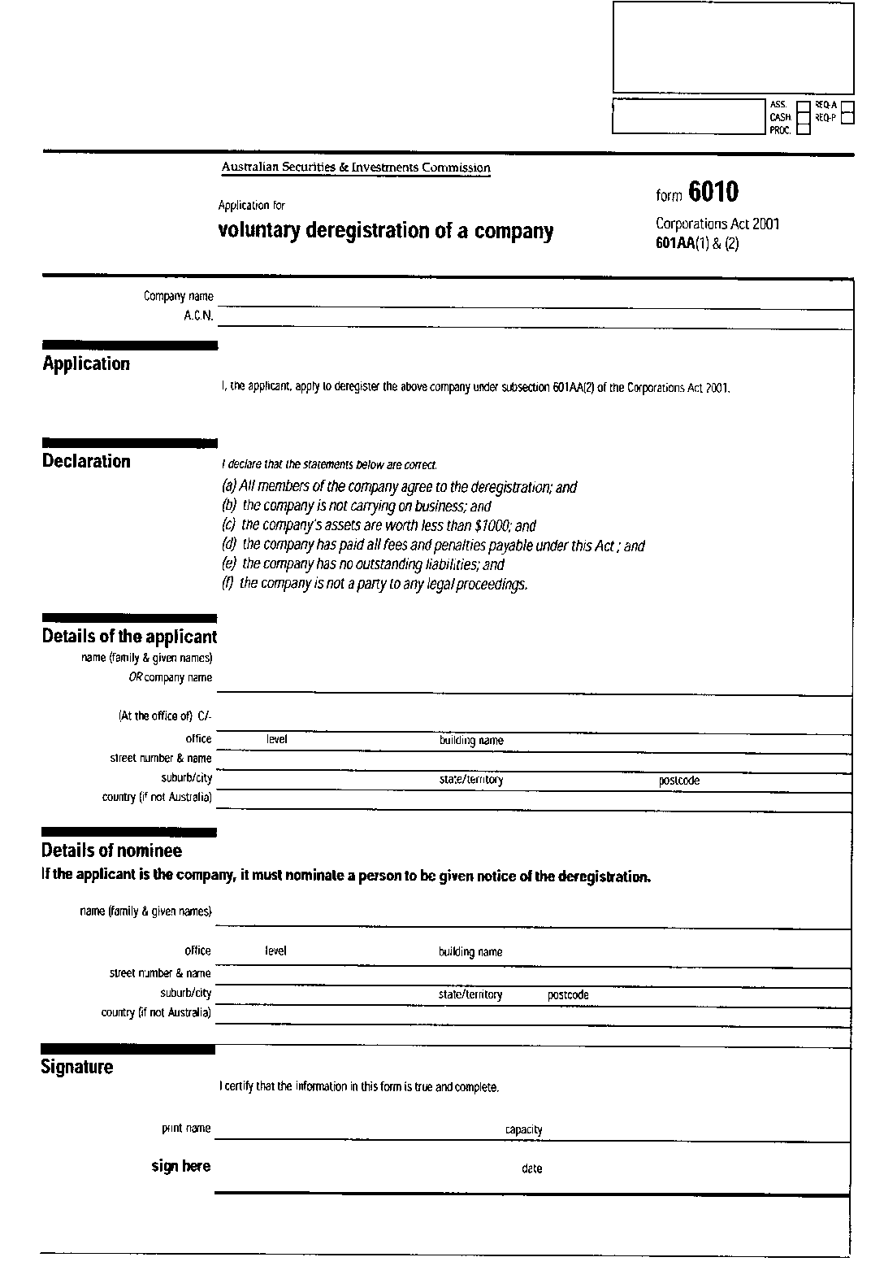
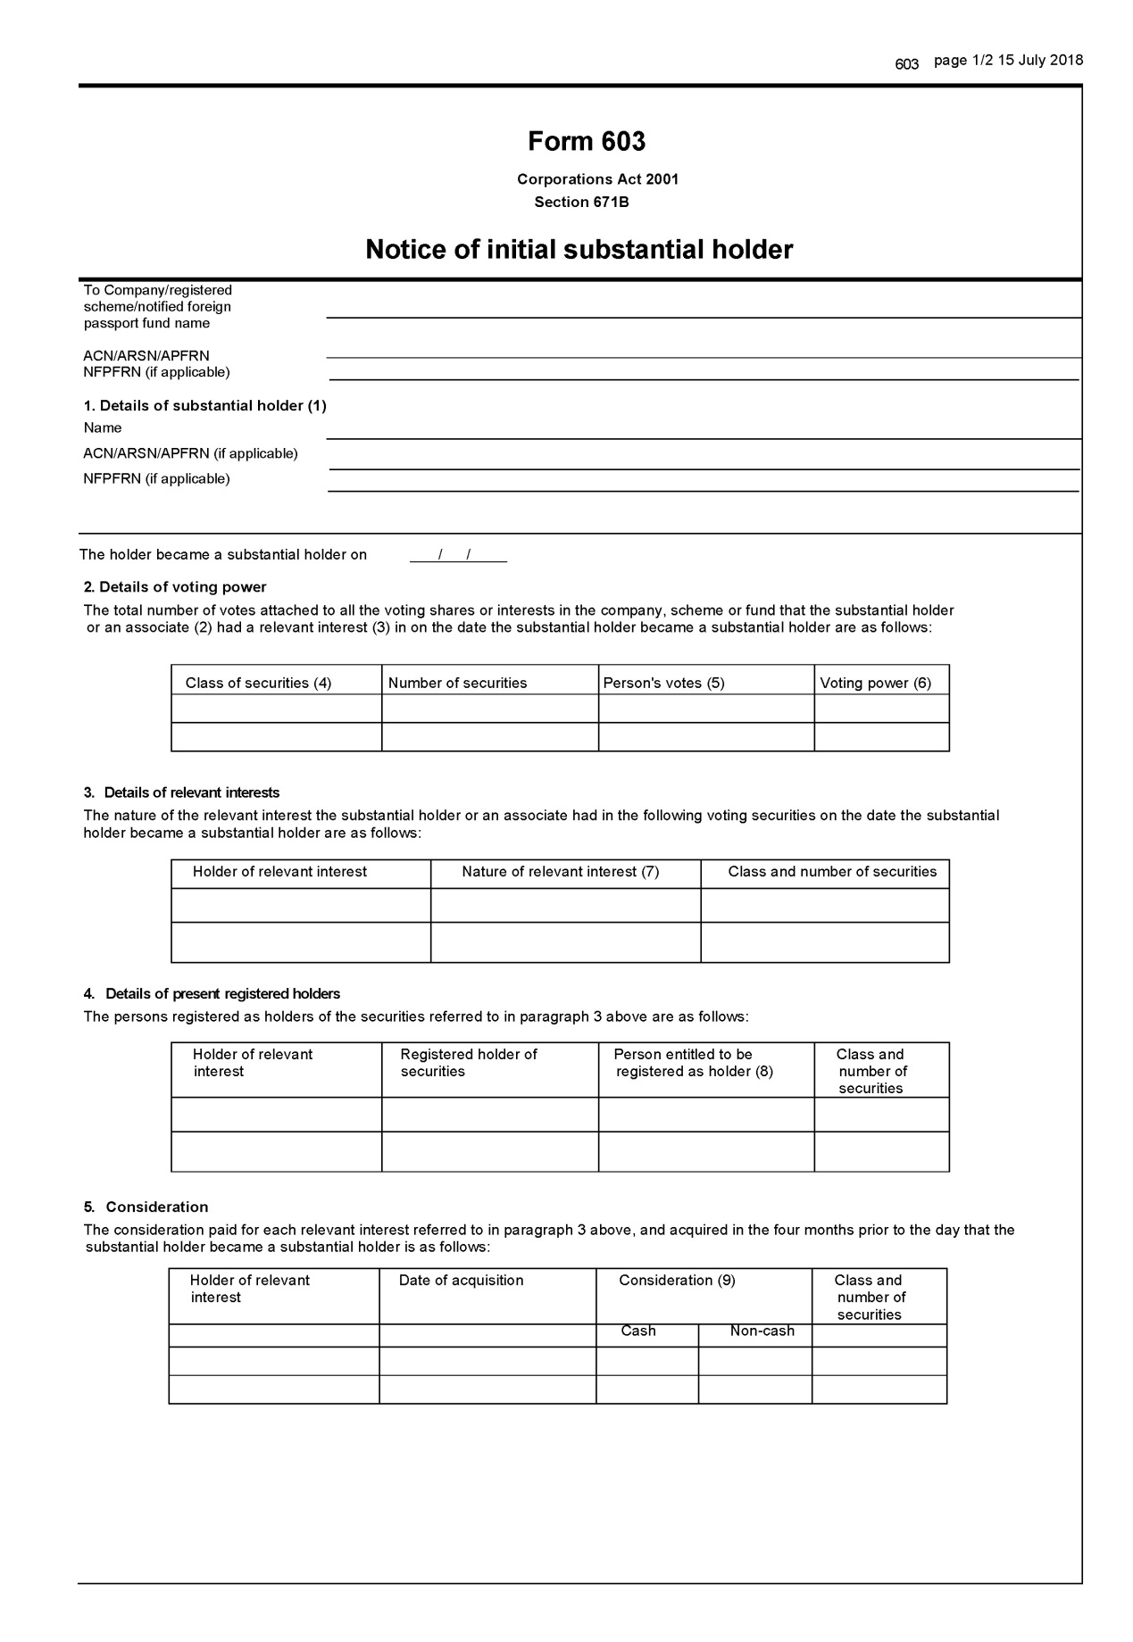
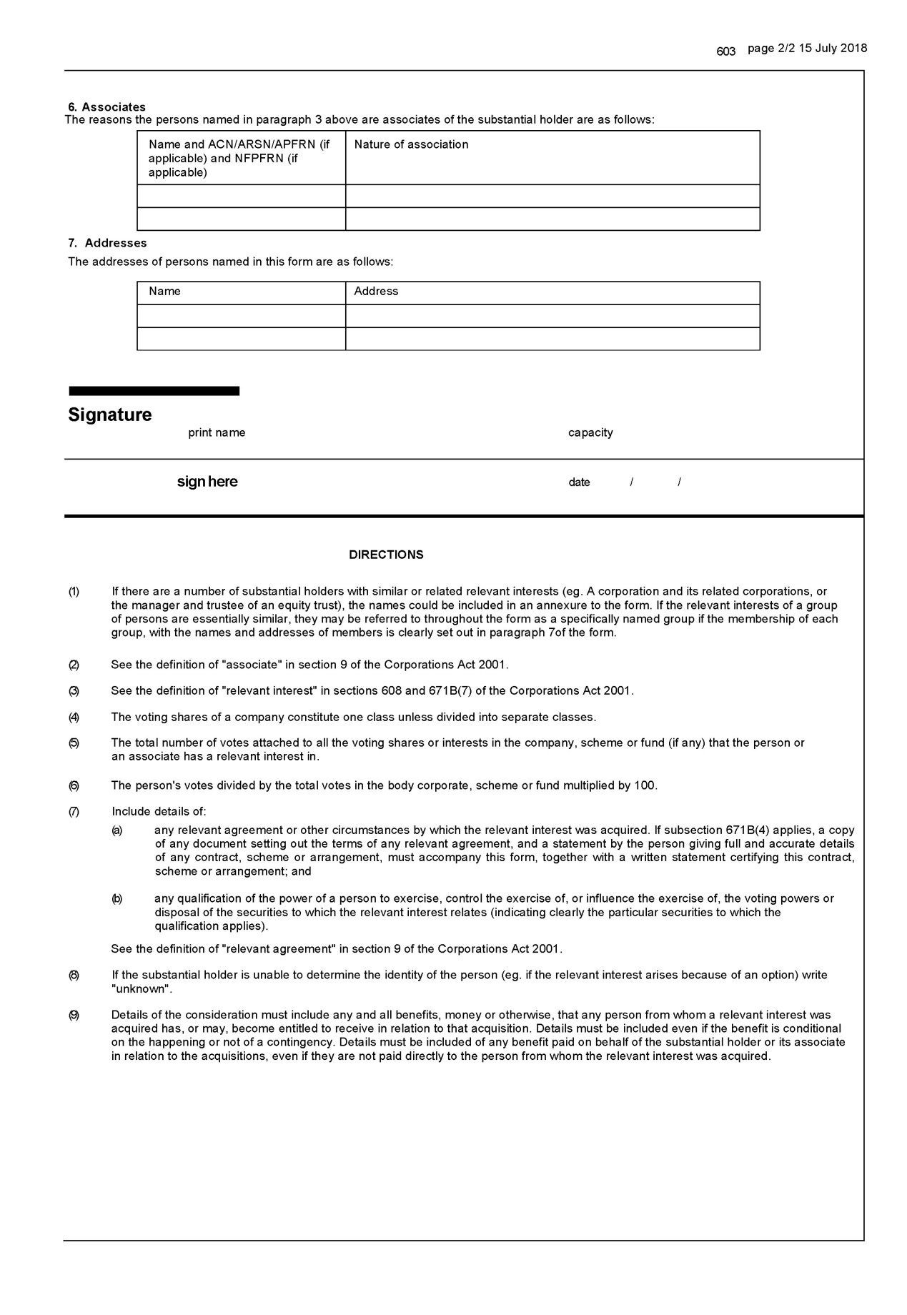
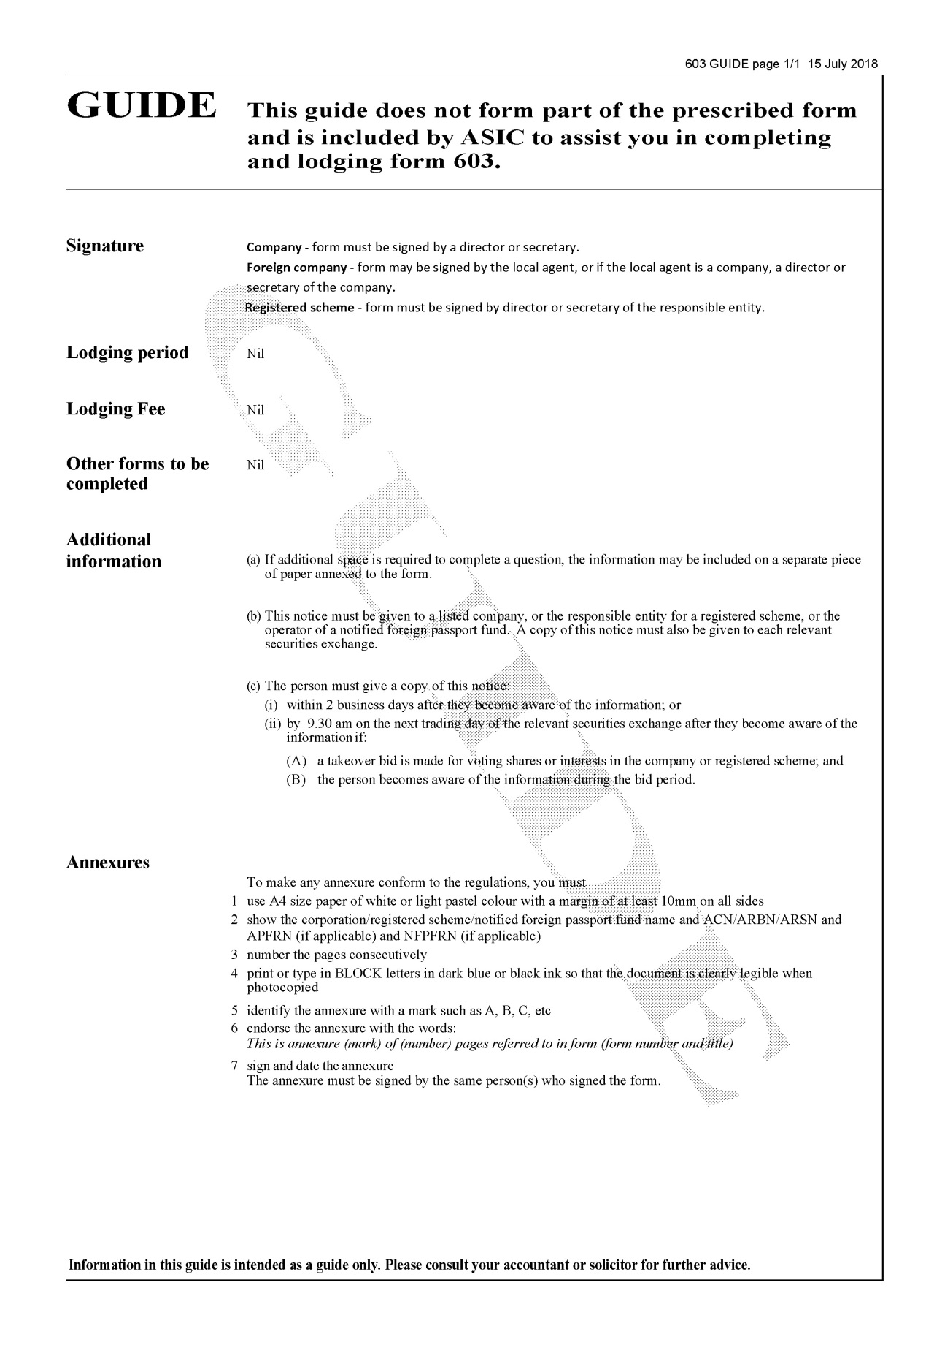
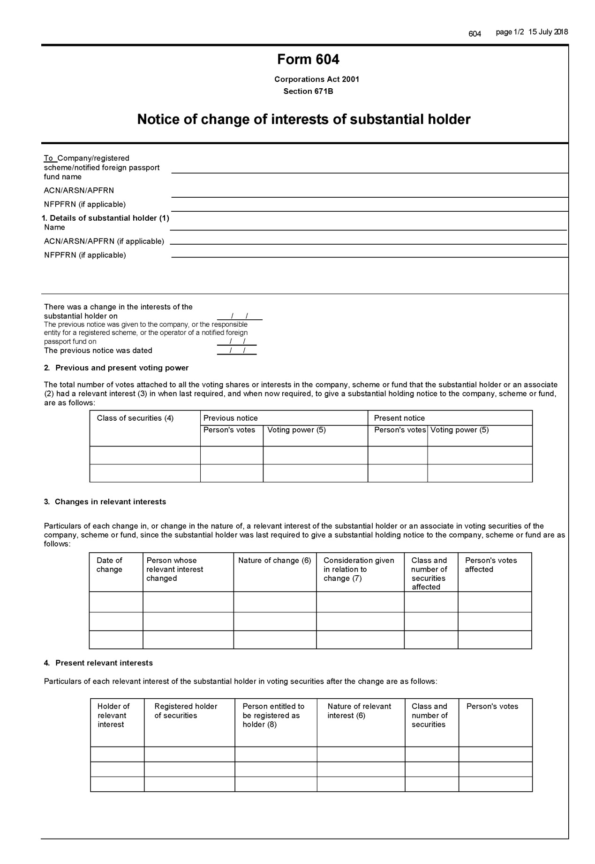
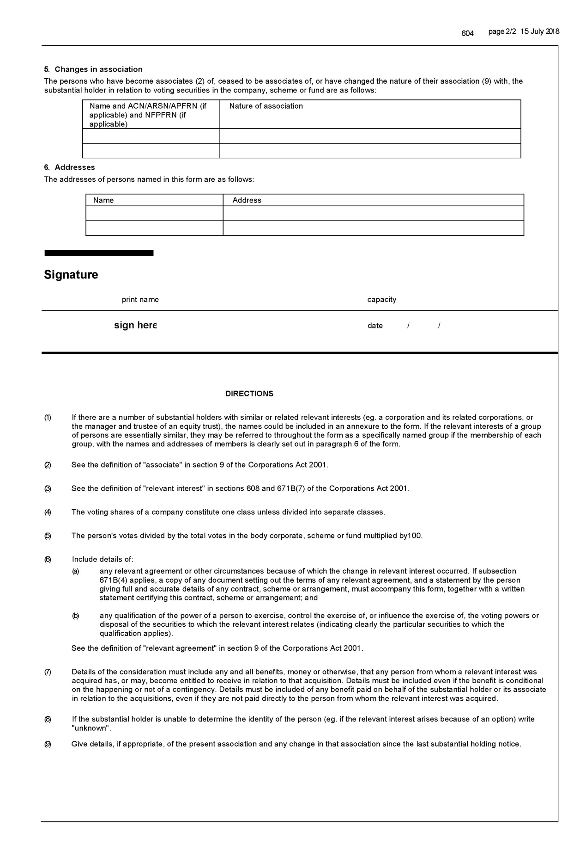
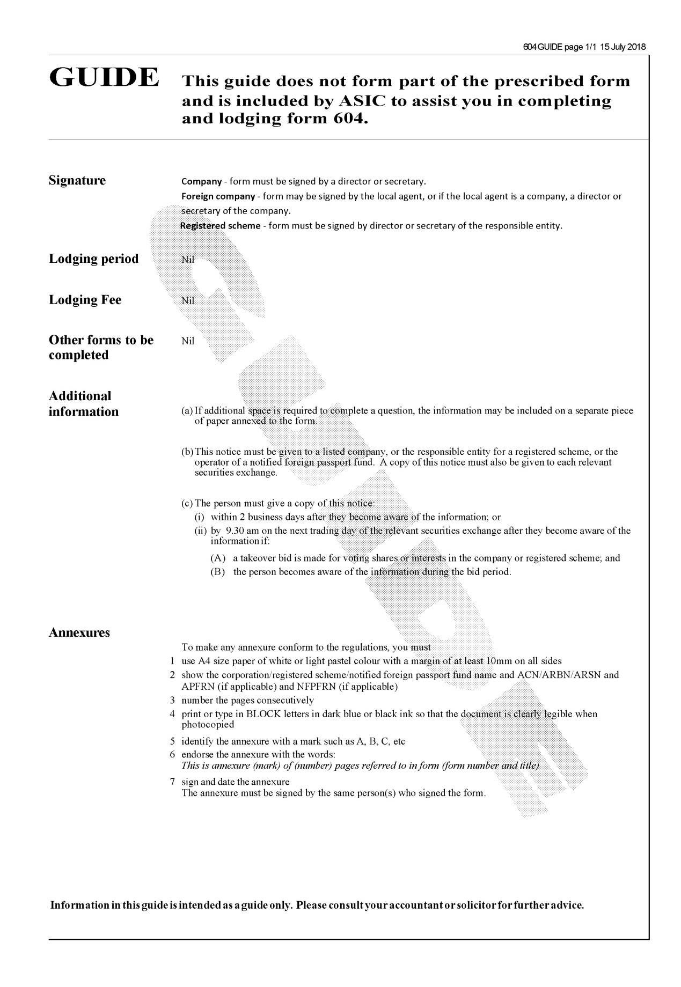
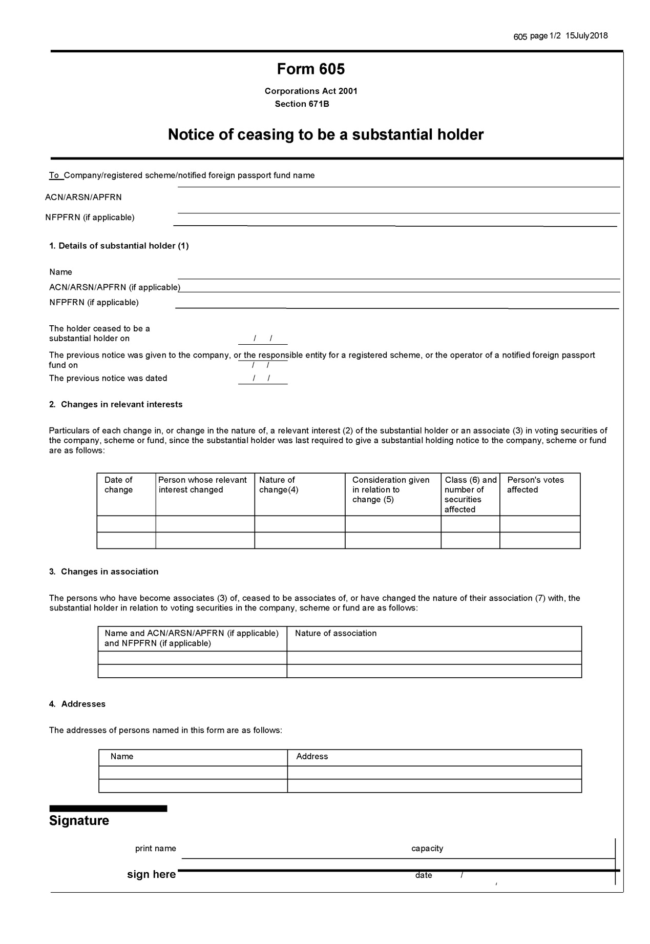
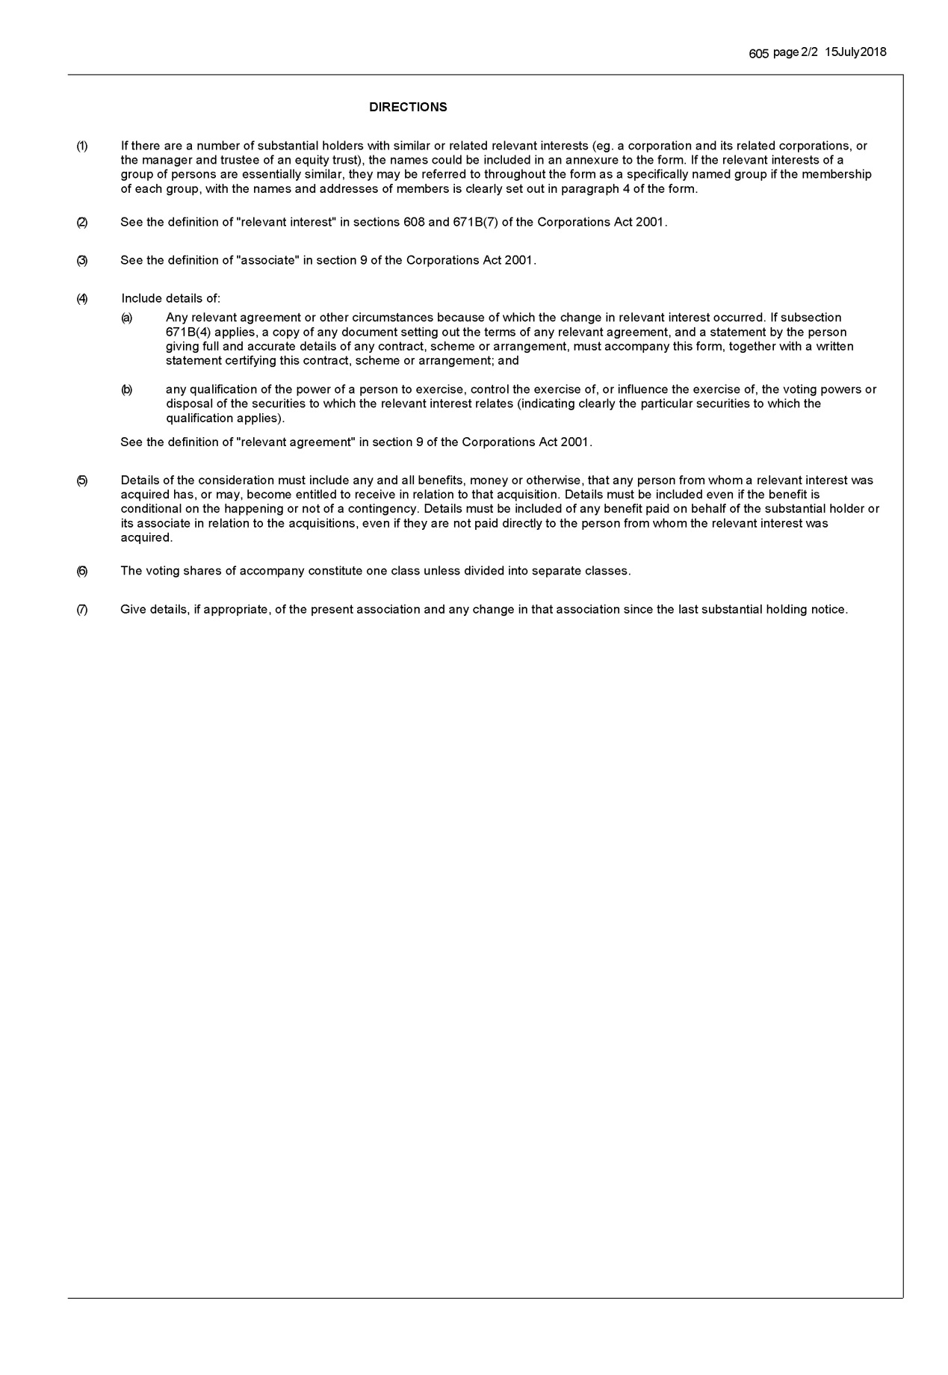
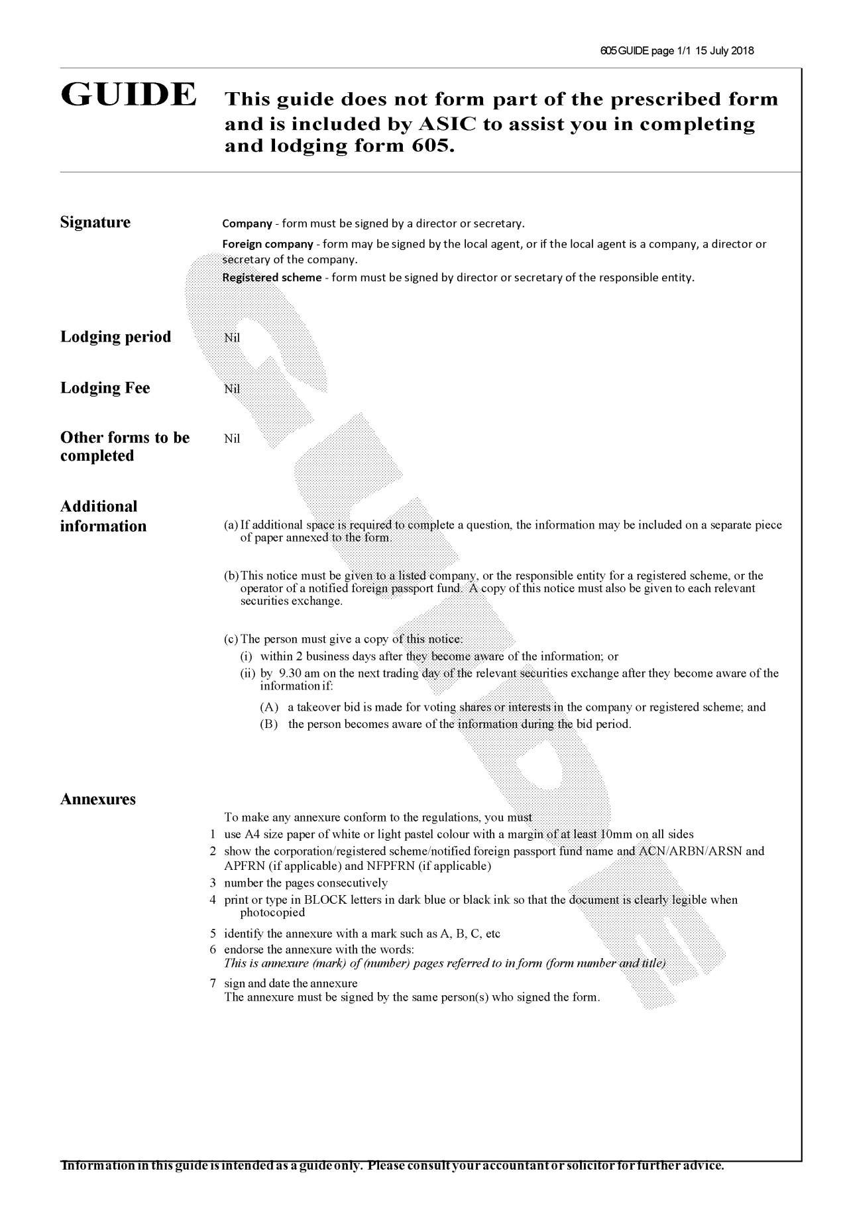

Form 719
(regulations 7.5.90 and 7.5.92)

Corporations Regulations 2001
STATEMENT ABOUT PAYMENTS OUT OF FINANCIAL INDUSTRY DEVELOPMENT ACCOUNT
1. The name of the market licensee to which this statement relates is (insert name of market licensee).
2. This statement relates to the financial year ending on (insert date) (the relevant financial year).
3. Specify in respect of each purpose approved by the Minister under subregulation 7.5.88 of the Regulations:
(a) the terms of the purpose as so approved are:
(insert terms)
(b) the date of that approval was (date);
(c) the amount of payments made for that purpose during the relevant financial year was $(amount);
(d) the total, as at the end of the relevant financial year, of all payments made for this purpose in the relevant financial year and previous financial years was $(amount);
(e) further payments for this purpose *are / *are not envisaged.
4. The total of payments for all purposes in respect of the relevant financial year was $(amount).
REPORT OF AUDITOR
*I/We (insert name of the auditor or auditors signing this report), report that:
(a) *I / *We have audited the above statement; and
(b) it accurately represents the payments that it mentions.
Dated
(signature of auditor)
(under the signature add the name under which the auditor practises or the name of the firm in which the auditor is employed)
* Omit if not applicable
DECLARATION
I (insert name of officer of the market licensee and the office he or she occupies), declare:
(a) that, to the best of my knowledge and belief, the information contained in the above statement is correct; and
(b) that the Board of (insert name of the market licensee) has accepted the information contained in the statement and resolved that the statement be lodged with ASIC.
Dated
(signature of officer of the market licensee)
(under the signature add the name of the person signing)

Form 719A
(subregulation 7.5.56(4))

Corporations Regulations 2001
COMPENSATION FOR LOSSES RESULTING FROM THE UNAUTHORISED TRANSFER OF RIGHTS, SHARES, DEBENTURES OR OTHER SECURITIES BY DEALER
This notice relates to the unauthorised transfer of securities by (insert name of the dealer who is claimed to have transferred securities without authority of transferor) (in this notice called ‘the dealer’) of (insert residential address of the dealer) *formerly carrying on / *carrying on business at (insert address of the principal place of business of the dealer, including State or Territory).
A person wishing to make a claim under regulation 7.5.54 or 7.5.55 of the Corporations Regulations 2001 in respect of loss suffered as a result of a transfer of securities executed between (insert date of first day of applicable period) and (insert date of last day of applicable period, being a date before the date on which the notice is first to be published) (inclusive) by the dealer without authority must lodge his or her claim with:
Securities Exchanges Guarantee Corporation
(insert address, including State or Territory and postcode).
The claim must be made in writing before the end of (specify last application day, at least 3 months after last day of publication of notice).
Under subregulation 7.5.56(3) of the Corporations Regulations 2001, a claim that is not made before the end of that day is barred unless the Board of the Securities Exchanges Guarantee Corporation otherwise determines.
The effect of regulation 7.5.54 of the Corporations Regulations 2001 is to allow a person who:
(a) owned securities that were transferred by a dealer; and
(b) did not authorise the dealer to transfer those securities; and
(c) suffered loss as a result of the transfer;
to make a claim for compensation for the loss suffered in respect of the securities.
The effect of subregulation 7.5.55(1) of the Corporations Regulations 2001 is to allow:
(a) a person to whom securities were transferred by the dealer without the authority of the owner of the securities; or
(b) a successor in title of that person;
to make a claim for compensation for the loss suffered in respect of the securities.
Under regulation 7.5.55 of the Corporations Regulations 2001, the following persons are not entitled to make a claim:
(a) a person who knew that the owner of the securities had not authorised the dealer to transfer them;
(b) a person who is connected with the dealer in a way described in regulation 7.5.04 of the Corporations Regulations 2001.
(signature of an officer of the SEGC)
(under the signature add the words ‘for the Securities Exchanges Guarantee Corporation’)
(add the date of signature)
* Omit if not applicable

Form 719B
(subregulation 7.5.61(4))

Corporations Regulations 2001
NOTICE CALLING FOR CLAIMS AGAINST SECURITIES EXCHANGES GUARANTEE CORPORATION
This notice relates to claims for pecuniary loss suffered in respect of a contravention of the ASTC certificate cancellation provisions by (insert name of dealer who is claimed to have contravened SCH certificate cancellation provisions) (in this notice called ‘the dealer’) *formerly carrying on business / *carrying on business at (insert business address of the dealer).
A person wishing to make a claim under subregulation 7.5.60(1) of the Corporations Regulations 2001 for pecuniary loss suffered in respect of a contravention by the dealer of the SCH certificate cancellation provisions during the period beginning on and ending on (insert dates) is required to serve the claim on:
Securities Exchanges Guarantee Corporation
(insert address including relevant State or Territory and postcode).
The claim must be made in writing and served on or before the end of (specify last application day — at least 3 months after last day of publication of notice).
(NOTES:
1. Under subregulation 7.5.61(3) of the Corporations Regulations 2001, a claim that is not served before the end of the day specified will be barred, unless the Board of the Securities Exchanges Guarantee Corporation (‘SEGC’) otherwise determines.
2. Regulation 7.5.60 of the Corporations Regulations 2001 provides that a person who suffers pecuniary loss in respect of a contravention, by a dealer, of the ASTC certificate cancellation provisions may make a claim in respect of the loss. ASTC certificate cancellation provisions are provisions of the ASTC operating rules that deal with brokers cancelling certificates or other documents of title to Part 4 financial products or with matters incidental to that function.)
A person may not make a claim under regulation 7.5.60 of the Corporations Regulations 2001 if:
(a) the loss is in respect of an unauthorised execution (within the meaning of regulation 7.5.53 of those Regulations) in respect of which the person has made, or is entitled to make a claim under Subdivision 4.7 of Part 7.5 of those Regulations; or
(b) the person was involved in the contravention of the ASTC certificate cancellation provisions.
(signature of an officer of the SEGC)
for the Securities Exchanges Guarantee Corporation
(add the date of signature)
* Omit if not applicable

Form 720
(subregulation 7.5.70(1))

Corporations Regulations 2001
NOTICE CALLING FOR CLAIMS AGAINST THE SECURITIES EXCHANGES GUARANTEE CORPORATION
In relation to (insert name of dealer who has become insolvent) (in this notice called ‘the dealer’) of (insert residential address of the dealer), *formerly / carrying on business at (insert address of the principal place of business of the dealer, including State or Territory), a dealer who has become insolvent.
Persons wishing to make a claim under subregulation 7.5.64(1) of the Corporations Regulations 2001 in respect of property that was, in the course of, or in connection with, the dealer’s business of dealing in securities, entrusted to or received by the dealer (or another person as provided under that subregulation) are required to lodge their claim with:
The Securities Exchanges Guarantee Corporation
(insert address, including State or Territory and postcode).
The claim must be made in writing on or before (insert date).
Subject to regulation 7.5.70 of the Corporations Regulations 2001, claims not made on or before that date are barred unless the Board of the Securities Exchanges Guarantee Corporation otherwise determines.
Subregulation 7.5.64(1) of the Corporations Regulations 2001 provides to the effect that, where the requirements of that provision are otherwise met, a person may make a claim in respect of property that was, in the course of, or in connection with, the dealer’s business of dealing in securities, entrusted to or received by:
(a) unless paragraph (b) applies, the dealer or an employee of the dealer; or
(b) if the dealer was, at the time the property was so entrusted or received, a partner in a participant, the participant, or a partner in, or an employee of, the participant.
(signature of an officer of the SEGC)
(under the signature add the words ‘For the Securities Exchanges Guarantee Corporation’)
(add the date of signature)
* Omit if not applicable

Form 721
(regulation 7.5.80)
Corporations Regulations 2001
NOTICE OF DISALLOWANCE OF CLAIM AGAINST THE SECURITIES EXCHANGES GUARANTEE CORPORATION
(Set out the name and address of the claimant or the claimant’s solicitor and an appropriate form of salutation)
In relation to (insert name of the dealer to whom the claim relates), *formerly carrying on / *carrying on business at (insert business address of the dealer).
The *Board of the Securities Exchanges Guarantee Corporation / *delegate of the Board of the Securities Exchanges Guarantee Corporation under section 890C of the Corporations Act 2001 has considered your claim against the Corporation in respect of (insert description of the circumstances giving rise to the claim and the loss allegedly suffered by the claimant).
After considering all the available evidence, the Corporation has decided that the claim under *regulation (insert relevant regulation number) / *regulations (insert relevant regulation numbers) should be *disallowed / *partly disallowed to the extent set out below.
If you are not satisfied with this decision, you may bring proceedings within 3 months after service of this notice (see section 888H of the Act).
Yours sincerely,
(signature of an officer of the Corporation)
(under the signature add the words ‘for the Securities Exchanges Guarantee Corporation’)
(add the date of signature)
(If the claim has been partly disallowed, insert a heading
‘PARTICULARS OF PARTIAL DISALLOWANCE’
and specify the necessary particulars under it)
* Omit if not applicable

Form 905

Registration no:

Corporations Act 2001
PARTICULARS OF CESSATION OR CHANGE RELATING TO A PERSON REGISTERED AS AN AUDITOR UNDER SUBSECTION 1287(1)
Surname | First or given names
Residential address

*1. CESSATION
On (insert date) , I ceased to practise as an auditor. I request ASIC to exercise its discretion under subsection 1290(1) and cancel my registration as an auditor.

*2. CHANGE OF NAME
On (insert date) , I changed my name
from:
to:

*3. CHANGE IN OTHER PARTICULARS
*On (insert date) , the full address of the principal place at which I practise was changed from:
to: (insert full address)

*On (insert date) , the full address of a place at which I practise was changed from:
to: (insert full address)

*On (insert date) , I commenced to practise at: (insert full address)

*On (insert date) , I commenced to practise under a name and style other than my own at: (insert full address)

*On (insert date) , I ceased to practise at: (insert full address)

*On (insert date) , the *name/*address of a firm of which I am *a member/*an employee was changed from:
to:

*On (insert date) , I became *a member/*an employee of: (insert name and full address)

*On (insert date) , I ceased to be *a member/*an employee of: (insert name and full address)

*On (insert date) , a name or style other than my own under which I practise was changed from:
to:

Dated: (insert date)

(signature of the registered company auditor)

* Omit if not applicable
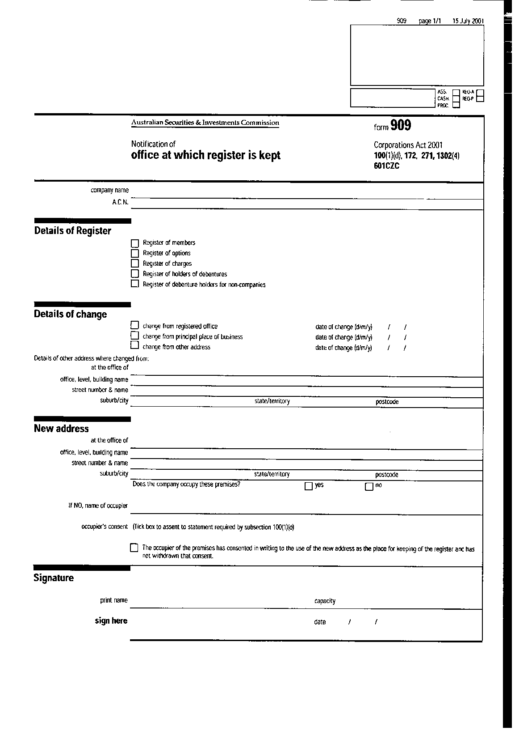
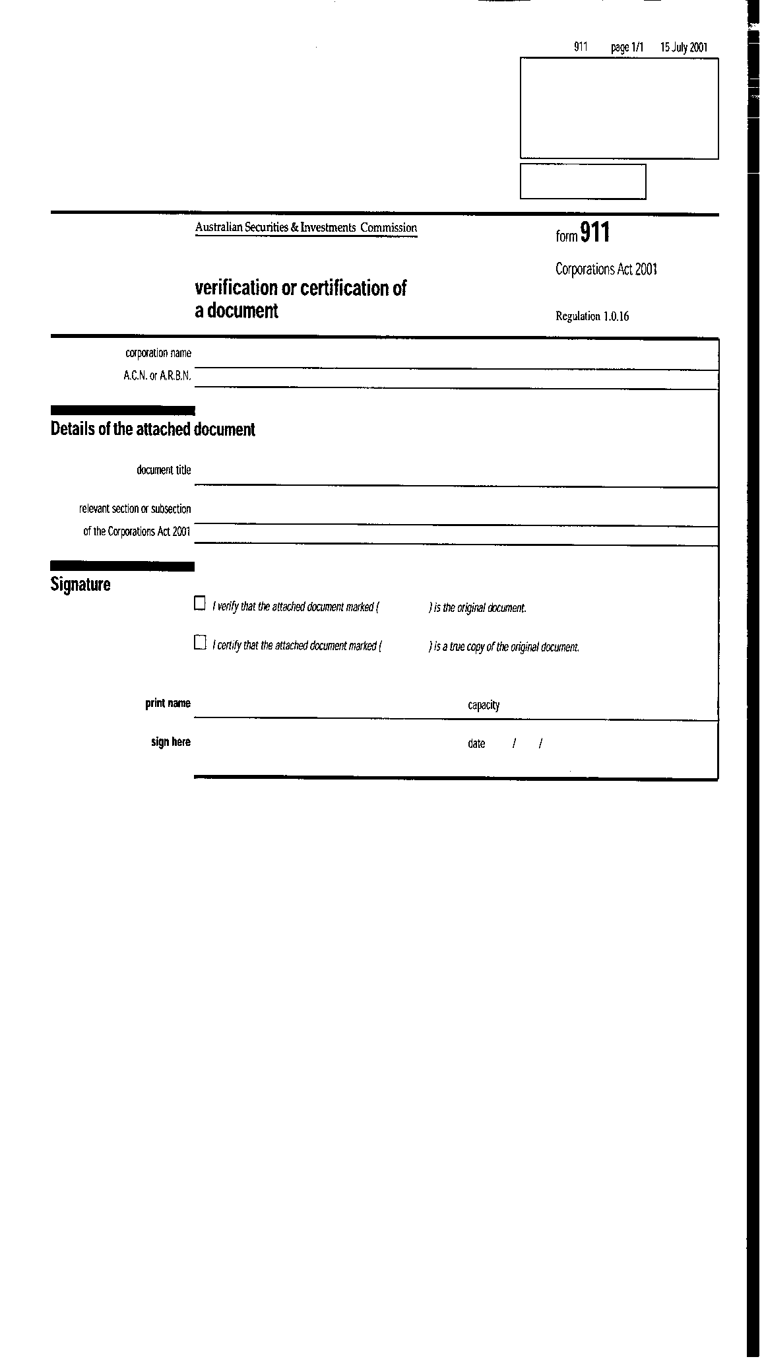

Schedule 2A—Forms of transfer of Division 3 securities
(regulation 7.11.04)

Form 1

DIVISION 3 SECURITY TRANSFER FORM |  | MARKING STAMP
PART 1
Full name of company:
Description of Division 3 assets: | Class: |  | If not fully paid, paid to: | Register:
Quantity: | [Words] |  | [Figures]
Transfer identification number:
Full name(s) of transferor(s):
The transferor(s) hereby transfer(s) the above Division 3 assets to the transferee(s) named in Part 2 hereof or to the several transferees named in Part 2 of the Broker’s Transfer Form(s), Split Transfer Form(s) or Consolidated Transfer Form(s) relating to the assets.
This transfer is executed on the transferor’s behalf by the transferor’s broker, who certifies:
(a) as to the validity of documents; and
(b) that stamp duty, if payable, has been or will be paid.
[Transferor’s broker’s stamp]
Affixed at
on
(place and date of affixing stamp)
PART 2

Full name(s) and address(es) of transferee(s): |  | Transferee’s broker hereby certifies:  (a) that the Division 3 assets set out in Part 1 above, having been purchased in the ordinary course of business, are to be registered in the name(s) of the transferee(s) named in this Part; and  (b) that stamp duty, if payable, has been or will be paid;  and hereby requests that such entries be made in the register as are necessary to give effect to this transfer;  [Transferee’s broker’s stamp]  Date of affixing stamp:
PART 3

Transferee’s broker hereby certifies:
(a) that the Division 3 assets set out in Part 1 above, having been purchased in the ordinary course of business, are to be registered in the name(s) of the transferee(s) named in the Consolidated Transfer Form relating to the Division 3 assets; and
(b) that stamp duty, if payable, has been or will be paid;
and hereby requests that such entries be made in the register as are necessary to give effect to this transfer.
[Transferee’s broker’s stamp]
Date of affixing stamp:

Form 2

BROKER’S TRANSFER FORM |  | MARKING STAMP
PART 1
Full name of company:
Description of Division 3 assets: | Class: |  | If not fully paid, paid to: | Register:
Quantity: | [Words] |  | [Figures]
Transfer identification number:  Full name(s) of transferor(s): | Transferor’s broker hereby certifies:  (a) that the Security Transfer Form relating to the Division 3 assets set out above has been or will be lodged at the company’s office; and  (b) that stamp duty, if payable, has been or will be paid.  [Transferor’s broker’s stamp]  Affixed at  on  (place and date of affixing stamp)
PART 2

Full name(s) and address(es) of transferee(s): | Transferee’s broker hereby certifies:  (a) that the Division 3 assets set out in Part 1 above, having been purchased in the ordinary course of business, are to be registered in the name(s) of the transferee(s) named in this Part; and  (b) that stamp duty, if payable, has been or will be paid;  and hereby requests that such entries be made in the register as are necessary to give effect to this transfer.  [Transferee’s broker’s stamp]  Date of affixing stamp:
PART 3

Transferee’s broker hereby certifies:
(a) that the Division 3 assets set out in Part 1 above, having been purchased in the ordinary course of business, are to be registered in the name(s) of the transferee(s) named in the Consolidated Transfer Form relating to the assets; and
(b) that stamp duty, if payable, has been or will be paid;
and hereby requests that such entries be made in the register as are necessary to give effect to this transfer.
[Transferee’s broker’s stamp]
Date of affixing stamp:

Form 3

SPLIT TRANSFER FORM |  | MARKING STAMP
PART 1

Full name of company:
Description of Division 3 assets: | Class: |  | If not fully paid, paid to: | Register:
Quantity: | [Words] |  | [Figures]
Transfer identification number:  Full name(s) of transferor(s): | The [name of market licensee] hereby certifies that the Security Transfer Form or the Broker’s Transfer Form relating to the Division 3 assets set out above has been or will be lodged at the company’s office.  [Market licensee stamp]  Affixed at  on  (place and date of affixing stamp)
PART 2

Full name(s) and address(es) of transferee(s) | Transferee’s broker hereby certifies:  (a) that the Division 3 assets set out in Part 1 above, having been purchased in the ordinary course of business, are to be registered in the name(s) of the transferee(s) named in this Part; and  (b) that stamp duty, if payable, has been or will be paid;  and hereby requests that such entries be made in the register as are necessary to give effect to this transfer.  [Transferee’s broker’s stamp]  Date of affixing stamp:
PART 3

Transferee’s broker hereby certifies:
(a) that the Division 3 assets set out in Part 1 above, having been purchased in the ordinary course of business, are to be registered in the name(s) of the transferee(s) named in the Consolidated Transfer Form relating to the Division 3 assets; and
(b) that stamp duty, if payable, has been or will be paid;
and hereby requests that such entries be made in the register as are necessary to give effect to this transfer.
[Transferee’s broker’s stamp]
Date of affixing stamp:

Form 4

CONSOLIDATED TRANSFER FORM |  | MARKING STAMP
PART 1

Full name of company:
Description of Division 3 assets: | Class: |  | If not fully paid, paid to: | Register:
Quantity: | [Words] |  | [Figures]
Transfer identification number:
Transfer Consolidation Number(s):
PART 2

Full name(s) and address(es) of transferee(s): | Transferee’s broker hereby certifies:  (a) that the Division 3 assets set out in Part 1 of the Form(s) whose Transfer Consolidation Number(s) is (or are) set out in Part 1 above, having been purchased in the ordinary course of business, are to be registered in the name(s) of the transferee(s) named in this Part; and  (b) that stamp duty, if payable, has been or will be paid;  and hereby requests that such entries be made in the register as are necessary to give effect to the transfer(s).  [Transferee’s broker’s stamp]  Date of affixing stamp:

Form 5

SECURITY RENUNCIATION AND TRANSFER FORM |  |  | MARKING STAMP
PART 1

Full name of company:
Description of Division 3 rights: |  |  |  | Register:
Quantity: |  | [Words] |  | [Figures]
Transfer identification number:
Full name(s) of transferor(s):
The transferor(s) hereby renounce(s) and transfer(s) the above Division 3 rights in favour of the transferee(s) named in Part 2 hereof or to the several transferees named in Part 2 of the Broker’s Renunciation and Transfer Form(s), Renunciation and Split Transfer Form(s) or Renunciation and Consolidated Transfer Form(s) relating to the above Division 3 rights.
This transfer and renunciation is executed on the transferor’s behalf by the transferor’s broker, who certifies:
(a) as to the validity of documents; and
(b) that stamp duty, if payable, has been or will be paid.
[Transferor’s broker’s stamp]
Affixed at
on
(place and date of affixing stamp)
PART 2

Full name(s) and address(es) of transferee(s): | Transferee’s broker hereby certifies:  (a) that, the Division 3 rights set out in Part 1 above having been purchased in the ordinary course of business, the Division 3 assets to which the Division 3 rights relate are to be issued to the transferee(s) named in this Part; and  (b) that stamp duty, if payable, has been or will be paid;  and hereby requests that the Division 3 assets be issued by the company to the transferee(s) and such entries be made in the register as are necessary to give effect to this renunciation and transfer.  [Transferee’s broker’s stamp]  Date of affixing stamp:
PART 3

Transferee’s broker hereby certifies:
(a) that, the Division 3 rights set out in Part 1 above having been purchased in the ordinary course of business, the Division 3 assets to which the rights relate are to be issued to the transferee(s) named in the Renunciation and Consolidated Transfer Form relating to the Division 3 rights; and
(b) that stamp duty, if payable, has been or will be paid;
and hereby requests that the Division 3 assets be issued by the company to the transferee(s) and such entries be made in the register as are necessary to give effect to this renunciation and transfer.
[Transferee’s broker’s stamp]
Date of affixing stamp:

Form 6

BROKER’S RENUNCIATION AND TRANSFER FORM |  | MARKING STAMP
PART 1

Full name of company:
Description of Division 3 rights: |  |  | Register:
Quantity: | [Words] |  | [Figures]
Transfer identification number:
Full name(s) and address(es) of transferor(s): | Transferor’s broker hereby certifies:  (a) that the Security Renunciation and Transfer Form relating to the Division 3 rights set out above has been or will be lodged at the company’s office; and  (b) that stamp duty, if payable, has been or will be paid.  [Transferor’s broker’s stamp]  Affixed at  on  (place and date of affixing stamp)
PART 2

Full name(s) and address(es) of transferee(s): | Transferee’s broker hereby certifies:  (a) that, the Division 3 rights set out in Part 1 above having been purchased in the ordinary course of business, the Division 3 assets to which the Division 3 rights relate are to be issued to the transferee(s) named in this Part; and  (b) that stamp duty, if payable, has been or will be paid;  and hereby requests that the Division 3 assets be issued by the company to the transferee(s) and such entries be made in the register as are necessary to give effect to this renunciation and transfer.  [Transferee’s broker’s stamp]  Date of affixing stamp:
PART 3

Transferee’s broker hereby certifies:
(a) that, the Division 3 rights set out in Part 1 above having been purchased in the ordinary course of business, the Division 3 assets to which the Division 3 rights relate are to be issued to the transferee(s) named in the Renunciation and Consolidated Transfer Form relating to the rights; and
(b) that stamp duty, if payable, has been or will be paid;
and hereby requests that the Division 3 assets be issued by the company to the transferee(s) and such entries be made in the register as are necessary to give effect to this renunciation and transfer.
[Transferee’s broker’s stamp]
Date of affixing stamp:

Form 7

RENUNCIATION AND SPLIT TRANSFER FORM |  | MARKING STAMP
PART 1
Full name of company:
Description of Division 3 rights: |  |  | Register:
Quantity: | [Words] |  | [Figures]
Transfer identification number:
Full name(s) of transferor(s): | The [name of market licensee] hereby certifies that the Security Renunciation and Transfer Form or the Broker’s Renunciation and Transfer Form relating to the Division 3 rights set out above has been or will be lodged at the company’s office.  [Market licensee stamp]  Affixed at  on  (place and date of affixing stamp)
PART 2
Full name(s) and address(es) of transferee(s): | Transferee’s broker hereby certifies:  (a) that, the Division 3 rights set out in Part 1 above having been purchased in the ordinary course of business, the Division 3 assets to which the Division 3 rights relate are to be issued to the transferee(s) named in this Part; and  (b) that stamp duty, if payable, has been or will be paid;  and hereby requests that the Division 3 assets be issued by the company to the transferee(s) and such entries be made in the register as are necessary to give effect to this renunciation and transfer.  [Transferee’s broker’s stamp]  Date of affixing stamp:
PART 3
Transferee’s broker hereby certifies:
(a) that, the Division 3 rights set out in Part 1 above having been purchased in the ordinary course of business, the Division 3 assets to which the Division 3 rights relate are to be issued to the transferee(s) named in the Renunciation and Consolidated Transfer Form relating to the rights; and
(b) that stamp duty, if payable, has been or will be paid;
and hereby requests that the Division 3 assets be issued by the company to the transferee(s) and such entries be made in the register as are necessary to give effect to this renunciation and transfer.
(Transferee’s broker’s stamp)
Date of affixing stamp:

Form 8

RENUNCIATION AND CONSOLIDATION TRANSFER FORM |  | MARKING STAMP
PART 1
Full name of company:
Description of Division 3 rights: |  |  | Register:
Quantity: | [Words] |  | [Figures]
Transfer identification number:
Transfer Consolidation Number:
PART 2
Full name(s) and address(es) of transferee(s): | Transferee’s broker hereby certifies:  (a) that, the Division 3 rights set out in Part 1 of the Form(s) whose Transfer Consolidation Number(s) is (or are) set out in Part 1 above having been purchased in the ordinary course of business, the Division 3 assets to which the Division 3 rights relate are to be issued to the transferee(s) named in this Part; and  (b) that stamp duty, if payable, has been or will be paid;  and hereby requests that the Division 3 assets be issued by the company to the transferee(s) and such entries be made in the register as are necessary to give effect to the renunciation(s) and transfer(s).  [Transferee’s broker’s stamp]  Date of affixing stamp:

Form 9

TRUSTEE TRANSFER FORM |  |  | MARKING STAMP
PART 1
Full name of company:
Description of Division 3 assets: | Class: |  |  | If not fully paid, paid to: | Register:
Quantity: |  | [Words] |  | [Figures]
Transfer identification number, where appropriate:
Full name(s) of transferor(s):
PART 2
Full name(s) and address(es) of transferee(s): |  | Transferor hereby certifies that the Division 3 assets set out in Part 1 above are to be registered in the name(s) of the transferee(s) named in this Part, being the person(s) for or on whose behalf the transferor held them, either alone or together with another person or other persons, in the ordinary course of business immediately before the execution of this transfer, and hereby requests that such entries be made in the register as are necessary to give effect to this transfer.
I [or We] hereby transfer the above Division 3 assets to the transferee(s) named in Part 2 hereof.
Execution by the transferor(s):
Date of execution:

Form 10

TRUSTEE RENUNCIATION AND TRANSFER FORM
PART 1
Full name of company:
Description of Division 3 rights: |  |  | Register:
Quantity: | [Words] |  | [Figures]
Transfer identification number, where appropriate:
Full name(s) of transferor(s):
PART 2
Full name(s) and address(es) of transferee(s): | Transferor hereby certifies that, the Division 3 rights set out in Part 1 above having been transferred to the person(s) for or on whose behalf the transferor held them, either alone or together with another person or other persons, in the ordinary course of business immediately before the transfer, the Division 3 assets to which the Division 3 rights relate are to be issued to the transferee(s) named in this Part, and hereby requests that the Division 3 assets be issued by the company to the transferee(s) and that such entries be made in the register as are necessary to give effect to this renunciation and transfer.
I [or We] hereby renounce and transfer the above Division 3 rights in favour of the transferee(s) named in Part 2 hereof.
Execution by the transferor(s):
Date of execution:

