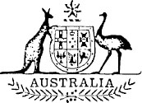
Statutory Rules
1976 No. 9
REGULATION UNDER THE PAPUA NEW GUINEA (STAFFING ASSISTANCE) ACT 1973-1975.*
I, THE Administrator of the Government of Australia, acting with the advice of the Executive Council, hereby make the following Regulation under the Papua New Guinea (Staffing Assistance) Act 1973-1975.
Dated this fifth day of January, 1976.
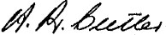
Administration
By His Excellency’s Command,
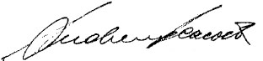
Minister of State for Foreign Affairs.

Amendment of the Papua New Guinea (Staffing Assistance) (Termination of Employment) Regulations†
Membership of Tribunal.
Regulation 12 of the Papua New Guinea (Staffing Assistance) (Termination of Employment) Regulations is amended by omitting paragraph (a) and substituting the following paragraph:—
“ (a) a person appointed by the Minister, who shall be the Chairman;”.

* Notified in the Australian Government Gazette on 22 January 1976.
† Statutory Rules 1973, No. 237, as amended by Statutory Rules 1974, No. 22; and 1975, No. 92.
Printed by Authority by the Government Printer of Australia
18124/75—Recommended retail price 5c 2/3.12.1975

