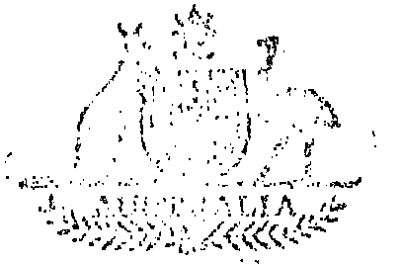

Statutory Rules
1973 No. 56
REGULATIONS UNDER the PAPUA NEW GUINEA (MEMBERS OF THE FORCES BENEFITS) ACT 1957*
I, the GOVERNOR-GENERAL of the Commonwealth of Australia, acting with the advice of the Federal Executive Council, hereby make the following Regulations under the Papua New Guinea (Members of the Forces Benefits) Act 1957.
Dated this twenty-sixth day of April 1978.
ZELMAN COWEN
Governor-General
By His Excellency’s Command,
Attorney-General
for and on behalf of the
Minister of State for Veterans’ Affairs
––––––––
AMENDMENTS OF THE PAPUA NEW GUINEA (MEMBERS OF THE FORCES BENEFITS) REGULATIONS†
First Schedule.
1. The First Schedule to the Papua New Guinea (Members of the Forces Benefits) Regulations is amended—
(a) by omitting from Table A—
“ Widow of member………………………………………………….. | 72.50
Defendant of member under 16 years of age…………………………… | 12.70 ”.
and substituting—
“ Widow of member……………………………………………………… | 75.15
Dependant of member under 16 years of age…………………………… | 12.80 ”; and
(b) by omitting from Table B—
“ Member……………………………………………………………………. | 110.50 ”
and substituting—
“ Member……………………………………………………………………. | 115.75 ”.
Application
2. The amendments made by regulation 1 have effect in relation to instalments of pension falling due on or after 1 May 1978.
–––––––––––––––––––––––––––––––––––––––––––––––––––––––––––––––––––––––––––––––––
* Notified in the Commonwealth of Australia Gazette on 1978.
† Statutory Rules 1961, No. 73 as amended by Statutory Rules 1964, No. 112; 1970, No, 62; 1975, No. 98; 1976, No. 209; and 1977, No. 166.
––––––––––––––––––––
Printed by Authority by the Commonwealth Government Printer
10517/78 Cat. No. — Recommended retail price 10c 12/28.3.1978

