STATUTORY RULES
1968 No.
————
REGULATIONS UNDER THE COMMONWEALTH EMPLOYEES’ FURLOUGH ACT 1943-1968.*
I, THE GOVERNOR-GENERAL in and over the Commonwealth of Australia, acting with the advice of the Federal Executive Council, hereby make the following Regulations under the Commonwealth Employees’ Furlough Act 1943-1968.
Dated this fourth day of July, 1968.
CASEY
Governor-General.
By His Excellency’s Command,
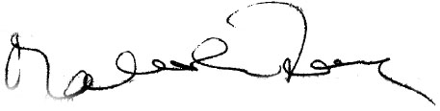
Minister of State for Education and Science acting for and on behalf of the Prime Minister.
—————
Amendments of the Commonwealth Employees’ Furlough Regulations†
Approving authority.
1. Regulation 3 of the Commonwealth Employees’ Furlough Regulations is repealed.
2. After regulation 4 of the Commonwealth Employees’ Furlough Regulations the following regulation is added:—
Prescribed class of seamen.
“5. For the purposes of section 6a of the Act, seamen included in any of the following descriptions are a prescribed class of seamen:—
(a) able seamen;
(b) ordinary seamen;
(c) crew attendants;
(d) lamp trimmers;
(e) storekeepers;
(f) greasers;
(g) motormen;
(h) firemen;
(i) oil burners;
(j) trimmers;
(k) wipers;
(l) boatswains;
(m) donkeymen; and
(n) deck boys.”.

* Notified in Commonwealth Gazette on , 1968.
† Statutory Rules 1957, No. 49, as amended by Statutory Rules 1967, No, 100.
—————————
By Authority: A. J. Arthur, Commonwealth Government Printer, Canberra
16674/68—Price 5c 9/12.6.1968

