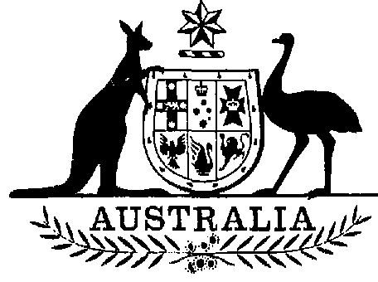
Statutory Rules 1988 No. 161 ¹
Civil Aviation (Buildings Control)
Regulations
I, THE GOVERNOR-GENERAL of the Commonwealth of Australia, acting with the advice of the Federal Executive Council and pursuant to section 4 of the Acts Interpretation Act 1901, hereby make the following Regulations under the Civil Aviation Act 1988.
Dated 30 June 1988
N. M. STEPHEN
Governor-General
By His Excellency’s Command,
Gareth Evans
Minister of State for Transport
and Communications

_________

Citation
1. These Regulations may be cited as the Civil Aviation (Buildings Control) Regulations.
Interpretation
2. In these Regulations, unless the contrary intention appears:
“interest” in relation to land, means:
(a) a legal or equitable estate or interest in the land; or
(b) a right, power or privilege over, or in connection with, the land;
“object” includes a tree or other natural obstacle.
(S.R. 147/88)—Cat. No. 16/23.6.1988

Prohibition of the construction of buildings in specified areas
3. (1) A person shall not, except in accordance with an approval given under these Regulations, construct within an area to which this regulation applies a building or structure.
Penalty: $1,000.
(2) In this regulation, “an area to which this regulation applies” means an area described in Schedule 1 by reference to the plan that bears the number specified in the description and is in the Schedule so specified.
Prohibition of the construction of buildings of more than 25 feet in height in specified areas
4. (1) A person shall not, except in accordance with an approval given under these Regulations, construct within an area to which this regulation applies a building or structure having a greater height above the ground than 25 feet.
Penalty: $1,000.
(2) In this regulation, “an area to which this regulation applies” means an area described in Schedule 2 by reference to the plan that bears the number specified in the description and is in the Schedule so specified.
Prohibition of the construction of buildings of more than 50 feet in height in specified areas
5. (1) A person shall not, except in accordance with an approval given under these Regulations, construct within an area to which this regulation applies a building or structure having a greater height above the ground than 50 feet.
Penalty: $1,000.
(2) In this regulation, “an area to which this regulation applies” means an area described in Schedule 3 by reference to the plan that bears the number specified in the description and is in the Schedule so specified.
Prohibition of the construction of buildings of more than 150 feet in height in certain areas
6. (1) A person shall not, except in accordance with an approval given under these Regulations, construct within an area to which this regulation applies a building or structure having a greater height above the ground than 150 feet.
Penalty: $1,000.
(2) In this regulation, “an area to which this regulation applies” means an area described in Schedule 4 by reference to the plan that bears the number specified in the description and is in the Schedule so specified.
Application for approval
7. (1) An application for approval to construct a building or structure, the construction of which is prohibited under regulation 3, 4, 5 or 6 without approval, shall be in writing and shall be lodged with the Authority or a person authorised in writing by the Authority for the purposes of this regulation.
(2) An application for approval shall state the nature and the proposed situation of the building or structure, its height above the ground and the purposes for which it will be used.
(3) The Authority may, by notice in writing, require an applicant to furnish such further information in respect to the application as is reasonably required for a proper consideration of the application.
Grant or refusal of approval
8. (1) The Authority or a person authorised in writing by the Authority for the purposes of this regulation may grant an approval to construct a building or structure, the construction of which is prohibited under regulation 3, 4, 5 or 6 without approval.
(2) The Authority may refuse an application for approval or may grant an application for approval subject to such conditions with respect to the construction of the building or structure or with respect to the marking of the building or structure as are specified in the approval.
(3) After the grant of an approval under this regulation, the Authority may, by notice in writing served on the person to whom the approval has been given:
(a) impose conditions with respect to the marking of the building or structure;
(b) revoke any or all of the conditions subject to which the approval was given;
(c) vary the conditions with respect to the marking of the building or structure; and
(d) impose conditions with respect to the marking of the building or structure additional to the conditions subject to which an approval was given;
and the conditions as so imposed, altered or added to from time to time shall be deemed to be the conditions subject to which the approval is granted.
(4) The Authority shall not:
(a) refuse an application for approval;
(b) grant an application for approval subject to conditions; or
(c) impose conditions with respect to the construction of a building or structure or with respect to the marking of a building or structure;
unless the Authority is satisfied that the building or structure, if erected, or the building or structure if erected otherwise than in accordance with the conditions, as the case may be, will or may constitute an obstruction, hazard or potential hazard to aircraft flying in the vicinity of the aerodrome situated within the area in which it is proposed to construct the building or structure.
Review of decisions
9. (1) Application may be made to the Administrative Appeals Tribunal for review of a decision under subregulation 8 (2), 8 (3) or 11 (1).
(2) Where the Authority makes a decision referred to in subregulation (1) and gives to a person whose interests are affected by the decision notice in writing of the making of the decision, the notice shall include a statement to the effect that, if the person is dissatisfied with the decision, application may, subject to the Administrative Appeals Tribunal Act 1975, be made to the Administrative Appeals Tribunal for review of the decision and, except where subsection 28 (4) of that Act applies, also include a statement to the effect that the person may request a statement under section 28 of that Act.
(3) A contravention of subregulation (2) in relation to a decision does not affect the validity of the decision.
Penalty for failing to comply with conditions subject to which an approval is granted
10. A person to whom an approval is granted under regulation 8, shall comply with the conditions, if any, subject to which the approval is granted.
Penalty: $1,000.
Removal or marking of hazards to air navigation
11. (1) Where:
(a) there is, in an area to which regulation 3 applies, a building, structure or object that constitutes or may constitute an obstruction, hazard or potential hazard to aircraft flying in the vicinity of the aerodrome named in the description of that area;
(b) there is, in an area to which regulation 4 applies a building, structure or object having a greater height above the ground than 25 feet that constitutes or may constitute an obstruction, hazard or potential hazard to aircraft flying in the vicinity of the aerodrome named in the description of that area;
(c) there is, in an area to which regulation 5 applies, a building, structure or object having a greater height above the ground than 50 feet that constitutes or may constitute an obstruction, hazard or potential hazard to aircraft flying in the vicinity of the aerodrome named in the description of that area; or
(d) there is, in an area to which regulation 6 applies a building, structure or object having a greater height above the ground than 150 feet that constitutes or may constitute an obstruction, hazard
or potential hazard to aircraft flying in the vicinity of the aerodrome situated within that area;
the Authority may, by notice in writing:
(e) direct the removal within a time specified in the notice of the whole or a specified part of the building, structure or object; or
(f) give directions with respect to the marking, whether by way of lights or otherwise, of the building, structure or object in such manner as the Authority considers is necessary to ensure that the existence of the building, structure or object is visible by day or by night to aircraft flying in the vicinity of the aerodrome named in the description of that area.
(2) The powers conferred by subregulation (1) may be exercised in relation to a building or structure whether or not approval has been given under these Regulations to the construction of the building or structure.
(3) A notice under subregulation (1) may be addressed to the person who owns the land on which the building or structure is erected or the object is situated or to the person in occupation of that land or to both of those persons.
(4) A notice under subregulation (1) may be served:
(a) by leaving it with, or tendering it to, the person, or to each of the persons, to whom it is addressed;
(b) by posting it in a prepaid registered letter to the person, or to each of the persons, to whom it is addressed at his or her last known place of abode; or
(c) where a person to whom the notice is addressed cannot be found and the place of abode of the person is unknown—by affixing it in a conspicuous position on or near to the object to which the notice relates.
(5) A person shall comply with the requirements in a notice served on him or her under this regulation.
Penalty: $200.
Provisions applicable where notice is not complied with
12. Where a person fails to comply, within such reasonable time as is specified in a notice served on him or her under regulation 11, with a requirement in the notice, the Authority may, by notice in writing, direct such persons as are specified in the notice to enter upon the land on which the building, structure or object concerned is situated and carry out the requirement which has not been complied with.
Compensation for acquisition of property
13. (1) Where, but for this regulation, the operation of a provision of these Regulations would result in the acquisition of property from a person otherwise than on just terms, there is payable to the person by the Authority
such reasonable amount of compensation as is agreed upon between the person and the Authority or, failing agreement, as is determined by a court of competent jurisdiction.
(2) In subregulation (1), “acquisition of property” and “just terms” have the same respective meanings as in paragraph 51 (xxxi) of the Constitution.
Compensation in respect of certain loss, damage or expense
14. Where, under these Regulations, a building, structure or object has been removed from any land or has been marked, any person who suffers loss or damage, or incurs expense, in or as a direct result of the removal or marking, is entitled to be paid compensation by the Authority in respect of that loss, damage or expense.
Authority and authorised persons to have certain powers
15. (1) A person authorised in writing by the Authority may enter upon any land for the purpose of:
(a) ascertaining whether the provisions of these Regulations are being complied with;
(b) ascertaining whether the conditions to which an approval given by the Authority under these Regulations is subject are being complied with;
(c) determining the terms of a notice to be served under regulation 11;
(d) ascertaining whether the requirements in a notice served under regulation 11 are being, or have been complied with; or
(e) gaining access to an area specified in a Schedule.
(2) The Authority may authorise any necessary action and the use of any reasonable force for the purpose of preventing a contravention of, or securing compliance with, these Regulations.
False statements
16. A person shall not wilfully make a false or misleading statement in or in connection with an application under regulation 7.
Penalty: $200.
Transitional
17. (1) Where:
(a) an approval given under the Air Navigation (Buildings Control) Regulations for the purposes of a provision of those Regulations was in effect immediately before the commencement of these Regulations; and
(b) that provision is one to which a provision of these Regulations corresponds;
the approval has effect after the commencement of these Regulations as if it had been given under these Regulations for the purposes of the corresponding provision of these Regulations.
(2) Where:
(a) an application under the Air Navigation (Buildings Control) Regulations was made for an approval to construct a building or structure the construction of which was prohibited under a provision of those Regulations;
(b) the application had not been dealt with before the commencement of these Regulations; and
(c) the provision of the Air Navigation (Buildings Control) Regulations referred to in paragraph (a) was one to which a provision of these Regulations corresponds;
the application shall be taken, upon the commencement of these Regulations, to have been made under these Regulations for an approval for the purposes of the corresponding provision of these Regulations to construct the building or structure.
THE SCHEDULES
SCHEDULE 1 Regulation 3
Item No. | Area
1 | Each of the areas of land in the vicinity of the aerodrome known as Sydney (Kingsford Smith) Airport in the State of New South Wales delineated by cross hachuring on Plan No. 1 in Schedule 5.
2 | Each of the areas of land in the vicinity of the aerodrome known as Sydney (Kingsford Smith) Airport in the State of New South Wales delineated by cross hachuring on Plan No. 2 in Schedule 5.
3 | Each of the areas of land in the vicinity of the aerodrome known as Bankstown Airport in the State of New South Wales delineated by cross hachuring on Plan No. 7 in Schedule 5.
4 | The area of land in the vicinity of the aerodrome known as Bankstown Airport in the State of New South Wales delineated by cross hachuring on Plan No. 8 in Schedule 5.
5 | The area of land in the vicinity of the aerodrome known as Moorabbin Airport in the State of Victoria delineated by cross hachuring on Plan No. 11 in Schedule 5.
6 | The area of land in the vicinity of the aerodrome known as Moorabbin Airport in the State of Victoria delineated by cross hachuring on Plan No. 12 in Schedule 5.
7 | Each of the areas of land in the vicinity of the aerodrome known as Moorabbin Airport in the State of Victoria delineated by cross hachuring on Plan No. 13 in Schedule 5.
8 | The area of land in the vicinity of the aerodrome known as Moorabbin Airport in the State of Victoria delineated by cross hachuring on Plan No. 14 in Schedule 5.
SCHEDULE 1—continued
Item No. | Area
9 | The area of land in the vicinity of the aerodrome known as Adelaide Airport in the State of South Australia delineated by cross hachuring on Plan No. 17 in Schedule 5.
10 | Each of the areas of land in the vicinity of the aerodrome known as Adelaide Airport in the State of South Australia delineated by cross hachuring on Plan No. 18 in Schedule 5.
11 | The area of land in the vicinity of the aerodrome known as Adelaide Airport in the State of South Australia delineated by cross hachuring on Plan No. 20 in Schedule 5.
12 | The area of land in the vicinity of the aerodrome known as Adelaide Airport in the State of South Australia delineated by cross hachuring on Plan No. 21 in Schedule 5.
13 | The area of land in the vicinity of the aerodrome known as Melbourne Airport in the State of Victoria delineated by cross hachuring on Plan No. 1 in Schedule 6.
14 | The area of land in the vicinity of the aerodrome known as Melbourne Airport in the State of Victoria delineated by cross hachuring on Plan No. 2 in Schedule 6.
15 | The area of land in the vicinity of the aerodrome known as Essendon Airport in the State of Victoria delineated by cross hachuring on Plan No. 3 in Schedule 6.
16 | The area of land in the vicinity of the aerodrome known as Essendon Airport in the State of Victoria delineated by cross hachuring on Plan No. 4 in Schedule 6.
17 | The area of land in the vicinity of the aerodrome known as Essendon Airport in the State of Victoria delineated by cross hachuring on Plan No. 5 in Schedule 6.
SCHEDULE 2 Regulation 4
Item No. | Area
1 | Each of the areas of land in the vicinity of the aerodrome known as Sydney (Kingsford Smith) Airport in the State of New South Wales delineated by oblique hachuring on Plan No. 1 in Schedule 5.
2 | The area of land in the vicinity of the aerodrome known as Sydney (Kingsford Smith) Airport in the State of New South Wales delineated by oblique hachuring on Plan No. 2 in Schedule 5.
3 | The area of land in the vicinity of the aerodrome known as Sydney (Kingsford Smith) Airport in the State of New South Wales delineated by oblique hachuring on Plan No. 3 in Schedule 5.
4 | The area of land in the vicinity of the aerodrome known as Sydney (Kingsford Smith) Airport in the State of New South Wales delineated by oblique hachuring on Plan No. 4 in Schedule 5.
5 | Each of the areas of land in the vicinity of the aerodrome known as Bankstown Airport in the State of New South Wales delineated by oblique hachuring on Plan No. 7 in Schedule 5.
6 | The area of land in the vicinity of the aerodrome known as Bankstown Airport in the State of New South Wales delineated by oblique hachuring on Plan No. 8 in Schedule 5.
SCHEDULE 2—continued
Item No. | Area
7 | The area of land in the vicinity of the aerodrome known as Moorabbin Airport in the State of Victoria delineated by oblique hachuring on Plan No. 11 in Schedule 5.
8 | The area of land in the vicinity of the aerodrome known as Moorabbin Airport in the State of Victoria delineated by oblique hachuring on Plan No. 12 in Schedule 5.
9 | The area of land in the vicinity of the aerodrome known as Moorabbin Airport in the State of Victoria delineated by oblique hachuring on Plan No. 13 in Schedule 5.
10 | Each of the areas of land in the vicinity of the aerodrome known as Moorabbin Airport in the State of Victoria delineated by oblique hachuring on Plan No. 14 in Schedule 5.
11 | Each of the areas of land in the vicinity of the aerodrome known as Adelaide Airport in the State of South Australia delineated by oblique hachuring on Plan No. 17 in Schedule 5.
12 | The area of land in the vicinity of the aerodrome known as Adelaide Airport in the State of South Australia delineated by oblique hachuring on Plan No. 18 in Schedule 5.
13 | The area of land in the vicinity of the aerodrome known as Adelaide Airport in the State of South Australia delineated by oblique hachuring on Plan No. 19 in Schedule 5.
14 | The area of land in the vicinity of the aerodrome known as Adelaide Airport in the State of South Australia delineated by oblique hachuring on Plan No. 20 in Schedule 5.
15 | The area of land in the vicinity of the aerodrome known as Adelaide Airport in the State of South Australia delineated by oblique hachuring on Plan No. 21 in Schedule 5.
16 | The area of land in the vicinity of the aerodrome known as Melbourne Airport in the State of Victoria delineated by oblique hachuring on Plan No. 1 in Schedule 6.
17 | The area of land in the vicinity of the aerodrome known as Melbourne Airport in the State of Victoria delineated by oblique hachuring on Plan No. 2 in Schedule 6.
18 | The area of land in the vicinity of the aerodrome known as Melbourne Airport in the State of Victoria delineated by oblique hachuring on Plan No. 7 in Schedule 6.
19 | The area of land in the vicinity of the aerodrome known as Melbourne Airport in the State of Victoria delineated by oblique hachuring on Plan No. 8 in Schedule 6.
20 | The area of land in the vicinity of the aerodrome known as Melbourne Airport in the State of Victoria delineated by oblique hachuring on Plan No. 9 in Schedule 6.
21 | The area of land in the vicinity of the aerodrome known as Melbourne Airport in the State of Victoria delineated by oblique hachuring on Plan No. 10 in Schedule 6.
22 | The area of land in the vicinity of the aerodrome known as Essendon Airport in the State of Victoria delineated by oblique hachuring on Plan No. 3 in Schedule 6.
23 | The area of land in the vicinity of the aerodrome known as Essendon Airport in the State of Victoria delineated by oblique hachuring on Plan No. 4 in Schedule 6.
24 | The area of land in the vicinity of the aerodrome known as Essendon Airport in the State of Victoria delineated by oblique hachuring on Plan No. 5 in Schedule 6.
SCHEDULE 2—continued
Item No. | Area
25 | Each of the areas of land in the vicinity of the aerodrome known as Essendon Airport in the State of Victoria delineated by oblique hachuring on Plan No. 6 in Schedule 6.
SCHEDULE 3 Regulation 5
Item No. | Area
1 | The area of land in the vicinity of the aerodrome known as Sydney (Kingsford Smith) Airport in the State of New South Wales delineated by vertical hachuring on Plan No. 5 in Schedule 5, other than areas of land delineated by oblique hachuring on plans Nos. 3 and 4 in that Schedule.
2 | The area of land in the vicinity of the aerodrome known as Sydney (Kingsford Smith) Airport in the State of New South Wales delineated by vertical hachuring on Plan No. 6 in Schedule 5.
3 | The area of land in the vicinity of the aerodrome known as Bankstown Airport in the State of New South Wales delineated by vertical hachuring on Plan No. 9 in Schedule 5.
4 | The area of land in the vicinity of the aerodrome known as Bankstown Airport in the State of New South Wales delineated by vertical hachuring on Plan No. 10 in Schedule 5.
5 | The area of land in the vicinity of the aerodrome known as Moorabbin Airport in the State of Victoria delineated by vertical hachuring on Plan No. 15 in Schedule 5.
6 | The area of land in the vicinity of the aerodrome known as Moorabbin Airport in the State of Victoria delineated by vertical hachuring on Plan No. 16 in Schedule 5.
7 | The area of land in the vicinity of the aerodrome known as Adelaide Airport in the State of South Australia delineated by vertical hachuring on Plan No. 22 in Schedule 5.
8 | The area of land in the vicinity of the aerodrome known as Melbourne Airport in the State of Victoria delineated by vertical hachuring on Plan No. 11 in Schedule 6.
9 | The area of land in the vicinity of the aerodrome known as Melbourne Airport in the State of Victoria delineated by vertical hachuring on Plan No. 12 in Schedule 6.
10 | The area of land in the vicinity of the aerodrome known as Melbourne Airport in the State of Victoria delineated by vertical hachuring on Plan No. 13 in Schedule 6.
11 | The area of land in the vicinity of the aerodromes known as Melbourne Airport and Essendon Airport in the State of Victoria delineated by vertical hachuring on Plan No. 14 in Schedule 6.
SCHEDULE 4 Regulation 6
Item No. | Area
1 | Each of the areas of land in the vicinity of the aerodrome known as Sydney (Kingsford Smith) Airport in the State of New South Wales delineated by horizontal hachuring on Plan No. 5 in Schedule 5.
2 | Each of the areas of land in the vicinity of the aerodrome known as Sydney (Kingsford Smith) Airport in the State of New South Wales delineated by horizontal hachuring on Plan No. 6 in Schedule 5.
3 | The area of land in the vicinity of the aerodrome known as Bankstown Airport in the State of New South Wales delineated by horizontal hachuring on Plan No. 9 in Schedule 5.
4 | The area of land in the vicinity of the aerodrome known as Bankstown Airport in the State of New South Wales delineated by horizontal hachuring on Plan No. 10 in Schedule 5.
5 | Each of the areas of land in the vicinity of the aerodrome known as Moorabbin Airport in the State of Victoria delineated by horizontal hachuring on Plan No. 15 in Schedule 5.
6 | The area of land in the vicinity of the aerodrome known as Moorabbin Airport in the State of Victoria delineated by horizontal hachuring on Plan No. 16 in Schedule 5.
7 | Each of the areas of land in the vicinity of the aerodrome known as Adelaide Airport in the State of South Australia delineated by horizontal hachuring on Plan No. 22 in Schedule 5.
8 | The area of land in the vicinity of the aerodrome known as Melbourne Airport in the State of Victoria delineated by horizontal hachuring on Plan No. 11 in Schedule 6.
9 | The area of land in the vicinity of the aerodrome known as Melbourne Airport in the State of Victoria delineated by horizontal hachuring on Plan No. 12 in Schedule 6.
10 | The area of land in the vicinity of the aerodrome known as Melbourne Airport in the State of Victoria delineated by horizontal hachuring on Plan No. 13 in Schedule 6.
11 | The area of land in the vicinity of the aerodromes known as Melbourne Airport and Essendon Airport in the State of Victoria delineated by horizontal hachuring on Plan No. 14 in Schedule 6.
12 | The area of land in the vicinity of the aerodrome known as Essendon Airport in the State of Victoria delineated by horizontal hachuring on Plan No. 15 in Schedule 6.
SCHEDULE 5
Plan No. 1—Sydney (Kingsford Smith) Airport
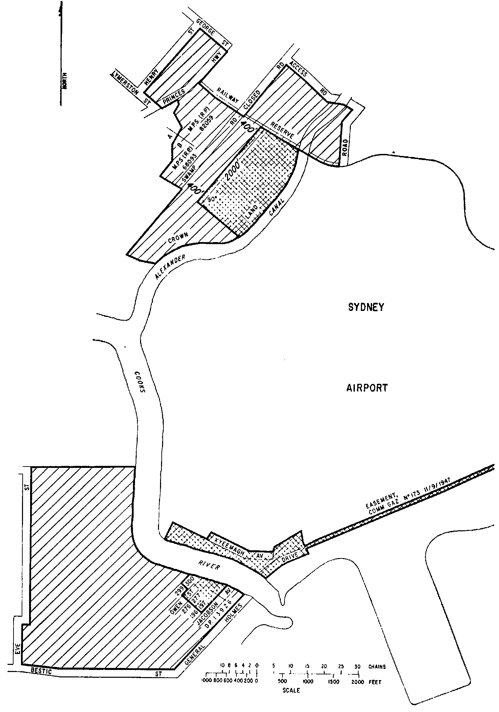
SCHEDULE 5—continued
Plan No. 2—Sydney (Kingsford Smith) Airport
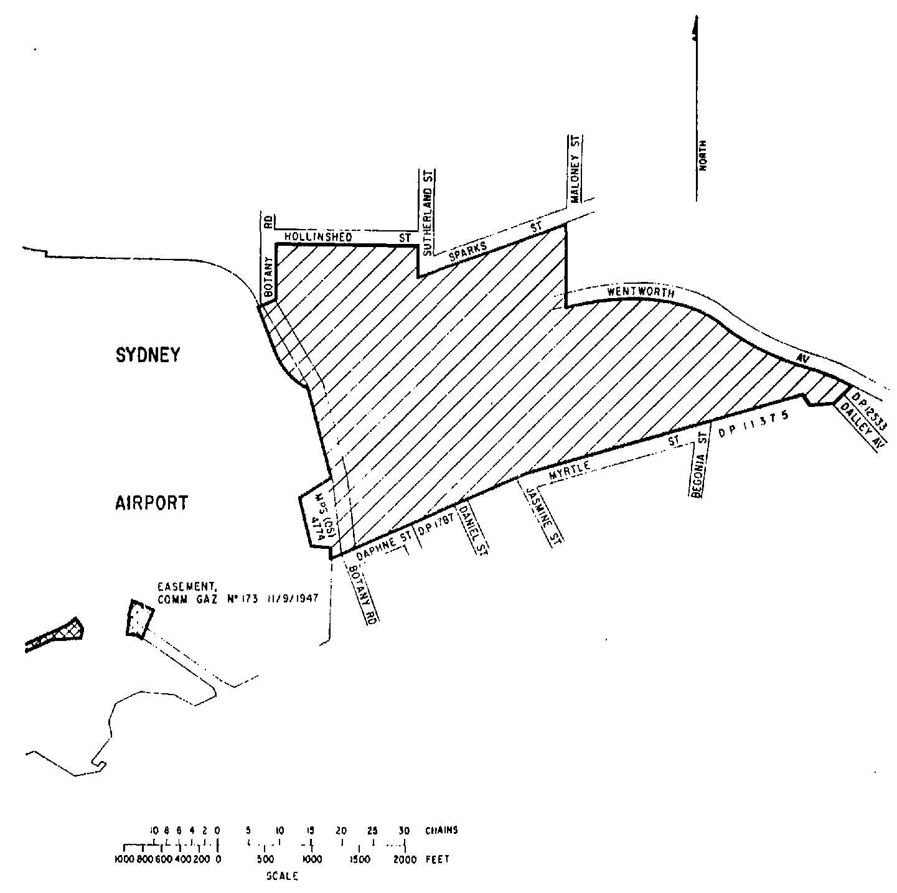
SCHEDULE 5—continued
Plan No. 3—Sydney (Kingsford Smith) Airport
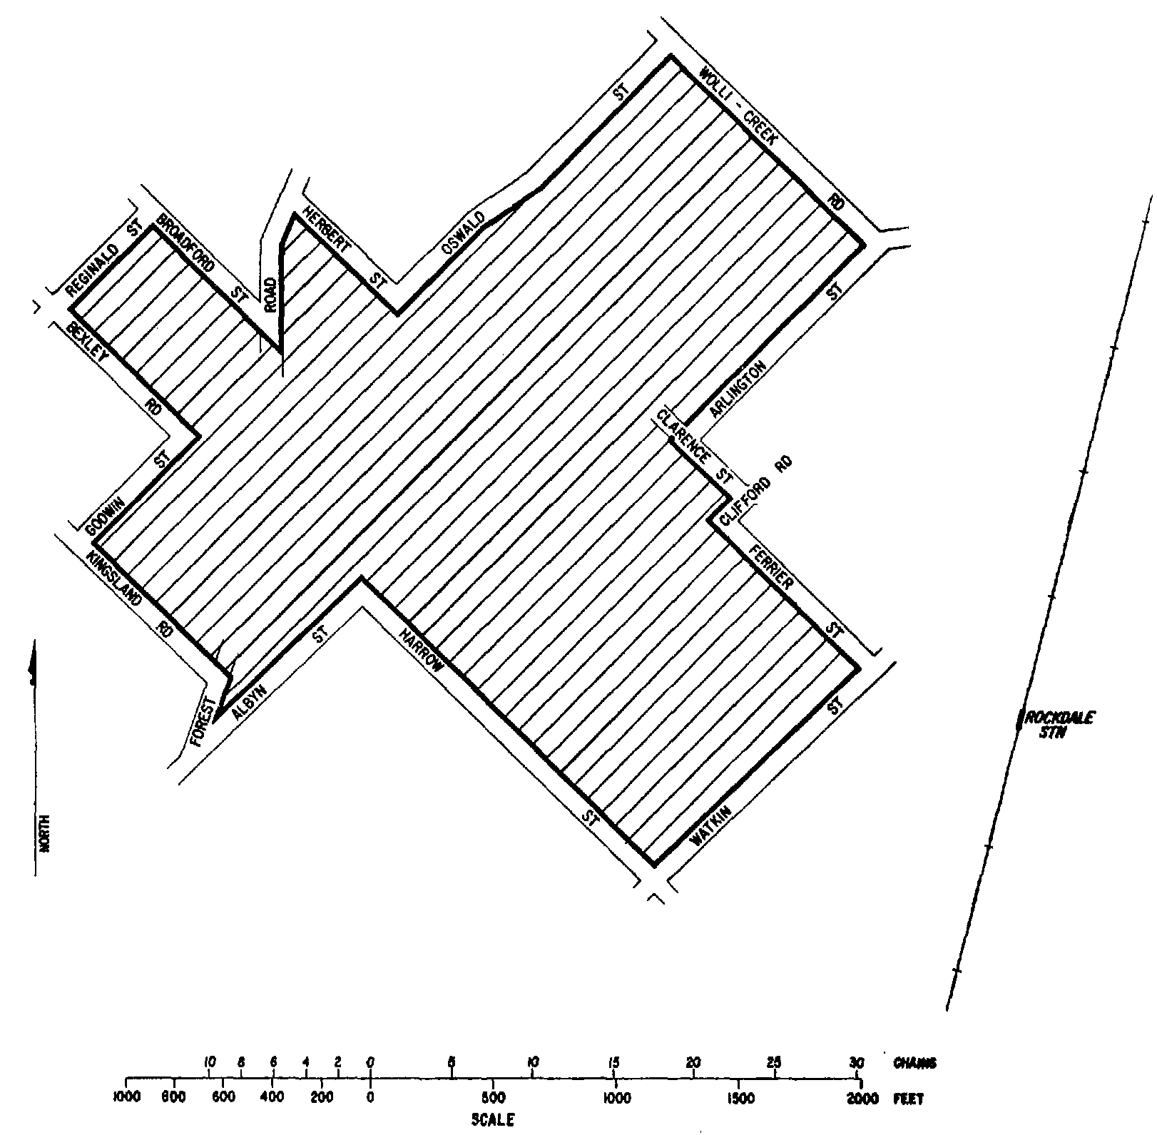
SCHEDULE 5—continued
Plan No. 4—Sydney (Kingsford Smith) Airport
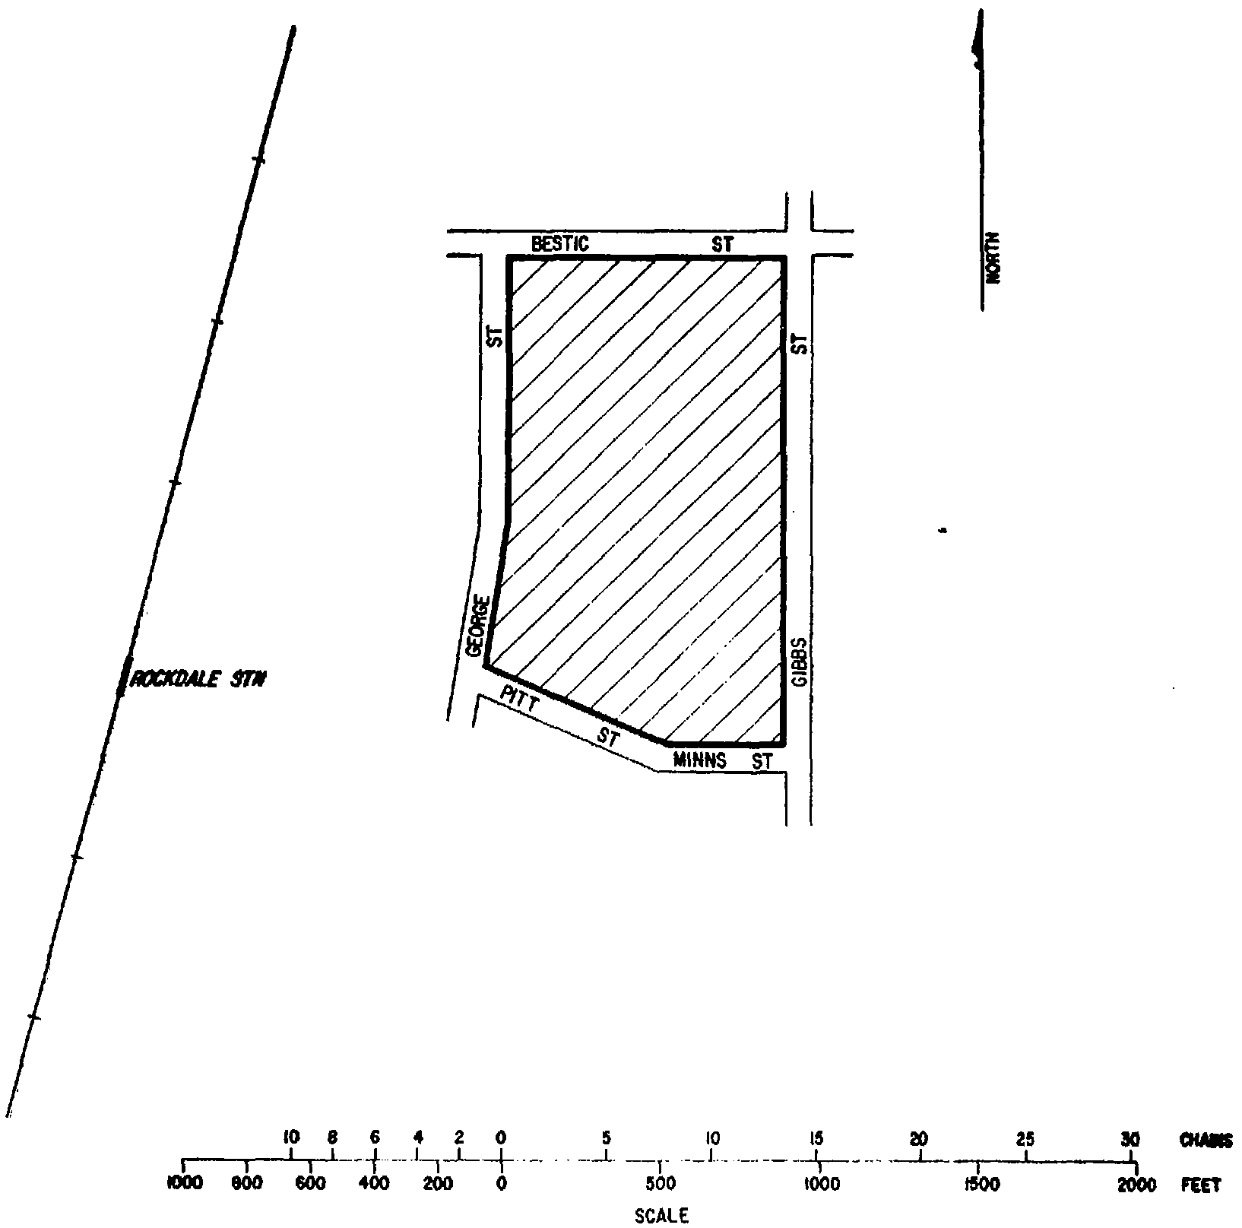
SCHEDULE 5—continued
Plan No. 5—Sydney (Kingsford Smith) Airport
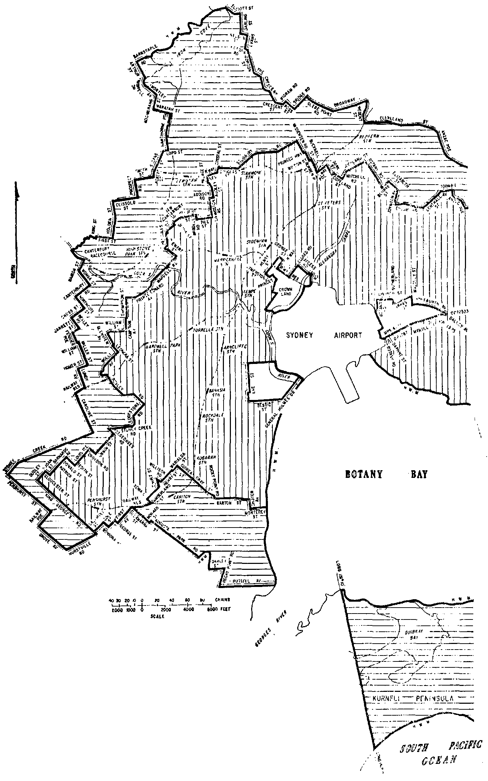
SCHEDULE 5—continued
Plan No. 6—Sydney (Kingsford Smith) Airport
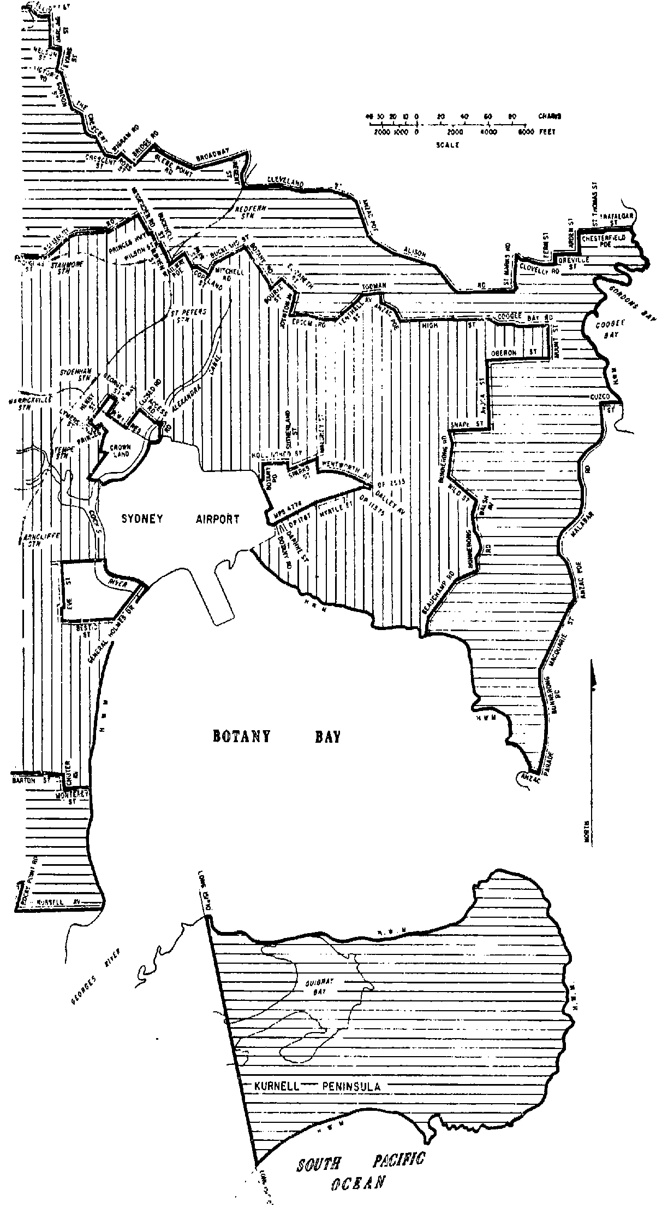
SCHEDULE 5—continued
Plan No. 7—Bankstown Airport
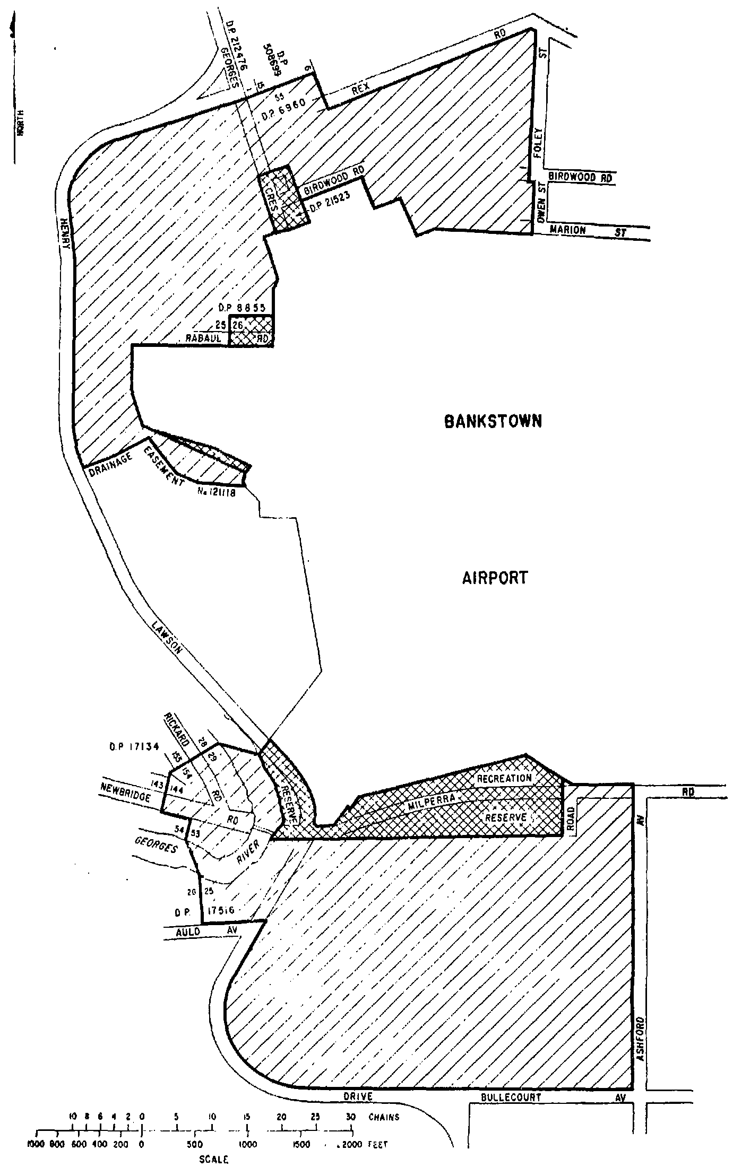
SCHEDULE 5—continued
Plan No. 8—Bankstown Airport
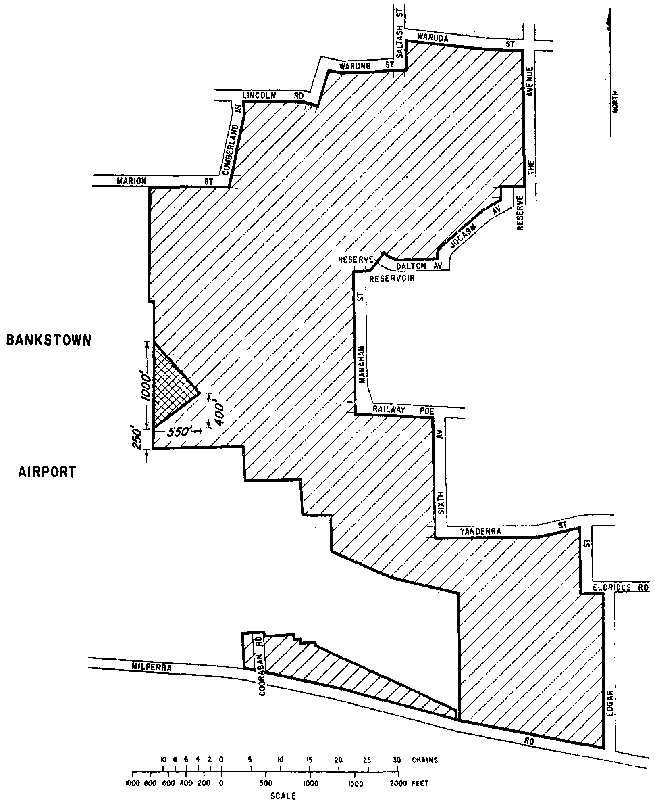
SCHEDULE 5—continued
Plan No. 9—Bankstown Airport
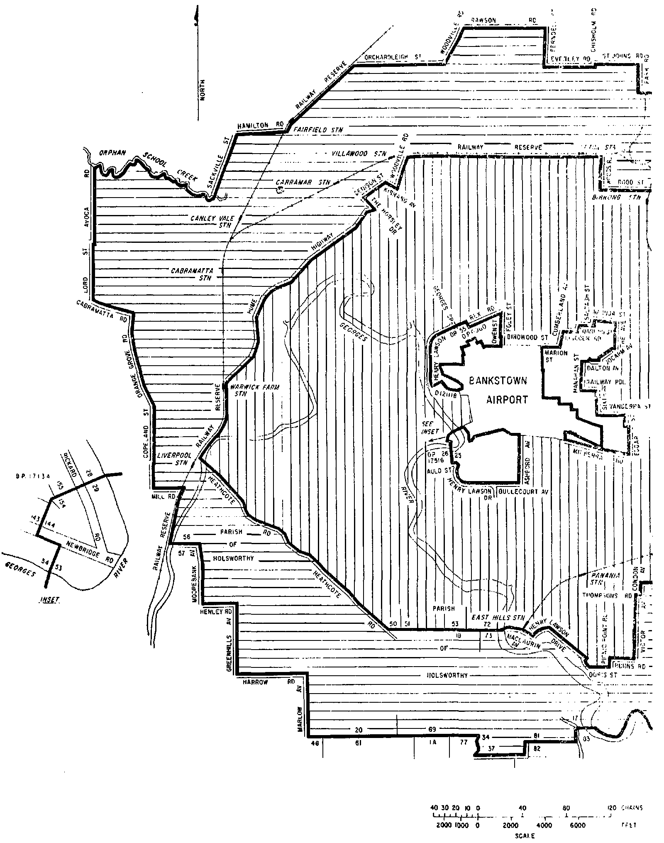
SCHEDULE 5—continued
Plan No. 10—Bankstown Airport
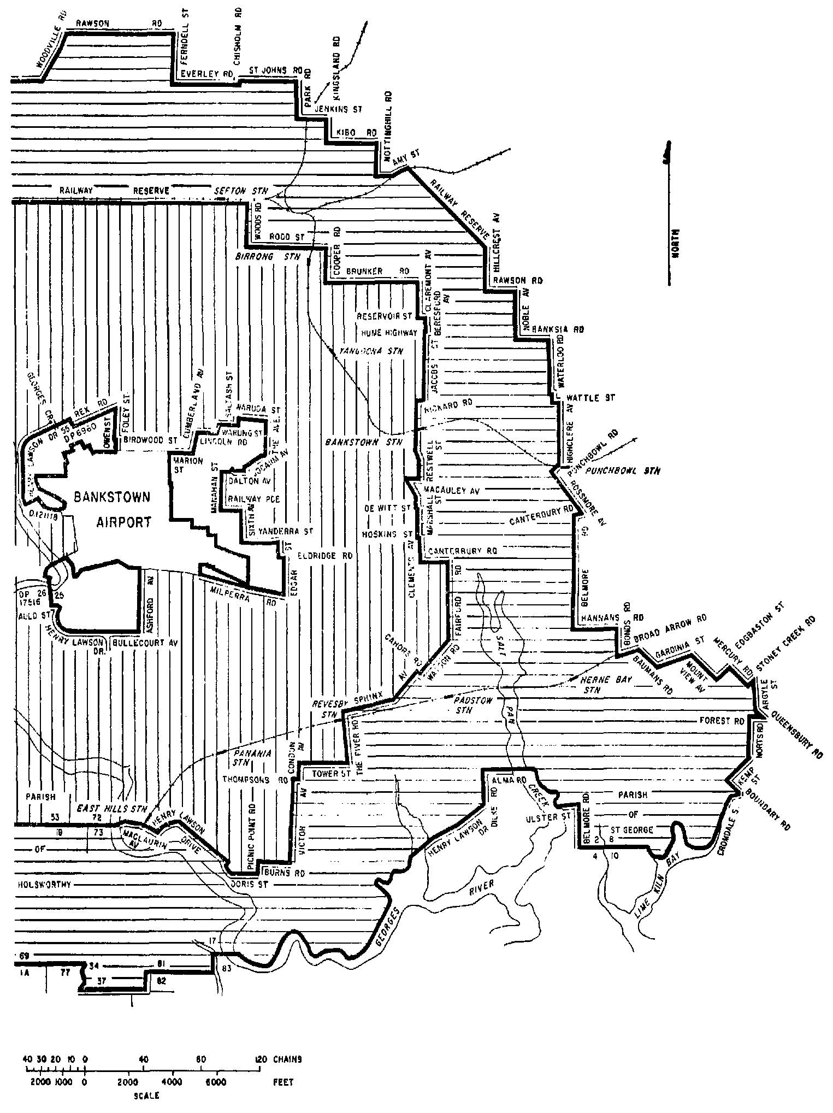
SCHEDULE 5—continued
Plan No. 11—Moorabbin Airport
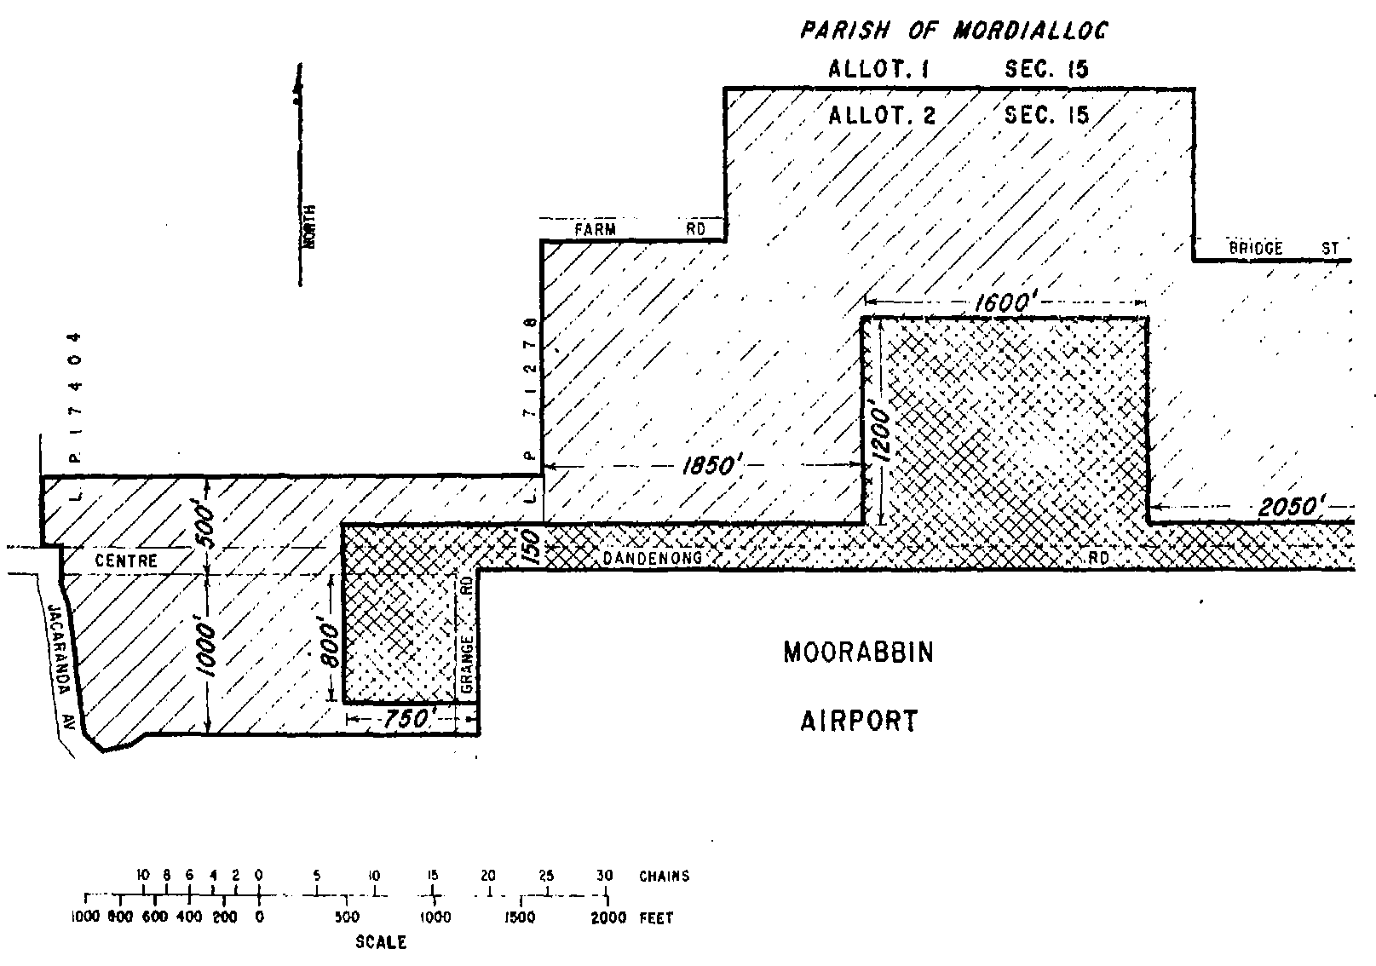
SCHEDULE 5—continued
Plan No. 12—Moorabbin Airport
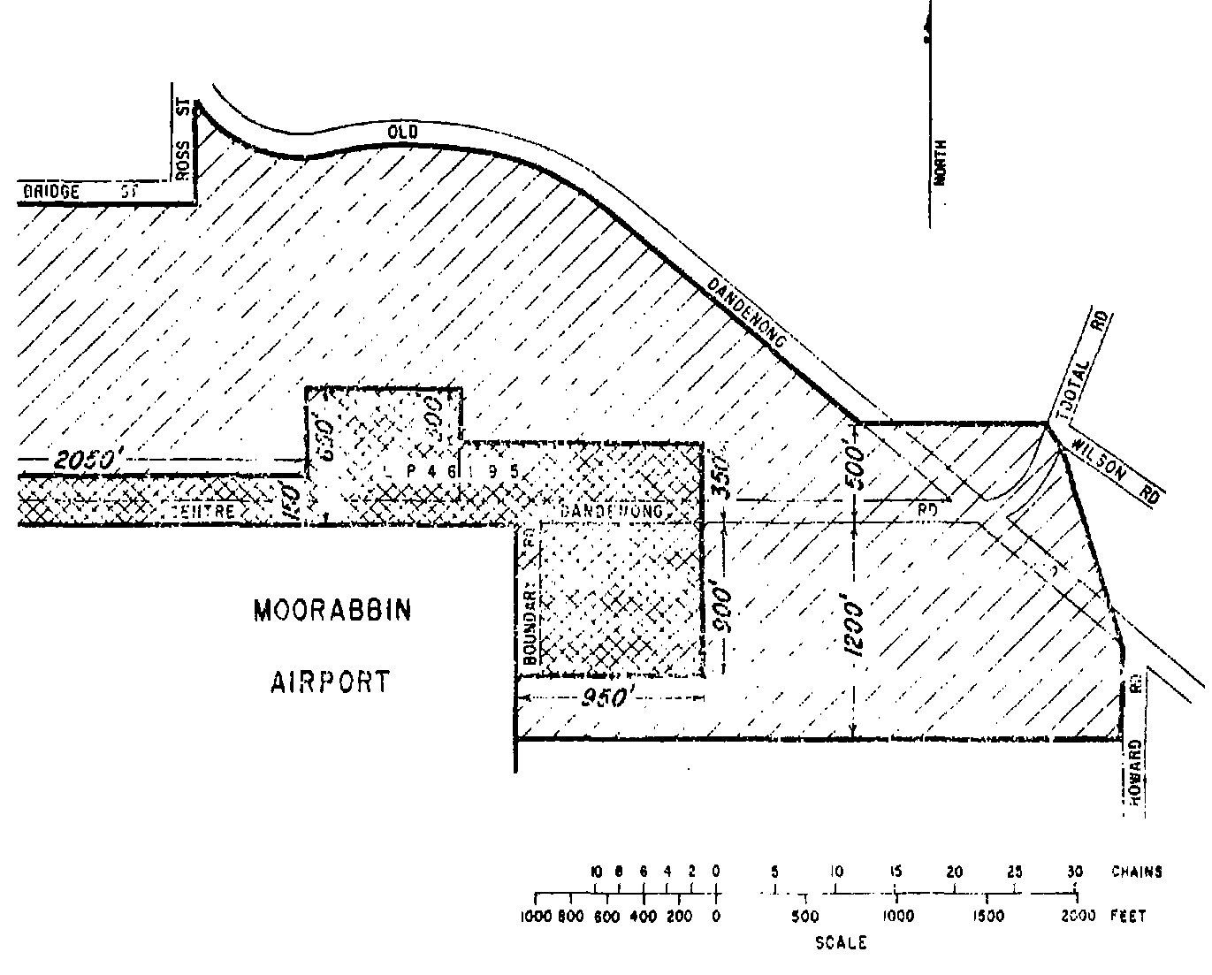
SCHEDULE 5—continued
Plan No. 13—Moorabbin Airport
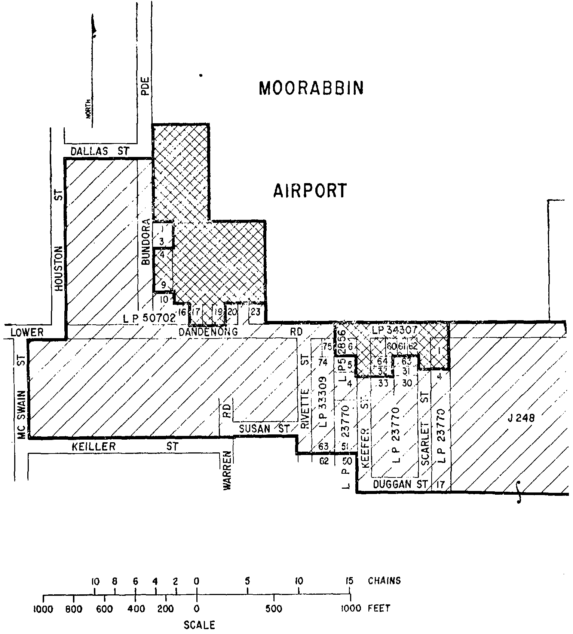
SCHEDULE 5—continued
Plan No. 14—Moorabbin Airport
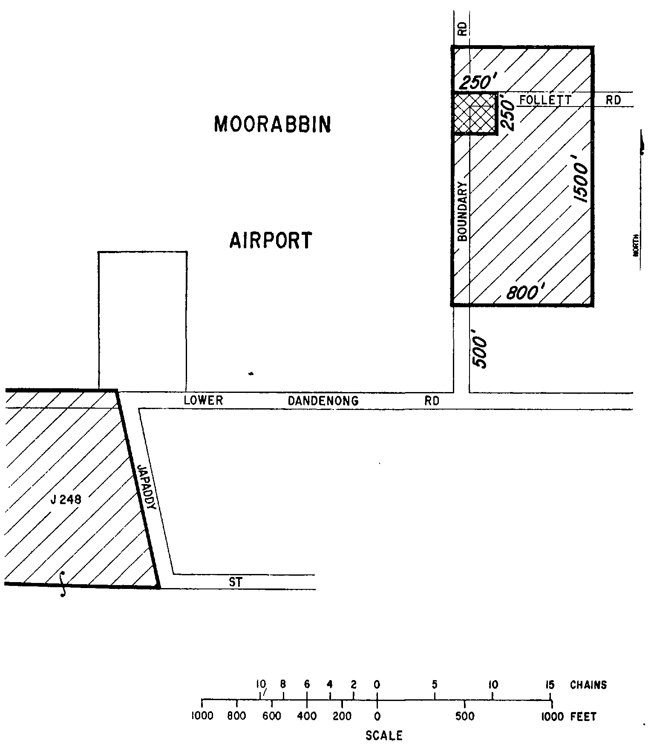
SCHEDULE 5—continued
Plan No. 15—Moorabbin Airport
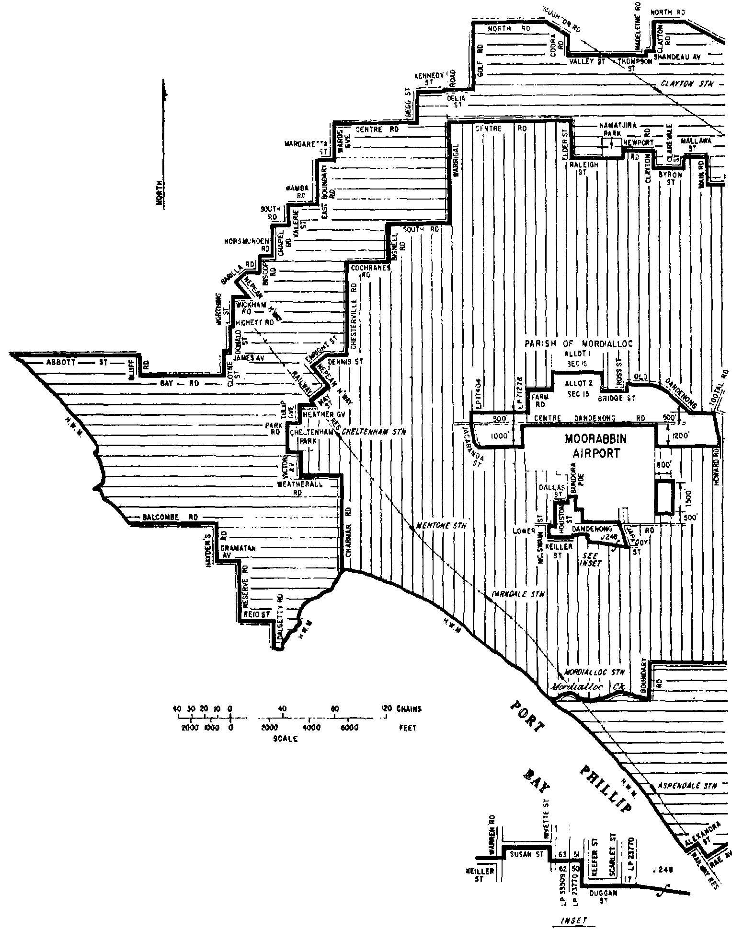
SCHEDULE 5—continued
Plan No. 16—Moorabbin Airport
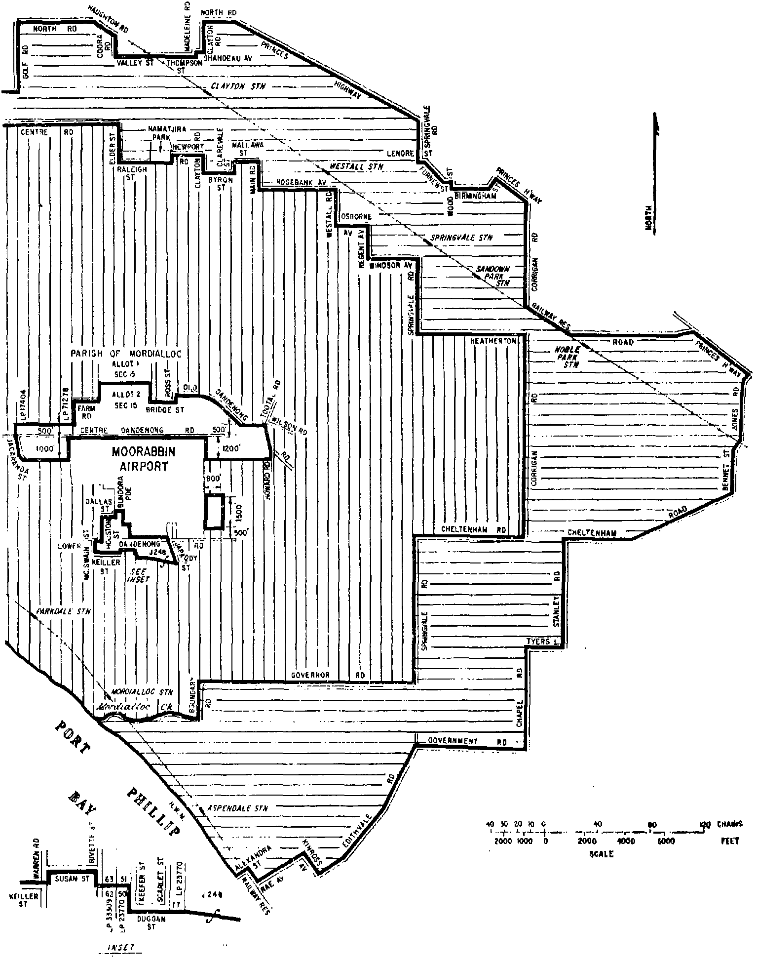
SCHEDULE 5—continued
Plan No. 17—Adelaide Airport
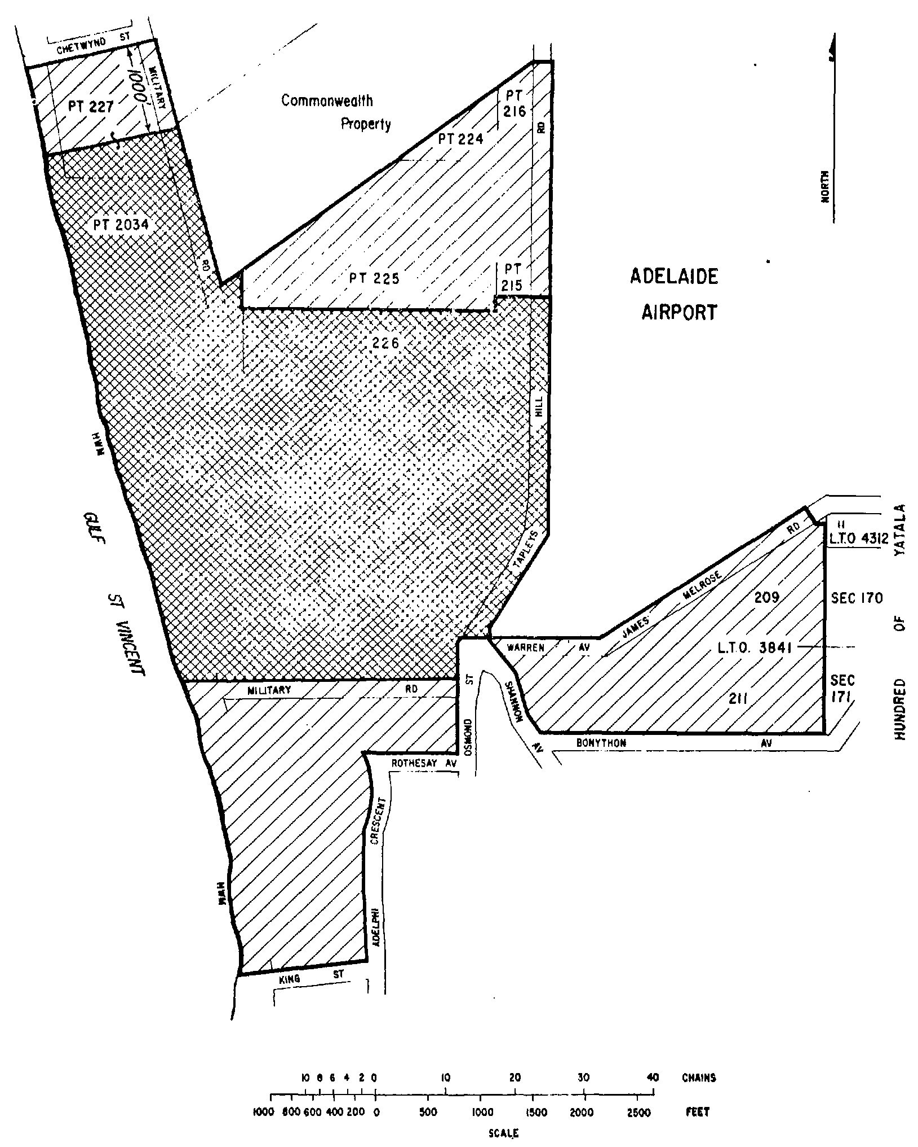
SCHEDULE 5—continued
Plan No. 18—Adelaide Airport
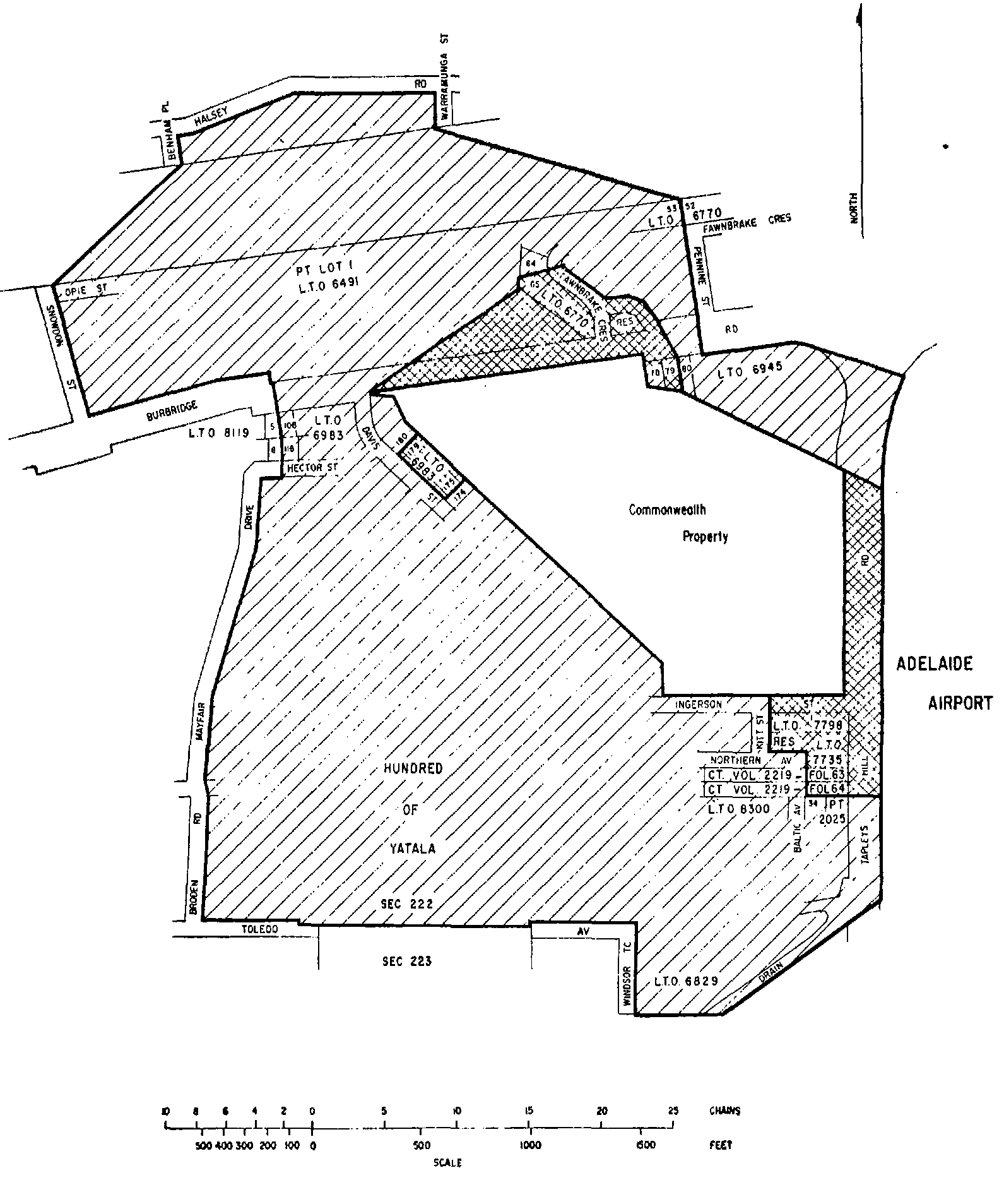
SCHEDULE 5—continued
Plan No. 19—Adelaide Airport
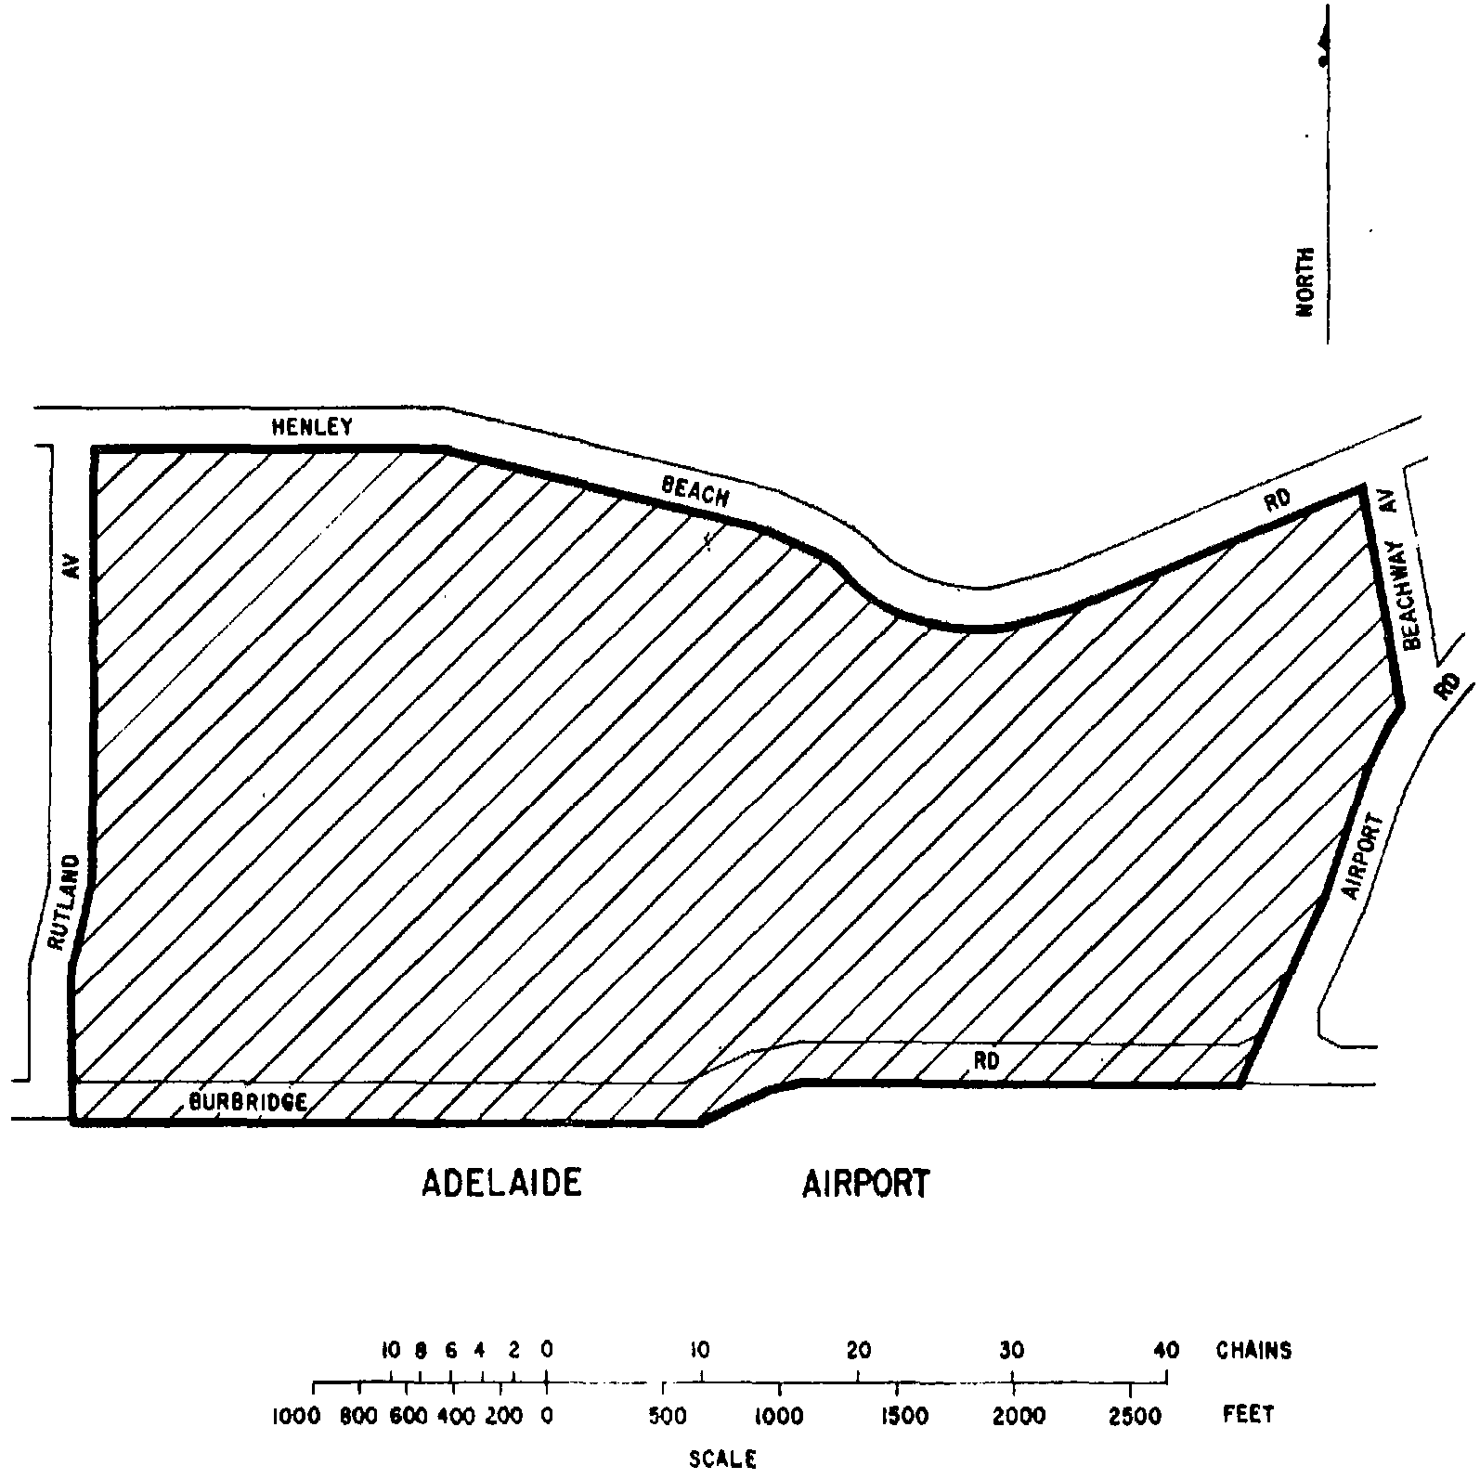
SCHEDULE 5—continued
Plan No. 20—Adelaide Airport
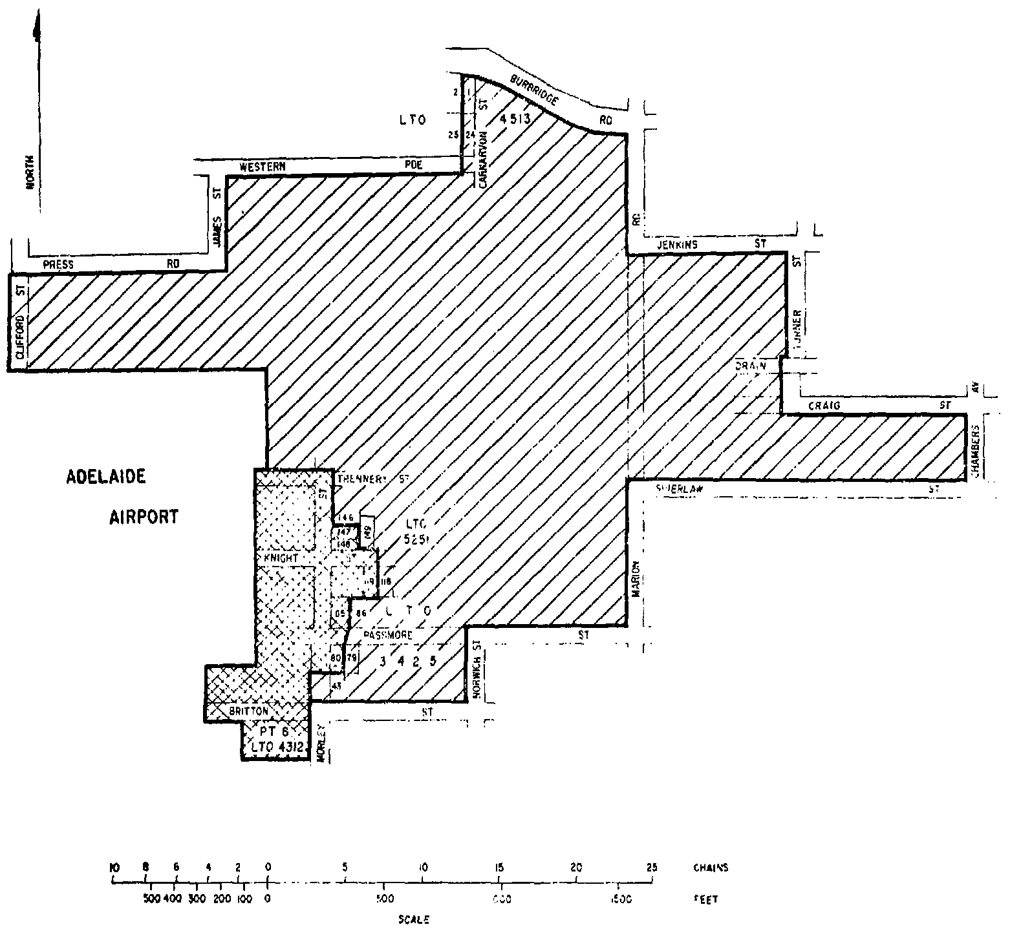
SCHEDULE 5—continued
Plan No. 21—Adelaide Airport
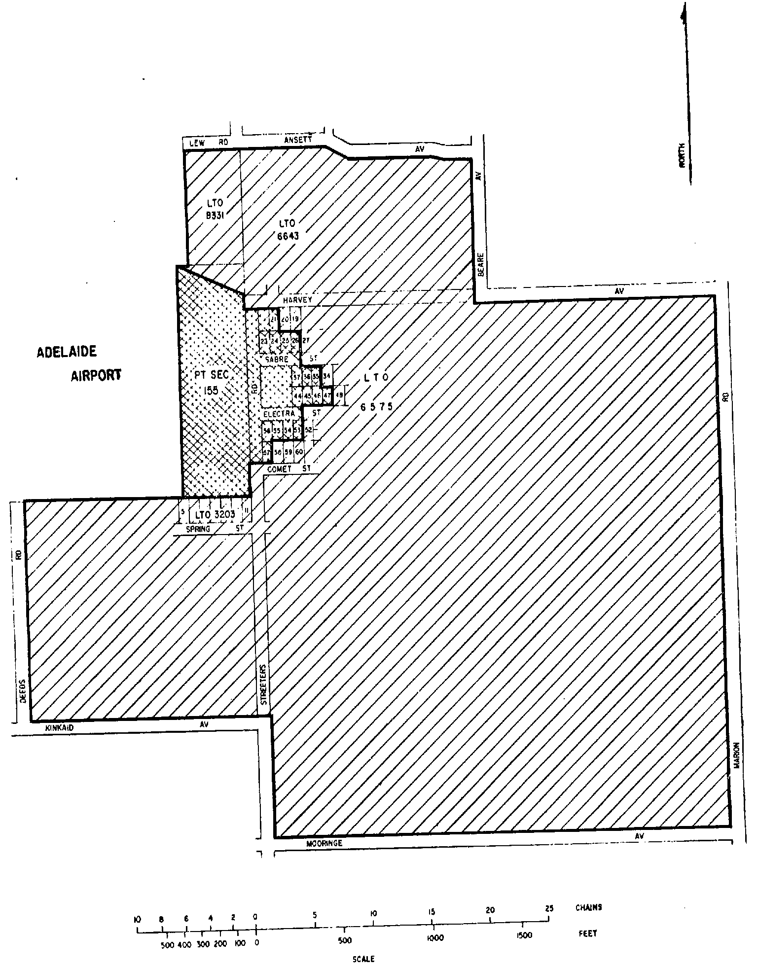
SCHEDULE 5—continued
Plan No. 22—Adelaide Airport
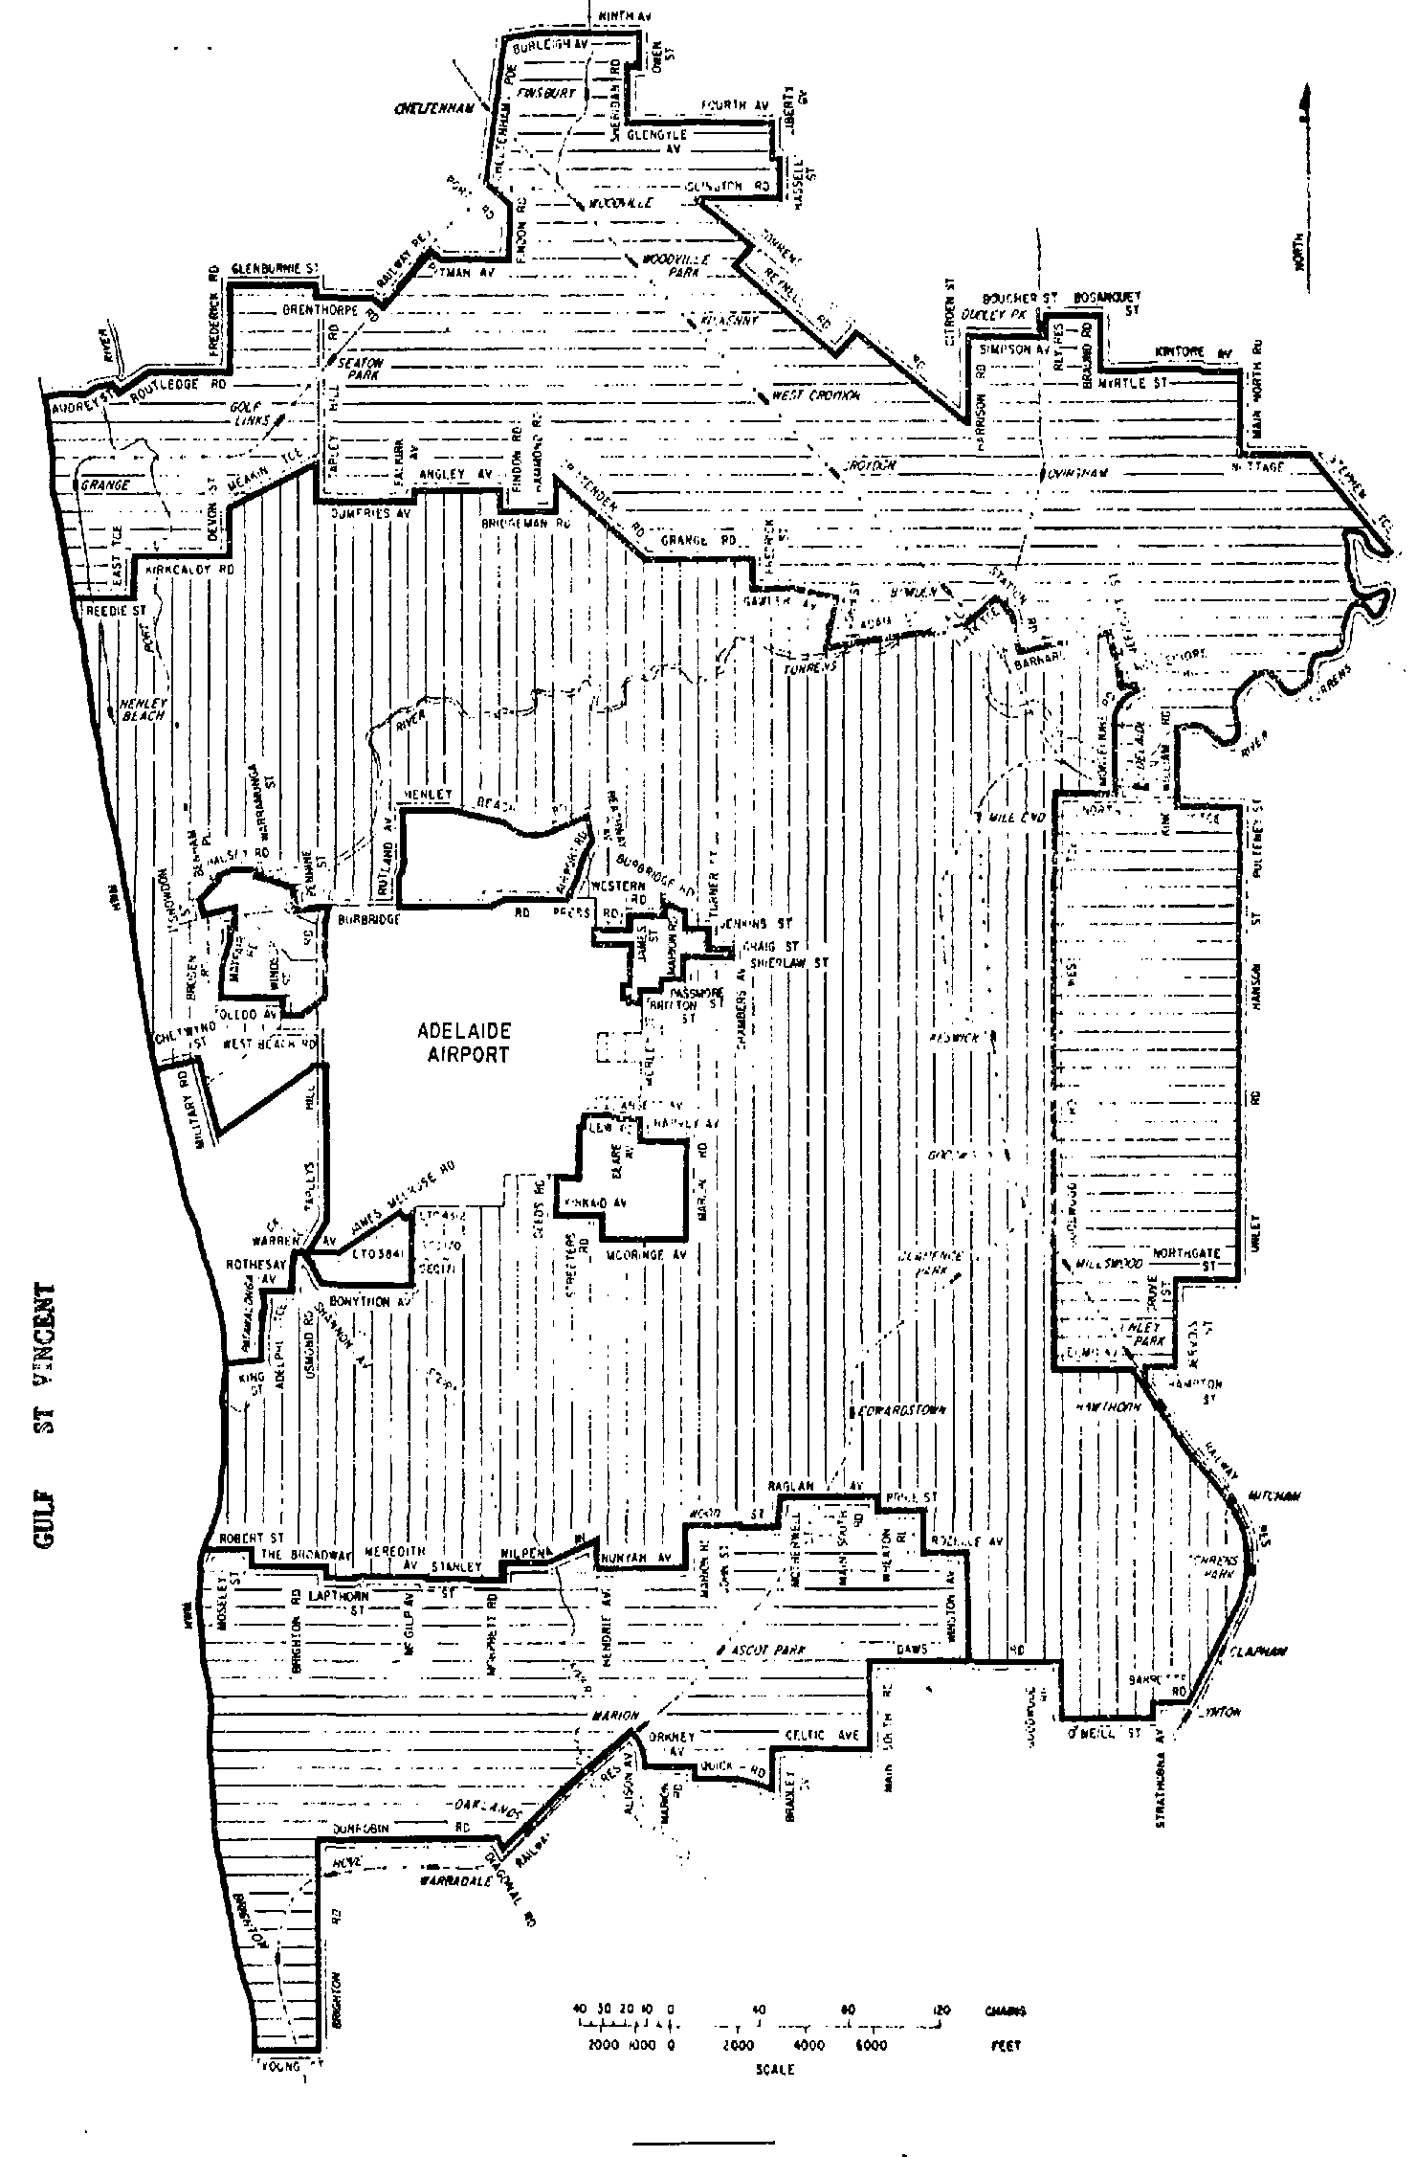
SCHEDULE 6
Plan No. 1—Melbourne Airport
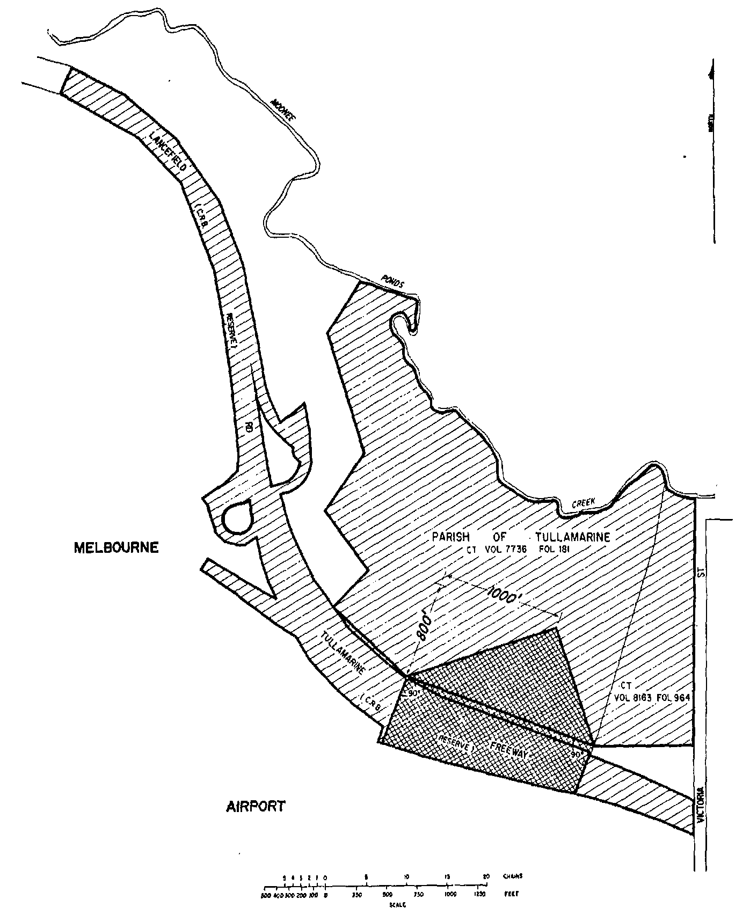
SCHEDULE 6—continued
Plan No. 2—Melbourne Airport
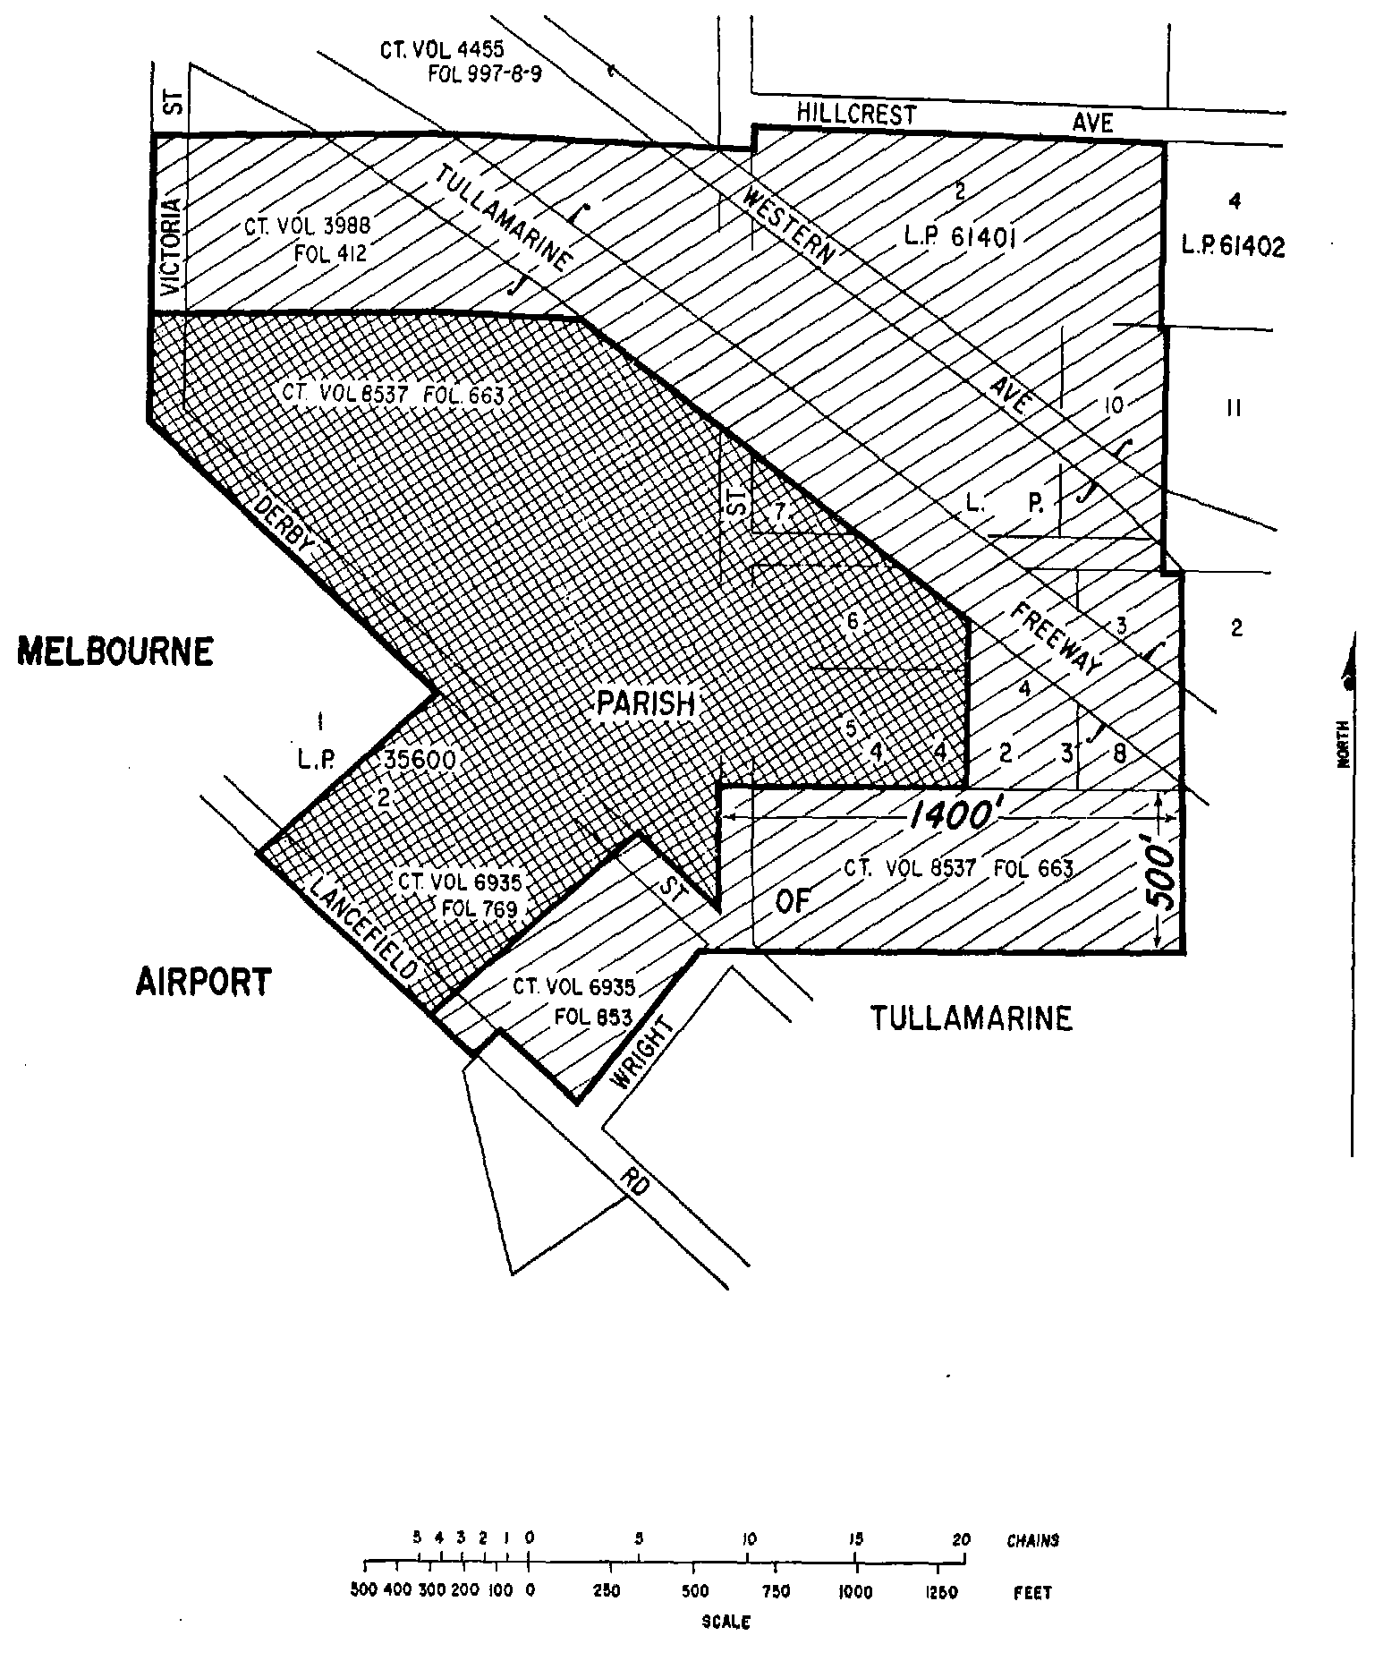
SCHEDULE 6—continued
Plan No. 3—Essendon Airport
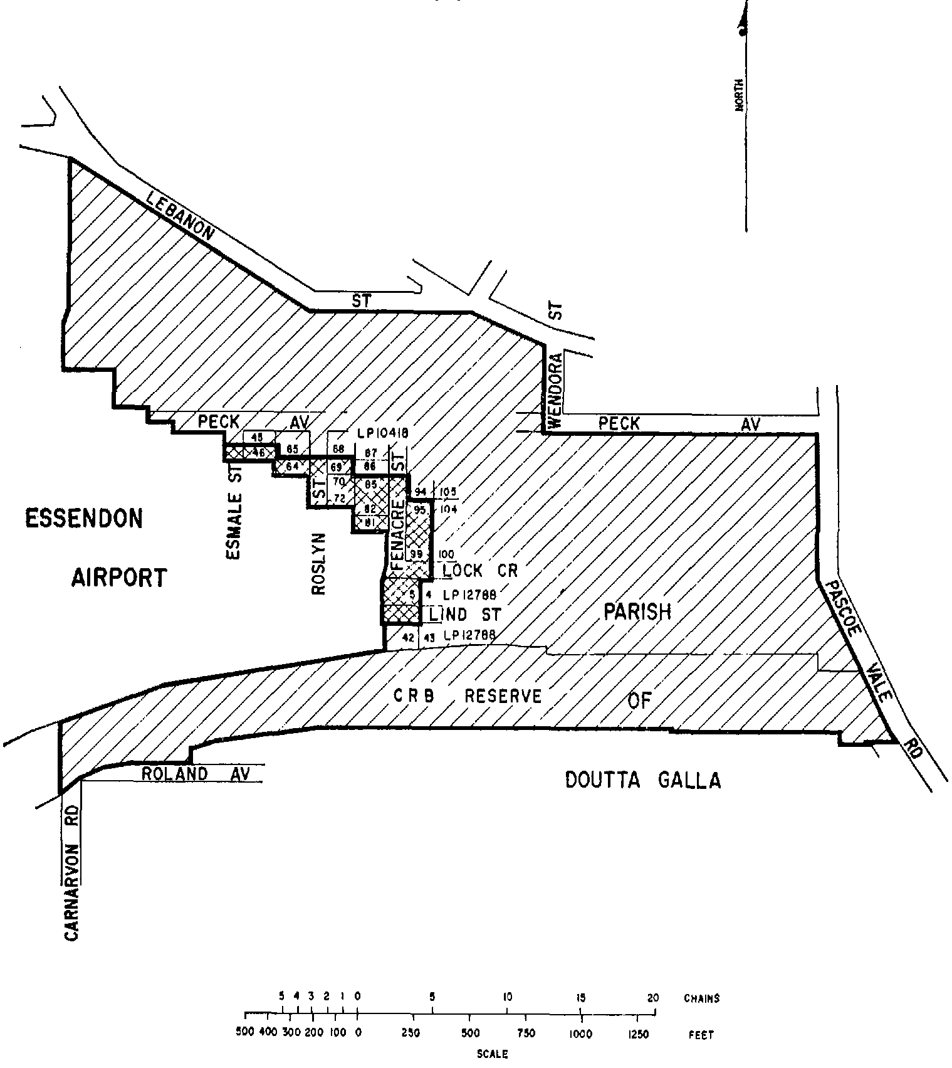
SCHEDULE 6—continued
Plan No. 4—Essendon Airport
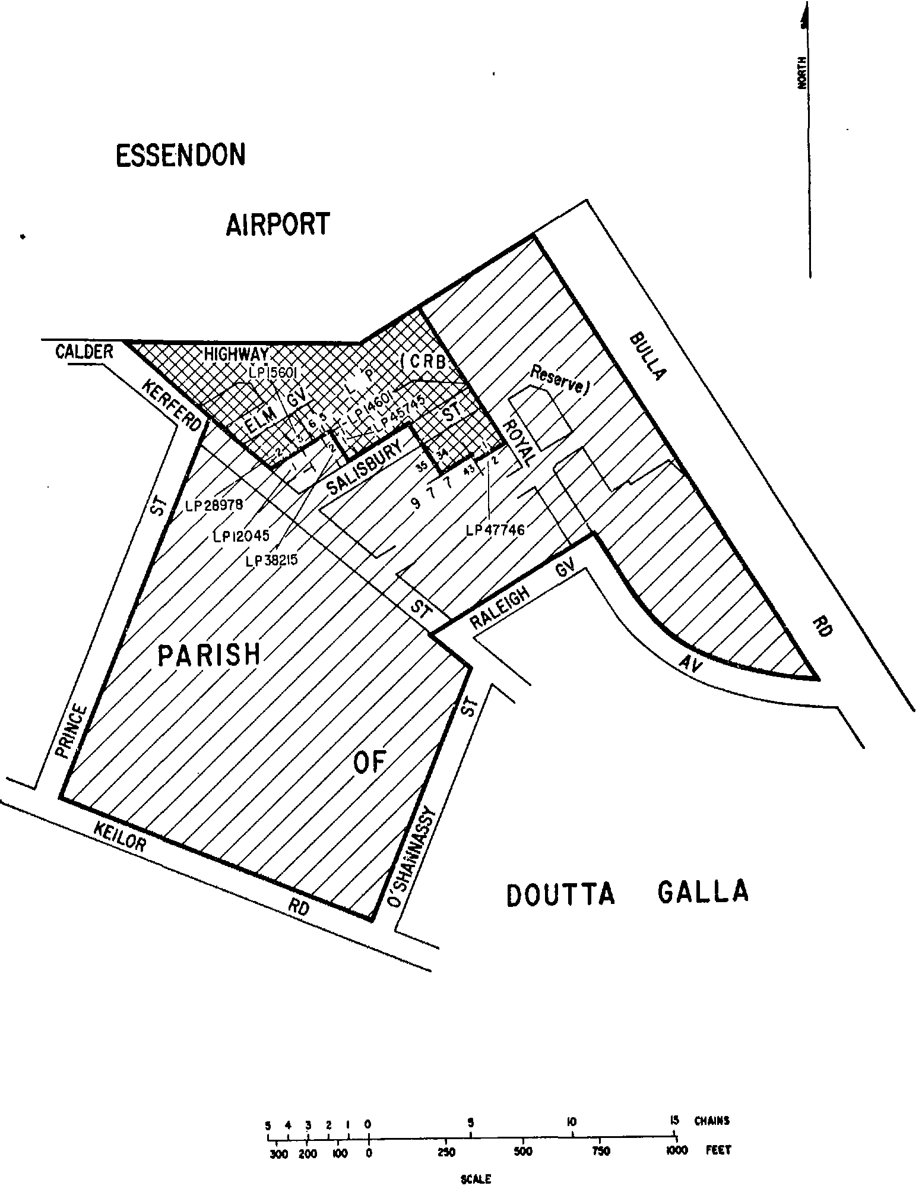
SCHEDULE 6—continued
Plan No. 5—Essendon Airport
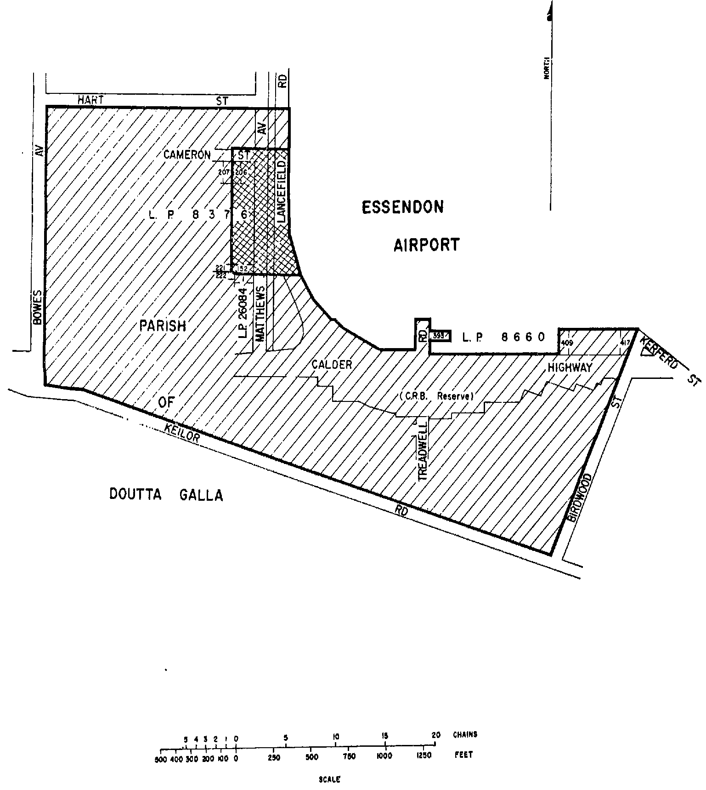
SCHEDULE 6—continued
Plan No. 6—Essendon Airport
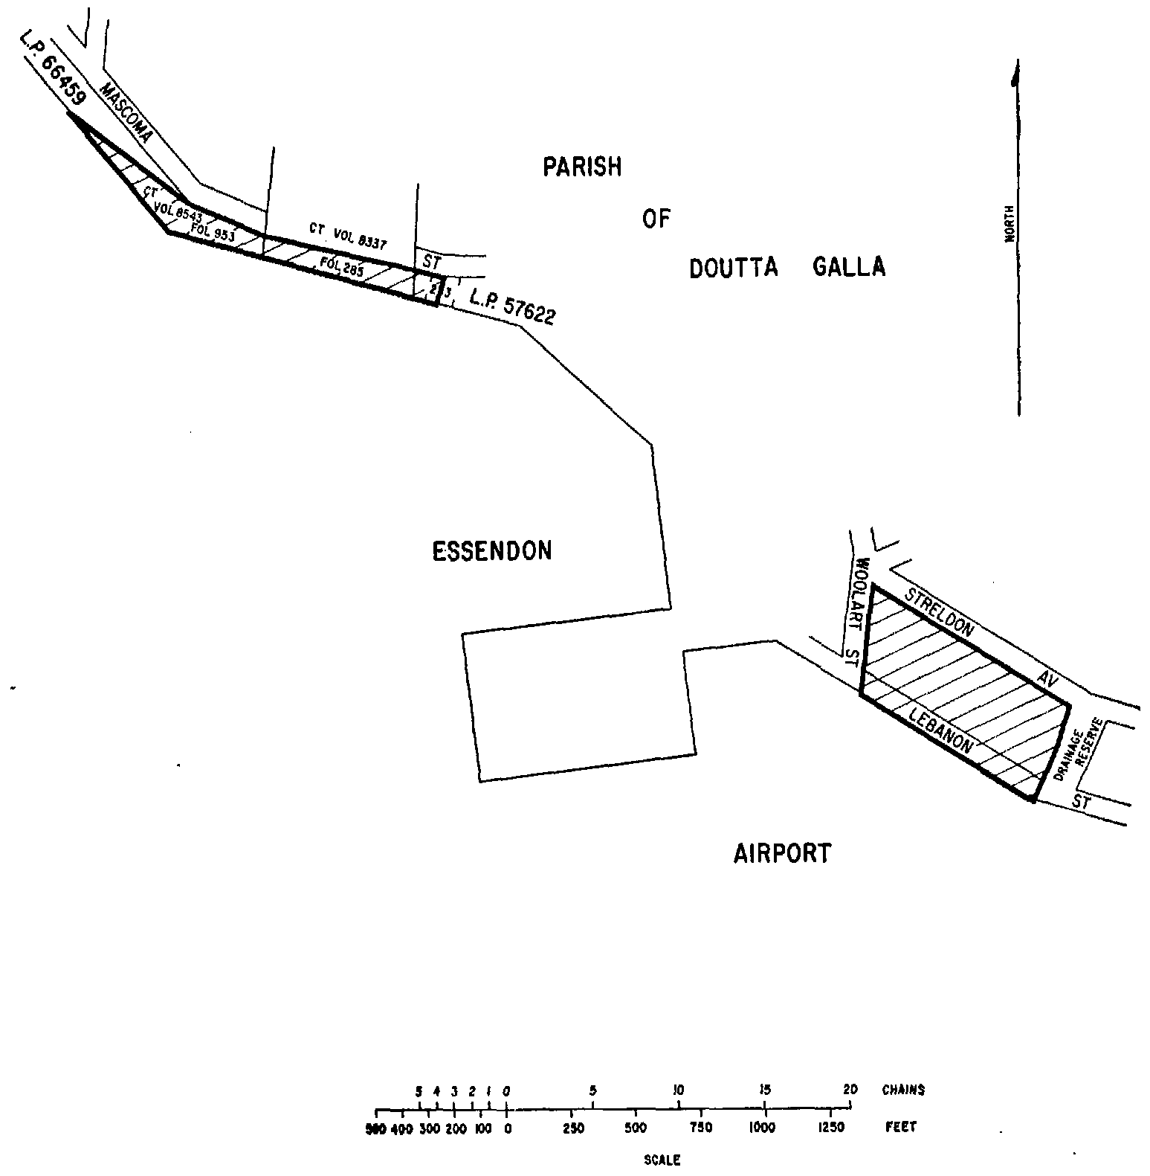
SCHEDULE 6—continued
Plan No. 7—Melbourne Airport
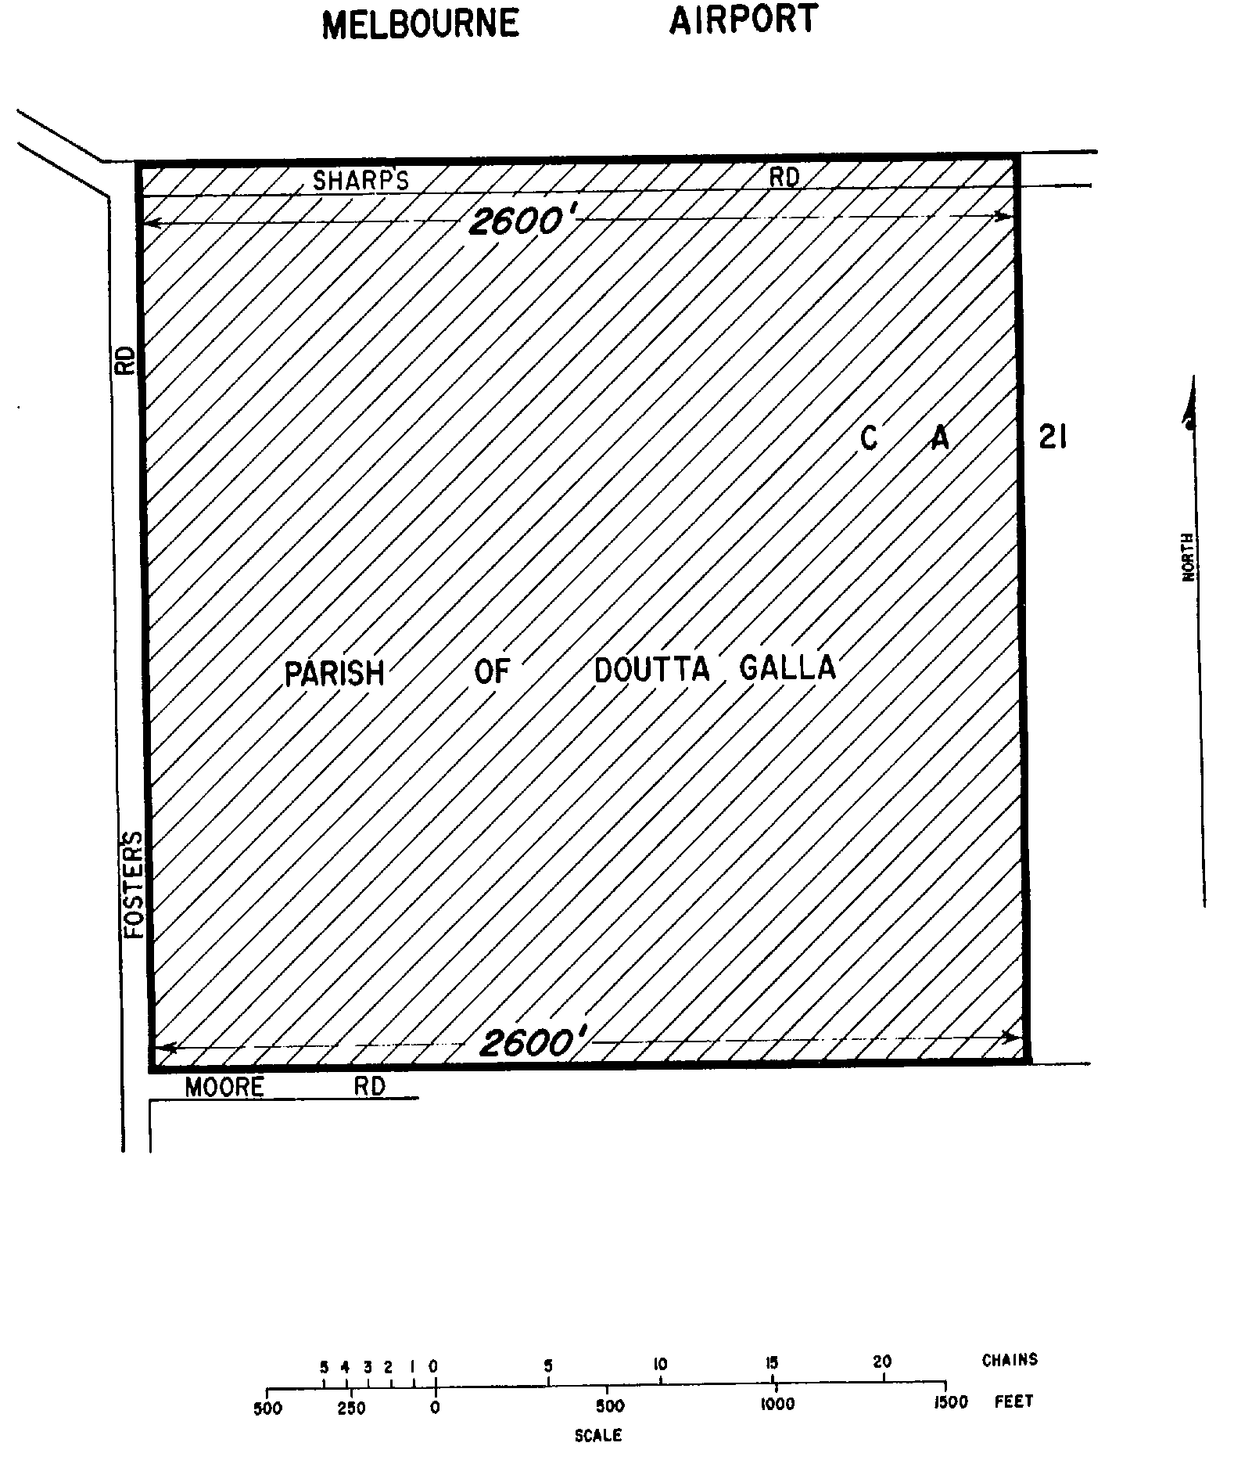
SCHEDULE 6—continued
Plan No. 8—Melbourne Airport
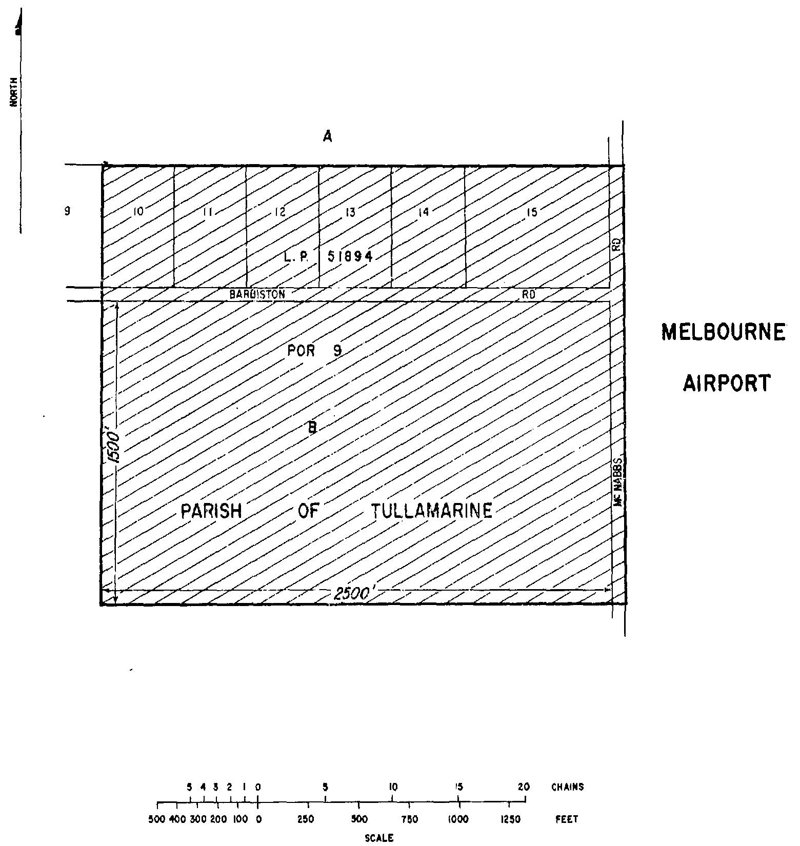
SCHEDULE 6—continued
Plan No. 9—Melbourne Airport
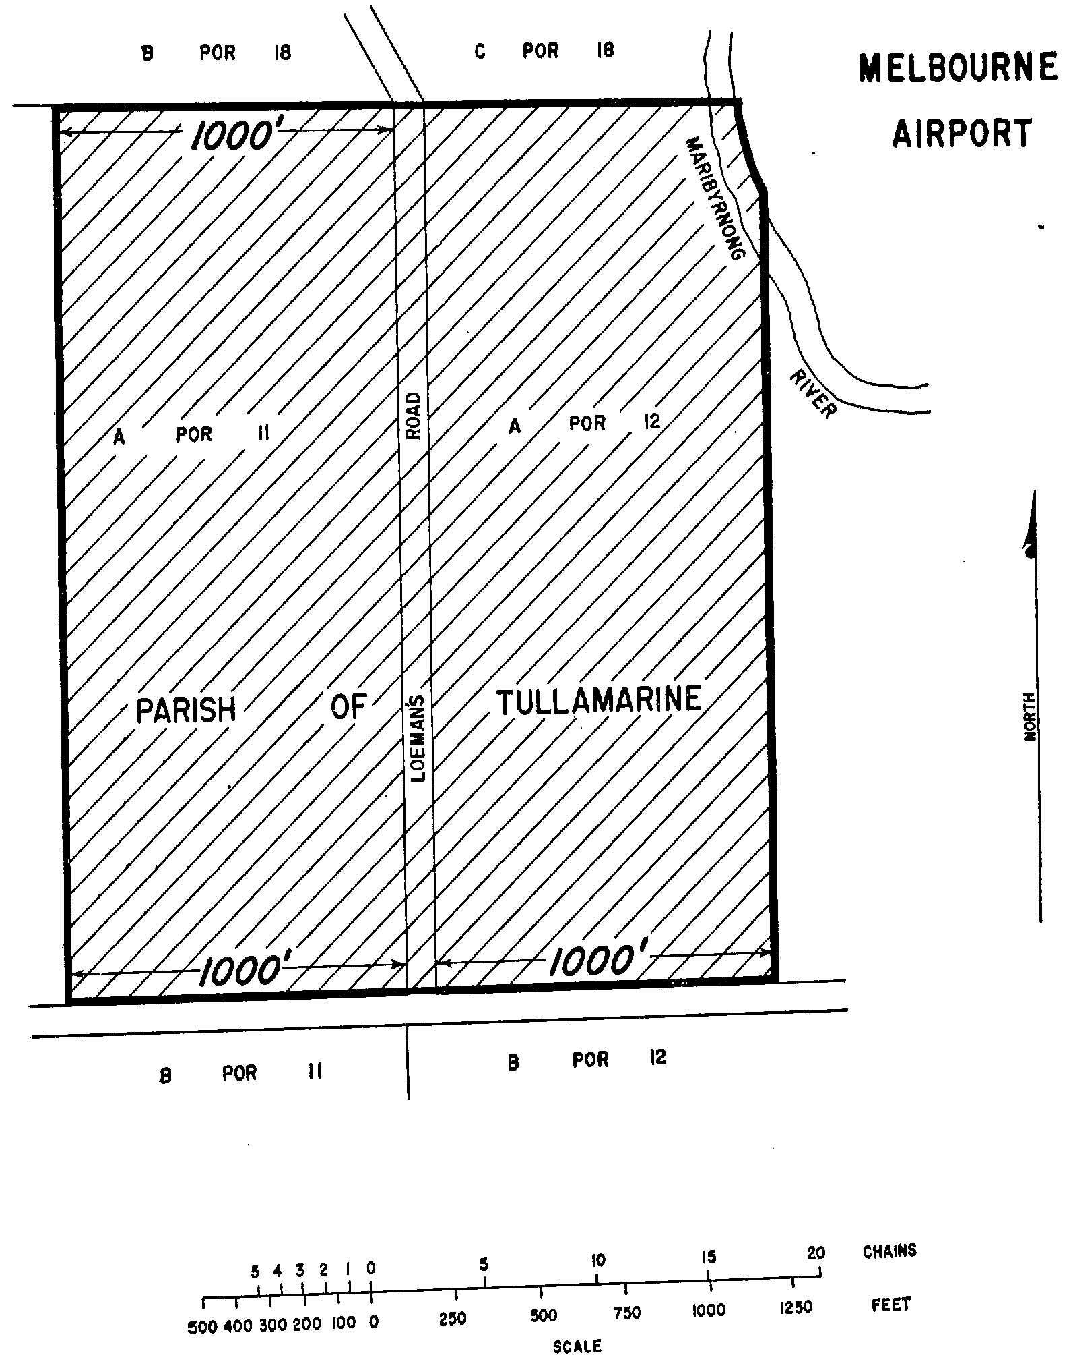
SCHEDULE 6—continued
Plan No. 10—Melbourne Airport
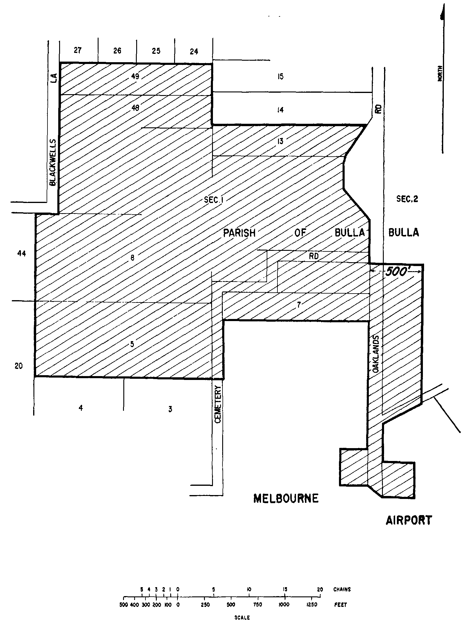
SCHEDULE 6—continued
Plan No. 11—Melbourne Airport
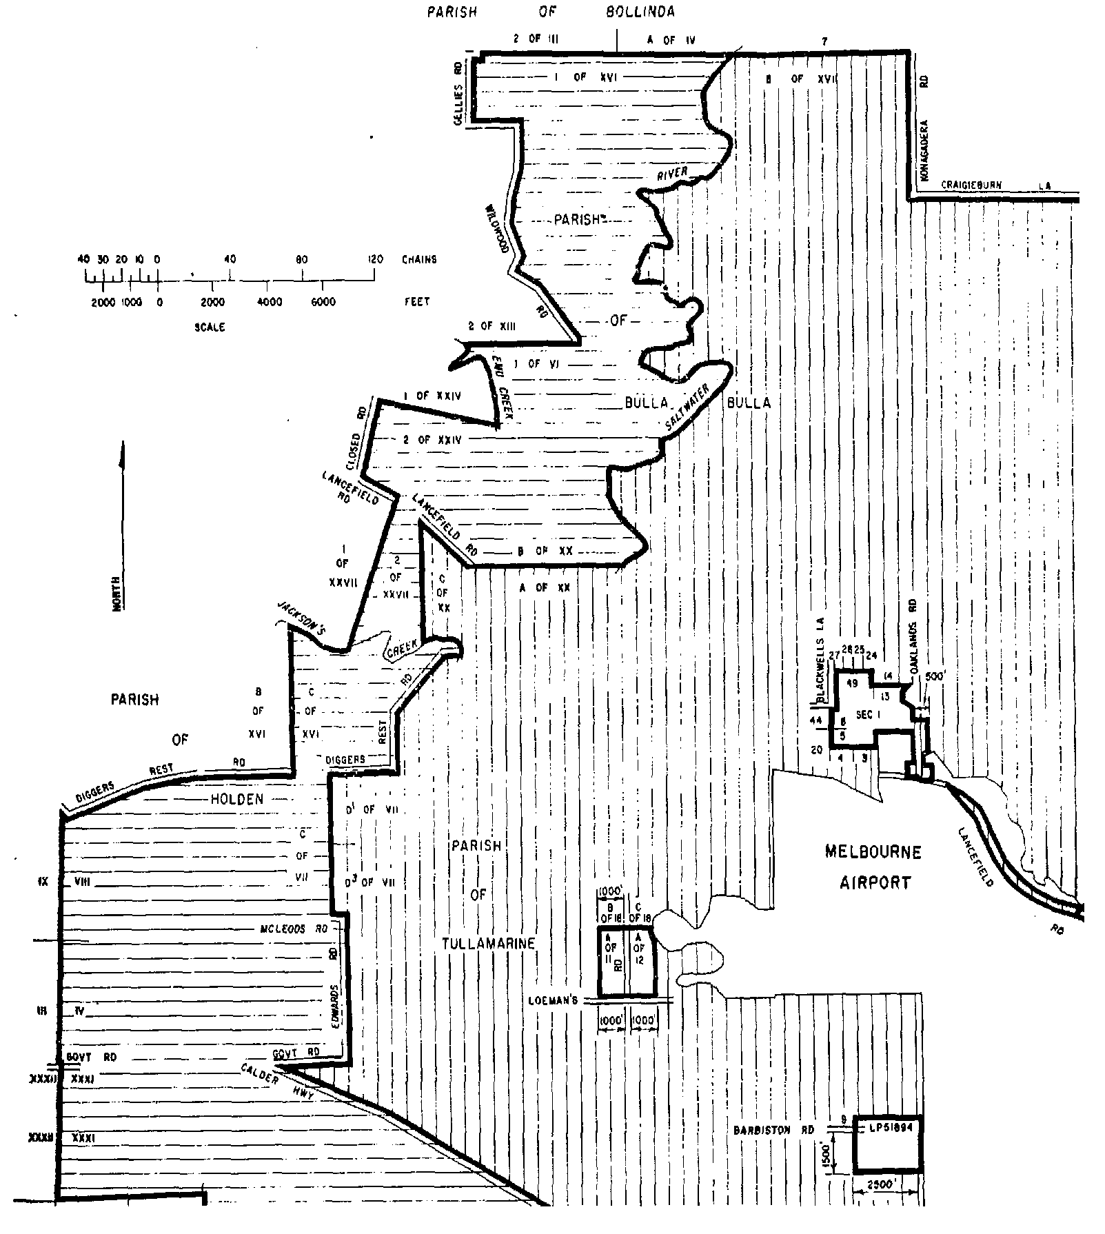
SCHEDULE 6—continued
Plan No. 12—Melbourne Airport
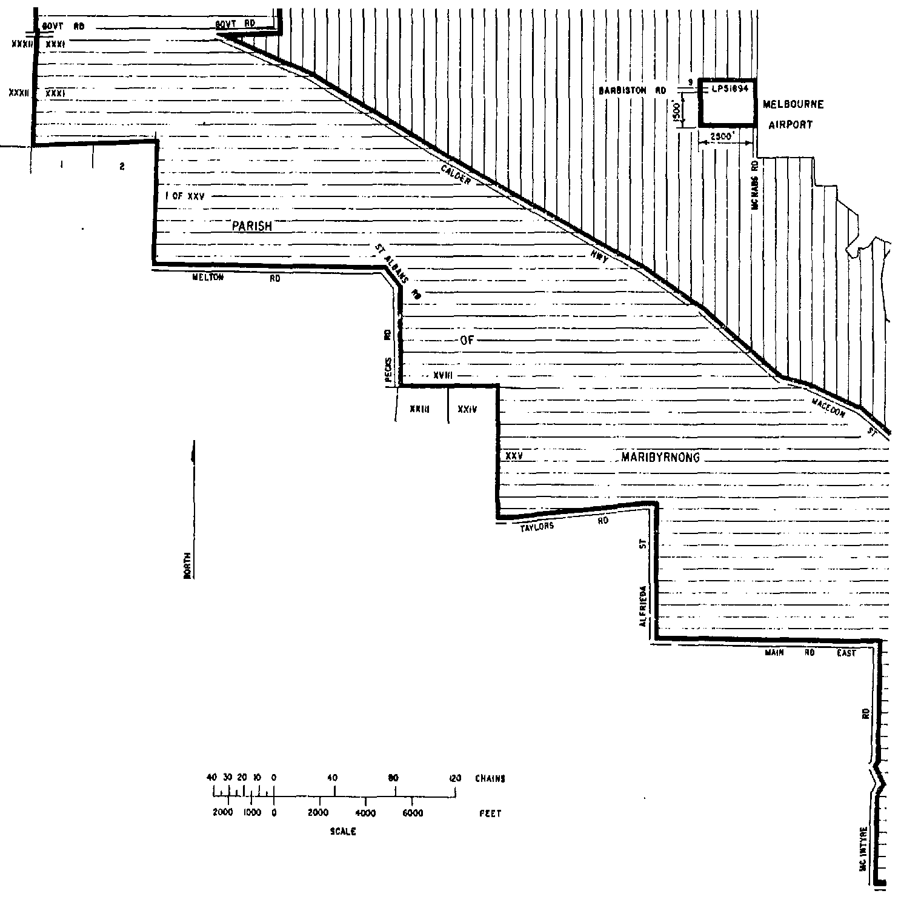
SCHEDULE 6—continued
Plan No. 13—Melbourne Airport
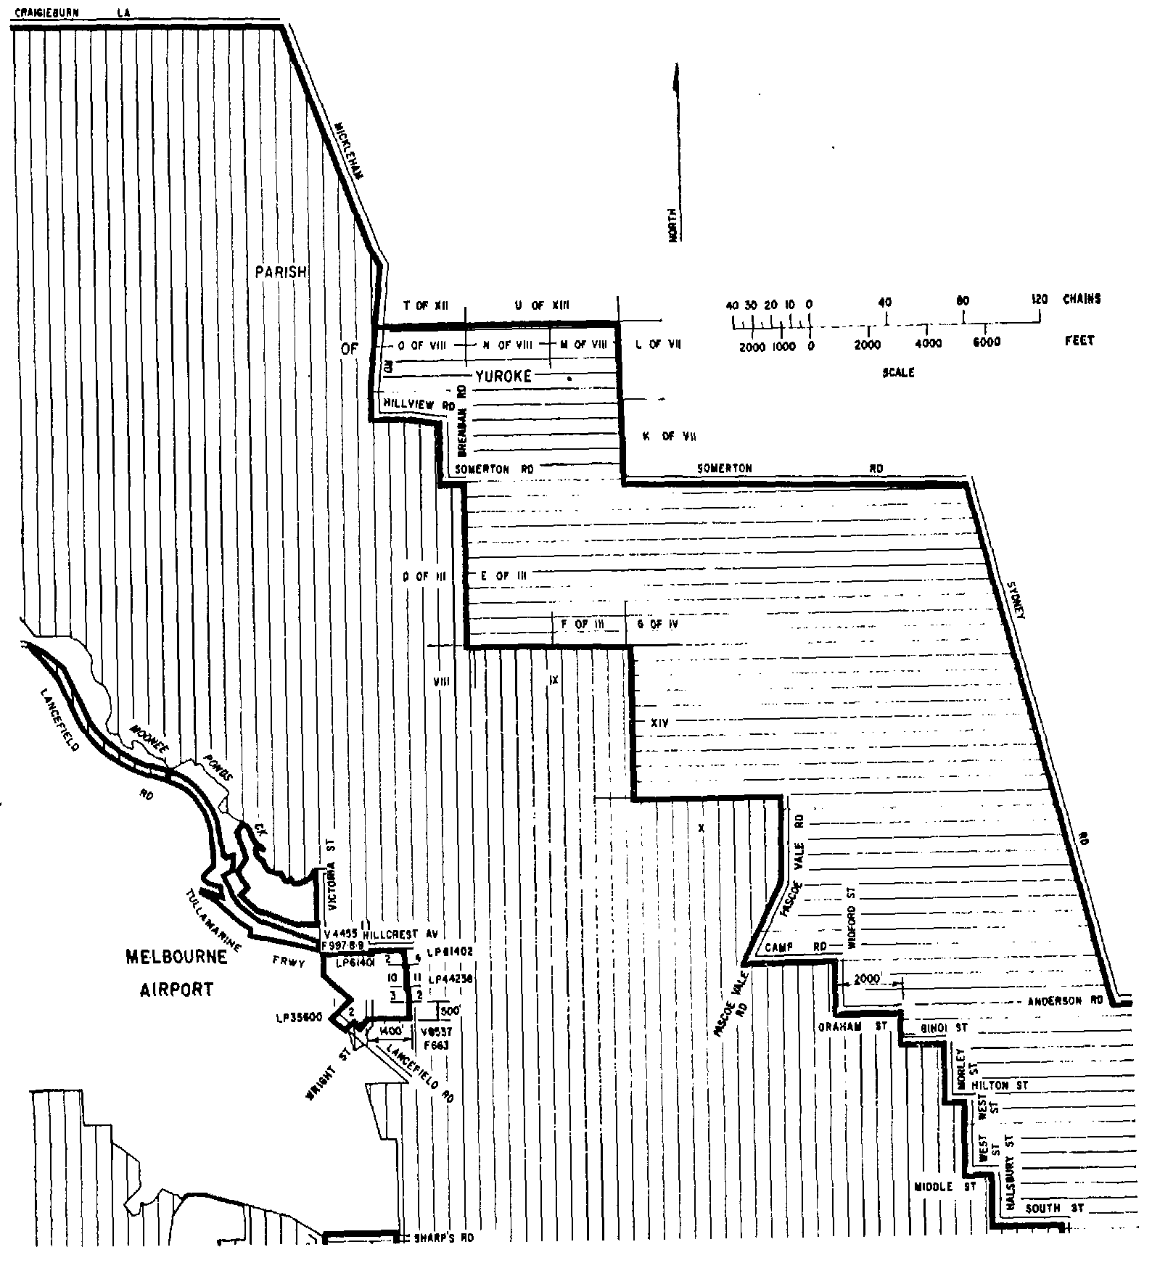
SCHEDULE 6—continued
Plan No. 14—Melbourne Airport and Essendon Airport
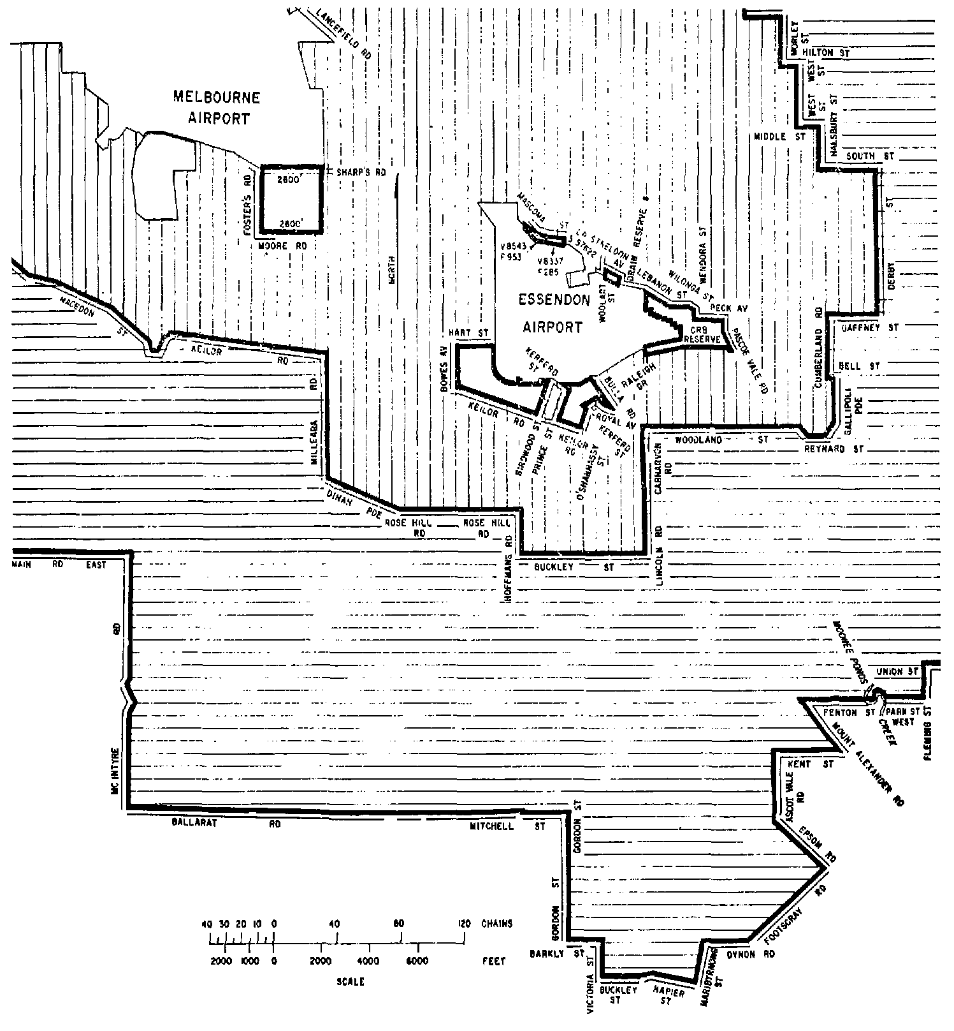
SCHEDULE 6—continued
Plan No. 15—Essendon Airport
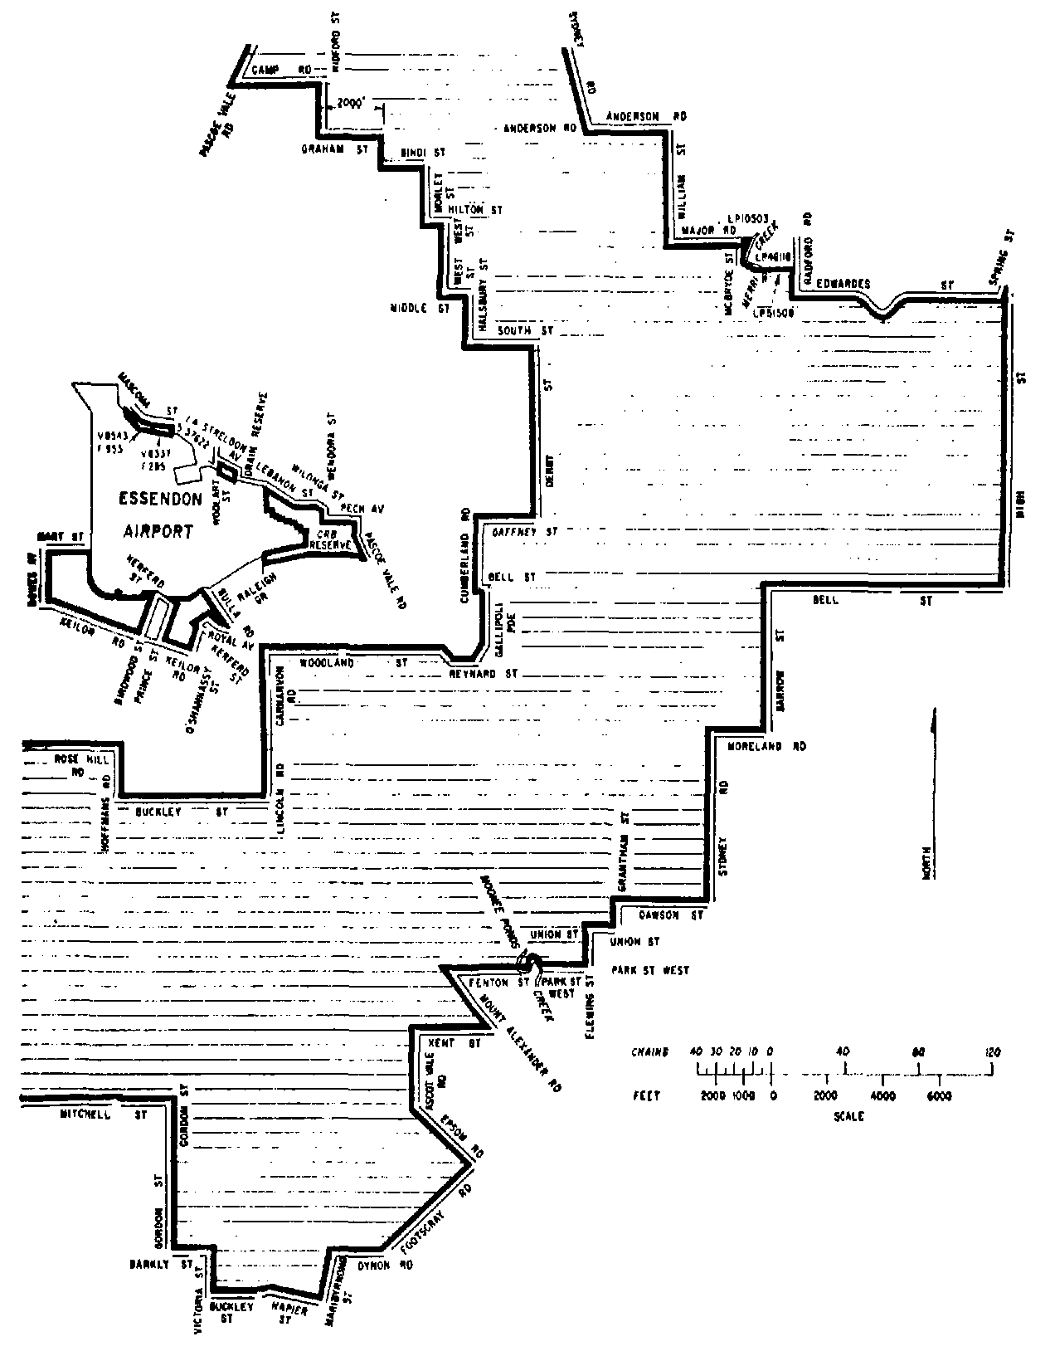
PLAN OF MELBOURNE AIRPORT AND ESSENDON AIRPORT SHOWING AREAS AFFECTED BY THE CIVIL AVIATION (BUILDINGS CONTROL) REGULATIONS
(NOTE—This Plan does not form part of the Civil Aviation (Buildings Control) Regulations and is printed for convenience of reference only.
A reference in this plan to a numbered plan is a reference to the plan so numbered in Schedule 6 to the Civil Aviation (Buildings Control) Regulations.)
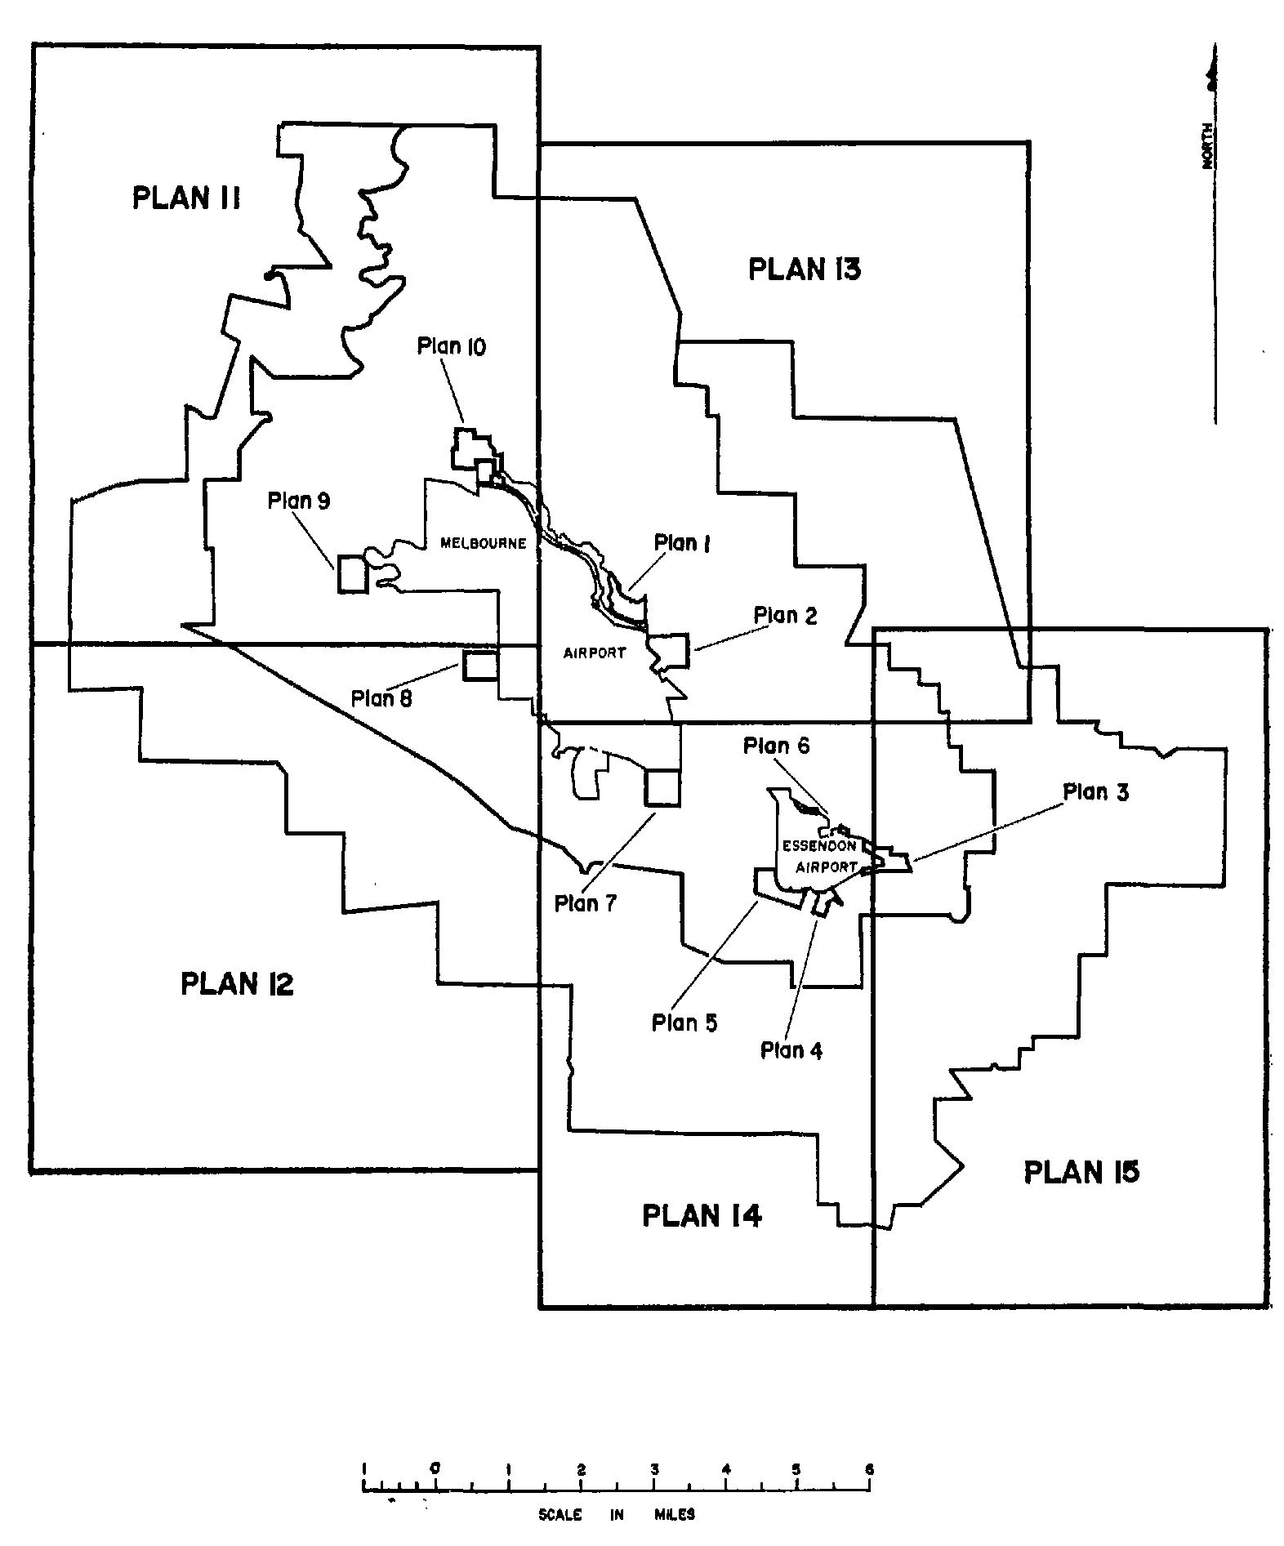
NOTE
1. Notified in the Commonwealth of Australia Gazette on 30 June 1988.
Printed by Authority by the Commonwealth Government Printer

