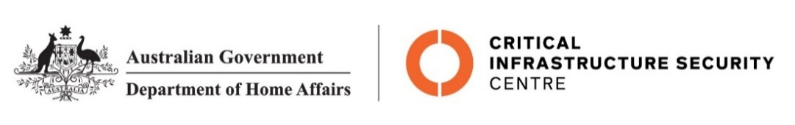

NTC-29535

Aviation Transport Security Act 2004

NTC-29535 – DECLARATION OF SECURITY CONTROLLED AIRPORT AND ESTABLISHMENT OF AIRSIDE AREA – PERTH AIRPORT

I am a Delegate of the Secretary of the Department of Home Affairs. Under subsection 28(2) of the Aviation Transport Security Act 2004 (the Act), I:

REVOKE notice NTC-29400 which declared Perth Airport as a security controlled airport as published in the Gazette (C2025G00586 on 20 October 2025); and

DECLARE Perth Airport is a security controlled airport, the boundaries of Perth Airport are shown on the attached maps which form part of this notice; and

ESTABLISH, in accordance with section 29 of the Act, an airside area for Perth Airport being that area indicated as the airside area on the attached maps which form part of this notice.

This Notice commences upon publication in the Gazette.

Karen Peevor (Position No: 60098937)
Delegate of the Secretary of the Department of Home Affairs

5 November 2025

Note:
- Gazette means the Commonwealth of Australia Gazette
- This Notice remains in force until otherwise revoked in writing and upon subsequent publication in the Gazette

