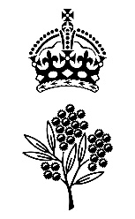

Government House

CANBERRA ACT 2600

2 October 2025

Order of Australia - Resignation - General Division - November 2025

It is notified for general information that the Governor-General of the Commonwealth of Australia has accepted the resignation as a member of the Order of Australia in the General Division with effect from 2 October 2025 of:

Mr Faddy Zouky

To cease to have the award of the Medal of the Order of Australia

By Her Excellency’s Command

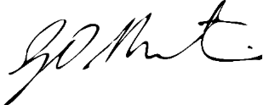

Gerard Martin PSM
Official Secretary to the Governor-General
Secretary of the Order of Australia

