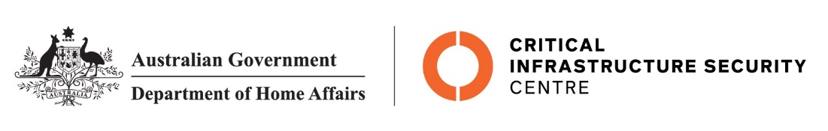

NTC-28872

***Aviation Transport Security Regulations 2005***

**NTC-28872 – EXEMPTION FROM DISPLAYING AN AVIATION SECURITY IDENTIFICATION CARD IN A SECURE AREA**

I am a Delegate of the Secretary of the Department of Home Affairs. Under subregulation 3.08(3) of the *Aviation Transport Security Regulations 2005* (the Regulations), I:

**GIVE** contractors and members of the Australian Defence Force (ADF), and contractors and members of the Republic of Singapore Air Force (RSAF), an exemption from displaying an Aviation Security Identification Card (ASIC) in the secure area of Rockhampton Airport for the purposes of carrying out their assigned duties as part of ‘Exercise Wallaby 2025’.

This exemption is subject to the following conditions:

1. movement by ADF and RSAF members and contractors into the airside area beyond the airside special event zone established in notice NTC-28873 is permitted for the purposes of carrying out maintenance and repair activities for aircraft that are part of ‘Exercise Wallaby 2025’; and
2. movement by ADF and RSAF members and contractors into the airside area beyond the airside special event zone established in notice NTC-28873 is permitted for the establishment and removal of exercise infrastructure and equipment, and to provide logistical support to all participants involved in ‘Exercise Wallaby 2025’.

This exemption is given from 0001 hours on 19 August 2025 to 2359 hours on 14 November 2025.

**Note**: Regulation 3.06 of the Regulations prescribes the permitted circumstances where members of

the ADF, including visiting forces, need not display an ASIC in the secure area.

Melissa (Loo) Keighran (Position No: 48000573)

Delegate of the Secretary of the Department of Home Affairs

16 August 2025