HEAVY VEHICLE NATIONAL LAW

**QUEENSLAND CLASS 3 HEAVY VEHICLE (PORT OF BRISBANE FLAT RACK AND OPEN TOP CONTAINER) MASS AND DIMENSION EXEMPTION NOTICE 2025 (No.1)**

PART 1 PRELIMINARY

1. Purpose
   1. The purpose of this notice is to exempt vehicles transporting flat rack and open top containers within the Port of Brisbane from the prescribed mass and dimension requirements specified in the notice.
2. Authorising provisions
   1. This notice is made under section 117 of the Heavy Vehicle National Law (HVNL) as in force in each state or territory.
3. Title
   1. This notice may be cited as the *Queensland Class 3 Heavy Vehicle (Port Of Brisbane Flat Rack And Open Top Container) Mass And Dimension Exemption Notice 2025 (No.1)*.
4. Commencement
   1. This notice commences on 29 August 2025.
5. Expiry
   1. This notice expires on 28 August 2030.
6. Definitions
   1. Unless otherwise stated, words and expressions used in this notice have the same meanings as those defined in the HVNL and its regulations.
   2. In this notice—

***flat rack container*** means a freight container without side walls or a roof.

**pilot and escort guideline**means the *Guideline for Pilot and Escort Operations in Queensland*published on the Queensland Government Publications Portal.

***open top container*** means a freight container without a roof.

***port road*** means the roads controlled by Port of Brisbane Pty Ltd as shown in Appendix 1 of this notice.

***regulation*** means the *Heavy Vehicle (Mass, Dimension and Loading) National Regulation*.

***spacing***, in relation to an axle, means the distance between the centreline of an axle and the centreline of another axle.

***night-time*** means the period beginning at sunset and ending at sunrise.

1. Application
   1. This notice applies to Class 3 tandem drive prime mover combinations transporting flat rack or open top containers on a port road.
2. Approved Routes
   1. A vehicle operating under this notice may travel on all green roads identified in Appendix 1 within the Port of Brisbane area north of the Captain Bishop Bridge.
   2. Lucinda Drive Overpass is restricted to vehicles with a GCM of 68.0t or less.

PART 2 EXEMPTION FROM PRESCRIBED MASS REQUIREMENTS

Division 1—General Exemption

1. General exemption
   1. A vehicle operating under this notice that complies with the conditions of this notice is exempt from the specified provisions of the Regulation.
2. Conditions
   1. Container twist locks must be used to secure a container to a trailer.
   2. Vehicles must have a minimum axle spacing of 1.2m.
   3. Each axle on a trailer must have 4 tyres.
   4. The minimum ground contact width of any trailer axle group is 2.4m.
3. Mass Limits
   1. A vehicle operating under this notice that complies with section 11 (2) of this notice, is exempt from section 2(1)(a)(iv) and (b) of Schedule 1 of the Regulation—
   2. Subject to the application of Division 5, the maximum allowable mass on an axle or axle group is the lowest of the applicable mass limits obtained for that axle, axle group or drive/dolly combination from—
      1. Division 2 – Axle and axle group mass limits relating to tyre section width; or
      2. Division 3 – Axle and axle group mass limits for prime movers and trailers; or
      3. Division 4 – Mass limits for drive/dolly combinations.

Division 2—Exemptions from prescribed mass requirements – Axle mass limits relating to tyre section width

1. General exemption
   1. A vehicle operating under this notice that complies with section 13 is exempt from the mass requirements in Part 1 section 4 of the Regulation, and Table 1 (Axle mass limits table) of Part 2 of Schedule 1 of the Regulation.
2. Conditions
   1. The mass on an axle of a vehicle must not be more than the mass limit stated in Table 1 of this notice.

TABLE 1 – MASS LIMITS PER AXLE ACCORDING TO TYRE WIDTH

| **Tyre section width of narrowest tyre on the axle (mm)** | | **Mass limit if the axle has 2 tyres (t)** | **Mass limit if the axle has 4 tyres (t)** |
| --- | --- | --- | --- |
| **At least** | **but less than** |
| 190 | 228 | - | 9.0 |
| 228 | 254 | - | 9.5 |
| 254 | 279 | 6.0 | 10.0 |
| 279 | - | 6.5 | 11.0 |

* 1. The mass on an axle group of a vehicle must not be more than the mass limit stated in Table 1 of this notice multiplied by the number of axles in that axle group.

Division 3—Exemptions from prescribed mass requirements – Axle mass limits for prime movers and trailers

1. General exemption
   1. A vehicle operating under this notice that complies with the requirements of section 15, is exempt from section 4 (Mass limits for a single axle or axle group) and Table 1 (Axle mass limits table) of Schedule 1 of the Regulation.
2. Conditions
   1. The mass on an axle or axle group of a prime mover must not be more than the mass limit specified in Table 2 of this notice.

TABLE 2 - PRIME MOVER AXLE AND AXLE GROUP MASS LIMITS

| **Axle or axle group description** | **Mass limit (t)** |
| --- | --- |
| Single steer axle | 6.0 |
| Single steer axle on a vehicle that complies with the requirements of section 1(1)(a), (b), (c), (d) and (e) of Schedule 3 (Steer axle mass exception limits) of the Regulation | 6.5 |
| Twinsteer (non load sharing) | 10.0 |
| Twinsteer (load sharing) | 12.0 |
| Tandem drive – dual tyres | 18.5 |

* 1. The mass on an axle or axle group of a trailer or a low loader dolly must not be more than the applicable mass limit specified in Table 3 of this notice.

TABLE 3 - TRAILER AND DOLLY AXLE AND AXLE GROUP MASS LIMITS

| **Number and spacing of axles in group**  **(Minimum axle spacing in metres)** | **Axle group mass limit (t)** |
| --- | --- |
| 1 axle | 9.0 |
| 2 axles with 1.2m spacing | 18.5 |
| 2 axles with 1.8m spacing | 18.5 |
| 3 axles with 1.2m spacing between adjacent axles | 25.0 |
| 3 axles with at least 3.2m spacing between the 1st & 3rd axle | 27.0 |
| 4 axles with 1.2m spacing between adjacent axles | 30.0 |
| 4 axles with 1.2m spacing between the 1st & 2nd and 3rd & 4th axles, and 2.4m spacing between the 2nd & 3rd axles | 35.0 |

Division 4—Exemptions from prescribed mass requirements – Drive/dolly combination mass limits

1. General exemption
   1. A vehicle operating under this notice that complies with section 17 or 18 is exempt from the following mass requirements set out in Schedule 1 to the Regulation—
      1. Section 4 (Mass limits for a single axle or axle group) and Table 1 (Axle mass limits table); and
      2. Section 5 (Mass limits relating to axle spacing generally) and Table 2 (Axle spacing mass limits general table).
2. Mass limit - Distance between prime mover and single axle dolly
   1. The sum of the mass on the prime mover drive axle group, and the mass on the dolly axle must not be more than the mass limit shown in Table 4 of this notice for the overall drive dolly spacing of the configuration.
   2. In this section—

***overall drive dolly spacing***, means the longitudinal distance in metres from the centerline of the front axle of a prime mover tandem drive group to the centerline of the dolly axle, marked as “A” in Figure 1.

Figure 1 Measurement of Overall Drive Dolly Spacing

This figure shows how to measure the overall drive dolly spacing of a combination including a single axle dolly.**Figure 1**

TABLE 4 - MASS LIMITS (SUM) FOR PRIME MOVER & SINGLE AXLE DOLLY COMBINATIONS

| **Overall drive dolly spacing (m)** | **Mass Limit (t)**  **(Sum of Mass on Prime Mover and Dolly Axles)** |
| --- | --- |
| 2.8 | 25.0 |
| 3.0 | 26.0 |
| 3.2 | 27.0 |
| 3.4 | 27.5 |

1. Mass limit - Distance between prime mover and tandem axle dolly
   1. The sum of the mass on the prime mover drive axle group and the mass on the dolly group axle must not be more than the mass limit shown in Table 5 of this notice for the overall drive dolly spacing of the configuration.
   2. In this section—

***overall drive dolly spacing*** means the longitudinal distance in metres from the centerline of the front axle of a prime mover tandem drive group to the centerline of the rear dolly axle, marked as “B” in Figure 2.

Figure 2 Measurement of Overall Drive Dolly Spacing

This figure shows how to measure the overall drive dolly spacing of a combination including a double axle dolly.

Figure 2

TABLE 5 - MASS LIMITS (SUM) FOR PRIME MOVER TANDEM DRIVE – TANDEM AXLE DOLLY COMBINATIONS

| **Overall drive dolly spacing (metres)** | **Mass Limit (t)**  **(Sum of Mass on Prime Mover and Dolly Axles)** |
| --- | --- |
| 3.6 | 29.0 |
| 3.8 | 30.0 |
| 4.0 | 31.0 |
| 4.2 | 32.0 |
| 4.4 | 33.0 |
| 4.6 | 34.0 |
| 4.8 | 35.0 |
| 5.0 | 36.0 |
| 5.2 | 37.0 |

Division 5— Effect of shorter spacing between load and prime mover

1. Calculation of Maximum Allowable Loaded Mass
   1. This section applies if the distance between the centre-line of the foremost axle of a trailer and the centre-line of the rearmost axle of either of a component mentioned in (a) or (b) is less than 6.0m—
      1. the dolly, if one is used; or
      2. the prime mover, if no dolly is used.
   2. The maximum allowable loaded mass for a vehicle mentioned in subsection (1) is determined by applying section 11 of this notice to calculate the total of masses on all axles, and subtracting 1.0t for every 0.3m or part thereof by which the distance in subsection (1) is less than 6m.

PART 3 EXEMPTION FROM PRESCRIBED DIMENSION REQUIREMENTS

1. General Dimension exemption
   1. A vehicle operating under this notice that complies with sections 21 and 22 is exempt from sections 3, 4, 7 and 8 of Schedule 6 of the Regulation.
2. Conditions – Allowable dimensions
   1. A vehicle operating under this notice must not exceed the following dimensions—
      1. Width – 5.5m; or
      2. Height – 6.7m; or
      3. Length – 35.0m.
3. Condition - Low deck height trailer
   1. If the loaded height of a heavy vehicle exceeds 4.8m, the load must be transported on a trailer with a loading deck no more than 1.2m above the ground.
4. Condition – Laden Vehicle
   1. A laden vehicle operating under this notice, which is longer than 30m must have a rear-end steering unit.
5. Exemption - Vehicle combination rear overhang
   1. A vehicle operating under this notice that complies with subsection (2) or (3) is exempt from the provisions of section 5 of Schedule 6 of the Regulation.
   2. Where the overall length of a vehicle combination transporting a flat rack container and any load the flat rack container is carrying is up to 25.0m in overall length, the rear overhang shall be the lesser of 5.5m or 25% of the overall length of the vehicle combination.
   3. Where the overall length of a vehicle combination transporting a flat rack container and any load the flat rack container is carrying exceeds 25.0m in overall length, the rear overhang must not exceed the limits shown in Table 6 of this notice.

TABLE 6 - REAR OVERHANG LIMITS

| **Combination length (m)** | | **Rear overhang (m)** |
| --- | --- | --- |
| **Longer than** | **Not Longer than** | **Up to** |
| 25.00 | 25.25 | 6.82 |
| 25.25 | 25.50 | 6.89 |
| 25.50 | 25.75 | 6.95 |
| 25.75 | 26.00 | 7.02 |
| 26.00 | 26.25 | 7.09 |
| 26.25 | 26.50 | 7.16 |
| 26.50 | 26.75 | 7.22 |
| 26.75 | 27.00 | 7.29 |
| 27.00 | 27.25 | 7.36 |
| 27.25 | 27.50 | 7.43 |
| 27.50 | 27.75 | 7.49 |
| 27.75 | 28.00 | 7.56 |
| 28.00 | 35.00 | 7.60 |

PART 4 CONDITIONS OF OPERATION – PILOT and ESCORT REQUIREMENTS

1. Pilot and escort condition
   1. Pilot and escort requirements must be carried out in accordance with
      1. Table 7 of this notice, for roads within a critical area as described in the Pilot and Escort Guideline.

Table 7 – PILOT AND ESCORT REQUIREMENTS - CRITICAL AREA

Table 7 - PILOT AND ESCORT REQUIREMENTS - CRITICAL AREA

Table 7 shows the number and type of pilots or escorts required by vehicles within a critical area, according to their width and length. 

1. Pilot and Escort Condition – Night-Time Travel for vehicles not requiring Pilot or Escorts
   1. A vehicle operating under this notice, which does not exceed 3.1m in width and/or 25m in length is permitted to travel at night-time without pilots or escorts; and
   2. A vehicle operating under this notice, which does not exceed 3.1m in width and/or 26m in length is permitted to travel at night-time on an approved B-Double or Road Train Route without pilots or escorts.

Jose Arredondo

*Manager Network Access Policy*

**National Heavy Vehicle Regulator**

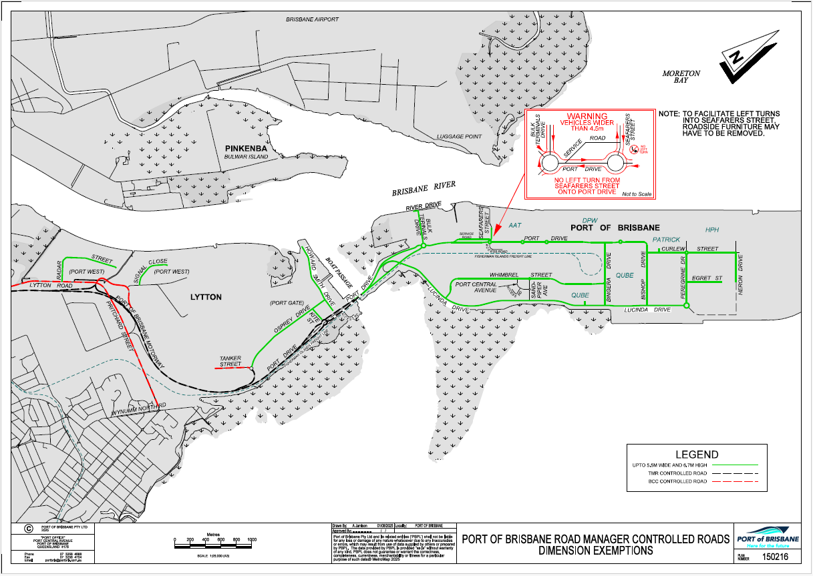**Appendix 1 Map of Port Roads**