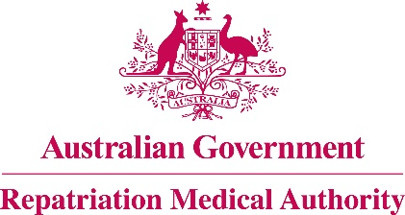

**DECLARATION UNDER SUBSECTION 196B(6)**

**OF THE *VETERANS’ ENTITLEMENTS ACT 1986***

**CONCERNING BLAST INDUCED MILD TRAUMATIC BRAIN INJURY**

The Repatriation Medical Authority (the Authority), under subsection 196B(6) of the *Veterans' Entitlements Act 1986* (the Act), makes the following declaration in respect of the investigation concerning blast induced mild traumatic brain injury notified in the Commonwealth of Australia Gazette of 28 April 2025.

The Authority declares that it does not propose to make a Statement of Principles concerning blast induced mild traumatic brain injury, for the purposes of subsection 196B(2) or (3) of the Act. The reason is that the Authority is of the view that the sound medical and scientific evidence is insufficient to enable the Authority to determine a causal link between low level blast exposure and enduring neurocognitive impairment in the absence of acute symptoms of TBI either on the basis of reasonable hypothesis or balance of probability. The sound medical and scientific evidence is therefore insufficient in order to determine Statements of Principles for blast induced mild traumatic brain injury.

|  |  |
| --- | --- |
| The Common Seal of the )  Repatriation Medical Authority )  was affixed at the direction of: ) |  |
|  | PROFESSOR TERENCE CAMPBELL AM CHAIRPERSON 15 August 2025 |

***Repatriation Medical Authority***

***GPO Box 1014, Brisbane, Qld 4001***

***Telephone: (07) 3815 9404 Email: info@rma.gov.au***