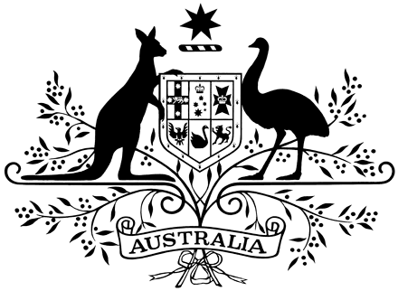

**PROCLAMATION**

WHEREAS His Majesty King Charles the Third, by Commission under His Royal Sign Manual and the Great Seal of Australia dated 19 April 2023, appointed me, the Honourable Christopher Dawson, Companion of the Order of Australia, Australian Police Medal, Governor of the State of Western Australia to administer the Government of the Commonwealth of Australia in the event of the absence out of Australia or the death, incapacity or removal of the Governor-General for the time being, or in the event of the Governor-General having temporarily absented herself from office for any reason:

And whereas the Governor-General is from today absent out of Australia:

Now let it be known that, having taken the prescribed oaths, I have this day assumed the administration of the Government of the Commonwealth of Australia.

Signed and sealed with the

Great Seal of Australia

on 3 August 2025

Christopher Dawson

Administrator

By His Excellency’s Command

Anthony Albanese

Prime Minister