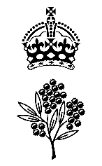

**Government House**

**CANBERRA ACT 2600**

**9 June 2025**

**The King’s Birthday 2025 Honours List**

The Governor-General is pleased to announce the following appointments and awards:

**Order of Australia**

General Division Companion of the Order of Australia (AC)

Officer of the Order of Australia (AO)

Member of the Order of Australia (AM)

Medal of the Order of Australia (OAM) including Honorary

Military Division Officer of the Order of Australia (AO)

Member of the Order of Australia (AM)

Medal of the Order of Australia (OAM)

**Meritorious Service Awards**

Public Service Medal (PSM)

Australian Police Medal (APM)

Australian Fire Service Medal (AFSM)

Ambulance Service Medal (ASM)

Emergency Services Medal (ESM)

Australian Corrections Medal (ACM)

**Distinguished Service Decorations**

Commendation for Distinguished Service

**Conspicuous Service Decorations**

Conspicuous Service Cross (CSC)

Bar to the Conspicuous Service Medal (CSM and Bar)

Conspicuous Service Medal (CSM)

Please Note: A comprehensive list of recipients can be found at www.gg.gov.au and www.honours.pmc.gov.au/honours/search.

# By Her Excellency’s Command

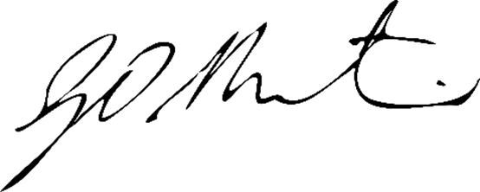

# 

**Gerard Martin PSM**

Official Secretary to the Governor-General