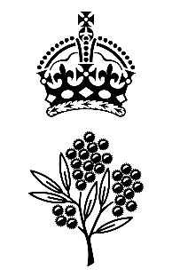

**Government House**

**CANBERRA ACT 2600**

##### 01 April 2025

**ORDER OF AUSTRALIA**

It is notified for general information that the Governor-General of the Commonwealth of Australia has accepted the resignation as a member of the Order of Australia in the General Division with effect from 01 April 2025 of:

**The Honourable Alan James Boulton**

To cease to be appointed an Officer of the Order of Australia

# By Her Excellency’s Command

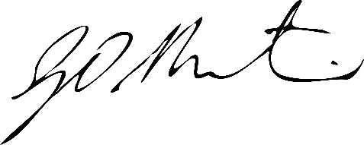

#### Gerard Martin PSM

Official Secretary to the Governor-General

Secretary of the Order of Australia