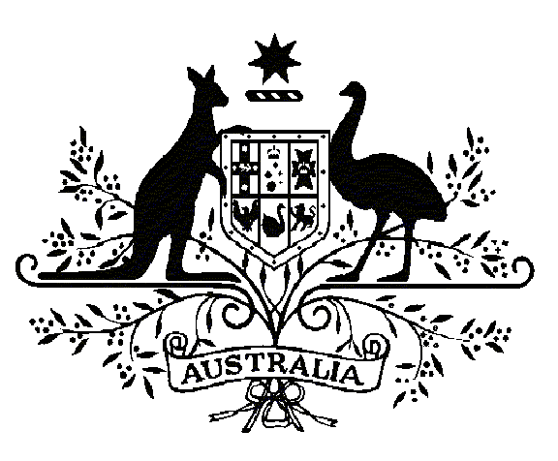

Specialist Medical Review Council

**Declaration and Reasons for Decisions**

*Section 196W  
Veterans’ Entitlements Act 1986*

**Re: Statements of Principles Nos. 01 and 02 of 2022,**

**in respect of Hashimoto thyroiditis**

Declaration No. 37

1. In relation to the RMA Statements of Principles **Nos. 01 and 02 of 2022** concerning **Hashimoto thyroiditis** made under subsections 196B of the *Veterans' Entitlements Act 1986* (the VEA), the Council under subsection 196W(5) of the VEA:

DECLARES that the sound medical-scientific evidence available to the RMA is insufficient to justify the amendment of:

1. Statement of Principles No. 2 of 2022 to include the following factors(s):

**posttraumatic stress disorder;** and

1. Factors 9(9) and 9(19) of Statement of Principles No. 1 of 2022 to replace ‘having posttraumatic stress disorder at the *time of* the’ with ‘having posttraumatic stress disorder *before* the’.

|  |  |  |  |  |  |
| --- | --- | --- | --- | --- | --- |
| Christian Gericke  Convener | Kimberly Alexander  Councillor | Ian Gardner  Councillor | | Kate O’Connor  Councillor | Richard Arenson  Councillor |
| The Common Seal of the  Specialist Medical Review  Council was affixed to this  document by authority of the  Council in the presence of: | | |  | | |
| Dated 24 March 2025 | | | David Janik  Registrar  Specialist Medical Review Council | | |