Excise Tariff Act 1921
NOTICE OF SUBSTITUTED RATES OF EXCISE DUTY
NOTICE No. 4 (2024)
I, Peter Vujanic, delegate of the Commissioner of Taxation, in accordance with subsections 6AA(11) and 6AAB(9) of the Excise Tariff Act 1921 (the Tariff Act), give notice that, on and from 1 September 2024, the substituted rate of excise duty for goods classified to each item of the Schedule to the Tariff Act set out in Column 1 of the following table is the rate set out in Column 2 opposite each item.
In this notice, “item” means item and subitem.
THE TABLE
Column 1 | Column 2
Excise tariff item | Substituted rate of duty
5.1 | $1.36623 per stick
5.5 | $2101.89 per kilogram of tobacco content
5.8 | The amount of duty worked out under section 6AAC
Dated this 15th day of August 2024
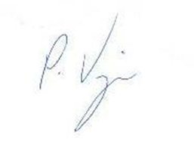
Peter Vujanic
Delegate of the Commissioner of Taxation

