
Government House
Canberra ACT 2600

29 July 2024
Her Excellency the Governor-General directs it to be notified, for general information, that:
- she has sworn in as Executive Councillors:

- Ms Kate Thwaites MP;

- Mr Josh Wilson MP; and

- Mr Julian Hill MP.

- she has made the following appointments:

- The Hon Tony Burke MP as Minister for Home Affairs, Minister for Immigration and Multicultural Affairs, Minister for Cyber Security and Minister for the Arts;
- The Hon Julie Collins MP as Minister for Agriculture, Fisheries and Forestry and Minister for Small Business;
- Senator the Hon Murray Watt as the Minister for Employment and Workplace Relations;
- The Hon Clare O’Neil MP as Minister for Housing and Minister for Homelessness;
- Senator the Hon Malarndirri McCarthy as Minister for Indigenous Australians;
- The Hon Pat Conroy MP as Minister for Defence Industry and Capability Delivery and Minister for International Development and the Pacific;
- The Hon Andrew Giles MP as Minister for Skills and Training;
- Senator the Hon Jenny McAllister as Minister for Cities and Minister for Emergency Management;
- The Hon Matt Thistlethwaite MP as Assistant Minister for Immigration;
- The Hon Patrick Gorman MP as the Assistant Minister to the Prime Minister, the Assistant Minister for the Public Service, the Assistant Minister to the Attorney-General;
- The Hon Ged Kearney MP as Assistant Minister for Health and Aged Care and Assistant Minister for Indigenous Health;
- The Hon Tim Ayres MP as Assistant Minister for a Future Made in Australia and Assistant Minister for Trade;
- Senator the Hon Anthony Chisholm as Assistant Minister for Education, Assistant Minister for Regional Development and Assistant Minister for Agriculture, Fisheries and Forestry;
- Ms Kate Thwaites MP as Assistant Minister for Social Security, Assistant Minister for Ageing and Assistant Minister for Women;
- Mr Josh Wilson MP as the Assistant Minister for Climate Change and Energy; and
- Mr Julian Hill MP as the Assistant Minister for Citizenship and Multicultural Affairs.

By Her Excellency’s Command

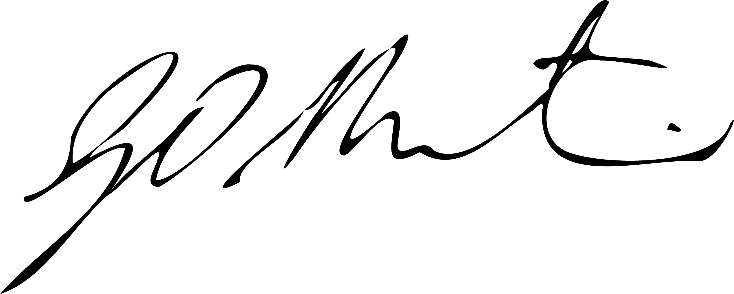

Gerard Martin PSM
Acting Official Secretary to the Governor-General

