***Aboriginal and Torres Strait Islander Heritage Protection Act 1984* (Cth)**

**Notice of an application for the protection of a specified area, being the area known as area known as Pulyku (Booylgoo Range), near Sandstone, Western Australia**

**Invitation to make representations**

I, Andrew Cawthorn, hereby give notice as follows:

The Minister for the Environment and Water (**minister**), responsible for the *Aboriginal and Torres Strait Islander Heritage Protection Act 1984* (Cth)(**Act**), has received an application made under section 10 of the Act. The application is seeking long term preservation and protection of a significant Aboriginal area being the area known as Pulyku (Booylgoo Range), near Sandstone, Western Australia. The minister has appointed me to provide a report to the minister under paragraph 10(1)(c) of the Act.

### The Applicants

The application is made by Tjiwarl Traditional Owners, Mr Kado Muir, Mr Michael Tullock and Mr Brett Lewis (**applicants**).

### The purpose of the application

The application seeks the long-term preservation or protection of the area specified in the application (the **specified area**). This area is depicted in Figure 1. Section 10 of the Act confers power on the minister to make a declaration to preserve and protect an area where the minister is satisfied that it is a ‘significant Aboriginal area’ under threat of injury or desecration. A ‘significant Aboriginal area’ is an area of land or water in Australia that is ‘of particular significance to Aboriginals in accordance with Aboriginal tradition’. ‘Aboriginal tradition’ is the ‘body of traditions, observances, customs and beliefs of Aboriginals generally or of a particular community or group of Aboriginals, and includes any such traditions, observances, customs or beliefs relating to particular persons, areas, objects or relationships’.

### Matters the report is required to deal with

The minister must consider my report pursuant to section 10 of the Act in relation to the specified area before deciding whether to make a declaration under section 10 of the Act. Under subsection 10(4) of the Act, the report is required to deal with the following matters:

1. the particular significance of the area to Aboriginals;
2. the nature and extent of the threat of injury to, or desecration of, the area;
3. the extent of the area that should be protected;
4. the prohibitions and restrictions to be made with respect to the area;
5. the effects the making of a declaration may have on the proprietary or pecuniary interests of persons other than the Aboriginal or Aboriginals who made the application, or on whose behalf the application is made;
6. the duration of any declaration;
7. the extent to which the area is or may be protected by or under a law of a State or Territory, and the effectiveness of any remedies available under any such law; and
8. such other matters (if any) as prescribed.

### The specified area

Figure 1 depicts the area for which preservation and protection is sought. This specified area is described as the area known as Pulyku (Booylgoo Range), near Sandstone, Western Australia.

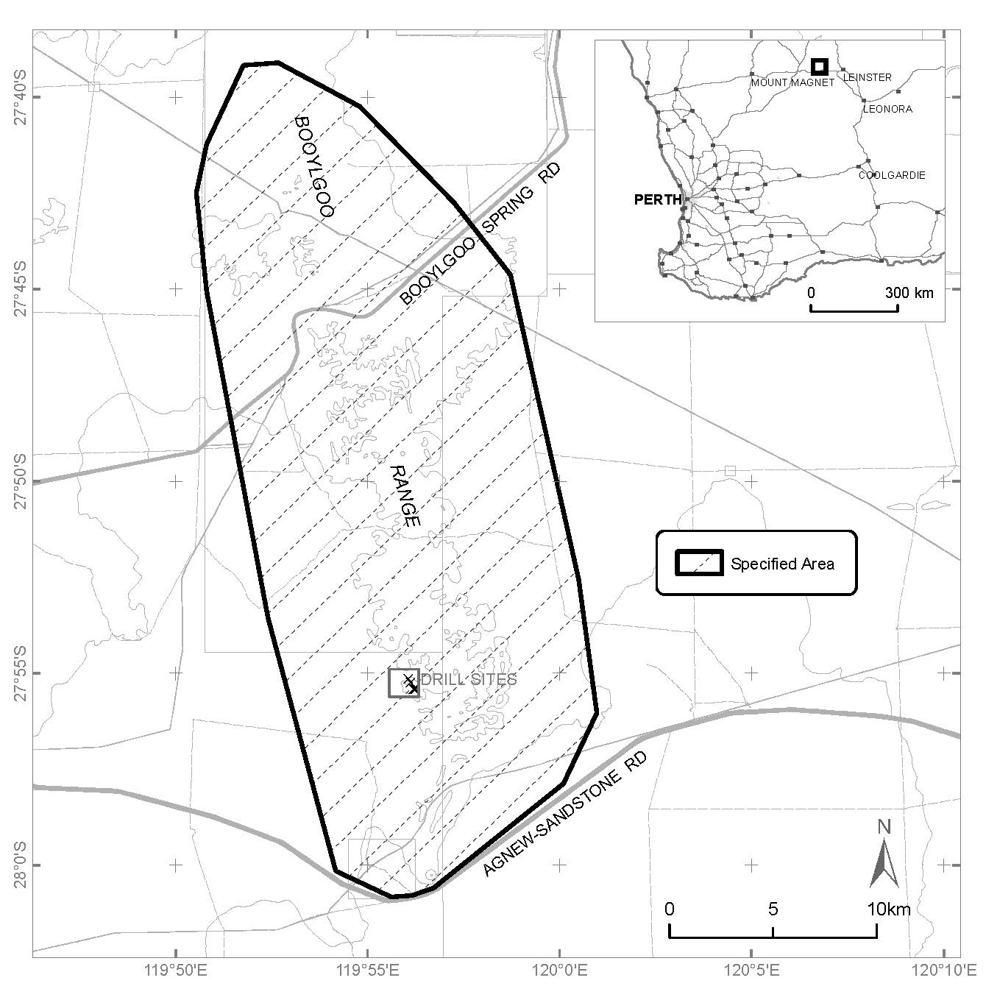

Figure 1 Map showing the specified area being the area known as Pulyku (Booylgoo Range), near Sandstone, Western Australia

### Claims in relation to ‘significant Aboriginal area’

The applicants claim the specified area is of particular significance to the Tjiwarl Native Title Holders and other Western Desert Aboriginal peoples in accordance with Aboriginal tradition for the following reasons:

* Pulyku (Boolygoo Range) is of extremely high traditional significance to the Tjiwarl native title holders and other Western Desert Aboriginal peoples.
* The specified area is associated with a Husband and Wife Tjukurrpa (dreaming) (a travelling story connecting many sites across Tjiwarl country and beyond), Marlu tjunta (kangaroo thigh), Karnka (Crow), Watja (bush potato), Tjilkarli (pencil yam) and Kakalala (sulphur-crested cockatoo) Dreamings.
* There are three levels of interaction with Tjukurrpa at Pulyku:
  + The laws of Pulyku give precedent to the proper observance and maintenance of respectful relationships. In this situation, the Karnka offended the laws of respectful relationships between a son-in-law and his in-laws in constantly badgering them to share their food with him. The reaction of Karnka’s in-laws to his behaviour was to throw all the food on the ground in contempt at his behaviour.
  + In the physical domain of today, the remains of this food has transformed into a cultural landscape that consists of Pulyku and its surrounds. Marlu tjunta became the Boolygoo Range, with three springs representing Murti (the knee), Pulyku (the sinew), and Mulumulu (the hip joint). The Watja went flying away to fall on what is now the western side of the range, while Tjilkarli, being much lighter in weight, fell on the eastern side of the range.
  + The third level of the laws of Pulyku pertain to respectful relationships in the taking and using of resources. There are non-human Kukaparr (spiritual beings) that reside within the hills of the range, which are the guardians of the Tjukurrpa as well as guardians of the traditional laws for the appropriate access to, and the taking of and using of resources within the Pulykucultural landscape. Kukaparr must not be disturbed unless in accordance with specific protocols.
* The specified area is a site complex containing many features which are associated with numerous Tjukurrpa. Significant sites include three freshwater spring sites, extensive chert and ochre quarry sites, rock formations, caves and gaps that make up the range and associated topography.
* Pulyku is home to deceased ancestors whose kurti (spirits) reside there.
* The specified area contains traditional foods, Watja and Tjilkarli,which are not otherwise found for vast distances. These foods are harvested and consumed according to protocol and rituals.

### Claimed threat of injury or desecration

The applicants claim that the specified area is under threat from exploratory drilling and associated infrastructure proposed by Mabrouk Minerals Ltd. The applicant’s state:

* previous exploration has caused multiple instances of injury and desecration;
* the proposed works will result in injury and desecration which cannot be remedied; and
* as the spiritual essences associated with Pulyku is of a dangerous nature, any disturbance and desecration of Pulyku will result in spiritual retributions and damaging consequences for Tjiwarl Native Title Holders.

The applicants claim that in the making of the section 18 consent decision, the WA Minister caused desecration and injury to the site area of Pulyku and to the Tjiwarl native title holders, as he made that decision against the explicit wishes and active opposition of Tjiwarl people.

### Invitation to make representations

Interested parties are invited to furnish representations in connection with my report to:

Andrew Cawthorn

PO Box 208, Crafers, South Australia, 5152

Ph: +61 401 608 510

Email: [andrewcawthorn@proton.me](mailto:andrewcawthorn@proton.me)

Interested parties are urged to **contact me** as soon as possible to be provided with further information about the submission process, including the provision of the Application, the making of representations in response to the Application, and the making of final comments in response to representations received.

Representations must be made in writing by 5pm [AWST] on Monday 17 June 2024. **Do not send your representations directly to the minister.** First Nations people without representatives may provide an oral representation.

Representations made by, or on behalf of, more than one person should be signed by each of those persons.

### Representations received by the due date may subsequently be provided to the applicants and other interested parties for their review and comment in order to meet procedural fairness requirements. If representations are circulated to the applicants and/or other interested parties for comment, an additional period will be allowed for those parties to make any final comments in writing. Representations will only be circulated to the applicants and/or other interested parties where the representation may adversely affect the interests of that particular interested party. Please contact me should you have any questions about this.

### Claiming confidentiality

If you wish to claim confidentiality over any part of your representation, please identify why you are claiming confidentiality and how you wish confidentiality to apply. Representations will be provided to the minister and the Department of Climate Change, Energy, the Environment and Water (**department**), along with the section 10 report. Representations, even those subject to confidentiality, may be disclosed where it is authorised or required by law, to meet procedural fairness requirements, and in response to a request by a House or Committee of the Parliament of the Commonwealth.

**Privacy notice**

What is personal information and sensitive information?

The *Privacy Act 1988* (Cth) (the **Privacy Act**)sets out how the department can collect, use and disclose the personal and sensitive information of individuals.

‘Personal information’ is any information or opinion about an identified individual, or an individual who is reasonably identifiable (whether true or not).

‘Sensitive information’ is a subset of personal information and includes any information or opinion about an individual’s racial or ethnic origin, political opinion or association, religious beliefs or affiliations, philosophical beliefs, sexual orientation or practices, trade or professional associations and memberships, union membership, criminal record, health or genetic information and biometric information or templates.

Your personal information will be used and stored in accordance with the Australian Privacy Principles set out in Schedule 1 of the Privacy Act.

Collection and use of personal information  
  
By submitting a representation in response to the ‘Notice of an application for the preservation and protection of a specified area, being Pulyku (Booylgoo Range), near Sandstone, Western Australia’ you consent to the collection of all personal information (including sensitive information) contained in your representation, by myself as the section 10 reporter and by the department. By submitting a representation, you agree that you have read and understood this Privacy Notice.

I, Andrew Cawthorn, collect your personal information contained in your representation for the purposes of consideration in drafting a report under section 10 of the Act in relation to the specified area and related purposes. I will disclose your personal information to the department for the purpose of providing a section 10 report.

The department collects your personal information contained in your representation, and any subsequent correspondence in relation to your representation, for the purposes of the minister’s consideration in deciding whether to make a declaration under section 10 of the Act in relation to the specified area and related purposes.

Disclosure of personal information

By submitting a representation, you consent to the disclosure of all personal information contained in your representation to: the department; the minister; parties that may be affected by the decision of the minister under section 10 of the Act, should this be required to meet procedural fairness requirements; and other Commonwealth entities, State or Territory entities, and/or persons or organisations as necessary for the purposes of preparing and considering a report under section 10 of the Act and making a decision, provided the disclosure is consistent with relevant laws.

Your personal information will not be disclosed to overseas recipients unless such disclosure is necessary to consider an application made under section 10 of the ATSHIP Act or for related purposes.

Anonymous representations

You can choose to make an anonymous representation and/or to not disclose relevant personal information in your representation. However, this may mean your representation cannot be fully considered under the Act in relation to the specified area.

Personal and sensitive information of other individuals

If your representation contains the personal information of another person, you are responsible for ensuring the other person has agreed to their personal information being collected, used and disclosed for the purposes set out in this Privacy Notice. This includes giving them a copy of the Gazette Notice and this Privacy Notice.

Privacy Policy

The department's [Privacy Policy](https://www.dcceew.gov.au/about/commitment/privacy) is available at <https://www.dcceew.gov.au/about/commitment/privacy>. It contains more information about how personal information is handled, how to access or correct your personal information, and how to make a complaint.