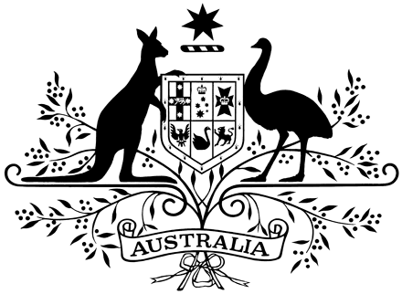

**PROCLAMATION**

WHEREAS Her Late Majesty Queen Elizabeth the Second, by Commission under Her Royal Sign Manual and the Great Seal of Australia dated 4 February 2022, appointed me, the Honourable Margaret Beazley, Companion of the Order of Australia, King’s Counsel, Governor of the State of New South Wales to administer the Government of the Commonwealth of Australia in the event of the absence out of Australia or the death, incapacity or removal of the Governor-General for the time being, or in the event of the Governor‑General having temporarily absented himself from office for any reason:

And whereas the Governor-General is from today absent out of Australia:

Now let it be known that, having taken the prescribed oaths, I have this day assumed the administration of the Government of the Commonwealth of Australia.

Signed and sealed with the

Great Seal of Australia

on 14 May 2024

Margaret Beazley

Administrator

By Her Excellency’s Command

Anthony Albanese

Prime Minister