Government House
CANBERRA ACT 2600

18 April 2024

Distinguished Service Decorations

It is notified for general information that the Governor-General has cancelled the award of the Commendation for Distinguished Service made to:

Chief Petty Officer Gavin Stevens

By His Excellency’s Command

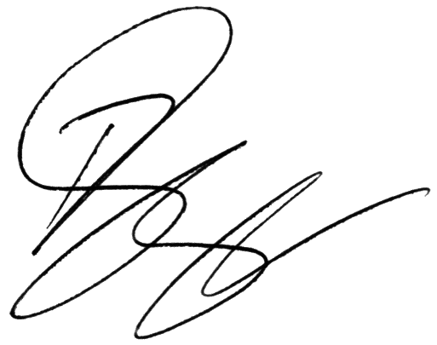

Paul Singer MVO
Official Secretary to the Governor-General

