# 

**Government House**

**CANBERRA ACT 2600**

**31 January 2024**

**Gallantry Decorations**

**The Governor-General is pleased to announce the following Gallantry Decoration:**

**MEDAL FOR GALLANTRY (MG)**

**Chief Petty Officer Gavin Ronald STEVENS**

For acts of gallantry in action in hazardous circumstances as a commander, Tactical Explosive Ordnance Disposal patrol from Australian Clearance Diving Team Three on Operation FALCONER in Al Faw Peninsula, Iraq on 16 April 2003.

By His Excellency’s command

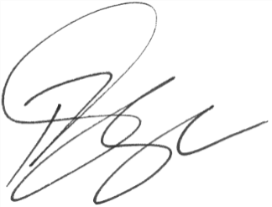

### **Paul Singer MVO**

Official Secretary to the Governor-General