**COMPETITION AND CONSU­­­­MER ACT 2010**

**Variation and extension of declaration under sections 152AL, 152ALA and 152AO – Fixed terminating access service - 2024**

1. Pursuant to sections 152AL, 152ALA and 152AO of the Competition and Consumer Act 2010 (the CCA), and with effect from 1 July 2024, the Australian Competition and Consumer Commission (ACCC) varies and extends the Fixed Terminating Access Service (FTAS) declaration which took effect from 1 July 2019 under section 152AL of the CCA by deleting Annexure 1 of the FTAS declaration and replacing it with Annexure 1 of this Instrument.
2. Pursuant to subsection 152ALA(1) of the CCA, the expiry of the FTAS declaration is 30 June 2029.

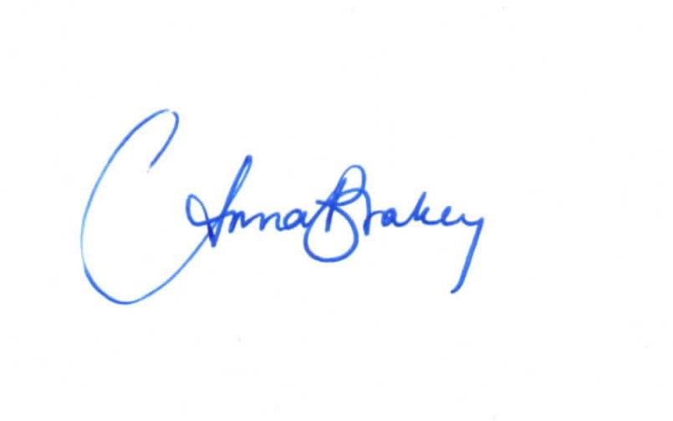

………………………………………….

Anna Brakey

Commissioner

Australian Competition and Consumer Commission

Dated: 26 March 2024

**Annexure 1: Service description for the FTAS**

An access service for the carriage of voice calls from a POI to end-customer assigned numbers from the geographic number ranges of the Australian Numbering Plan and directly connected to the access provider’s network.

**Services**

The service is provided on a call that is handed over for termination to a customer directly connected to the access provider's network with numbering in accordance with the Australian Numbering Plan.

**Definitions**

Where words or phrases used in this declaration are defined in the Act or the Telecommunications Act 1997, they have the same meaning given in the relevant Act.

In this Appendix:

**point of Interconnection** or **POI** means an agreed location which:

* is a physical point of demarcation between the networks nominated by the access seeker and the access provider; and
* is associated (but not necessarily co-located with) with one or more gateway exchanges of each of the networks nominated by the access seeker and the access provider in respect of the POIs nominated by the access provider.