***Customs Act 1901***

**Notice under paragraph 15(2)(a)**

**Wharf Notice of Appointment (No. 24/03) –**

**Port of Port Adelaide – Outer Harbour Berths 1-4**

I, Phil Emerson, delegate of the Comptroller-General of Customs, under paragraph 15(2)(a) of the *Customs Act 1901*:

1. REVOKE the notice titled ‘Wharf Appointment No. 2353’, published in the *Commonwealth of Australia Gazette,* appointing as a wharf the area known as Outer Harbour Berths 1-4 in the Port of Port Adelaide in South Australia and fixing the limits of that wharf; and
2. APPOINT as a wharf the area known as Outer Harbour Berths 1-4 in the Port of Port Adelaide in South Australia; and
3. FIX as the limits of that wharf the areas within the red boundary line as indicated in **Attachment A** to this notice.

Dated the 2nd day of March 2024.

Phil Emerson

Director Ports Policy

Traveller Policy and Industry Engagement

Industry and Border Systems Division

Australian Border Force

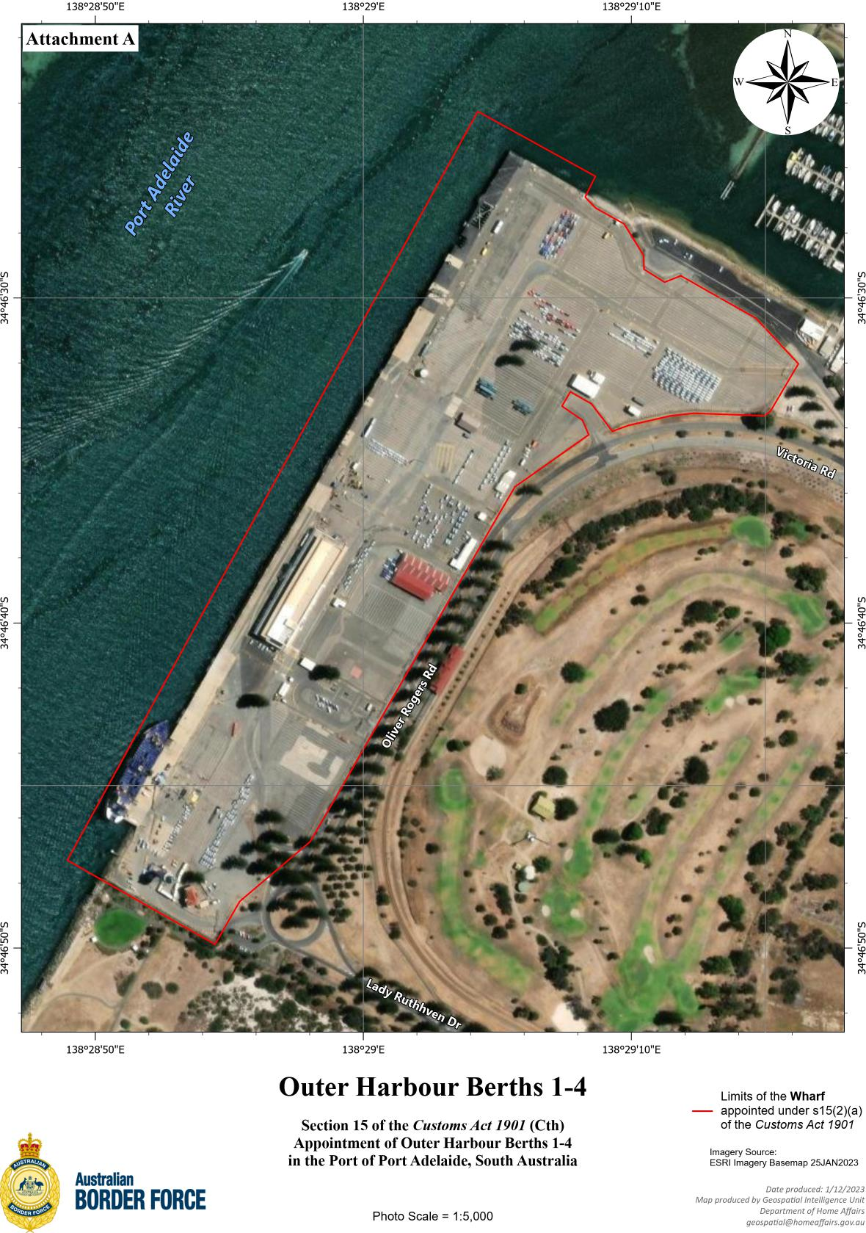

|  |  |
| --- | --- |
| Section 15 of the Customs Act 1901 (Cth)  Appointment of Outer Harbour Berths 1-4  in the Port of Port Adelaide, South Australia  Photo scale 1=5,000 | ___ Limits of the **Wharf** appointed under s15 (2)(a) of the Customs Act 1901  Imagery Source: ESRI Imagery Base Map 25 Jan 2023  Date produced: 1/12/2023  Map produced by Geospatial Intelligence Unit Department of Home Affairs [*geospatial@homeaffairs.gov.au*](mailto:geospatial@homeaffairs.gov.au) |

