# 

**Government House**

**CANBERRA ACT 2600**

**6 August 2021**

**Honorary Appointment - Military Division - January 2024**

**The Governor-General is pleased to announce the following appointment in the   
Order of Australia:**

**HONORARY OFFICER (AO) IN THE MILITARY DIVISION**

**General Mark A MILLEY,** Washington, United States of America

For distinguished service and dedication to strengthening the military relationship between Australia and the United States through exceptional leadership and steadfast commitment to enhancing Alliance cooperation.

By His Excellency’s command

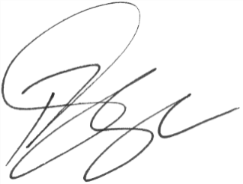

### **Paul Singer MVO**

Official Secretary to the Governor-General