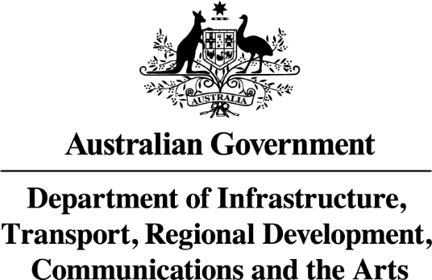

AIRPORTS (PROTECTION OF AIRSPACE) REGULATIONS 1996

Notice of Declaration of Prescribed Airspace
for Western Sydney International (Nancy-Bird Walton) Airport 2023

NOTICE is hereby given that on 16 June 2023, the Department of Infrastructure, Transport, Regional Development, Communications and the Arts, pursuant to subregulation 5(1) of the Airports (Protection of Airspace) Regulations 1996, declared prescribed airspace for Western Sydney International (Nancy-Bird Walton) Airport.

Charts of the prescribed airspace for the Western Sydney International (Nancy-Bird Walton) Airport are available for inspection or purchase from:

Western Sydney Airport Regulatory Policy Branch,
Department of Infrastructure, Transport, Regional Development, Communications and the Arts
GPO Box 594 CANBERRA ACT 2601

