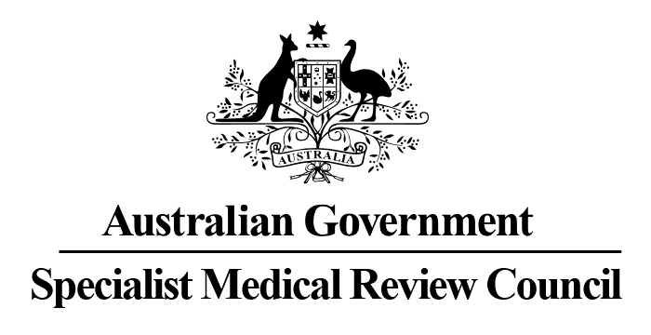

**Declaration No. 36**

**Malignant Neoplasm of the Breast**

**Statements of Principles Nos. 96 and 97 of 2014**

*Section 196W of the   
Veterans’ Entitlements Act 1986*

In relation to the Repatriation Medical Authority (the Authority) **Statements of Principles Instrument Nos. 96 and 97 of 2014 concerning malignant neoplasm of the breast (as amended)**, made under subsection 196B of the *Veterans’ Entitlements Act 1986* (the Act), the Council:

**DECLARES**, under subsection 196W(5)(b) of the Act, that there is insufficient sound medical-scientific evidence on which the Authority could have relied to amend the Statements of Principles with respect to non-oral combined hormonal contraceptives; and

**RECOMMENDS** that the Authority undertake a further review of the Statements of Principles having regard to replacing the defined term of ‘combined oral contraceptive pill’ with the defined term of ‘combined hormonal contraceptive’ where it appears in clause 6(c), 6(c)(i) and 6(c)(ii) which, in the opinion of the Council, reflects the classification of contraceptives used in current medical practice.

|  |  |  |  |
| --- | --- | --- | --- |
|  |  |  | |
| Charles Guest  Convener | Meagan Brennan  Councillor | Catriona Melville  Councillor | |
| The Common Seal of the Specialist Medical Review Council was affixed to this document by authority of the Council in the presence of: | )  )  ) )  ) | | |
| Dated 17 May 2023 | David Janik  Registrar Specialist Medical Review Council | |

The Council’s Reasons for Decisions are published at www.smrc.gov.au/decisions. Alternatively, a copy may be requested by contacting the Council at PO Box 965, Brisbane QLD 4001 or at smrc.registrar@smrc.gov.au.