Government House

CANBERRA ACT 2600

6 July 2022

Honorary Appointment - Military Division - July 2022

The Governor-General is pleased to announce the following appointment:

HONORARY OFFICER (AO) IN THE MILITARY DIVISION

Air Marshal Kevin Ronald SHORT
For distinguished service in fostering the military relationship
between Australia and New Zealand through exceptional
leadership, unwavering commitment, strategic foresight
and uncompromising professionalism.

By His Excellency’s command

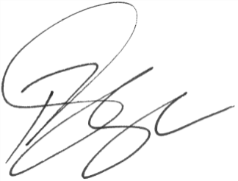

Paul Singer MVO

Official Secretary to the Governor-General

