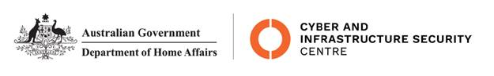

NTC-22887

**Aviation Transport Security Act 2004**

**NTC-22887 NOTICE OF DECLARATION OF SECURITY CONTROLLED AIRPORT AND ESTABLISHMENT OF AIRSIDE AREA – GOLD COAST AIRPORT**

I, **JENNIFER MURILLO**, A/g Assistant Director, Transport Security Operations, Aviation and Maritime Security Division:

**REVOKE**, under subsection 28(2) of the Aviation Transport Security Act 2004(the Act),

Notice NTC-22276 which declared Gold Coast Airport as a security controlled airport as published in the *Gazette (C2022G00105, 07 06 2022)*.

**DECLARE**, under subsection 28(2) of the Act, that Gold Coast Airport is a security controlled airport, the boundaries of Gold Coast Airport are shown on the attached map which forms part of this notice; and

**ESTABLISH,** in accordance with section 29 of the Act, an airside area for Gold Coast Airport being that area indicated as the airside area on the attached map.

This Notice commences upon publication in the *Gazette*.

Date: 16 June 2022

Jennifer Murillo

Delegate of the Secretary of the

Department of Home Affairs

Note:

1. *Gazette* means the *Commonwealth of Australia Gazette*
2. This Notice remains in force until otherwise revoked in writing and upon subsequent publication in the *Gazette*

