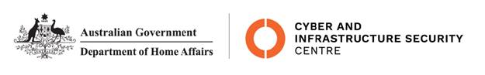

NTC-22560

***Aviation Transport Security Act 2004***

**NTC-22560 - DECLARATION OF SECURITY CONTROLLED AIRPORT AND ESTABLISHMENT OF AIRSIDE AREA – LAUNCESTON AIRPORT**

I am a Delegate of the Secretary of the Department of Home Affairs. Under subsection 28(2) of the

*Aviation Transport Security Act 2004* (the Act), I:

**REVOKE** notice NTC-18026 which declared Launceston Airport as a security controlled airport as

published in the *Gazette* (C2020G00998 on 8 December 2020); and

**DECLARE** Launceston Airport is a security controlled airport, the boundaries of Launceston Airport

are shown on the attached maps which form part of this notice; and

**ESTABLISH,** in accordance with section 29 of the Act, an airside area for Launceston Airport being

that area indicated as the airside area on the attached maps which form part of this notice.

This Notice commences upon publication in the *Gazette*.

Jaran Blethyn

Assistant Director, Regulatory Compliance

Cyber and Infrastructure Security Operations

Delegate of the Secretary of the

Department of Home Affairs

23 May 2022

Note:

1. *Gazette* means the *Commonwealth of Australia Gazette*
2. This Notice remains in force until otherwise revoked in writing and upon subsequent publication in the *Gazette*

