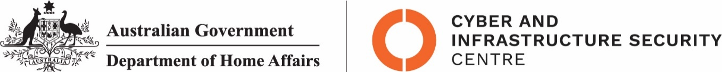

NTC-21819

***Aviation Transport Security Act 2004***

**NTC-21819 – DECLARATION OF SECURITY CONTROLLED AIRPORT AND ESTABLISHMENT**

**OF AIRSIDE AREA – WEIPA AIRPORT**

I am a Delegate of the Secretary of the Department of Home Affairs (Secretary). Under subsection

28(2) of the *Aviation Transport Security Act 2004* (the Act), I:

**REVOKE** Notice NTC-12931 which declared Weipa Airport as a security controlled airport as

published in the *Gazette (C2017G00484, 3 May 2017)*; and

**DECLARE** Weipa Airport is a security controlled airport, the boundaries of Weipa Airport are shown

on the attached map which forms part of this notice; and

**ESTABLISH,** in accordance with section 29 of the Act, an airside area for Weipa Airport being that

area indicated as the airside area on the attached map which forms part of this notice.

This Notice commences upon publication in the *Gazette*.

Daniel Panozzo

A/g Assistant Director, Regulatory Compliance

Cyber and Infrastructure Security Operations

Delegate of the Secretary of the

Department of Home Affairs

15 November 2021

Note:

1. *Gazette* means the *Commonwealth of Australia Gazette*
2. This Notice remains in force until otherwise revoked in writing and upon subsequent publication in the *Gazette*

This is a map of Weipa Airport which 
has been declared a security controlled airport. The map establishes airport 
boundaries and airside areas for the purposes of section 28 and section 29 
of the Aviation Transport Security Act 2004