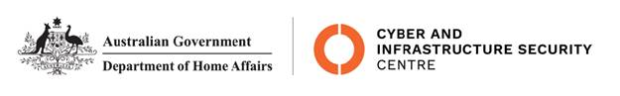

NTC-21892

***Aviation Transport Security Act 2004***

**NTC-21892 - DECLARATION OF SECURITY CONTROLLED AIRPORT AND ESTABLISHMENT OF AIRSIDE AREA - PERTH AIRPORT**

I am a Delegate of the Secretary of the Department of Home Affairs (Secretary). Under subsection

28(2) of the *Aviation Transport Security Act 2004* (the Act), I:

**REVOKE** notice NTC-21870 which declared Perth Airport as a security controlled airport published in the *Gazette* (C2021G00838 on 4 November 2021); and

**DECLARE** that Perth Airport is a security controlled airport, the boundaries of Perth Airport are shown

on the attached maps which form part of this notice; and

**ESTABLISH,** in accordance with section 29 of the Act, an airside area for Perth Airport being that

area indicated as the airside area on the attached maps which form part of this notice.

This Notice commences upon publication in the *Gazette*.

Jaran Blethyn

Assistant Director, Regulatory Compliance

Cyber and Infrastructure Security Operations

Delegate of the Secretary of the

Department of Home Affairs

10 November 2021

Note:

1. *Gazette* means the *Commonwealth of Australia Gazette*
2. This Notice remains in force until otherwise revoked in writing and upon subsequent publication in the *Gazette*

