

Government House

Canberra ACT 2600

**Appointments revoked, appointments made by the Governor General – 8 October 2021**

His Excellency the Governor-General directs it to be notified, for general information, that:

1. He has revoked the appointments of:

* The Hon Scott Morrison MP as Minister for the Public Service;
* The Hon Angus Taylor MP as Minister for Energy and Emissions Reduction; and
* The Hon Ben Morton MP as Parliamentary Secretary to the Prime Minister and Parliamentary Secretary to the Minister for the Public Service and Parliamentary Secretary to the Minister for Finance.

1. He has appointed as a Member of the Federal Executive Council:

* Mr Tim Wilson MP.

1. He has made the following appointments:

* The Hon Angus Taylor MP as Minister for Industry, Energy and Emissions Reduction;
* The Hon Melissa Price MP as Minister for Science and Technology;
* The Hon Ben Morton MP as Minister for the Public Service and Special Minister of State; and
* The Hon Tim Wilson MP as Parliamentary Secretary to the Minister for Industry, Energy and Emissions Reduction.

By His Excellency’s Command

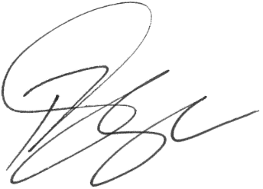

**Paul Singer MVO**

Official Secretary to the Governor-General