***Customs Act 1901***

**Notice under subsection 234AA(3)**

**Specification of areas to which section 234AA applies (No. 21/26) – Sydney International Airport**

I, Jasmina Ackar, delegate of the Comptroller-General of Customs, under subsection 234AA(3) of the *Customs Act 1901* (the Act):

1. REVOKE the notice titled “NOTICE UNDER SECTION 234AA OF THE *CUSTOMS ACT 1901* AIRPORT RESTRICTED AREAS” published in the Commonwealth of Australia Gazette No. 49 on 11 December 2002, specifying areas in the International Terminal of Sydney International Airport as areas to which section 234AA of the Act applies; and
2. SPECIFY the areas within the red boundary lines as indicated in **Attachment A** and **Attachment B** to this notice, at the International Terminal of Sydney International Airport in the state of New South Wales, as areas to which section 234AA of the Act applies.

Dated the 5th day of October 2021.

(Signed)

Jasmina Ackar

Director Ports Policy

Traveller Policy and Industry Engagement

Industry and Border Systems Group

Australian Border Force

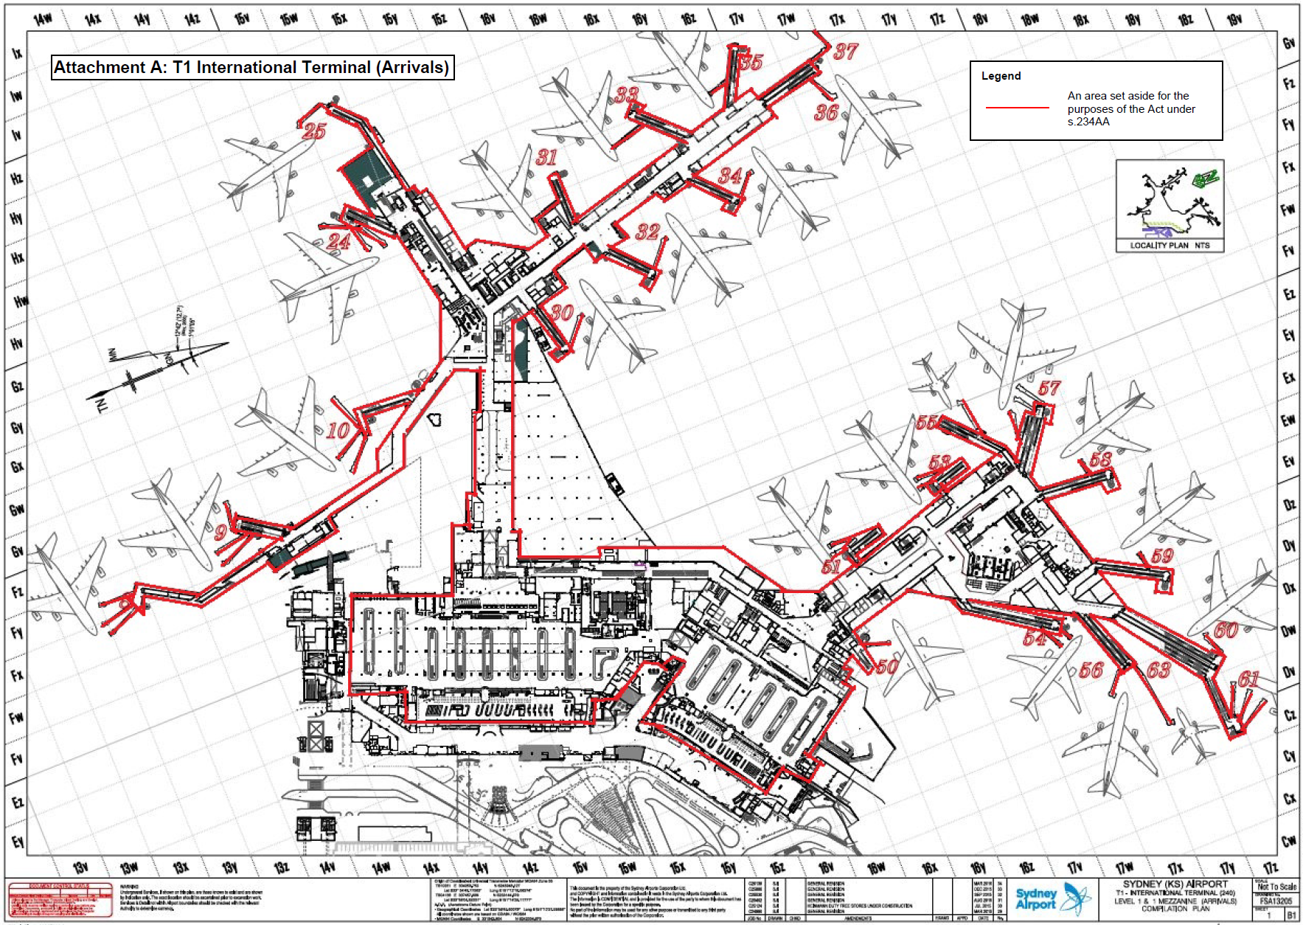

An area set aside for the purposes of the *Customs Act 1901* under s.234AA

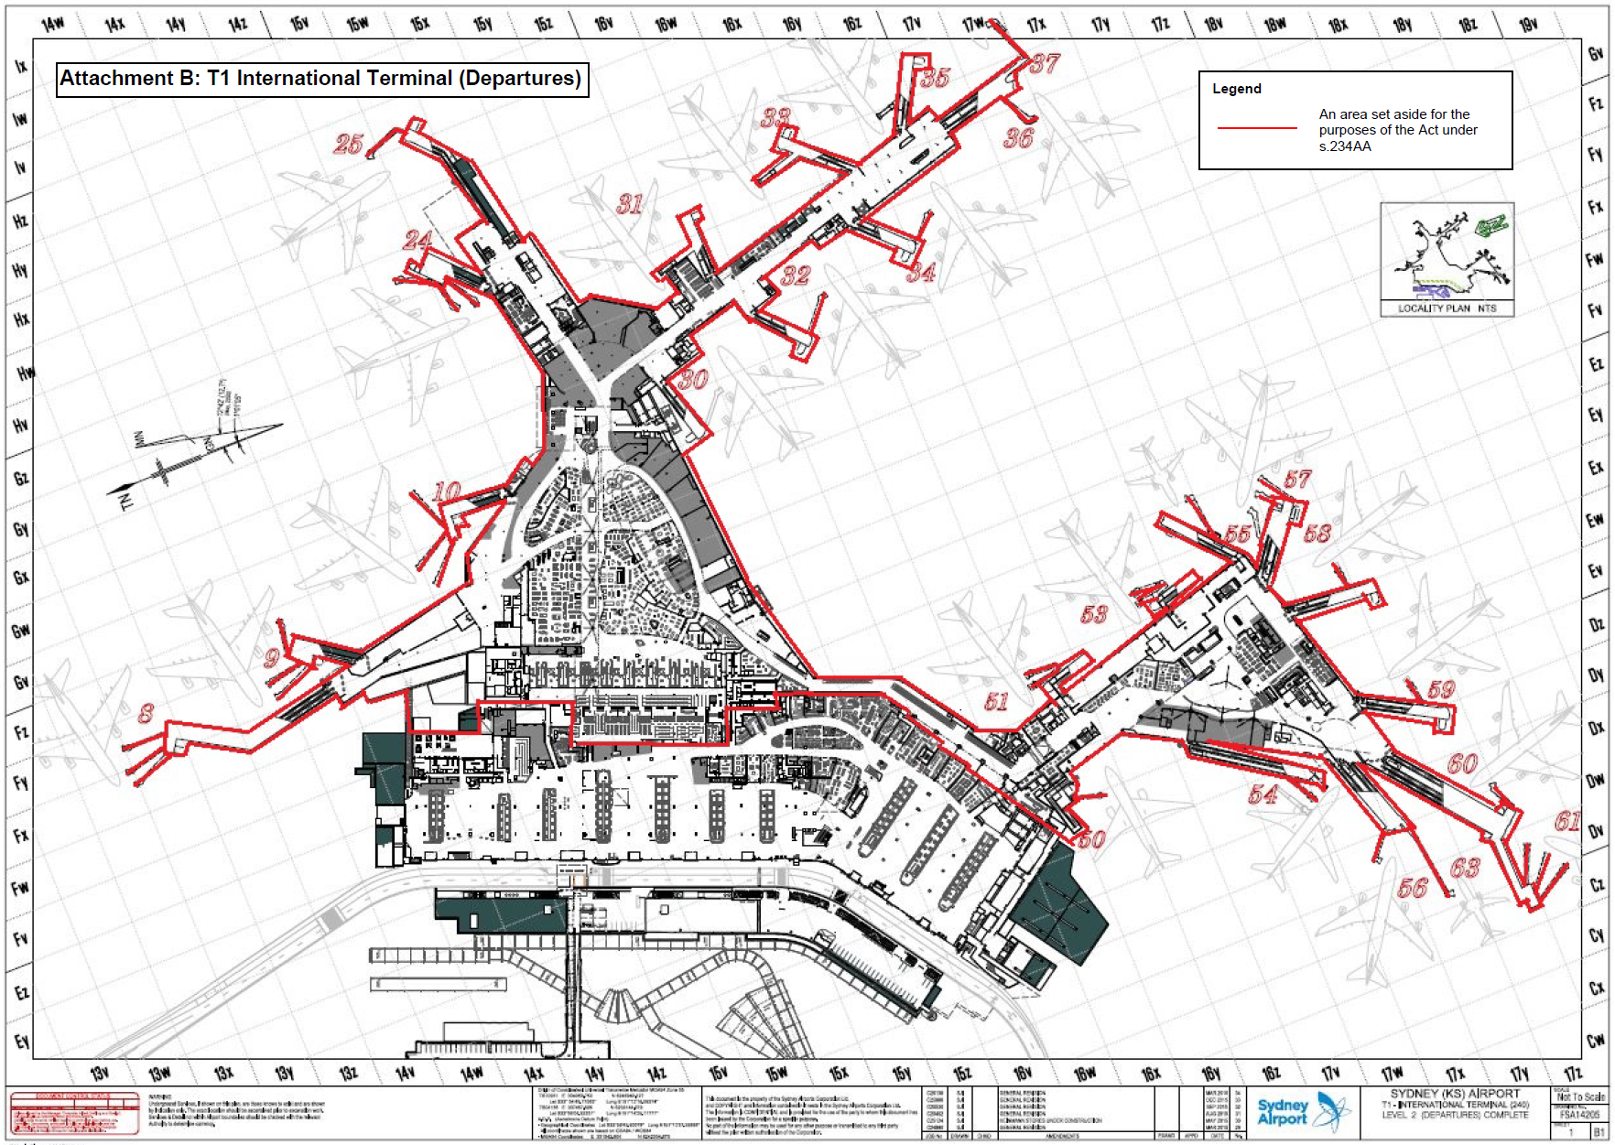

An area set aside for the purposes of the *Customs Act 1901* under s.234AA