***Aboriginal and Torres Strait Islander Heritage Protection Act 1984* (Cth)**

**Notice of an application for the protection of a specified area, being the area known as Burragorang Valley, near Warragamba, New South Wales**

**Invitation to make representations**

I, Greg Terrill, hereby give notice as follows:

The Hon Sussan Ley MP, responsible for the *Aboriginal and Torres Strait Islander Heritage Protection Act 1984* (Cth)(the **Act**), has received an application made under section 10 of the Act. The application is seeking long term preservation and protection of a significant Aboriginal area being the area known as Burragorang Valley, near Warragamba, New South Wales. The Minister has appointed me to provide a report to her under section 10(1)(c) of the Act.

### The Applicant

The application is made on behalf of the Gundungurra Aboriginal Heritage Association Inc. by Aunty Sharyn Halls.

### The purpose of the application

The application seeks the preservation or protection of the area specified in the application and depicted below in Figure 1, from injury or desecration. Section 10 of the Act enables the Minister to decide whether to make a declaration to preserve and protect the specified area, if the Minister is satisfied that the area is a significant Aboriginal area and is under threat of injury or desecration. In the Act, the term ‘significant Aboriginal area’ refers to an area that is of particular significance to Aboriginals in accordance with Aboriginal tradition. Section 3 of the Act provides definitions of relevant terms including ‘Aboriginal tradition’ and ‘injured or desecrated’. The area specified for protection, the claimed significance of the area and the claimed nature of the threat of injury or desecration is set out below.

### Matters the report is required to deal with

The Minister will consider my report under section 10 of the Act in relation to the area sought to be protected before deciding whether to make a declaration under section 10 of the Act. Under section 10(4) of the Act, the report is required to deal with the following matters:

1. the particular significance of the area to Aboriginals;
2. the nature and extent of the threat of injury to, or desecration of, the area;
3. the extent of the area that should be protected;
4. the prohibitions and restrictions to be made with respect to the area;
5. the effects the making of a declaration may have on the proprietary or pecuniary interests of persons other than the Aboriginal or Aboriginals on whose behalf the application is made;
6. the duration of any declaration;
7. the extent to which the area is or may be protected by or under a law of the State or Territory, and the effectiveness of any remedies available under any such law; and
8. such other matters (if any) as prescribed.

### The area sought to be protected (the 'specified area')

The Applicant has specified the area for which protection is sought as a traditional area. This is the area known as the Burragorang Valley, near Warragamba, New South Wales.

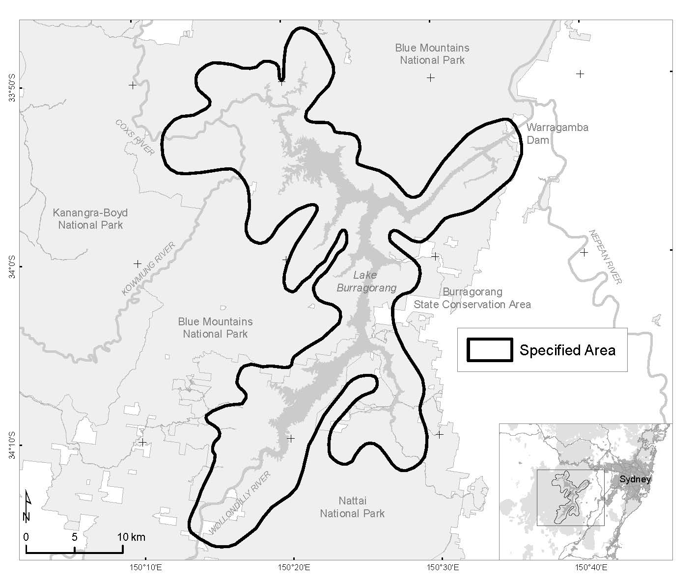

Figure - 1 Map showing the specified area of Burragorang Valley, near Warragamba, NSW

### Claimed nature of particular significance

The Applicant states that the specified area is of particular significance in accordance with Aboriginal tradition because it is the location of a creation story and several intersecting song lines. Further, the specified area contains landscape features from the chase of Gurangatch (Giant Eel) by Mirrigan (a Tiger Quoll like animal).

### Claimed threat of injury or desecration

The Applicant states that the potential injury or desecration is attributed to the proposed raising of the Warragamba Dam walls. The Applicant claims the proposed works “will erase the tangible landscape features recorded in the Burragorang Valley creation story, impacting connection with landscape features described and handed down over countless generations of Gundungurra People”. Further, it will “destroy Gundungurra culture and the spirit of the People, but also all other Aboriginal people in the region that are interconnected to this story, and how it relates to the creation of their own Countries through these ancestral beings”.

### Invitation to make representations

Interested persons are invited to furnish representations in connection with my report to:

**Dr Greg Terrill**

**PO Box 227**

**Dickson, ACT, 2602**

**Ph: 0417 048 259**

**Email: gterrill99@gmail.com**

Representations must be made in writing by **5pm, Friday the 26 February 2021** or within such further period as may be allowed. **Do not send your representations directly to the Minister.**

If you wish to claim confidentiality over any part of your representation, please identify why you are claiming confidentiality and how you wish confidentiality to apply. Representations will be provided to the Minister for the Environment and the Department of Agriculture, Water and the Environment, along with the section 10 report. Representations, even those subject to confidentiality, may be disclosed where it is authorised or required by law, to meet procedural fairness requirements, and in response to a request by a House or Committee of the Parliament of the Commonwealth.