Australian Communications and Media Authority
Telecommunications (Numbering Charges) Act 1997 – Subsection 18(2) Determination for the purposes of subsection 18(1)

Enabling Legislation
- The Australian Communications and Media Authority (the ACMA) makes this Determination under subsection 18(2) of the Telecommunications (Numbering Charges) Act 1997 (the Act).
Commencement
- This Determination commences on the date it is made.
Determination
- For 2021, the ACMA determines 11 April 2021 to be the day for the purposes of subsection 18(1) of the Act.
Note: Under subsection 18(1) of the Act, if a carriage service provider holds an allocated number at the beginning of a day determined under subsection 18(2) of the Act, a charge is imposed by Part 3 of the Act on the number.

Dated: 11 January 2021
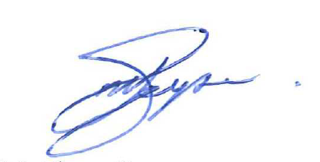
Matthew Geysen
_______________________________
Matthew Geysen, Senior Executive Service - Level 1, as a delegate of the Australian Communications and Media Authority

