NTC -19840

Aviation Transport Security Act 2004

NOTICE OF DECLARATION OF SECURITY CONTROLLED AIRPORT AND AIRSIDE AREA – GOLD COAST AIRPORT

I, MICHAEL GRAY, Assistant Director, Transport Security Operations, Aviation and Maritime Security:

REVOKE, under subsection 28(2) of the Aviation Transport Security Act 2004 (the Act), Notice NTC-15286 which declared Gold Coast Airport as a security controlled airport as published in the Gazette, (C2018G00827, 19 October 2018); and

DECLARE, under subsection 28(2) of the Act, that Gold Coast Airport is a security controlled airport, the boundaries of Gold Coast Airport are shown on the attached map titled ‘Gold Coast Airport – Airport Boundary & Airside Area Map’ and as further detailed by Terminal 1 Insert Maps 1 to 4 that form part of this notice; and

ESTABLISH, in accordance with section 29 of the Act, an airside area for Gold Coast Airport being that area indicated as the airside area on the attached map ‘Gold Coast Airport – Airport Boundary & Airside Area Map’ and as further detailed by Terminal 1 Insert Maps 1 to 4 that form part of this notice.

This Notice commences upon publication in the Gazette.

Date: 27 December 2020

Mick Gray
Delegate of the Secretary of the
Department of Home Affairs

Note:
- Gazette means the Commonwealth of Australia Gazette
- This Notice remains in force until otherwise revoked in writing and upon subsequent publication in the Gazette.

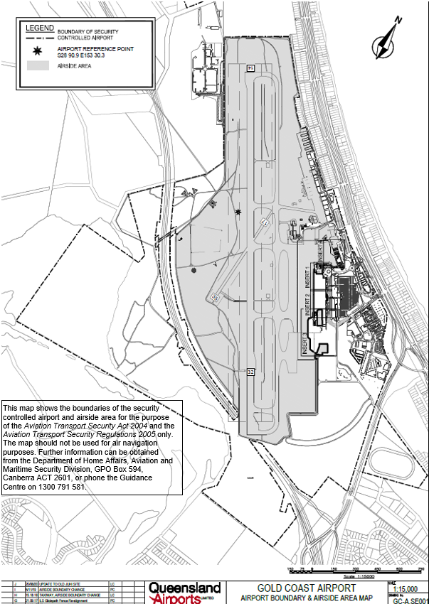

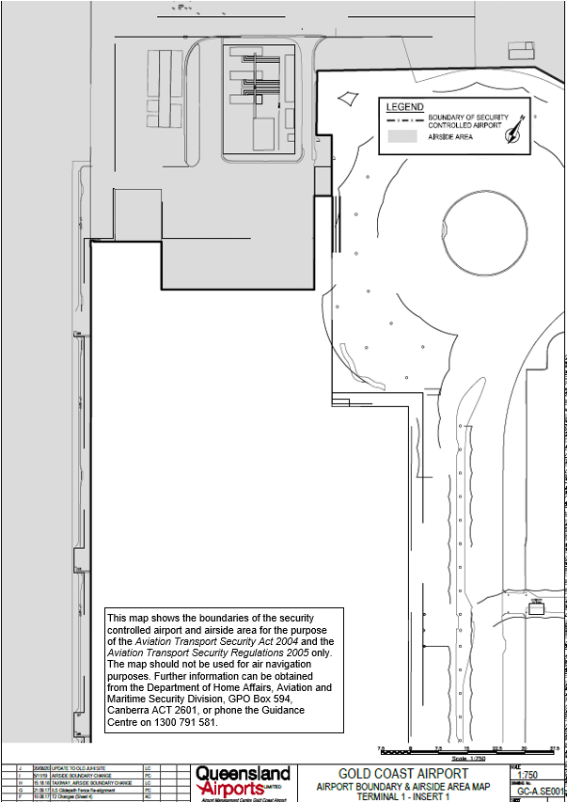

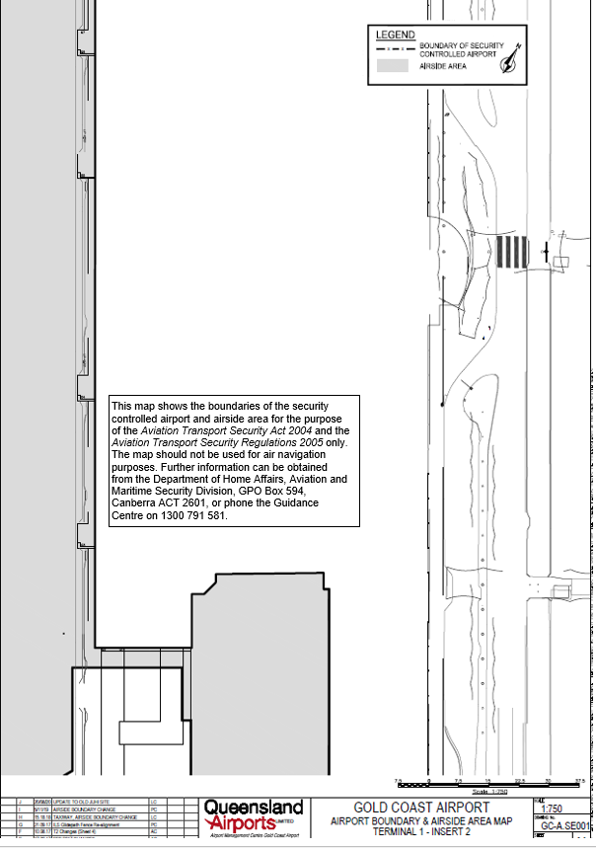

This map shows the boundaries of the security controlled airport and airside area for the purpose of the Aviation Transport Security Act 2004 and the Aviation Transport Security Regulations 2005 only. The map should not be used for air navigation purposes. Further information can be obtained from the Department of Home Affairs, Aviation and Maritime Security Division, GPO Box 594, Canberra ACT 2601, or phone the Guidance Centre on 1300 791 581.

