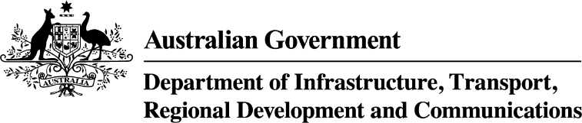

NOTICE OF DECISION TO GRANT AN AUTHORISATION UNDER THE AIRPORTS (ENVIRONMENT PROTECTION) REGULATIONS 1997
Pursuant to Part 5 of the Airports (Environment Protection) Regulations 1997, notice is given that on
28 October 2020 a decision was made by the Airport Environment Officer for Sydney (Kingsford Smith) Airport to grant authorisation to Sydney Water Corporation to periodically discharge sewerage from the overflow point at Discharge Bay, Mill Pond at Sydney Airport until 31 March 2021.
Copies of the decision can be inspected at the offices of the Sydney Airport Lessee Company at the Nigel Love Building, 10 Arrivals Court, Sydney International Airport.

