**COMMONWEALTH OF AUSTRALIA**

***Sections 226, 264 and 708***

***Offshore Petroleum and Greenhouse Gas Storage Act 2006***

**VARIATION OF PIPELINE LICENCE VIC/PL18**

**(FLOUNDER TO TUNA PIPELINE)**

I, **GRAEME ALBERT WATERS**, the National Offshore Petroleum Titles Administrator, on behalf of the Commonwealth–Victoria Offshore Petroleum Joint Authority hereby vary Pipeline Licence VIC/PL18, dated 30 August 1996 (the Licence), for which:

**BHP Billiton Petroleum (Bass Strait) Pty. Ltd.**

(ABN 29 004 228 004)

**Esso Australia Resources Pty Ltd**

(ABN 62 091 829 819)

are the registered titleholders, as set out below.

The variation takes effect on the day on which a notice of the variation is published in the Commonwealth Government Gazette.

Made under the *Offshore Petroleum and Greenhouse Gas Storage Act 2006*  
of the Commonwealth of Australia

**GRAEME ALBERT WATERS**

TITLES ADMINISTRATOR

ON BEHALF OF THE COMMONWEALTH–VICTORIAOFFSHORE PETROLEUM JOINT AUTHORITY

1. The text of the Renewal of Pipeline Licence on Page 1 is varied by:
2. deleting the words:

*“the renewal of Pipeline Licence VIC/PL18, to have effect for a period of twenty-one years from and including the 30th day of August 1996.”*

and replacing with:

*“the renewal of Pipeline Licence VIC/PL18, in the offshore area of Victoria, subject to:*

1. *the conditions set out in this licence:*
2. *the provisions of the Act; and*
3. *the provisions of the Regulations;*

*to construct and operate a pipeline for the conveyance of petroleum, of the design, size, and capacity specified herein, along the route specified herein, in relation to the seabed specified herein, and to operate the pumping stations, tank stations, and valve stations specified in the positions herein, to have effect from and including the 30th day of August 1996.*

*The licensee shall at all times comply with the provisions of the Act and Regulations (amended from time to time).*

1. The ‘INTERPRETATION’ on Page 2 of the Licence is varied by deleting the current text under the heading ‘INTERPRETATION’

and

substituting under the heading the following:

*“In this document:*

*“the Act” means the Offshore Petroleum and Greenhouse Gas Storage Act 2006 and includes any Act with which that Act is incorporated and words used in this document have the same respective meanings as in the Act; and*

*“the Regulations” means regulations made under the Act;*

*“Pipeline” has the same meaning given in the Act.”*

1. The ‘FIRST SCHEDULE’ of the Licence is varied by deleting the current text below the heading ‘FIRST SCHEDULE,’ ‘ROUTE OF PIPELINE’

and

substituting under the heading ‘FIRST SCHEDULE,’ ‘ROUTE OF PIPELINE’ the following:

*“The route of the pipeline is described in the table below, and displayed in the map below, commencing at the flange immediately downstream of the Last Valve Off (LVO) on the Flounder platform and terminating at the first flange upstream of the First Valve On (FVO) on the Tuna Platform. Coordinates are based on Geodetic Datum of Australia (GDA94).*

|  |  |  |  |
| --- | --- | --- | --- |
| **ID** | **DESCRIPTION** | **EASTING** | **NORTHING** |
| 1 | LVO Flounder Manifold | 625859.58 | 5758703.21 |
| 2 | Inflection Point 01 | 625872.38 | 5758703.79 |
| 3 | Inflection Point 02 | 625939.09 | 5759035.67 |
| 4 | Inflection Point 03 | 626163.92 | 5765269.69 |
| 5 | Inflection Point 04 | 625615.17 | 5770983.94 |
| 6 | Inflection Point 05 | 625630.81 | 5771109.54 |
| 7 | West Tuna Fluid Umbilical Crossing | 625623.46 | 5772200.20 |
| 8 | KPA350 South Gas Pipeline Crossing | 625623.51 | 5772222.48 |
| 9 | KPA350 North Gas Pipeline Crossing | 625623.33 | 5772272.70 |
| 10 | West Tuna Electrical Umbilical Crossing | 625623.23 | 5772300.92 |
| 11 | Inflection Point 06 | 625618.73 | 5773573.59 |
| 12 | Inflection Point 07 | 624365.90 | 5774390.58 |
| 13 | FVO Tuna Manifold | 624358.16 | 5774390.34 |

*Coordinate set above is based on GDA94 / MGA Zone 55, survey of pipeline centreline.”*

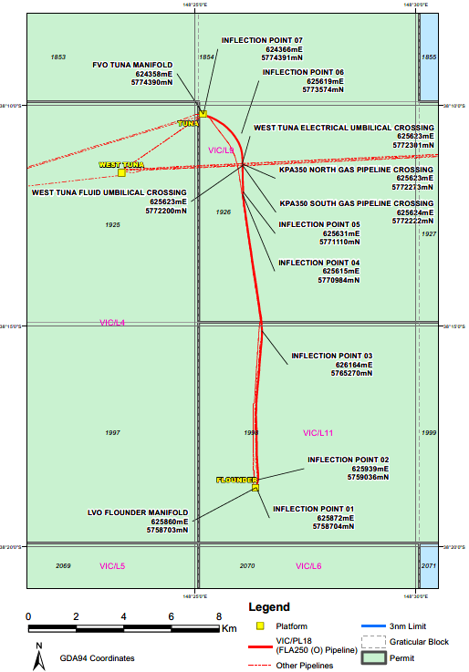

1. The ‘SECOND SCHEDULE’ of the Licence is varied by:
2. deleting the current text under ‘SPECIFICATION,’ Section (A) Design

and

substituting under the heading ‘SPECIFICATION,’ Section (A) Design the following:

*“The pipeline design is based on the following parameters –*

1. *a 250 mm nominal diameter pipeline for the conveyance of gaseous and liquid hydrocarbons;*
2. *a flow rate of 8000 sm3/d (0.050 MMbbl/d) of liquid hydrocarbons and 0.85 MMsm3/d (30.02 MMscf/d) of gaseous hydrocarbons;*
3. *an internal design pressure of 13790 kPag;*
4. *a design temperature of 93⁰C;*
5. *a specific gravity of 2.0 for the 50 mm weight coated pipeline (including contents);*
6. *a pipeline length of 16 km.”*
7. deleting from ‘SPECIFICATION,’ Section (B) Materials of Construction, the words:

*“The materials used in any repair, addition or alteration to the pipeline shall conform to the following specifications –”*

1. deleting the current text under ‘SPECIFICATION,’ Section (B) Materials of Construction, subsection (i) Steel Pipe

and

substituting under the heading ‘SPECIFICATION,’ Section (B) Materials of Construction, subsection (i) Steel Pipe the following:

*“The line pipe shall be in accordance with the requirements of the American Petroleum Institute Specification – API Spec 5L, 38th Edition 1990 for Grade X52 seamless pipe and Esso Australia Limited Supplemental pipe specification accompanying the pipeline licence application, ad except for the riser pipe the pipeline shall have the dimensions 273.1 mm O.D. and 12.7 mm W.T. The said riser pipe shall have the dimensions 273.1 mm O.D. and 18.3 mm W.T. with 11.1 mm W.T. API 5L X65 bends.”*

1. deleting ‘SPECIFICATION,’ Section (B) Materials of Construction, subsection (ii) Valves and Fittings
2. deleting from ‘SPECIFICATION,’ Section (B) Materials of Construction, subsection (iii) Protective Coating, the words:

*“and spirally wrapped with one ply of 6.81 kg (15 lb) coal tar saturated wrap and in accordance with the Esso Australia Limited Protective Coatings Specifications accompanying the original pipeline licence application.”*

1. amending the numbering of ‘SPECIFICATION,’ Section (B) Materials of Construction, subsection (iii) Protective Coating to be:

*“(ii) Protective Coating”*

1. amending the numbering of ‘SPECIFICATION,’ Section (B) Materials of Construction, subsection (iv) Weight Coating to be:

*“(iii) Weight Coating”*

1. deleting ‘SPECIFICATION,’ Section (C) Connections to Pipeline
2. amending the numbering of ‘SPECIFICATION,’ Section (D) Cathodic Protection to be:

*“(C) Cathodic Protection”*

1. deleting ‘SPECIFICATION,’ Section (E) Pressure Control
2. deleting all Part II ‘FURTHER CONDITIONS,’ Sections (A) to (E).