***Aboriginal and Torres Strait Islander Heritage Protection Act 1984* (Cth)**

**Notice of an application for the protection of a specified area, being the area known as ‘Apparrlu (Waubinin Mabauzi Lag and Waubinin Malu)’**

**on Murulag (or Prince of Wales Island), Torres Strait, Queensland**

**Invitation to make representations – Extension of time**

I, Daniel Leo, hereby give notice as follows:

On 28 November 2019, I gave notice that the Minister for the Environment, responsible for the *Aboriginal and Torres Strait Islander Heritage Protection Act 1984* (Cth)(the **Act**), has received an application made under section 10 of the Act (**Gazette - C2019G01060**). The application is seeking long term preservation and protection of a significant Aboriginal area, being within the area known as ‘Apparrlu’ on Murulag (or Prince of Wales Island), and adjacent waters of the Torres Strait, Queensland. The Minister has appointed me to provide a report to her under section 10(1)(c) of the Act.

I initially invited representations from interested persons or parties by 5pm Qld time on Thursday 23 January 2020. I have extended this period until 5pm Qld time on Thursday 26 February 2020 to give all interested persons or parties a further chance to comment if they wish.

### The Applicant

The application is made by Mr Milton Savage and Ms Enid Tom for and on behalf of the Kaurareg People.

### The purpose of the application

The application seeks the preservation or protection of the area specified in the application and depicted below in Figure 1, from injury or desecration. Section 10 of the Act enables the Minister to decide whether to make a declaration to preserve and protect the specified area, if the Minister is satisfied that the area is a significant Aboriginal area and is under threat of injury or desecration. In the Act, the term ‘significant Aboriginal area’ refers to an area that is of particular significance to Aboriginals in accordance with Aboriginal tradition. Section 3 of the Act provides definitions of relevant terms including ‘Aboriginal tradition’ and ‘injured or desecrated’. The area specified for protection, the claimed significance of the area and the claimed nature of the threat of injury or desecration is set out below.

### Matters the report is required to deal with

The Minister will consider my report under section 10 of the Act in relation to the area sought to be protected before deciding whether to make a declaration under section 10 of the Act. Under section 10(4) of the Act, the report is required to deal with the following matters:

1. the particular significance of the area to Aboriginals;
2. the nature and extent of the threat of injury to, or desecration of, the area;
3. the extent of the area that should be protected;
4. the prohibitions and restrictions to be made with respect to the area;
5. the effects the making of a declaration may have on the proprietary or pecuniary interests of persons other than the Aboriginal or Aboriginals on whose behalf the application is made;
6. the duration of any declaration; and
7. the extent to which the area is or may be protected by or under a law of the State or Territory, and the effectiveness of any remedies available under any such law.

### The area sought to be protected (the 'specified area')

The Applicant has specified an area for which protection is sought as a traditional area. This is the area known as ‘Apparrlu – Waubinin Mabauzi Lag’ (being above the high-water mark) and ‘Apparrlu – Waubinin Malu’ (being below the high-water mark) on Murulag in the Torres Strait, Queensland.

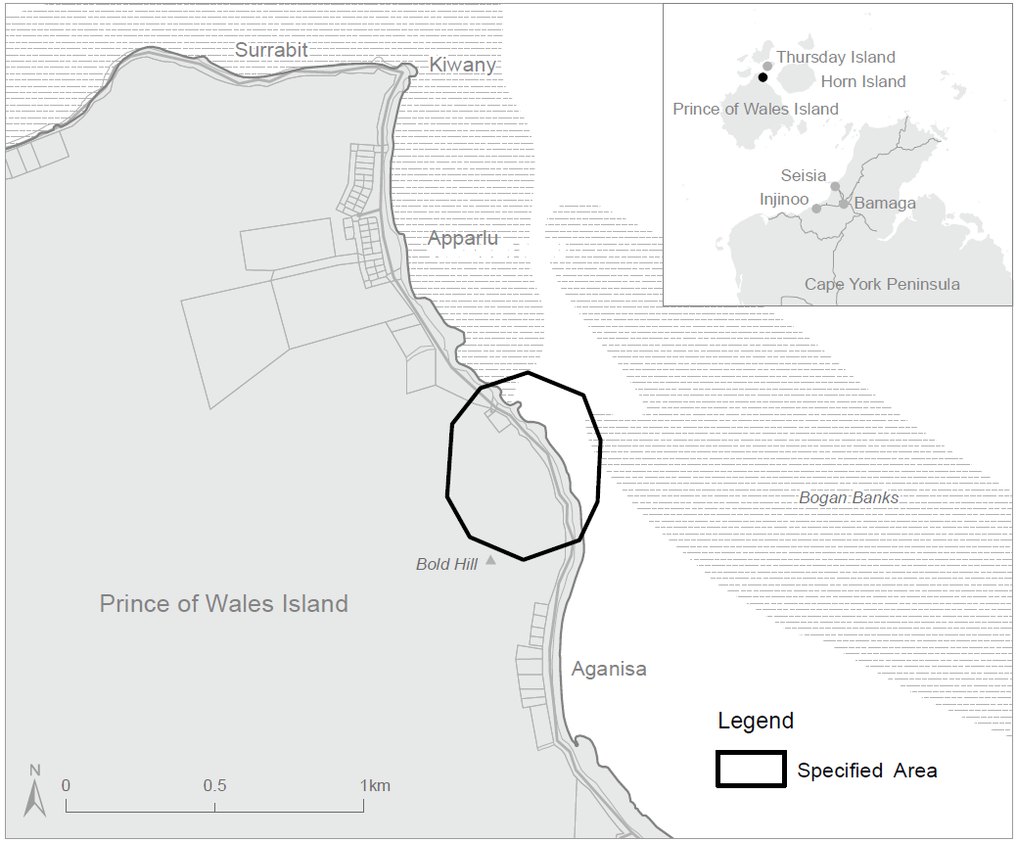

Figure 1 – Map showing the specified area within ‘Apparrlu’ on Murulag (or Prince of Wales Island), Qld

### Claimed nature of particular significance

The Applicant states that the specified area is of particular significance in accordance with Aboriginal tradition because:

* “Waubinin Mabauzi Lag is the site of a creation story about the warrior Waubin, and his role in the formation of the rocks, currents and seas around the Kaurareg islands (Waubinin Malu) which continue to protect the Kaurareg people from unwanted incursions.”
* The “foreshore and waters associated with Apparrlu was also site where rituals of propriation were performed at sea by the Kaurareg on returning to their mother island.”

Other statements made by the Applicant include that:

* Torres Shire “Council has assessed the area as being of ‘high Aboriginal archaeological potential’.”

A supporting document attached to the letter of application states that within the specified area there is an ‘archaeological site’ comprising a ‘standing stone’ and an ‘ethnographic site (Story Place)’. Of the latter:

* “The story of Waubin at the [specified area] … concerns his travels from the waterhole known as Rabau Nguki, located in the mid-southwestern part of the island. After his battle with Badane (another warrior who lived on the island) at Rabau Nguki, Waubin left the waterhole and travelled to the north eastern part of the island – Apparrlu. Here, he walked down the steep hill and into the water where his giant footsteps also created the currents”, plus certain vegetation and rock outcrops, with one of the latter alleged to be ‘damaged’ by roadworks.

### Claimed threat of injury or desecration

The Applicant claims that the threat of injury or desecration to ‘Apparrlu (Waubinin Mabauzi Lag)’ is from roadworks and harbour works proposed by the Torres Shire Council and the threat of injury or desecration to ‘Apparrlu (Waubinin Malu)’ is attributed to the same harbour works. The Applicant states that the Torres Shire Council’s proposed works would injure and desecrate the specified area because:

* It is “integral to the traditions, identity and well-being of the Kaurareg People in accordance with Kaurareg Aboriginal tradition”.
* “The geomorphic features, the rocks, sea-bed, currents and waters to be affected by the proposed development works are an integral part of Kaurareg heritage and identity and will be treated in a manner inconsistent with Kaurareg tradition.”
* “The proposed works may wreak changes to the currents which are an essential element of the dreaming narrative.”
* “Further there are fears that contractors and the like will be entering on the area and using it in a manner inconsistent with Kaurareg tradition.”
* The allegedly damaged rock outcrop will be further damaged, or even destroyed.
* “Sub-surface cultural deposits” / “archaeological deposits” will be damaged or destroyed.

### Invitation to make representations

Interested persons (or parties) are invited to furnish representations in connection with my report to:

Daniel Leo  
Director, Leo Anthropological Service Pty Ltd  
PO Box 1453 Ballina NSW 2478

Ph: 0487 266 622

Email: danleo@mail.com

Interested parties are urged to **contact me** as soon as possible to be provided with further information about the process. **Representations** must be made in writing by 5pm Qld time on Thursday 26 February 2020 or within such further period as may be allowed. **Do not send your representations directly to the Minister.**

Representations received by the due date will subsequently be provided to the applicant and to all interested parties who submitted a representation, and thereafter the applicant and such interested parties will be afforded an additional period of two weeks to make a **final comment** in writing.

If you wish to claim confidentiality over any part of your representation, please identify why you are claiming confidentiality and how you wish confidentiality to apply. Representations will be provided to the Minister for the Environment and the Department of the Environment and Energy, along with the section 10 report. Representations, even those subject to confidentiality, may be disclosed where it is authorised or required by law, to meet procedural fairness requirements, and in response to a request by a House or Committee of the Parliament of the Commonwealth.