Heavy Vehicle National Law

National Class 1 Special Purpose Vehicle Notice 2020 (No 1)

PART 1: PRELIMINARY

Purpose
- This Notice exempts certain types of Class 1 Special Purpose Vehicles (SPVs) from certain requirements of the Heavy Vehicle National Law (HVNL), the Heavy Vehicle (Mass Dimension and Loading) National Regulation (the Regulation) and the Heavy Vehicle (Vehicle Standards) National Regulation and provides conditions relevant to those exemptions.
- This Notice replaces and revokes the National Class 1 Special Purpose Vehicle Notice 2019 (No. 1).
Note: This Notice removes certain scheme registration requirements from the Queensland Schedule and updates a number of references. Exemptions, conditions and network access are unchanged.
All previous amendments applied to the National Class 1 Special Purpose Vehicle Notice are incorporated into this Notice.

Authorising Provision
This Notice is made under s61 and s117 of the Heavy Vehicle National Law as in force in each State and Territory.

Title
This Notice may be cited as the National Class 1 Special Purpose Vehicle Notice 2020.

Commencement
This Notice commences on 3 January 2020.

Expiry
This Notice expires on 5 May 2021.

Application
- This Notice applies in all participating jurisdictions.
- This Notice applies to a heavy motor vehicle that:
  - is a Class 1 Special Purpose Vehicle; and
  - complies with both the mass requirements set out in Part 2 of this Notice and the dimension requirements set out in Part 3 of this Notice; and
  - is not excluded by a condition of this Notice.

Definitions
- Unless otherwise stated, words and expressions used in this Notice have the same meanings as those defined in the HVNL.
- In this Notice -
All terrain mobile crane means an SPV that has all of the following features and requirements:
- is a mobile crane; and
- has two tyres per axle; and
- has at least 50% of its axles steerable; and
- is not a truck mounted SPV; and
- has on road and off road capability; and
- has separate driving and crane operating compartments.
Ground contact width means:
- in relation to an axle, the distance between the outermost point of ground contact of the outside tyres on each end of the axle; or
- in relation to an axle group, the greatest ground contact width of all the axles in the group.

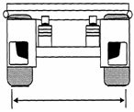
Figure 1 Illustration of ground contact width of an axle
Mobile concrete pump means a heavy motor vehicle with a component that can be used to transfer liquid concrete by pumping.

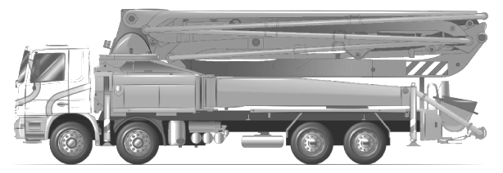
Figure 2 Illustrative example of a mobile concrete pump
Mobile crane means a heavy motor vehicle that is:
- equipped with a crane or other lifting device; and
- designed primarily for raising, moving and lowering a freely suspended load.
Carrier mounted SPV means a heavy motor vehicle that is an SPV where the axles, chassis frame and main equipment are built as an integral vehicle unit, and which cannot be divided without extreme effort, expense or risk of damage to it. A carrier mounted SPV is not a truck mounted SPV.

Example: Most mobile cranes including all terrain mobile cranes and truck cranes are carrier mounted SPVs.
Truck mounted SPV means an SPV built using an ADR compliant heavy vehicle cab chassis.

Example: Most concrete pumps and drilling rigs are truck mounted SPVs.

Pick and carry crane means an articulated mobile crane without stabiliser legs or outriggers which is designed to lift and carry a load.

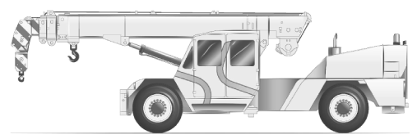
Figure 3 Illustrative example of a pick and carry crane

SPV means a special purpose vehicle as defined in s116 of the HVNL.

PART 2: EXEMPTIONS FROM PRESCRIBED DIMENSION REQUIREMENTS

NOTES ON PRESCRIBED DIMENSION REQUIREMENT EXEMPTIONS UNDER THIS NOTICE
This Part provides specific exemptions from the standard dimension requirements from Schedule 6 of the Regulation and provides replacement limits. Where no exemption is provided below, the dimension requirements in the HVNL and Regulation remain in force.
Note –
The exemptions in this Notice are subject to conditions set out in Schedule 8 of the Regulation applying to Class 1 heavy vehicles.

Exemptions and Dimension Limits
- A vehicle of the type set out in Column 2 of Table 1 is exempt from the dimension requirement of the Regulation specified in Column 3, if applicable.
- The dimensions set out in Column 4 of Table 1 for a type of vehicle set out in Column 2 must not be more than the dimension limit set out in Column 5 opposite that type of vehicle.
TABLE 1 Exemptions and Dimension limits
Column 1 | Column 2 | Column 3 | Column 4 | Column 5
Item No. | Type of vehicle operating under this Notice | Regulation  Schedule 6 exemption | Dimension | Limit
1 | Any | Section 8 | Height | 4.6m
2 | Any | Section 7(1) | Width | 3.5m  (or as specified in the NSW Schedule [vehicle standards only]^{[1]} or the SA Schedule^{[2]})
3 | Any | Section 3 | Length | 14.5m
4 | Any, excluding  3-axle all terrain mobile cranes | Section 5(1)(c) | Distance from the rear overhang line (ROH) to the rear of an SPV | Lesser of 4.0m or 90% of the wheelbase
5 | 3-axle all terrain mobile cranes  (excluded in QLD^{[3]}) | Section 5(1)(c) | Distance from the centre of the last two axles to the rear of the SPV | Lesser of 4.0m or 90% of the wheelbase
6 | Any, excluding mobile cranes | - | Projection in front of the centre of the steering wheel (FPJ) | 3.5m
7 | Mobile cranes | - | Projection in front of the centre of the steering wheel (FPJ) | 5.5m  (or as specified in SA schedule^{[4]})
[1] Please refer to Section 3(4) of NSW schedule.
[2] Please refer to Section 2(2) and 2(3) of SA schedule.
[3] Note that 3-axle all terrain mobile cranes are excluded by Section 2(1) of Queensland schedule.
[4] Please refer to Section 2(4) of SA schedule.
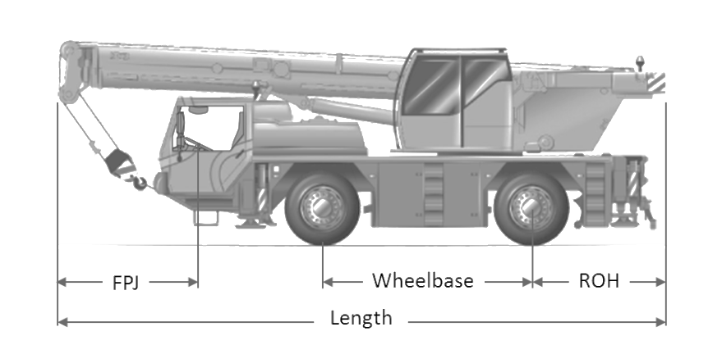
Figure 4 Illustrative example of an all terrain mobile crane showing relevant key dimensions

Rear Overhang for Mobile Concrete Pumps
- A mobile concrete pump complying with section 9(2) is exempt from the rear overhang requirement set out in Schedule 6, section 5(1)(c) of the Regulation.
- The distance from the rear overhang line to the rear of a mobile concrete pump may exceed 4.0m without exceeding 4.5m if the two following conditions are met:
- The tail swing performance and the low speed swept path performance of this vehicle, as measured in accordance with the PBS Scheme Standards and Vehicle Assessment Rules, do not exceed 0.30m and 7.40m respectively. This condition means that the vehicle operates within the PBS Level 1 tail swing and low speed swept path performance; and
- A certificate issued by a PBS assessor accredited under the PBS Scheme Assessor Accreditation rules, certifies that the assessed vehicle complies with the PBS Level 1 tail swing and low speed swept path performance standards. This certificate must be carried in the vehicle whenever it is travelling under this Notice. It must identify the vehicle uniquely by describing the base vehicle, concrete pump model and VIN. It must also contain scaled drawings showing the vehicle dimensions, vehicle low speed swept path and tail swing together with the actual assessment result values and corresponding Level 1 performance limits.
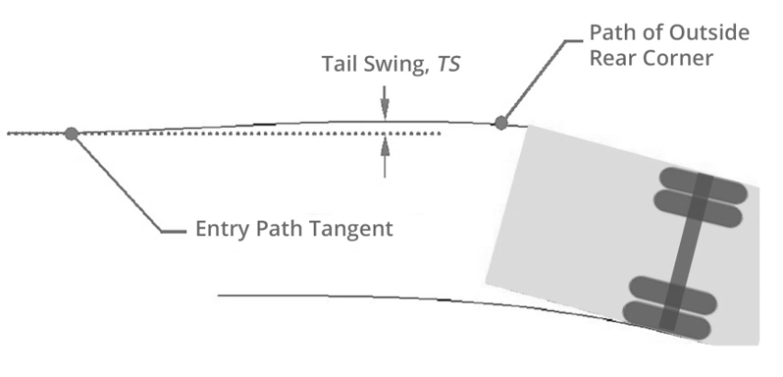
Figure 5 Illustration of tail swing performance measure
(Source: NHVR/NTC Performance-Based Standards Scheme – the Standards and Vehicle Assessment Rules).
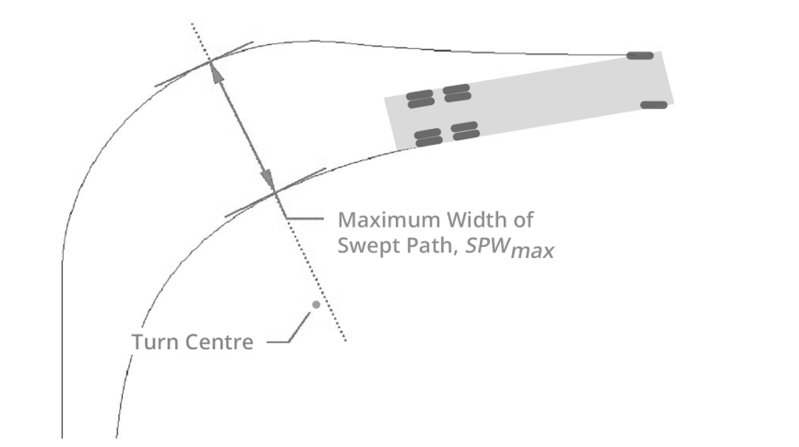
Figure 6 Plan view illustration of Maximum Width of Swept Path, SPWmax
(Source: NHVR/NTC Performance-Based Standards Scheme – the Standards and Vehicle Assessment Rules).
Note-
A comprehensive list of PBS assessors accredited under the PBS Scheme Assessor Accreditation rules is available on the NHVR website.
Note-
A certificate of conformance with PBS Level 1 Tail Swing and Swept Path performance template is available on the NHVR website.

PART 3: EXEMPTIONS FROM PRESCRIBED MASS REQUIREMENTS
NOTES ON PRESCRIBED MASS REQUIREMENT EXEMPTIONS UNDER THIS NOTICE
This Part provides specific exemptions from the standard mass requirements from Schedule 6 of the Regulation and provides replacement limits. Where no exemption is provided below, the mass requirements in the Regulation remain in force.

The mass exemptions provided in this part of the Notice are divided into the following sections:

- Total Mass Limits
- Requirements and exemptions specific to all terrain mobile cranes
- Mass limits for single axles and axle groups
- Tyre mass limits for single axles and each axle in an axle group

Exemptions

- An SPV to which this part applies is exempt from the following mass requirements in Schedule 1 to the Regulation:

- section 2(1)(b);
- section 4 and Table 1 (Axle mass limits table); and
- section 5(1) and Table 2 (Axle spacing mass limits general table).
Note-
Due to the operation of Table 2 of this Notice, s5(1) of the Regulation does not apply to a SPV operating under this Notice, even if this vehicle meets the conditions required to be a complying steer axle vehicle.
- Where a mass exemption limit under one section of this part is different from a mass exemption limit under another section for the same type of vehicle, single axle, axle group, tyre configuration or other condition, the lower limit applies.

Total mass limits

- The total mass of an SPV must not exceed the lesser of:

- The gross vehicle mass (GVM); and
- The sum of the mass limit for each single axle and axle group on the vehicle under sections 13 and 14 of this Notice; and
- 40 tonnes; and
- The mass worked out using the Gross Mass Limit Formula, as follows:

Mass in tonnes = (3 x L) + 15 ±G
where:

"L" is the distance in metres between the centre lines of the vehicle's foremost and rearmost axles; and
"± G" is a number of tonnes to be -

- added at the rate of 1 tonne for each 100mm by which the ground contact width of the heaviest axle or axle group exceeds 2.5m; or
- subtracted at the rate of 1 tonne for each 100mm by which the ground contact width of the heaviest axle or axle group is less than 2.4m.

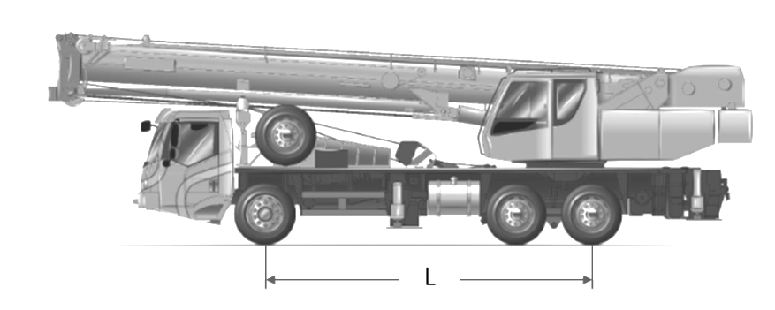
Figure 7 Example illustration of a 3-axle truck crane, showing distance “L”

Requirements and exemptions specific to all terrain mobile cranes
- The distance in metres (L) between the centre of the first axle and the centre of the last axle of a 2-axle all terrain mobile crane must be a minimum of 3.0m.
- A 2-axle all terrain mobile crane must have a ground contact width of at least 2.4m.
- The distance in metres (L) between the centre of the first axle and the centre of the last axle of a 3-axle all terrain mobile crane must be a minimum of 4.0m.
- A 3-axle all terrain mobile crane must have a ground contact width of at least 2.5m.
- A 3-axle all terrain mobile crane is exempted from compliance with the condition set out in section 11(1)(d) of this Notice (the Gross Mass Limit Formula).

Mass limits for single axles and axle groups
Note: Operation of section 13 and section 14 -
Section 13 and section 14 operate in conjunction. Section 13 sets out mass limits for different types of axles or axle groups. These mass limits have to be considered in conjunction with the mass limits set out in section 14. In particular, Table 2 sets out mass limits for single axle and each axle in an axle group, while Table 3 sets out limits related to tyre width.
For example, the mass limit for a tandem axle in an SPV fitted with 254mm wide single tyres, would be 12.0t which is the lower of the mass limit specified in Table 3 (14.0t) and the mass limit specified in Table 2 (two times 6.0t which equals 12.0t for the tandem axle group).
- For an SPV, the mass on a single axle or axle group described in Columns 2 and 3 of Table 2 of this Notice must not be more than the mass limit set out in Column 4 opposite its description.
TABLE 2 Axle mass limits
Column 1 | Column 2 | Column 3 | Column 4
Item No. | Type of axle or axle group | Minimum Ground Contact width of axle (metres) | Mass limit (tonnes)
1 | Single axle fitted with single tyres on:  - all terrain mobile cranes  - any other SPV | Any  Any | 12.0  7.0
2 | Single axle fitted with dual tyres on:  - pick and carry cranes  - any other SPV | Any  Any | 12.0  10.0
3 | Twinsteer axle group:  - without a load-sharing suspension system  - with a load-sharing suspension system | Any  Any | 10.0  16.0
4 | Tandem axle group fitted with single tyres | Any | 14.0
5 | Tandem axle group fitted with dual tyres where the centre lines of the axles are at least 1.20m but less than 1.35m apart. | 2.00  2.10  2.20  2.30  2.40  2.50  2.60  2.70  2.80  2.90  3.00  3.10  3.20 ^{[5]} | 16.0  17.0  18.0  19.0  20.0  20.0  21.0  22.0  23.0  24.0  25.0  26.0  27.0
6 | Tandem axle group fitted with dual tyres where the centre lines of the axles are at least 1.35m apart. | 2.00  2.10  2.20  2.30  2.40  2.50  2.60  2.70  2.80  2.90 ^{[5]} | 19.0  20.0  21.0  22.0  23.0  23.0  24.0  25.0  26.0  27.0
7 | Tri-axle group fitted with single tyres | Any | 18.0
8 | Tri-axle group fitted with dual tyres where the centre lines of the axles are at least 1.20m but less than 1.35 m apart. | 2.00  2.10  2.20  2.30  2.40  2.50 | 21.0  22.0  23.0  24.0  25.0  25.0
9 | Tri-axle group fitted with dual tyres where the centre lines of the axles are at least 1.35 m apart. | 2.00  2.10  2.20  2.30  2.40  2.50 | 23.0  24.0  25.0  26.0  27.0  27.0

[5] For ground contact widths wider than specified in Column 3, increased mass limits are available in Queensland - please refer to section 5(8) (Table 1) of Queensland schedule.

Tyre mass limits for single axles and each axle in an axle group

- The mass on a single axle or each axle of an axle group of an SPV must not exceed the mass limit stated in Table 3.
- If an SPV has an axle fitted with 2 tyres, the mass limit for the axle in relation to the narrowest tyre on that axle as specified in Column 2 of Table 3, is the limit set out opposite that axle in Column 3.
- As a specific exemption from section 14(1), the mass limit on an axle fitted with 2 tyres that are at least 445mm wide on an all terrain mobile crane, is increased to 12 tonnes unless excluded in a state schedule.
Note-
For specific state and territory requirements, refer to section 2(1) of the South Australia schedule, section 2(1) of the Tasmania schedule and section 3(1) of the Queensland schedule.
- If an SPV has an axle fitted with 4 tyres, the mass limit for the axle in relation to the narrowest tyre on that axle as specified in Column 2 of Table 3 is the limit set out opposite that axle in Column 4.
TABLE 3- Mass limit for single axles and each axle in an axle group (based on pavement capacity)
Column 1 | Column 2 |  | Column 3 | Column 4
Column 1 | Tyre width of the narrowest tyre on the axle |  | Column 3 | Column 4
Item No. | at least (mm) | but less than (mm) | Mass limit (t), if the axle has 2 tyres | Mass limit (t), if the axle has 4 tyres
1 | 190 | 228 | 4.5 | 9
2 | 228 | 254 | 5 | 9.5
3 | 254 | 279 | 6 | 10
4 | 279 | 305 | 6.5 | 11
5 | 305 | 330 | 7 | 12
6 | 330 | 356 | 7.5 | 13
7 | 356 | 381 | 8 | 14
8 | 381 | 406 | 9 | 14
9 | 406 | 458 | 10 | 14
10 | 458 | 508 | 11 | 14
11 | 508 | - | 12 | 14

- For the purposes of Table 3, the tyre width of a radial ply tyre is the number of millimetres marked on the tyre in the position labelled "Section width in mm" as shown in Figure 8 below.
- For the purposes of Table 3, the tyre width of a bias-belted tyre is the number of millimetres which is equal to 25.4 multiplied by the number marked on the tyre in the position labelled "Width code in inches" as shown in Figure 9 below.
Note-
1 inch = 25.4mm. The conversion is rounded up to the next whole millimetre.
- If no section width code is marked on a tyre, the tyre width for the purposes of Table 3 may be determined by measuring the width of the part of the tyre that normally comes into contact with the road surface.

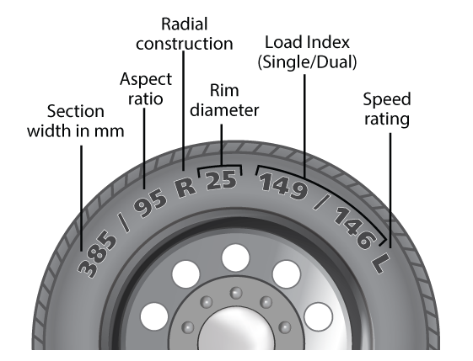 | 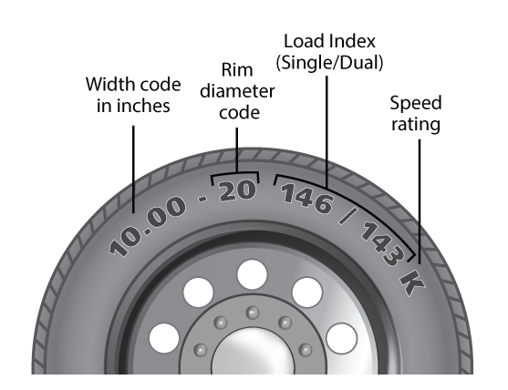
Figure 8 Position of section width marking  on radial ply tyre | Figure 9 Position of width code marking  on bias-belted tyre

PART 4: HEAVY VEHICLE STANDARDS EXEMPTION

Exemption from compliance with Heavy Vehicle Standards

Unless otherwise stated in a state schedule, an SPV complying with the dimension requirements outlined in Part 2 of this Notice is exempt from compliance with Schedule 2, section 34(1) of the Heavy Vehicle (Vehicle Standards) National Regulation.
Note-
Please refer to s3(4) of NSW schedule.
Note-
This section is intended to streamline the registration of SPVs.

PART 5: GENERAL CONDITIONS OF OPERATION
NOTE ON GENERAL CONDITIONS OF OPERATION

The exemptions in this part operate in conjunction with the conditions set out in Schedule 8 of the Regulation.

Warning Lights and Markings
- In addition to the requirements set out in Schedule 8, section 17(2) of the Regulation, a pattern covering an area of at least 0.16m² and consisting of diagonal stripes at least 150mm wide and alternatively coloured red and white, or black and white, must be marked on the left and right sides and extremity of any rigid projection extending more than 1.2m in front or to the rear of the body of a special purpose vehicle.
- Mobile cranes with a projection in front of the centre of the steering wheel (FPJ) exceeding 3.5m must have —
- side marker lights on both sides of the boom, as far forward as possible. The side marker lights must be shielded from the driver’s view, but be visible to other motorists approaching from the front and sides of the crane, and
- a yellow rotating warning light attached to the boom, as far forward as possible, that is shielded from the driver’s view.

Carrying additional equipment
- Subject to section 17(2), an SPV must not carry goods.
- An SPV may only carry additional equipment, tools, substances, or detached parts that are to be used in conjunction with the special purpose vehicle.
- The total mass of the additional equipment, tools, substances, or detached parts carried on an SPV under section 17(2) must not exceed 1 tonne.
- Fuel in the tank(s) connected to the vehicle fuel supply system is not considered as additional substances under section 17(2). In section 11(1) of this Notice, the total mass of an SPV is the sum of:
- the mass of the SPV; and
- the mass of any additional equipment, tools, substances, or detached parts it carries.

Note-
Examples of additional equipment, tools, substances, or detached parts described in section 17(2) include slings, hooks, tackle and timbers for cranes, water, cement, fly ash and extension pipes for a concrete pump, drill stems and rigging tools for a drill rig, fire-fighting equipment, quantity of water and foam for a fire truck.

Operation of State and Territory Schedules

A vehicle operating under this Notice must comply with the conditions set out in the Schedule for a participating jurisdiction where the vehicle is being used.

Peter Caprioli
Executive Director (Freight and Supply Chain Productivity)
National Heavy Vehicle Regulator

SCHEDULE 1 – AUSTRALIAN CAPITAL TERRITORY
- ACT definitions
- Unless otherwise stated, words and expressions used in this Schedule have the same meanings as those defined in the HVNL.
- In this Schedule -
Public holiday period means:
- a period of three or more consecutive days covering an Australian Capital Territory public holiday as published on the Chief Minister, Treasury and Economic Development Directorate’s website, and adjacent weekend days (for example, Easter and every long weekend); and
- the period between 23 December in one year and 3 January in the following year (inclusive).
- ACT application
This schedule applies to special purpose vehicles operating in the Australian Capital Territory (ACT).
- ACT conditions
- A pick and carry crane must comply with the following conditions:
- the maximum speed of the vehicle is not to exceed 80km/h. An 80km/h maximum speed sign must be fitted to the rear of the vehicle.
- a hydraulic steering warning decal must display a maximum speed limit of 80km/h.
- An SPV operating in the ACT must be fitted with a third number plate to the rear of an SPV where a single number plate may be obscured from enforcement detection devices.
- ACT stated areas and routes
- All SPVs covered by this Notice are permitted to use all public roads in the ACT subject to any conditions or restrictions in the list titled ‘ACT Special Purpose Vehicles Network – Routes with Mass and Width Conditions/Restrictions’ set out in Appendix 1.
- A vehicle that is more than 4.3 metres in height but no more than 4.6 metres in height, must only travel on routes that are listed in the Australian Capital Territory Class 2 General B-double Exemption Notice 2010 Amendment Notice 2015 (No.1) and the Australian Capital Territory Class 2 26m B-double Exemption Notice 2010 Amendment Notice 2015 (No.1).

- ACT area and route conditions
Where practical and safe to do so, an all terrain mobile crane must avoid being on a bridge at the same time as a B-double, a Class 1 heavy vehicle or a Class 3 heavy vehicle.

Appendix 1: ACT Special Purpose Vehicles Network

The ‘ACT Special Purpose Vehicles Network – Routes with Mass and Width Conditions/Restrictions’ list can be found on the NHVR website..

SCHEDULE 2 – NEW SOUTH WALES

- NSW definitions
- Unless otherwise stated, words and expressions used in this Schedule have the same meanings as those defined in HVNL.
- In this Schedule -
NSW Urban Zone means the area/zone displayed as the NSW Urban Zone on the map and/or list titled ‘NSW Special Purpose Vehicle Network’.
Newcastle Inner Zone means the area/zone displayed as the Newcastle Inner Zone on the map and/or list titled ‘NSW Special Purpose Vehicle Network’.
Newcastle Outer Zone means the area/zone displayed as the Newcastle Outer Zone on the map and/or list titled ‘NSW Special Purpose Vehicle Network’.
Public holiday period means:
- a period of three or more consecutive days covering a NSW public holiday as published in the NSW Government Gazette, and adjacent weekend days (for example, Easter and every long weekend); or
- the period between 23 December in one year and 3 January in the following year (inclusive).
Limited Access Locations means locations displayed as Limited Access Locations on the map and/or list titled ‘NSW Special Purpose Vehicle Network’.
Limited Access Zones means zones displayed as Limited Access Zones on the map and/or list titled ‘NSW Special Purpose Vehicle Network’.
Restricted Structures means bridges or structures displayed as Restricted Structures on the map and/or list titled ‘NSW Special Purpose Vehicle Network’.
Restricted Structures with Conditional Access means bridges or structures displayed as Restricted Structures with Conditional Access on the map and/or list titled ‘NSW Special Purpose Vehicle Network’.
- NSW application
This schedule applies to vehicles operating in New South Wales (NSW).
- NSW conditions
- To operate under this Notice in NSW, a mobile crane that exceeds 2.5 metres in width must be enrolled and monitored in the Intelligent Access Program (IAP) with Roads and Maritime Services in accordance with Chapter 7 of the Heavy Vehicle National Law.

- A current Certificate of Enrolment issued by Roads and Maritime Services must be carried in the vehicle to which section 3(1) of this Schedule applies and be produced when requested to do so by a Police Officer or an Authorised Officer.
Note: A Certificate of Enrolment is issued from Roads and Maritime Services when the vehicle is enrolled and monitored by the IAP in NSW.

- A pick and carry crane must comply with the following conditions:
- The maximum speed of the vehicle is not to exceed 80km/h. An 80km/h maximum speed sign must be fitted to the rear of the vehicle.
- A hydraulic steering warning decal must display a maximum speed limit of 80km/h.
- Two (2) convex mirrors with a minimum diameter of 300mm must be fitted to the vehicle and located no less than 1.0m from the foremost point of the jib. The mirrors must be located so that any reflected images from either side of the vehicle are clearly visible and discernible to the driver in his normal seating position.
- Section 15 of this Notice does not apply to an SPV, other than a mobile crane, which is wider than 2.5m.
- NSW stated areas and routes

- A 3-axle all terrain mobile crane must only travel on ‘SPV Level 3 Approved Routes’ as displayed on the map and/or list titled ‘NSW Special Purpose Vehicle Network’ on the RMS website.
- A vehicle other than a 3-axle all terrain mobile crane, must only travel on ‘SPV Level 1 Approved Routes’ as displayed on the map and/or list titled ‘NSW Special Purpose Vehicle Network’ on the RMS website.
- A vehicle that is more than 4.3m but no more than 4.6m in height must only travel on routes that are approved for 4.6m high vehicles as displayed on the map and/or list titled ‘NSW Special Purpose Vehicle Network’ on the RMS website.
- NSW areas and route conditions
- A vehicle operating under this Notice must comply with any conditions displayed as ‘Travel conditions exist on this route’ on the map and/or list titled ‘NSW Special Purpose Vehicle Network’.
- A vehicle must not travel in a Clearway or Transit Lane between the hours of 6:00am and 10:00am and between the hours of 3:00pm and 7:00pm.
- A vehicle must not travel on any classified State Road within the NSW Urban Zone between Monday and Friday (except on state-wide public holidays) between the hours of 7:00am and 9:00am and between the hours of 4:00pm and 6:00pm.
- Notwithstanding subsection (3), vehicles not exceeding 3.2m in width may operate in the Newcastle Outer Zone during peak hour times specified in subsection (3). Vehicles exceeding 3.2m in width must not travel within the Newcastle Outer Zone on any classified State Road during the peak hour times specified in subsection (3).
- A special purpose vehicle not wider than 2.5m may travel between sunset and sunrise.
- Notwithstanding subsection (5), a mobile crane not wider than 3.1m may travel between sunset and sunrise.
- A special purpose vehicle wider than 2.5m may only travel at night on roads or on roads in locations or zones displayed as ‘Roads and zones approved for oversize night travel’ on the map and/or list titled ‘NSW Special Purpose Vehicle Network’ in accordance with any times and conditions that apply.
- Notwithstanding subsection (7), a mobile crane wider than 3.1m may only travel at night on roads or on roads in locations or zones displayed as ‘Roads and zones approved for oversize night travel’ on the map and/or list titled ‘NSW Special Purpose Vehicle Network’ in accordance with any times and conditions that apply.
- A vehicle must not travel on or through a Limited Access Location or Limited Access Zone displayed as ‘Limited Access Locations’ or ‘Limited Access Zones’ on the map and/or list titled ‘NSW Special Purpose Vehicle Network’ if the vehicle exceeds one or more of the dimension limits as displayed on the Location or Zone and in accordance with any conditions that apply.
- A vehicle must not travel on any road displayed as ‘No oversize travel during public holiday periods’ on the map and/or list titled ‘NSW Special Purpose Vehicle Network’ during a public holiday period and in accordance with any times and conditions that apply.
- A vehicle must:
- Not travel over a bridge or structure displayed as ‘Restricted Structures’ on the map and/or list titled ‘NSW Special Purpose Vehicle Network’.
- Only travel over a bridge or structure displayed as ‘Restricted Structures with Conditional Access’ on the map and/or list titled ‘NSW Special Purpose Vehicle Network’ in accordance with any conditions that apply.
- When travelling across a bridge, a vehicle must travel at a steady speed not exceeding 40km/h.
- A special purpose vehicle wider than 2.5m, other than a mobile crane, must be accompanied by at least 1 pilot vehicle for night time travel.
- A mobile crane wider than 3.1m must be accompanied by at least 1 pilot vehicle for night time travel.

- NSW urban peak hour concession
- To operate under the Urban Peak hour Concession (UPC), an eligible mobile crane must be enrolled in a relevant UPC scheme in the IAP with Roads and Maritime Services.
Note-
More information on mobile crane operations under the UPC can be found on the RMS website.

- A mobile crane that meets all of the following requirements is exempt from section 6(1) of this Schedule for the purpose of enrolment requirements in the IAP with Roads and Maritime Services:
  - is not more than 2.5m wide;
  - is not more than 10.5m long;
  - does not have a projection in front of the centre of the steering wheel exceeding 5.5m; and
  - complies with all other mass and dimension requirements contained in this Notice.

- A mobile crane that meets all of the following requirements is exempt from section 6(1) of this Schedule for the purpose of enrolment requirements in the IAP with Roads and Maritime Services:
- is not more than 2.5m wide;
- is not more than 10.8m long;
- does not have a projection in front of the centre of the steering wheel exceeding 4.6m; and
- complies with all other mass and dimension requirements contained in this Notice.

Note-
Mobile cranes complying with the mass and dimension requirements contained in sections 6(2) and (3) of this Schedule are also eligible to operate under the UPC.

- A mobile crane operating under the UPC is exempted from section 5(1) of this Schedule for the purpose of conditions applying on the Great Western Highway from the Nepean River at Emu Plains to Katoomba.
- A mobile crane operating under the UPC is exempted from sections 5(2) and (3) of this Schedule.
- The UPC does not apply during state-wide public holidays or public holiday periods.

- Urban Access Concession
(1) To operate under the Urban Access Concession (UAC), an eligible mobile crane must be enrolled in a relevant UAC scheme in the IAP with Roads and Maritime Services.
Note- More information on mobile crane operations under the UAC can be found on the RMS website.

- A mobile crane that meets all of the following requirements is exempt from section 7(1) of this Schedule for the purpose of enrolment requirements in the IAP with Roads and Maritime Services:
- is not more than 2.5m wide;
- is not more than 14.5m long;
- does not have a projection in front of the centre of the steering wheel exceeding 3.5m; and
- complies with all other mass and dimension requirements contained in this Notice.

- A mobile crane that meets all of the following requirements is exempt from section 7(1) of this Schedule for the purpose of enrolment requirements in the IAP with Roads and Maritime Services:
- is not more than 2.5m wide;
- is not more than 10.8m long;
- does not have a projection in front of the centre of the steering wheel exceeding 5.5m; and
- complies with all other mass and dimension requirements contained in this Notice.

Note- Mobile cranes complying with the mass and dimension requirements contained in sections 7(2) and (3) of this Schedule are also eligible to operate under the UAC.

- A mobile crane operating under the UAC is exempted from section 5(1) of this Schedule for the purpose of conditions applying on the Great Western Highway from the Nepean River at Emu Plains to Katoomba.
- A mobile crane operating under the UAC is exempted from sections 5(2) and (3) of this Schedule.
- A mobile crane operating under the UAC may operate in the following tunnels:
- Cross City Tunnel from McLachlan Avenue, Rushcutters Bay to Harbour Street at Darling Harbour;
- Sydney Harbour Tunnel from F1 Warringah Freeway to the Cahill Expressway;
- Cahill Expressway from the Southern Toll Plaza to the Eastern Distributor;
- Eastern Distributor from the Cahill Expressway to Baker Street at Kensington;
- M5 East Motorway (tunnel) between King Georges Road interchange at Beverley Hills and General Holmes Drive, Mascot;
- Lane Cove Tunnel from Pacific Highway to Lane Cove River at Lane Cove North.
- When operating in a tunnel identified in section 7(6) of this Schedule and the forward projection of the mobile crane exceeds 3.5 metres a tether must be fitted that meets all of the following requirements:
- Be yellow and red in colour;
- Be manufactured to a standard outlined in AS 4497-1997;
- Be fitted from either of the travelling lugs of the boom to a lug at the front of the crane carrier; and
- Not obscure the visibility of the mobile crane’s number plate.

- The UAC does not apply during state-wide public holidays or public holiday periods.

SCHEDULE 3 – QUEENSLAND

- Queensland definitions
- Unless otherwise stated, words and expressions used in this Schedule have the same meanings as those defined in HVNL.
- In this Schedule -
Authority to operate (ATO) means an approval granted by TMR for a vehicle to conditionally operate at certain mass and dimension limits.
Note: This approval is recorded in the NHVR Portal by TMR and is based on a supervised weigh and measure.
Brisbane Urban Corridor means the route between Archerfield and Wishart consisting of Mt Gravatt-Capalaba Road west of the Gateway Motorway, Kessels Road, Riawena Road, and Granard Road.
Built-up area, in relation to a length of road, means an area in which there are buildings on land next to the road, or where there is street lighting at intervals not over 100m for a distance of at least 500m, or if the road is shorter than 500m, for the whole road.
Central Business District means the network of roads that are located within the regulated parking zone of any city.
City includes any place within the city limits of the following towns or cities listed and is not limited to the Central Business District of any such place. The towns or cities included are: Brisbane, Bundaberg, Caboolture, Cairns, Caloundra, Gladstone, Gold Coast, Ipswich, Logan City, Mackay, Maryborough, Mount Isa, Rockhampton, Townsville, and Toowoomba.
Overmass or excess mass means having a mass that, including the mass of any load, exceeds a relevant mass limit in the Heavy Vehicle (Mass, Dimension and Loading) National Regulation.
South east corner means the area bounded by Coolangatta in the south, Gympie in the north, and Toowoomba and Warwick in the west.
TMR means the Queensland Department of Transport and Main Roads.

- Queensland application
- This schedule applies to SPVs operating in Queensland excluding all terrain mobile cranes with 3 or more axles.
- To operate on the state controlled network in Queensland under this Notice, an SPV must comply with all applicable conditions of operation in this Notice.

- Queensland general conditions
- Section 14(3) of this Notice does not apply to all terrain mobile cranes operating in Queensland, which must comply with the tyre and axle mass requirements specified in Table 3 of this Notice.
- A vehicle operating under this Notice must have a current Authority to Operate (ATO).
- The operating mass and dimension of an SPV operating under this Notice must not exceed the limits specified in the ATO relevant to the vehicle being driven. If the mass and/or dimension limits applicable to an SPV operating under this Notice are greater than those specified in a vehicle’s ATO, the lower ATO mass and/or dimension limits prevail.
- A route assessment must be conducted based on the ‘Conditions of Operation Database’ before any journey and the driver must carry the following documents in the vehicle at all times whilst operating on the road network:
- a copy of the current conditions of operations for the route being undertaken, including temporary road closures or limits, from the ‘Conditions of Operations Database’; and
- all relevant permissions and authorities to ensure the movement of the oversize vehicle does not pose a danger to property or other road users.
- A SPV operating under this Notice must not tow a trailer or any other vehicle.
- A pick and carry crane must not exceed 80kph.
- Queensland requirements for oversize special purpose vehicles
- The maximum speed limit applying to an oversize SPV is:
- 90km/h outside built up areas, except where official traffic signs indicate a lower speed limit; or
- the vehicle manufacturer's specified limit if lower than (a).
Note: Where the oversize SPV is travelling at a speed that causes a build-up of traffic, the driver of the oversize vehicle must take all reasonable steps to alleviate the build-up of traffic. This does not include exceeding any speed limit mentioned in (a) or (b).
- The registered operator and/or driver of an oversize SPV must plan safe parking areas prior to a journey for circumstances where glare, fog, heavy rain, smoke, dust or insect plague restrict visibility such that the safety of other road users may be compromised.
- The registered operator and/or driver of an oversize SPV must as soon as practical report any damage caused by an oversize vehicle to the asset owner/s. In the event the damage presents a dangerous situation, the local police and the asset owner are to be advised immediately.

- Queensland requirements for overmass special purpose vehicles
- Unless otherwise specified in this Notice an SPV must have a load sharing suspension system fitted to all axle groups which have more than one axle in the group.
- All overmass SPVs must be made available for a supervised weighing to establish operational requirements.
Note
The requirement for a supervised weigh does not apply if an SPV is issued with an exemption.
- The registered operator and/or driver of an SPV must allow the vehicle to be weighed when requested by an Authorised Officer.
- An SPV must not be driven on a road, bridge or other structure at a mass that exceeds the mass limit:
- shown on a sign relating to the road, bridge, or other structure; or
- set during a temporary road closure or mass limitation.
- The following conditions apply to a SPV which carries additional equipment:
- the vehicle's tare and approved GVM must be recorded on the vehicle's ATO.
- additional equipment under section 17 of this Notice is permitted to be carried on the condition that the SPV does not exceed the tyre requirements, axle masses, axle group masses and total mass limits of the Notice or the vehicle's ATO mass limits.
- The term “substances” in section 17 of this Notice (Carrying additional equipment) does not include substances that are to be spread by the vehicle.
- Carrying a load other than the additional equipment under section 5(5) of this schedule on a road in Queensland is not permitted.
- An SPV must be configured to its day-to-day operational mass and mode as specified in its ATO and/or any removable/movable counterweight blocks are to be either removed for travel or located such that the maximum permitted axle masses are not exceeded.
- The mass on an axle group described in Columns 2 and 3 of Table 1 of this Schedule must not be more than the mass limit set out in Column 4 opposite its description.

Table 1 Axle mass limits for special purpose vehicles in Queensland
Column 1 | Column 2 | Column 3 | Column 4
Item No. | Type of axle or axle group | Minimum Ground Contact width of axle (metres) | Mass limit (tonnes)
1 | Tandem axle group fitted with dual tyres where the centre lines of the axles are at least 1.20m but less than 1.35 m apart. | 3.3 | 28.0
2 | Tandem axle group fitted with dual tyres where the centre lines of the axles are at least 1.35 m apart. | 3.0 | 28.0

- Queensland area and route conditions

Network accessible to SPVs operating under this Notice
- SPVs operating under this Notice have access to all state controlled roads in Queensland subject to the conditions of this schedule.
- SPVs operating under this Notice have access to local government roads and/or areas listed in the document titled ‘Queensland Special Purpose Vehicles Local Government Network’ subject to any conditions or restrictions set out in this document and in this schedule.
Note-
The ‘Queensland Special Purpose Vehicles Local Government Network’ list is available on the NHVR website.
Restrictions
- The registered operator and driver of an SPV operating under this Notice must ensure the vehicle does not operate in contravention of conditions, dimension limits or mass limits which exceed those specified for particular roads in the ‘Conditions of Operations Database’.
- The registered operator and driver of a pick and carry crane or of a 2 axle all terrain mobile crane that has a mass greater than 10t on one or more axles must ensure the vehicle does not cross a structure that is listed on the ‘Do not Cross Structure List for National Class 1 Special Purpose Vehicle Notice 2016’.
Note:
The Do not Cross Structure List for National Class 1 Special Purpose Vehicle Notice 2016 can be accessed On the TMR website.
The registered operator must register with TMR’s Heavy Vehicle Access Management online/email notification system to receive updates on conditions of structures.
- Current conditions of operations can be accessed via the TMR web site (see section 11 of this schedule).
- Where the height dimension of an oversize SPV is likely to interfere with overhead wires, or falls within the exclusion zone specified for overhead wires, approval must be obtained from the relevant authorities:
- electrical authority;
- telecommunications authority; and/or
- Queensland Rail.

- Queensland specific area conditions

- The driver of an oversize SPV operating under this Notice must observe the restrictions for the prescribed areas and roads set out in section 7(2) to 7(5) of this Schedule.
- A person must not drive an oversize SPV in the City of Brisbane, Gold Coast City or Central Business District of any other city between 7:00am and 9:00am or between 4:00pm and 6:00pm on business days unless the SPV is no wider than 3.5m and is travelling to or from a job site.
City of Brisbane
- An oversize SPV is not permitted in the following areas:
- Pacific Motorway (South East Freeway and Riverside Expressway) north of its intersection with the Gateway Arterial Road; or
- Western Arterial Road from Miskin Street, Toowong to Stafford Road, Everton Park (Frederick Street, Rouen Street, Boundary Street, Kaye Street, MacGregor Terrace, Jubilee Terrace, Elimatta Drive, Stewart Road, Wardell Street up to Lloyd St); or
- Houghton Highway Bridge and Ted Smout Bridge; or
- Clem 7 (North-South bypass) Tunnel; or
- Airport Link Tunnel; or
- Legacy Way Tunnel.

Queensland – south east corner
- An oversize SPV exceeding 3.1m in width is not permitted to travel on the roads within the south east corner between:
- 7.00am to sunset on Saturdays, Sundays and state-wide public holidays; and
- midday to sunset, the day prior to a state-wide long weekend.
- Despite section 7(3) of this Schedule an oversize SPV exceeding 3.1m in width is permitted to travel on the roads within the south east corner, except roads within the Brisbane Central Business District and Brisbane Urban Corridor from 7.00am to 10.00am on Saturdays, Sundays and state-wide public holidays.
- Despite section 7(3) an oversize SPV exceeding 3.1m in width is permitted to travel on the Warrego Highway and Ipswich Motorway between Toowoomba and Rocklea (including a radius of 500m from Ipswich Motorway, Rocklea) from 10.00am to 4.00pm on Sundays and 10.00am to sunset on a Saturday or a public holiday.
Note- A long weekend is when a weekend joins a public holiday.
Note- A reference to public holidays within this section does not include the Easter and Christmas periods (see section 10 of this Schedule regarding Seasonal Conditions).

- Queensland conditions of night travel
- An oversize SPV that does not exceed 3.1m in width is permitted to travel at night, unless otherwise restricted in this schedule.
- An oversize SPV exceeding 3.1m in width is permitted to travel until 7.00pm provided:
- the journey commences in daytime; and
- the journey being undertaken can be completed by 7.00pm.

- An oversize SPV exceeding 3.1m in width is permitted to travel within the boundary of the city of Brisbane or within the boundary of any other city from 12.00am (midnight) provided:
- the driver responsible considers that it is necessary to do so to complete a journey being undertaken on that day, and
- is out of the city boundary by 7.00am; and
- the vehicle is being escorted by at least 1 pilot or escort vehicle driving in front and 1 pilot or escort vehicle driving behind.

- Queensland temporary road closures and load limitations
- The registered operator must ensure that the driver of an SPV is aware of, and complies with, any temporary road closures or restrictions which may affect the proposed route.
- In the event of heavy or prolonged rain affecting a route, oversize movements may be restricted and/or mass limits in this Notice suspended or decreased until such time as determined by the road authority.
- Information concerning temporary road closures or restrictions affecting vehicles operating under this Notice is available 24 hours a day, seven days a week via the “Conditions of Operations Database” (see Section 11 of this Schedule).
- Queensland currency of conditions
- The driver of an SPV must carry a current copy (including all updates) of the “Conditions of Operation” when operating the vehicle.
- Current “Conditions of Operations” can be accessed:
- via the TMR website; select – Business and industry – Heavy vehicles – Excess mass and dimensions – Excess mass and dimensions conditions, then use the link to “Conditions of Operations Database”; or
- by contacting an excess mass permit issuing centre during office hours.

- Queensland tyre manufacturer’s ratings
- Modern tyre designations include manufacturer’s ratings in the form of a load index at a certain speed. The maximum safe tyre loads per tyre for truck tyres may be obtained by using load and speed indices as shown in Table 2 of this schedule.
- SPVs are only permitted to operate at a mass within this Notice if the tyre manufacturer’s ratings are not exceeded. Table 2 and Table 3 are to assist operators in assessing manufacturer’s ratings of vehicles.
Table 2 Load Index (Manufacturer’s Load Rating)
Load Capacity Index | Load per tyre (kg) | Load Capacity Index | Load per Tyre (kg) | Load Capacity Index | Load per tyre (kg)
128 | 1800 | 143 | 2725 | 158 | 4250
129 | 1850 | 144 | 2800 | 159 | 4375
130 | 1900 | 145 | 2900 | 160 | 4500
131 | 1950 | 146 | 3000 | 161 | 4625
132 | 2000 | 147 | 3075 | 162 | 4750
133 | 2060 | 148 | 3150 | 163 | 4875
134 | 2120 | 149 | 3250 | 164 | 5000
135 | 2180 | 150 | 3350 | 165 | 5150
136 | 2240 | 151 | 3450 | 166 | 5300
137 | 2300 | 152 | 3550 | 167 | 5450
138 | 2360 | 153 | 3650 | 168 | 5600
139 | 2430 | 154 | 3750 | 169 | 5800
140 | 2500 | 155 | 3875 | 170 | 6000
141 | 2575 | 156 | 4000 | 171 | 6150
142 | 2650 | 157 | 4125 | 172 | 6300

Table 3 Speed Index: Manufacturer’s Speed Rating
Speed Index | Speed (km/h)
F | 80
G | 90
J | 100
K | 110
L | 120
M | 130

SCHEDULE 4 – SOUTH AUSTRALIA

- South Australia application
This schedule applies to the following Class 1 special purpose vehicles:
- 3 and 4 axle carrier mounted SPVs consisting of a single axle or twin steer axle group at the front and a dual-drive tandem axle group at the rear.
- 3 and 4 axle truck mounted SPVs (including mobile concrete pumps) consisting of a single axle or twin steer axle group at the front and a dual-drive tandem axle group at the rear.
- 2 axle pick and carry cranes.
- 2 and 3 axle all terrain mobile cranes.

- South Australia conditions
- Section 14(3) of the Notice does not apply to all terrain mobile cranes operating in South Australia, which must comply with the tyre and axle mass requirements specified in Table 3 of the Notice.
- Truck mounted SPVs (including mobile concrete pumps) must not exceed 2.5m in width.
- All other SPVs covered by this Notice must not exceed a width of 3.1m.
- The projection forward of the centre of the steering wheel of a SPV, other than a pick and carry crane, must not be greater 3.5m.
- Where a pilot vehicle is specified to accompany the SPV, the pilot vehicle driver must operate in accordance with, and carry a copy of, the booklet titled “Escorting Guidelines for Oversize and Overmass Vehicles and Loads” published by the Department of Planning, Transport and Infrastructure (DPTI) and must produce that booklet when requested by an Authorised Officer or a Police Officer.
- An SPV must not be driven along a road or bridge at a mass which exceeds the mass shown on a sign relating to the road, bridge, or other structure.
- Travel is not permitted on any road where a special or temporary restriction applies.
- This Notice does not apply to a route that is newly formed, constructed or repaired or has been damaged by floods, submergence, subsidence or any other event or to which a special limitation has been applied.
- For the purposes of section 11 of Schedule 8 of the Regulation and prior to commencing a journey, the driver or operator must check the appropriate RAVnet map for any restrictions or limitations along the proposed route.
- All SPVs operating under this Notice in South Australia must be issued with a ‘Certificate of Approval for Road Travel’ from DPTI.
- The “Certificate of Approval for Road Travel” must be carried on the vehicle when operating under this Notice and be produced at the request of an Authorised Officer or a Police Officer.
Note-
To be issued with a Certificate of Approval, the SPV will need to be inspected and weighed and checked against the route network criteria.
The Certificate will detail the conditions of operation for road travel including but not limited to dimension and axle mass limits, loading or pilot vehicle requirements and any special delineation. Fees will apply for the inspection and assessment and must be paid at the time of booking the appointment.
- For the purposes of Schedule 8, section 11 of the Regulation, and in addition to that section:
- prior to commencing a journey, a driver or operator must check a route network map and traffic condition advisory service for updates and any road closures or restrictions (including the conditions of operation) or limitations along the proposed route on the DPTI web siteand
- in paragraph (a), a traffic condition advisory service —
    - means a service provided through a website maintained by a road authority or police service for the provision of advice regarding road closures and restrictions; and
    - includes a service designated as a traffic condition advisory service in a Schedule to this Notice.
Note-
If an operator causes or permits anything to fall on the road that may hinder or injure other road users (traffic signs, tree branches etc.) Australian Road Rule 293 requires the operator to remove it, or take action to have it removed.
- A pick and carry crane must not exceed 80kph.
- South Australia stated areas and routes
The SPVs described above may operate on the routes specified for that configuration as follows:
- a 3 axle all terrain mobile crane must only use the routes as specified on the South Australian RAVnet Map System titled ‘3-axle Crane Network’, set out in Appendix 1, and in accordance with any conditions or limitations specified for those routes.
- all other SPVs covered under this Notice in SA must only use the routes as specified on the South Australian RAVnet Map System titled ‘40.0t Special Purpose Vehicle Network’, set out in Appendix 1, and in accordance with any conditions or limitations specified for those routes.

- South Australia area and route conditions
- Travel is not permitted in the City of Adelaide Council area between the hours of 7.00am to 9.00am and 4.00pm to 6.00pm Monday to Friday inclusive. The driver or operator must contact the Council on (08) 8203 7303 at least 48 hours prior to the intended time of travel for approval and to be advised of any special conditions or requirements.
- Travel on any City of Adelaide Council roads is restricted to access worksites only. Through travel is not permitted.

Appendix 1
Routes set out as specified on the South Australian RAVnet Map System titled ‘40t Special Purpose Vehicle Network’
Routes set out as specified on the South Australian RAVnet Map System titled ‘3 axle Crane Network’

SCHEDULE 5 – TASMANIA

- Tasmania application
This schedule applies to the following Class 1 SPVs in Tasmania:
- 2-axle SPVs.

- Tasmania conditions
- Section 14(3) of the Notice does not apply to all terrain mobile cranes operating in Tasmania, which must comply with the tyre and axle mass requirements specified in Table 3 of this Notice.
- An SPV must not use any part of an approved route consisting of a road, bridge or other structure with a mass or dimension limit indicated by a traffic sign if the vehicle would exceed that mass or dimension limit.
- For the purposes Schedule 8, section 11 of the Regulation, the driver or operator of a SPV must undertake a route survey before travel to ensure that the vehicle can do so safely and without—
- damaging a road, structure (including a bridge), rail crossing, tree, road infrastructure, or roadside furniture; or
- disrupting essential services, including telecommunication, electricity, rail, gas, water or sewage services.
- A pick and carry crane must not exceed 80kph.
- Tasmania stated areas or routes
- A 2-axle SPV operating under this schedule is exempt from compliance with the condition set out in section 11(1)(d) (the Gross Mass Limit Formula) of this Notice.
- Under this Notice, an SPV described below may travel in accordance with the following:
- to travel on the Network described in Column 6 of Table 1 of this schedule, a 2-axle SPV must comply with the following conditions:
  - it must be of the type described in Column 2; and
  - its heaviest axle mass must not exceed the axle mass specified in Column 3 opposite its description; and
  - the distance between the centre of its first axle and the centre of its last axle must be greater than or equal to the distance specified in Column 4 opposite its description; and
  - Its total mass must not exceed the mass specified in Column 5 opposite its description.
- The ground contact width of a 2-axle SPV (with the exception of 2-axle all terrain mobile cranes) operating under this schedule must be greater than 2.3m for all axles.
- Tasmania area and route conditions

- An SPV operating under this Notice may operate on a route specified on the Tasmania Class 1 SPV Network Map, as set out in Appendix 1.
- An SPV operating under this Notice must comply with any condition or limitation for a route specified on the Tasmania Class 1 SPV Network Map, as set out in Appendix 1.
Appendix 1
Routes set out as specified on the Tasmania Class 1 SPV Network Map, available of the Tasmanian Department of State Growth website.

Table 1 Roads and areas approved for the operation of 2-axle SPVs in Tasmania
Column 1 | Column 2 | Column 3 | Column 4 | Column 5 | Column 6
Item No. | Type of SPV | Heaviest allowable axle mass (t) | Minimum distance between the centre of the first axle and the centre of the last axle (m) | Maximum total vehicle mass (t) | Network
1 | 2-axle Pick and Carry crane | 10.0 | 2.5 | 20.0 | SPVTAS2
2 | 2-axle Pick and Carry crane | 11.0 | 2.8 | 22.0 | SPVTAS2
3 | 2-axle Pick and Carry crane | 12.0 | 3.0 | 24.0 | SPVTAS2
4 | 2-axle all terrain mobile crane | 12.0 | 3.0 | 24.0 | SPVTAS2
5 | Other 2-axle SPVs | 10.0 | 2.5 | 20.0 | SPVTAS2

SCHEDULE 6 – VICTORIA
- Victoria definitions
- Unless otherwise stated, words and expressions used in this Schedule have the same meanings as those defined in the HVNL.
- In this Schedule -
Colac-Surf Coast Area means the area described in the Victorian Class 1 Oversize and Overmass (OSOM) Route Access Lists.
Note-
The Victorian Class 1 Oversize and Overmass (OSOM) Route Access Lists is located on the VicRoads website.
Gippsland Ranges Area means the area described in the Victorian Class 1 Oversize and Overmass (OSOM) Route Access Lists.
Mountainous Area means the area described in the Victorian Class 1 Oversize and Overmass (OSOM) Route Access Lists.
Otway Area means the area described in the Victorian Class 1 Oversize and Overmass (OSOM) Route Access Lists.

- Victoria application
This schedule applies to an SPV operating in Victoria.
- Victoria conditions
- If an all terrain mobile crane has the centre of a steering control to the left of the vehicle or has a boom which obscures the driver’s vision, it must either:
- be fitted with a closed circuit television system that provides the driver with an adequate view to the right rear quarter of the vehicle; or
- be accompanied by 1 pilot vehicle.
- Special Purpose Vehicles that exceed 14.0 tonnes on a twin-steer axle group must participate in the Intelligence Access Program (IAP).
- For the purposes of section 11 of Schedule 8 of the Regulation, and in addition to that section:
- prior to commencing a journey, a driver or operator must check a route network map and traffic condition advisory service for updates and any restrictions (including the conditions of operation) or limitations along the proposed route; and
- In paragraph (a), a traffic condition advisory service —
- means a service provided through a website maintained by a road authority or police service for the provision of advice regarding road closures and restrictions; and
- includes a service designated as a traffic condition advisory service in a Schedule to this Notice.
Note-
If an operator causes or permits anything to fall on the road that may hinder or injure other road users (traffic signs, tree branches etc.) Australian Road Rule 293 requires the operator to remove it, or take action to have it removed.
(4) A pick and carry crane must not exceed 80kph.
- Victoria stated areas and routes
- A vehicle operating under this Notice in Victoria may access routes set out in Appendix 1.
- An all terrain mobile crane that exceeds:
- 2.5m in width must not use any part of the approved routes consisting of the Mountainous Area or the Otway Area; or
- 3.0m in width must not use any part of the approved routes consisting of the Colac-Surf Coast Area or the Gippsland Ranges Area.

Note-
If travel is required on a route other than a route permitted under this Notice a mass or dimension exemption (permit) must be obtained from the National Heavy Vehicle Regulator for travel on that route.
- Victoria area and route conditions
- A Class 1 SPV operating under this Notice must comply with the restrictions and conditions set out in sections 6(1), (2) and (3) of this Schedule.
- A 2-axle all terrain mobile crane and a 2-axle pick and carry crane may only use the routes that are coloured green on the map titled ‘2-axle SPV Network’, and in accordance with any conditions and limitations specified for those routes.
- All other SPVs covered in this Notice including 3-axle all terrain mobile cranes and carrier mounted SPVs may only use the routes that are coloured green on the map titled ‘40t SPV Network’, and in accordance with any conditions and limitations specified for those routes.
- Victoria other route restrictions
- An all terrain mobile crane must not use any part of the approved routes consisting of:
- a timber deck bridge; or
- a road, bridge or other structure with a mass or dimension limit indicated by a traffic sign if the vehicle would exceed that mass or dimension limit; or
- a tunnel.
- An all terrain mobile crane that has a maximum speed capability of 60 km/h or less, may not be used on any freeway or tollway on the approved routes.
- For the purposes of section 6(2) of this Schedule, ‘maximum speed capability of a crane’ is the maximum speed the crane is able to reach on a horizontal surface, as determined by the crane manufacturer.
- Victoria conditions applying to particular routes
- Where practical and safe to do so, an all terrain mobile crane must avoid being on a bridge at the same time as a B-double, a Class 1 heavy vehicle or a Class 3 heavy vehicle.
- The following conditions apply if an all terrain mobile crane operating under this Notice is intended to be used on tollways:
- For travel on CityLink, the operator of the vehicle must:
- as soon as practicable, contact CityLink on Tel: (03) 9674 2001 or Fax (03) 9674 2060 to advise of the intended movement of that vehicle and obtain a reference number; and
- at least 30 minutes before the vehicle is to be used on CityLink, telephone CityLink on (03) 9674 2001 to confirm the intended travel and to obtain advice on traffic conditions, any road works and lane closures.
- For travel on EastLink, the operator of the vehicle must:
- as soon as practicable contact EastLink on Tel: (03) 9955 1900 or Fax: (03) 9955 1907 to advise of the intended movement of that vehicle and obtain a reference number; and
- at least 30 minutes before the vehicle is to be used on EastLink contact EastLink on (03) 9955 1900 to confirm the intended travel and obtain advice on traffic conditions, any road works and lane closures.
- If an SPV is wider than 3.0m, before attempting to cross a railway track and/or a tramway track, the driver or operator of the vehicle must first obtain permission from the Transport Compliance Unit of the Department of Transport Planning and Local Infrastructure. (Tel: (03) 9655 6134 - Mob 0417 054 626).
Appendix 1
Subject to sections 5 and 6 of this Schedule, an eligible vehicle may only use the routes that are coloured green on the maps titled ‘2-axle SPV network’ and ‘40t SPV Network’ (the approved routes), and in accordance with any conditions and limitations specified for those routes.
Note-
the ‘2-axle SPV Network’ and ‘40t SPV Network’ maps are located on the page of the VicRoads website called the ‘Heavy Vehicle Network Maps in Victoria’.

