
NTC-17651

Aviation Transport Security Act 2004

NOTICE OF DECLARATION OF SECURITY CONTROLLED AIRPORT AND ESTABLISHMENT OF AIRSIDE AREA – SYDNEY AIRPORT

I, CHRISTINE DEEGAN, Director, Transport Security Operations, Aviation and Maritime Security
Division:

REVOKE, under subsection 28(2) of the Aviation Transport Security Act 2004 (the Act), Notice
NTC-15611 which declared Sydney Airport as a security controlled airport as published in the Gazette (C2019G00037, 17 January 2019);

DECLARE, under subsection 28(2) of the Act, that Sydney Airport is a security controlled airport, the boundaries of Sydney Airport are as depicted on the attached maps which form part of this Notice;
and

ESTABLISH, in accordance with section 29 of the Act, an airside area for Sydney Airport being that
area as depicted as the airside area on the attached maps.

This Notice commences upon publication in the Gazette.

Date: 4 December 2019

Christine Deegan
Delegate of the Secretary of the
Department of Home Affairs

Note:
- Gazette means the Commonwealth of Australia Gazette
- This Notice remains in force until otherwise revoked in writing and upon subsequent publication in the Gazette.
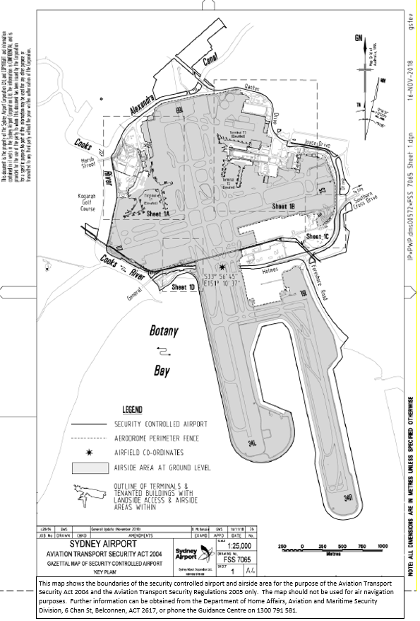
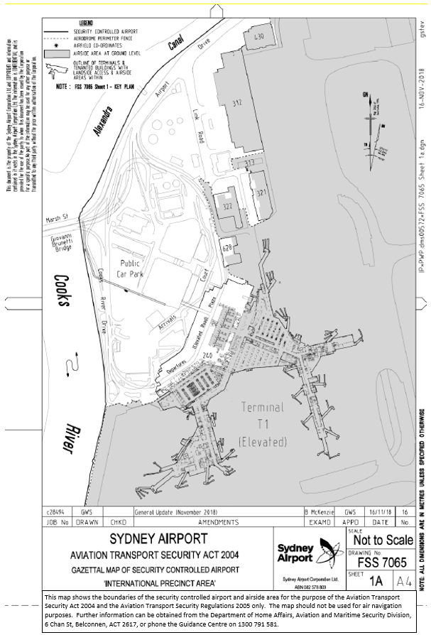

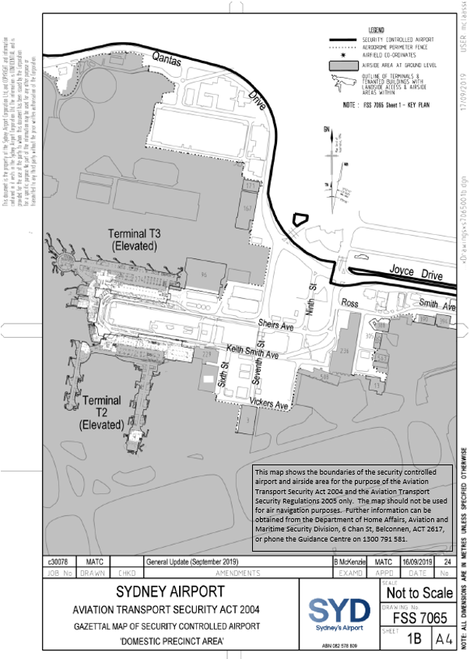

This map shows the boundaries of the security controlled airport and airside area for the purpose of the Aviation Transport Security Act 2004 and the Aviation Transport Security Regulations 2005 only. The map should not be used for air navigation purposes. Further information can be obtained from the Department of Home Affairs, Aviation and Maritime Security Division, 6 Chan St, Belconnen, ACT 2617, or phone the Guidance Centre on 1300 791 581.

This is a map [map 1 of 5] of Sydney Airport which has been declared a security controlled airport. The map establishes airport boundaries and airside areas for the purposes of section 28 and section 29 of the Aviation Transport Security Act 2004.