

NTC-16658

***Maritime Transport and Offshore Facilities Security Act 2003***

**Notice of declaration of security regulated port – Port of Newcastle**

I, **CHRISTINE DEEGAN**, Director, Transport Security Operations, Aviation and Maritime Security Division, under subsection 13(1) of the *Maritime Transport and Offshore Facilities Security Act 2003* (the Act):

**REVOKE** the declaration of the security regulated port of Port of Newcastle published in the *Gazette* (*C2014G01198, 14 November 2012)*; and

**DECLARE** that the area of the port of Port of Newcastle intended for use either wholly or partly in connection with the movement, loading, unloading, maintenance or provisioning of security regulated ships, the boundaries of which are shown on the attached map and descriptions, to be a security regulated port.

This Notice commences upon publication in the *Gazette*.

Date: 19 August 2019

Christine Deegan

Delegate of the Secretary of the

Department of Home Affairs

Note:

1. *Gazette* means the *Commonwealth of Australia Gazette*
2. This Notice remains in force until otherwise revoked in writing and upon subsequent publication in the *Gazette*.

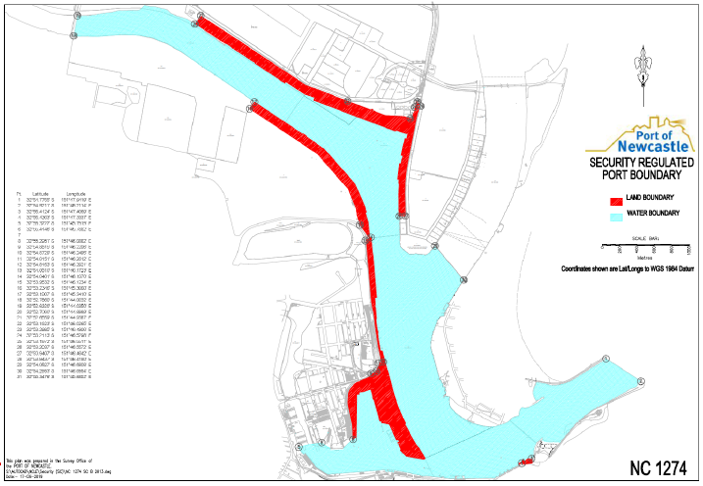

This map shows the boundaries of the security regulated port for the purposes of the Maritime Transport & Offshore Facilities Security Act 2003. This map is not intended for navigational purposes. Further information can be obtained from the Department of Home Affairs, Aviation and Maritime Security Division, GPO Box 594, Canberra ACT 2601, or phone the Guidance Centre on 1300 791 581