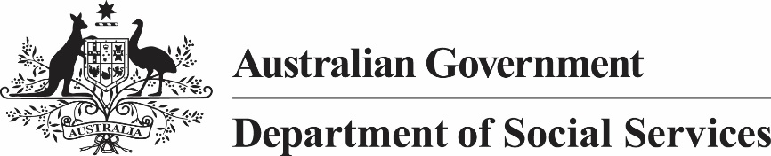

*Child Support (Assessment) Act 1989*

Notice under subsection 155(2A)

I, Kathryn Campbell, Secretary of the Department of Social Services, give notice under subsection 155(2A) of the *Child Support (Assessment) Act 1989* that the AWE amount (within the meaning of subsection 58AA(1) of that Act) for the quarter ending on 31 December 2018 is $1,225.00.

*[signed]*

Ms Kathryn Campbell AO CSC

Secretary

16 April 2019