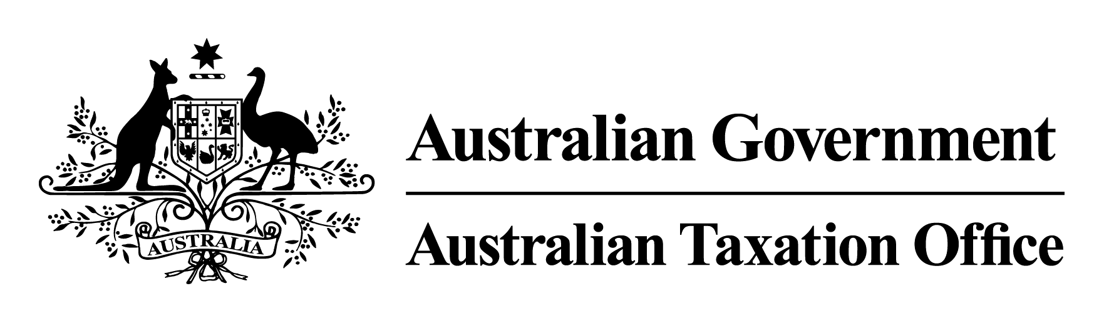

The Commissioner of Taxation, Chris Jordan, gives notice of the following Rulings, copies of which can be obtained from <http://ato.gov.au>/law.

| NOTICE OF RULINGS | | |
| --- | --- | --- |
| Ruling Number | Subject | Brief Description |
| CR 2019/3 | Income tax: Westpac Banking Corporation – Westpac Capital Notes 6 | The Ruling sets out the Commissioner’s view on the tax outcomes of the issue of the Westpac Capital Notes 6 by the Westpac Banking Corporation for the specified class of entities.  The Ruling applies from the income year ended 30 June 2019 to 30 June 2030. |
| CR 2019/4 | Fringe benefits tax: employer clients of Police Financial Services Limited, trading as BankVic, who are subject to the provisions of section 57A or 65J of the *Fringe Benefits Tax Assessment Act 1986* that make use of the BankVic Meals and Entertainment Card | The Ruling sets out the Commissioner’s view on the fringe benefits tax outcomes for employers who enter into an arrangement, either directly or via a third party intermediary salary packaging administrator, with Police Financial Services Limited trading as BankVic to provide BankVic Meals and Entertainment card to their employer’s employees and/or their employees’ associates.  The Ruling applies from 1 April 2018 to 31 March 2024. |
| CR 2019/5 | Income tax: BHP Group Limited – off‑market share buy‑back | The Ruling sets out the Commissioner’s view of the tax outcomes for the specified ordinary shareholders of BHP Group Limited who disposed of their ordinary shares in BHP under the off-market share buy-back announced by BHP on 1 November 2018..  The Ruling applies from 1 July 2018 to 30 June 2019. |
| CR 2019/6 | Income tax: Commonwealth Bank of Australia – CommBank PERLS XI Capital Notes | The Ruling sets out the Commissioner’s view of the tax outcomes for the specified class of investors who acquired CommBank PERLS XI Capital Notes.  The Ruling applies from 1 July 2018 to 30 June 2028. |
| CR 2019/7 | Income tax: Inghams Group Limited – return of share capital | The Ruling sets out the Commissioner’s view of the tax outcomes of the return of share capital on 18 December 2018 for specified holders of ordinary shares in Inghams Group Limited.  The Ruling applies from 1 July 2018 to 30 June 2019. |