**HEAVY VEHICLE NATIONAL LAW**

**National Heavy Vehicle Standards (Special Purpose Vehicles Exceeding 40 tonnes Total Mass) Exemption Notice 2018 (No. 1)**

1. **Purpose**

This Notice exempts certain categories of Class 1 Special Purpose Vehicles (SPVs) with a total mass exceeding 40t from complying with certain specifications of the *Heavy Vehicle (Vehicle Standards) National Regulation* (the National VS Regulation).

*Note: This Notice is not an access authorisation. This Notice only provides Vehicle Standards exemptions, and does not authorise access to the road network. To gain access to the road network, a vehicle must comply with a current access authorisation, either under Gazetted notice or under permit.*

1. **Authorising Provision**

This notice is made under section 61 of the *Heavy Vehicle National Law* (HVNL) as in force in each participating jurisdiction.

1. **Commencement**

This notice commences on the date of publication.

1. **Expiry**

This notice expires five years after publication.

1. **Title**

This notice may be cited as the *National Heavy Vehicle Standards (Special Purpose Vehicles Exceeding 40 tonnes Total Mass) Exemption Notice 2018*.

1. **Application**

This Notice applies to eligible vehicles operating in all participating jurisdictions.

1. **Definitions and interpretation**
2. Unless otherwise stated, words and expressions used in this notice have the same meanings as those defined in the HVNL.
3. In this notice—

***Additional Equipment*** means tools, substances and readily removable equipment required for the normal use of the vehicle

*Note: Examples of additional equipment include the following items*

|  |  |
| --- | --- |
| ***SPV Type*** | ***Additional Equipment*** |
| *Cranes* | *Counter weight, fly jib, additional hooks, slings and timbers.* |
| *Concrete pumps* | *Water, cement, fly ash, extension pipes and timbers* |
| *Drill rigs* | *Drill stems, rigging tools and timbers* |
| *Fire trucks* | *Fire-fighting equipment, quantity of water and foam* |
| *EWP* | *timbers* |

***All terrain mobile crane*** means an SPV that has all of the following features and requirements:

1. is a mobile crane; and
2. has two tyres per axle (a boom dolly operating as part of a crane may be fitted with 4 tyres per axle); and
3. has at least 50% of its axles steerable; and
4. is not a truck mounted SPV; and
5. has on-road and off-road capability.

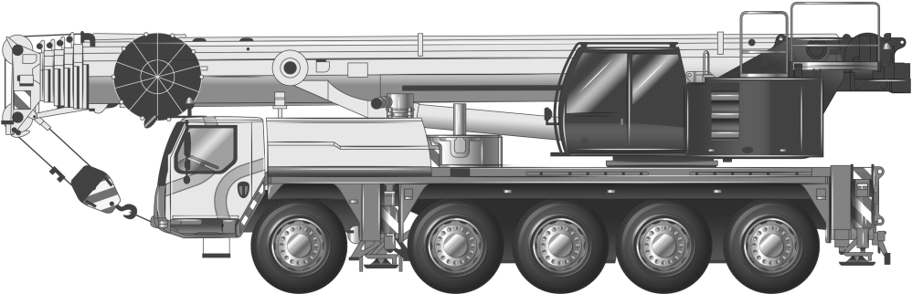

Figure 1 Illustrative example of an all terrain mobile crane

***Carrier mounted SPV*** means a heavy motor vehicle that is an SPV where the axles, chassis frame and main equipment are built as an integral vehicle unit and which cannot be divided without extreme effort, expense or risk of damage to it. A carrier mounted SPV is not a truck mounted SPV.

*Example: Most mobile cranes including all terrain mobile cranes and truck cranes are carrier mounted SPVs.*

***Boom dolly*** means a dolly which assists in supporting the mass of a crane’s boom when the boom has been rotated rearwards for on-road travel.

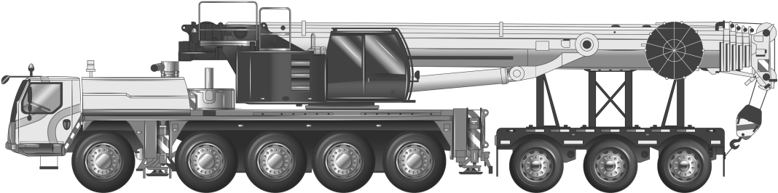

Figure 2 Illustrative example of a mobile crane fitted with a boom dolly

***Eligible Vehicle*** means an SPV, other than a trailer, with a total mass of more than 40t that complies with the conditional dimension requirements set out in sections 9, 10 and 11 of this Notice and:

1. is an SPV other than a crane that has up to 7 axles; or
2. is a crane;
   1. with up to 6 axles fitted with a boom dolly with up to and including 3 axles; or
   2. with up to 6 axles which operates without a boom dolly.

***Ground contact width*** means:

1. in relation to an axle, the distance between the outermost point of ground contact of the outside tyres on each end of the axle; or
2. in relation to an axle group, the greatest ground contact width of all the axles in the group.

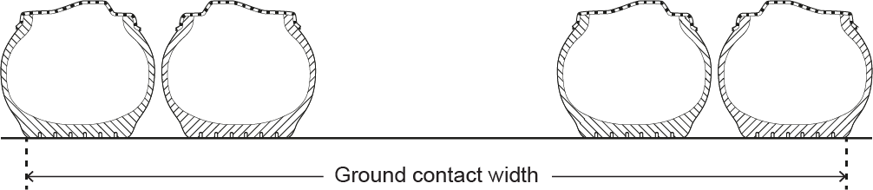

Figure 3 Illustration of ground contact width of an axle

***Mobile concrete pump means*** a heavy motor vehicle that is an SPV with a component that can be used to transfer liquid concrete by pumping.

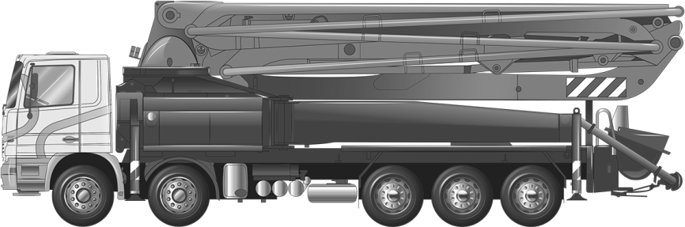

Figure 4 Illustrative example of a mobile concrete pump

***Mobile crane*** means a heavy motor vehicle that is an SPV that is:

1. equipped with a crane or other lifting device; and
2. designed primarily for raising, moving and lowering a freely suspended load.

***Rear Overhang*** means the distance measured between the rear of the vehicle and a point on the rear axle group as specified in Table 1 below.

Table 1: Rear Overhang

|  |  |
| --- | --- |
| ***SPV axle configuration*** | ***Overhang measurement*** |
| Non-steerable rear axle groups | The rear overhang is to be taken from the centre of the axle group to the rear of the vehicle. |
| Rear axle groups which incorporate steerable and non-steerable axles | The steerable axles should be disregarded so the rear overhang is taken from the centre of the non-steerable axles in the group to the rear of the vehicle. |
| All terrain mobile crane | The rear overhang is to be measured from the centre of the last two axles to the rear of the vehicle. |

***Total Mass of the SPV*** means:

1. the mass of the SPV ready for transport; and
2. the mass of any additional equipment.

***Truck mounted SPV*** means an SPV built using an Australian Design Rule (ADR) compliant heavy vehicle cab chassis***.***

***SPV*** means a Special Purpose Vehicle as defined in s116 of the Heavy Vehicle National Law.

1. A reference to a clause of an ADR is a reference to:
2. The version of the clause applying to the vehicle as a heavy vehicle standard; and
3. If the clause is omitted and remade (with or without modification) or renumbered and a version of the clause as remade or renumbered applies to the heavy vehicle as a vehicle standard the version of the clause as remade or renumbered applying to the heavy vehicle as a vehicle standard.
4. **Exemption - Vehicle Standards (Dimensions)**
5. An eligible vehicle operating under this notice is exempt from complying with the heavy vehicle standards in Schedule 2, section 34(1) of the *Heavy Vehicle (Vehicle Standards) National Regulation,* as specified in the conditional dimension requirements set out in section 9, section 10 and section 11.

*Note: While this notice may facilitate the registration of an SPV (provided all the conditions set out in the Notice are met) it does not provide any approvals in regards to the vehicle’s access to the road network.*

1. **Conditions - Vehicle Standards Dimension Requirements**
2. An eligible vehicle of the type set out in Column 2 of Table 3 is exempt from complying with Schedule 2, section 34(1) of the Heavy Vehicle (Vehicle Standards) National Regulation in so far as it requires compliance with the prescribed dimension requirement specified in Column 3, provided that the dimension does not exceed the limit specified in Column 5.

Table 2 Conditional Vehicle Standards Dimension Requirements

|  |  |  |  |  |
| --- | --- | --- | --- | --- |
| **Column 1** | **Column 2** | **Column 3** | **Column 4** | **Column 5** |
| **Item No.** | **Type of vehicle operating under this Notice** | **Relevant section of MDL Regulation**  **Schedule 6** | **Dimension** | **Limit** |
| 1 | Any | Section 8 | Height | 4.6m |
| 2 | Any | Section 7 | Width | 3.5m  (or as specified in the NSW Schedule[1] or the SA Schedule[2]) |
| 3 | Any | Section 3 | Length | 14.5m |
| 4 | Mobile cranes | Section 3 | Length | 16.5m |
| 5 | Carrier mounted mobile crane fitted with boom dolly | Section 3 | Length | 25m |
| 6 | Any mobile crane carrier with up to and including 5-axles and no greater than 16.5m in length | Section 5(1)(c) | Distance from the rear overhang (ROH) line to the rear of an SPV | Lesser of 4.0m or 90% of the wheelbase |
| 7 | Any mobile crane carrier with up to and including 5-axles and no greater than 16.5m in length | Section 5(1)(c) | Distance from the ROH line to the rear of an SPV | 4.0m to 4.5m if vehicle complies with Section 10 |
| 8 | Any mobile crane carrier exceeding 5 axles (including boom dolly) and/or greater than 16.5m in length | Section 5(1)(c) | Distance from the ROH line to the rear of an SPV | 4.5m if vehicle complies with Section 10 |

*[1] Please refer to Section 1(1) of NSW schedule.*

*[2] Please refer to Section 1(1) and 1(2) of SA schedule.*

1. **Conditions - Vehicle Standards Rear Overhang Line Requirements**
2. The distance from the ROH line to the rear of the SPV is permitted to be up to, and including, 4.5m if the three following conditions are met:
3. The tail swing performance and the low speed swept path performance of this vehicle, as measured in accordance with the PBS Scheme Standards and Vehicle Assessment Rules, do not exceed 0.30m and 7.40m respectively. This condition means that the vehicle operates within the PBS Level 1 tail swing and low speed swept path performance; and
4. The vehicle has a turning circle of 25m diameter or less; and
5. A certificate issued by a PBS assessor accredited under the PBS Scheme Assessor Accreditation rules, certifies that the assessed vehicle complies with the PBS Level 1 tail swing and low speed swept path performance standards. This certificate must be carried in the vehicle whenever it is travelling under this Notice. It must identify the vehicle uniquely by describing the base vehicle apparatus (i.e. concrete pump model) and Vehicle Identification Number (VIN) (or chassis number for non-truck based SPVs). It must also contain scaled drawings showing the vehicle dimensions, vehicle low speed swept path and tail swing, together with the actual assessment result values and corresponding Level 1 performance

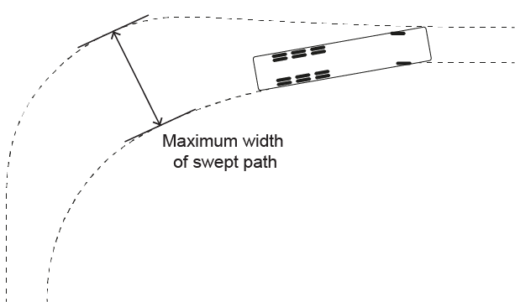

Figure 5 Illustration of tail swing performance measure (Source: NHVR/NTC Performance-Based Standards Scheme – the Standards and Vehicle Assessment Rules).

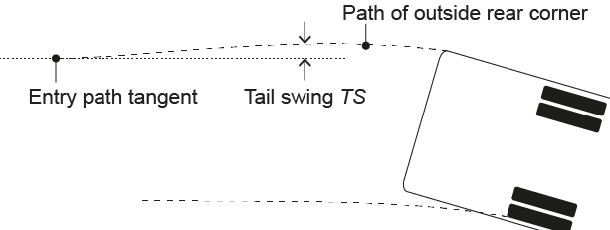

Figure 6 Plan view illustration of Maximum Width of Swept Path, SPWmax

(Source: NHVR/NTC Performance-Based Standards Scheme – the Standards and Vehicle Assessment Rules).

1. **Conditions - Forward projection requirements**
2. SPVs, excluding mobile cranes, must not have an object projecting greater than 3.5m in front of a line transecting the centre of the steering wheel.
3. A mobile crane must not have an object projecting greater than 5.5m in front of the centre of the steering wheel, or, if operating in South Australia, as specified in section 1(3) of the South Australia Schedule.
4. **Exemption - Schedule 4 Part 2 - Vehicle Configuration**
5. An eligible vehicle operating under this notice is exempt from complying with Schedule 2, Part 4 - Vehicle Configuration of the *Heavy Vehicle (Vehicle Standards) National Regulation.*
6. **Condition - Identification plate requirements**
7. SPVs must be fitted with either:
8. a manufacturer’s plate listing the vehicle’s details, or
9. a Commonwealth identification plate, in the case of a truck based SPV.
10. A crane dolly must be fitted with a Commonwealth identification plate stating the relevant approval number.
11. **Conditions - Warning lights and markings**
12. A pattern covering an area of at least 0.16m2 and consisting of diagonal stripes, at least 150mm wide and alternatively coloured red and white, or black and white, must be marked on the left and right sides and extremity of any rigid projection extending more than 1.2m in front or to the rear of the body of an SPV.
13. An SPV with a projection in front of the centre of the steering wheel exceeding 3.5m must have —
14. side marker lights on both sides of the projection, as far forward as possible. The side marker lights must be shielded from the driver’s view, but be visible to other motorists approaching from the front and sides of the vehicle, and
15. a yellow rotating warning light attached to the projection, as far forward as possible, that is shielded from the driver’s view.
16. Contrary to the requirements set out in Schedule 8, section 4 of the MDL, a warning light must be attached to the vehicle if it is wider than 2.5m or longer than 25m.
17. **Conditions - Driver visibility requirements**
18. An SPV must be designed to allow the driver in the normal driving position, a view of the road, pedestrians and traffic to the front and sides of the vehicle, so the driver can drive safely.

1. If an SPV has the centre of a steering control to the left of the vehicle which obscures the driver’s vision to the right of the vehicle due to a minor obstruction, it must be fitted with mirrors or an indirect vision device (i.e. camera) that counteracts the obstruction and provides the driver with an adequate view of the road, pedestrians and traffic to the right of the vehicle as intended by ADR 14/02.
2. If the driver of an SPV does not have an adequate view to the rear of the vehicle due to a minor obstruction, it must be fitted with mirrors or an indirect vision device (i.e. camera) that counteracts the driver’s obstruction and provides them with an adequate view of the road, pedestrians and traffic to the rear of the vehicle.
3. **Access Requirements**

This Notice only provides Vehicle Standards exemptions, and does not authorise access to the road network. To gain access to the road network, a vehicle must comply with a current access authorisation, either under Gazetted notice or under permit.

*Note: Valid access authorisations include Class 1 mass and dimension exemptions under the Heavy Vehicle National Law.*

1. **State Schedules**

An eligible vehicle operating under this Notice must comply with the conditions set out in the Schedule and relevant access exemption for a participating jurisdiction where the vehicle is being used.

Geoff Casey

*Executive Director Productivity and Safety*

**National Heavy Vehicle Regulator**

**SCHEDULE 1 – SOUTH AUSTRALIA**

1. **South Australia conditions**
2. Truck mounted SPVs (including mobile concrete pumps) must not exceed 2.5m in width.
3. All other SPVs covered by this Notice must not exceed a width of 3.1m.
4. The projection in front of the centre of the steering wheel of a SPV must not be greater than 3.5m.

**SCHEDULE 2 – NEW SOUTH WALES**

1. **NSW conditions**
2. SPVs, other than a mobile crane, must not exceed 2.5m in width.