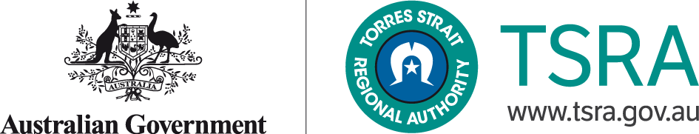

**APPOINTMENT OF THE TORRES STRAIT FISHERIES REGIONAL OWNERSHIP FRAMEWORK STEERING COMMITTEE AS A FORMAL ADVISORY COMMITTEE**

I, **CHARLIE KADDY**, Acting Chief Executive Officer, Torres Strait Regional Authority **HEREBY APPOINT** the Fisheries Regional Ownership Framework Steering Committee as a formal advisory committee under section 142M of the *Aboriginal and Torres Strait Islander Act 2005*.

Charlie Kaddy

Acting Chief Executive Officer

Torres Strait Regional Authority

08 November 2018