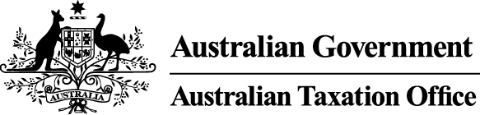
NOTICE OF DISQUALIFICATION
Superannuation Industry (Supervision) Act 1993

To:
Mr Larry Adams
CRANEBROOK NSW 2749
I, James O'Halloran, a delegate of the Commissioner of Taxation, give you notice as required by subsection 126A(6) of the Superannuation Industry (Supervision) Act 1993 (SISA), that I have disqualified you under subsection 126A(3) of the SISA.
I have disqualified you as I am satisfied that you are not a fit and proper person to be a trustee or a responsible officer of a body corporate that is a trustee, of a superannuation entity for the purposes of the SISA.
The disqualification takes effect on the day on which it is made.
Dated: 16 February 2018

James O'Halloran
Deputy Commissioner of Taxation

Per Colleen Shelton
Director VIC/TAS
Superannuation Engagement Assurance

Note 1:
Under subsection 126A(7) of the SISA, details of this disqualification notice will be published in the Commonwealth Government Notices Gazette.
Note 2:
Under section 126K of the SISA, it is an offence for a disqualified person, who knows that he or she is a disqualified person, to be, or act as a:
- trustee, investment manager or custodian of a superannuation entity
- responsible officer or a body corporate that is a trustee, investment manager or custodian, of a superannuation entity

The maximum penalty for committing this offence is two years jail.
Note 3:
Under subsection 126A(5) of the SISA, we may revoke this disqualification on our own initiative or on your written application.
Note 4:
Under section 344 of the SISA, if you are affected by this decision and are not satisfied with it, you can ask the Commissioner to reconsider the decision. This request must be made in writing within 21 days of receiving notice of this decision and must give the reasons you think the decision is wrong.

